**Blob Storage**

This doesn’t provide a hierarchy for storing files.

Container 2

Container 1

 

**File1 File2 Subfolder**

If you implement the above file structure and if you hop from one container to another you will find that the Subfolder will get disappeared. In order to make it persist you will need to add some files in Subfolder.

Container 2

Container 1

 

**File1 File2 Subfolder**



**File 3**

**Creating a Storage Account**

Search “Storage Accounts”

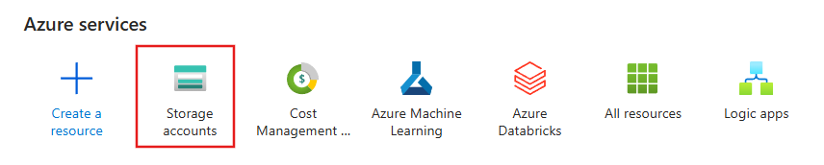

Click on “Create”

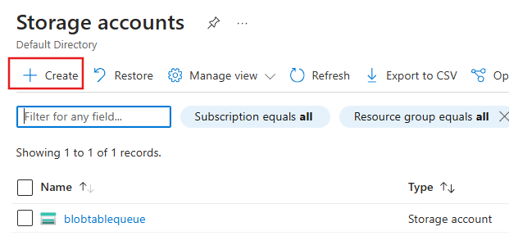

Fill all the relevant details

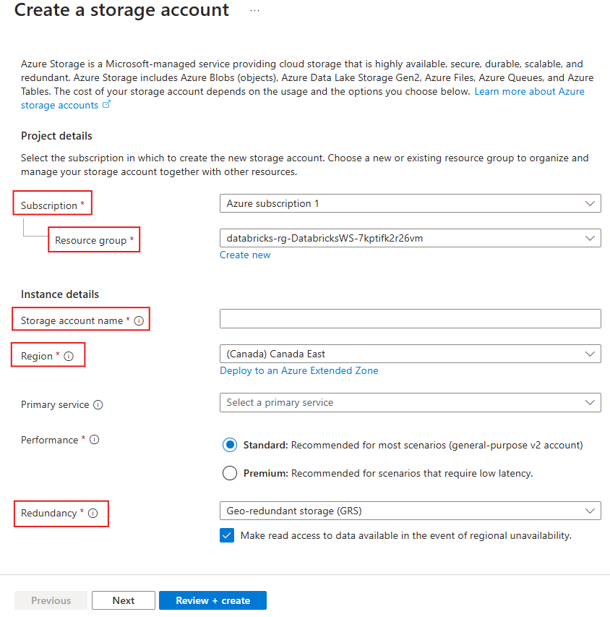

Review + create

**Creating Blob Storage**

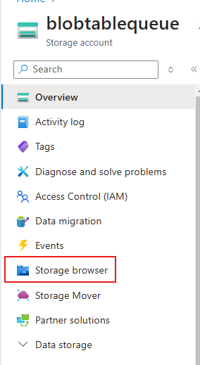

Once inside the Storage Account navigate to “Storage browser”

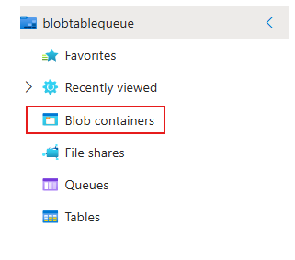

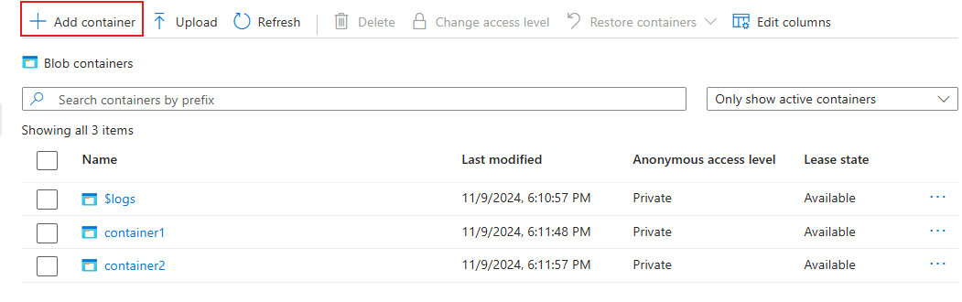

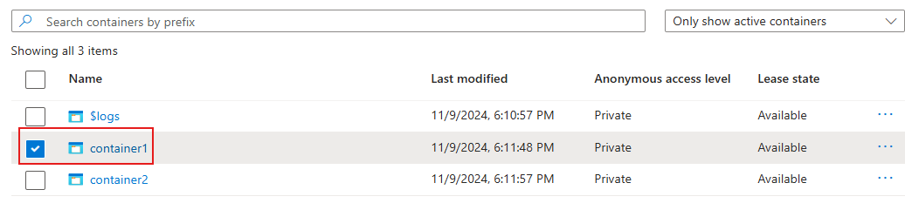

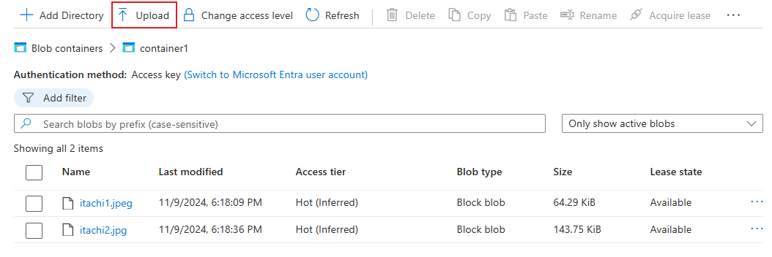

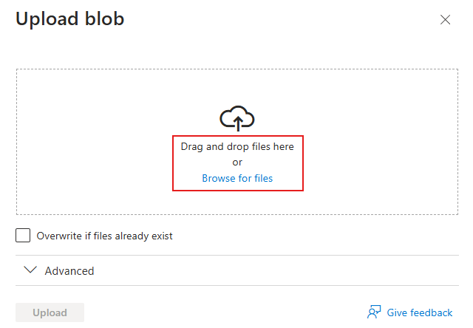

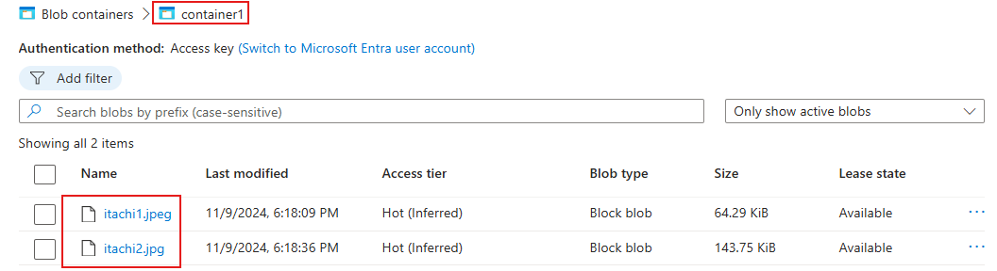

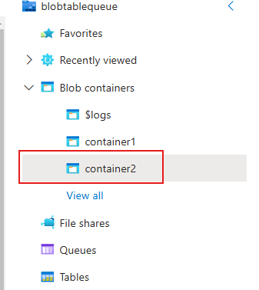

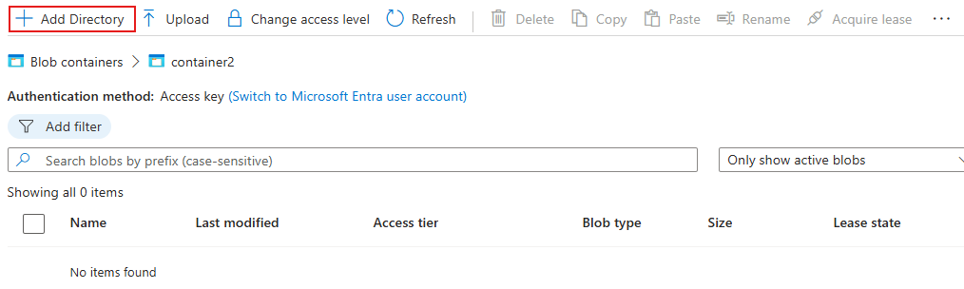

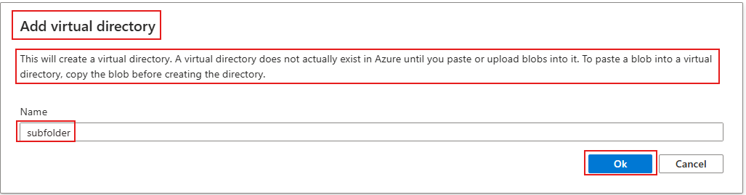

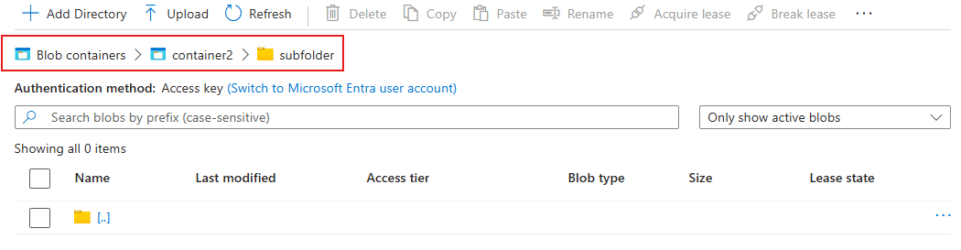

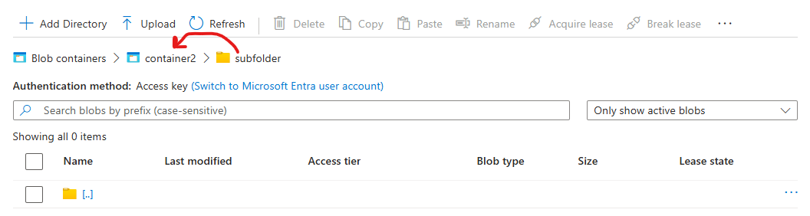

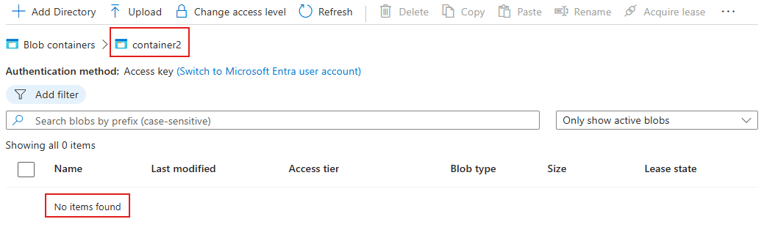

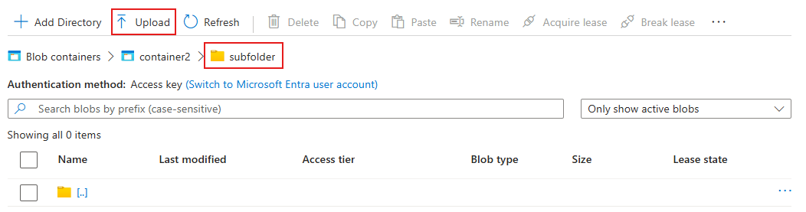

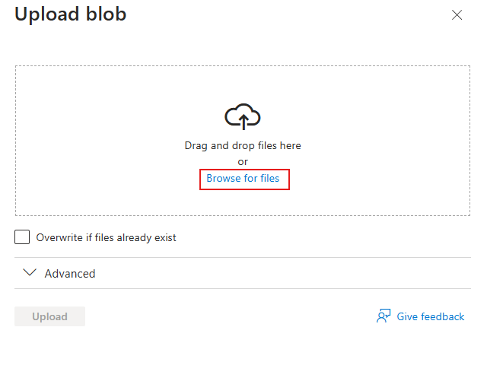

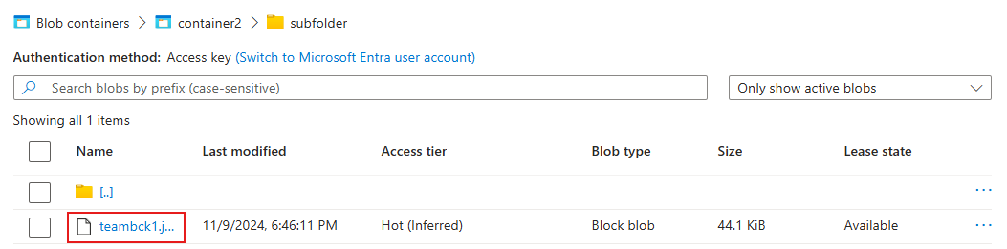

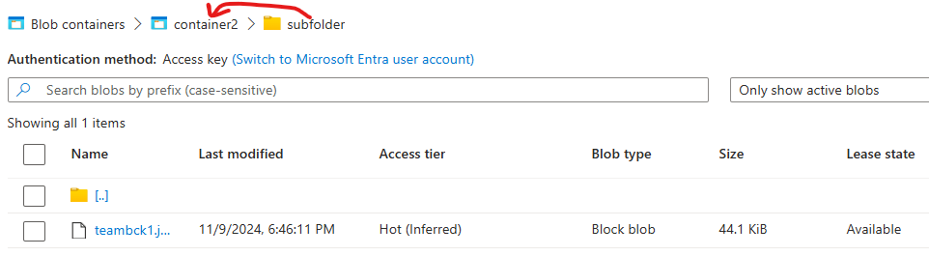

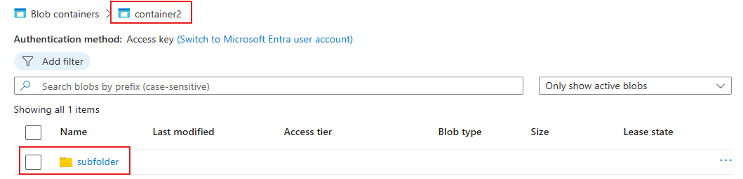

**Table**

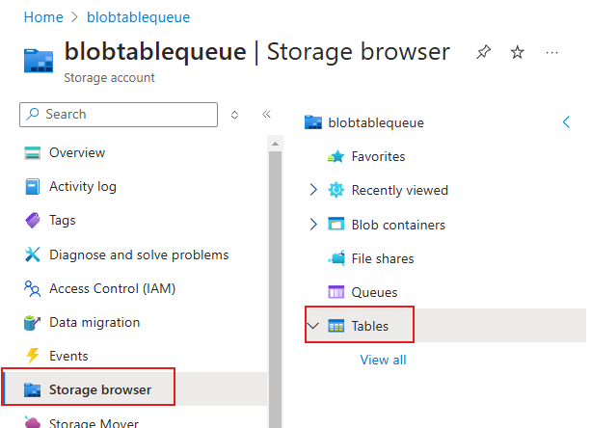

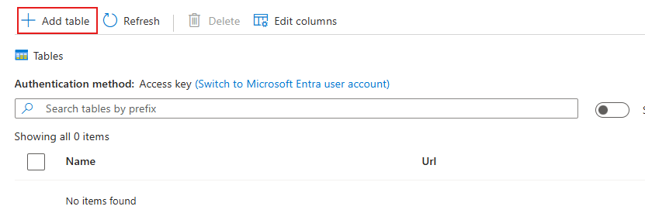

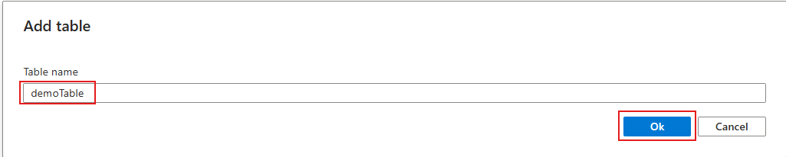

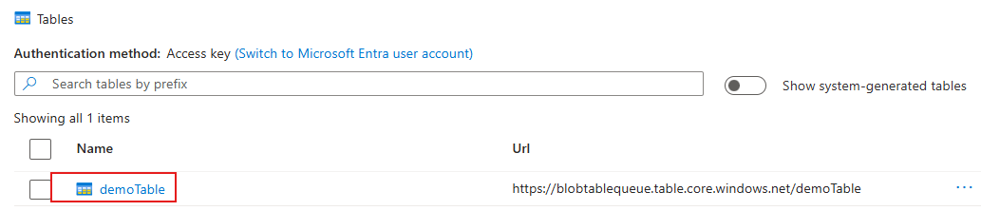

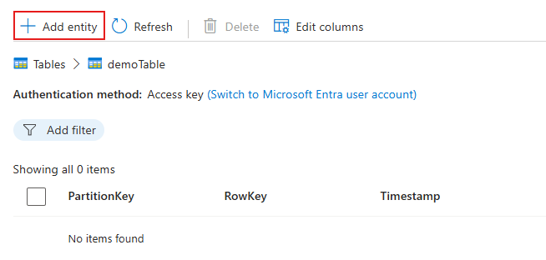

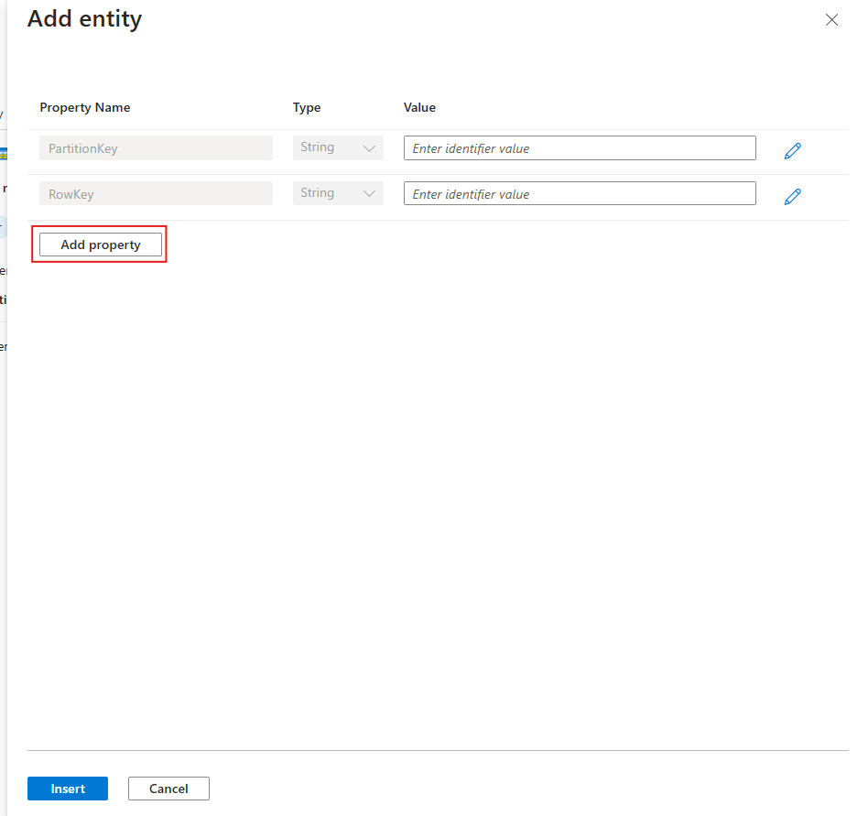

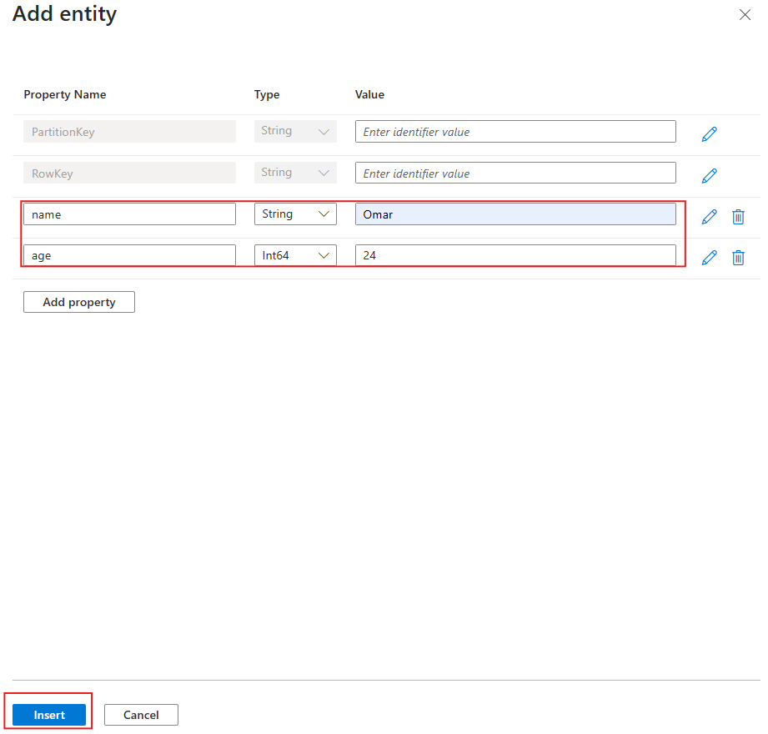

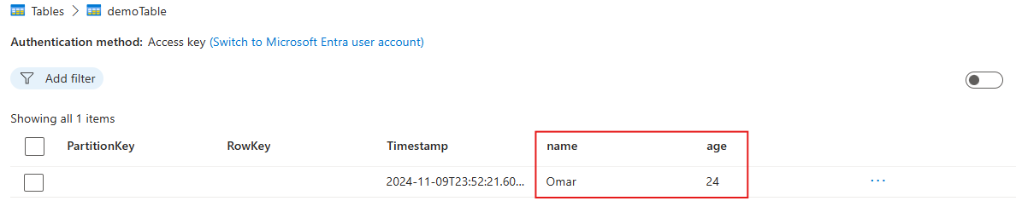

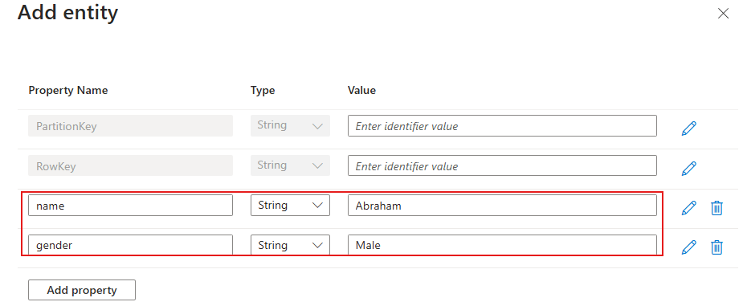

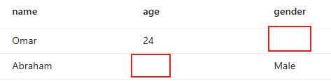

**Queue**

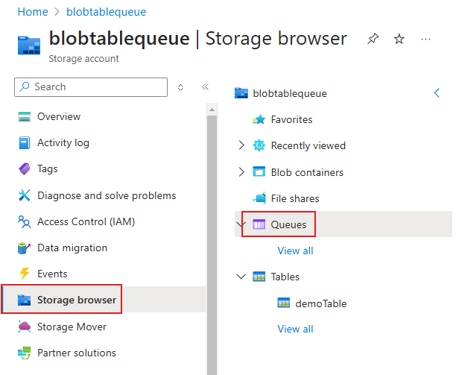

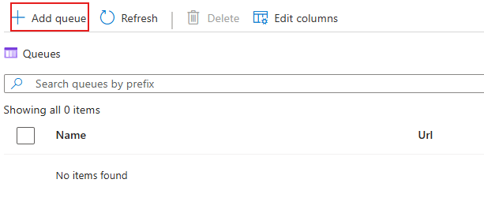

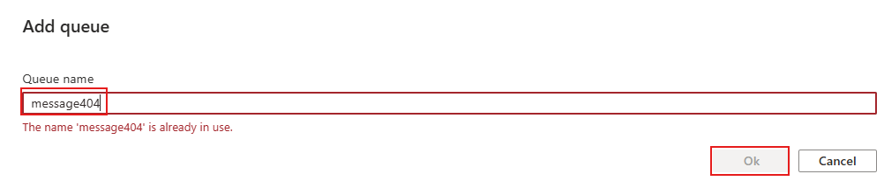



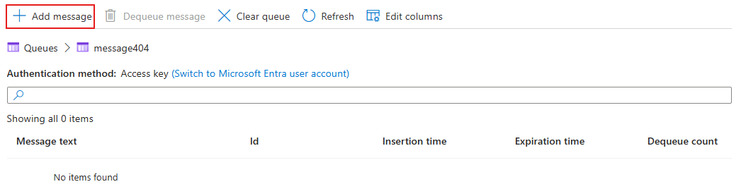

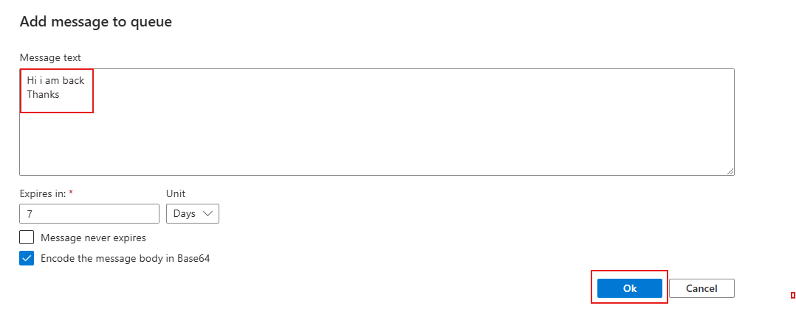

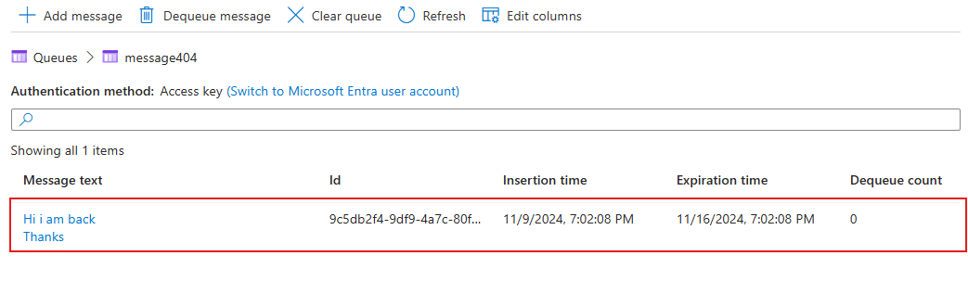

**Inside a Queue we have 2 messages**

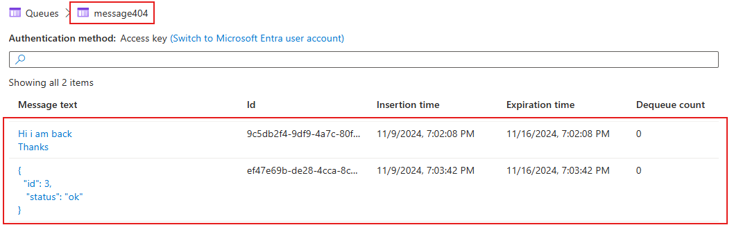

**To dequeue**

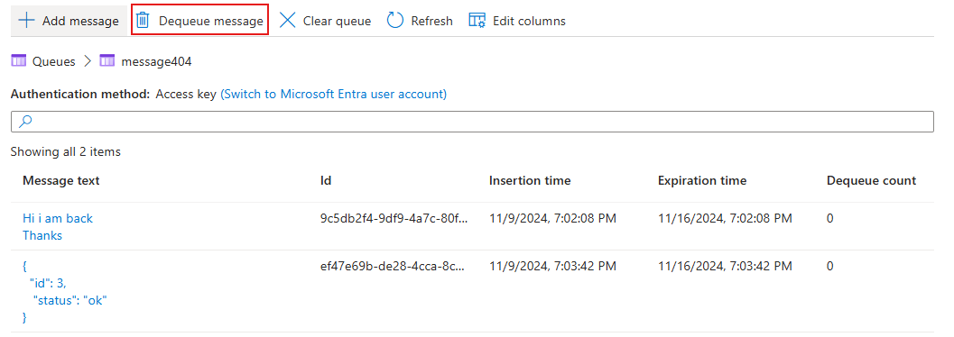

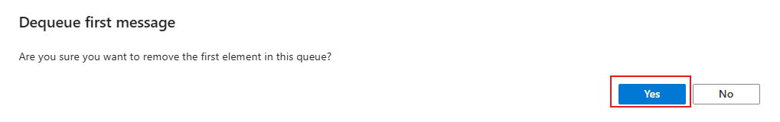

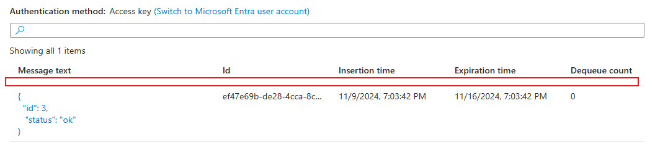

**Message 1 is gone**

**Lifecycle Management Policy**

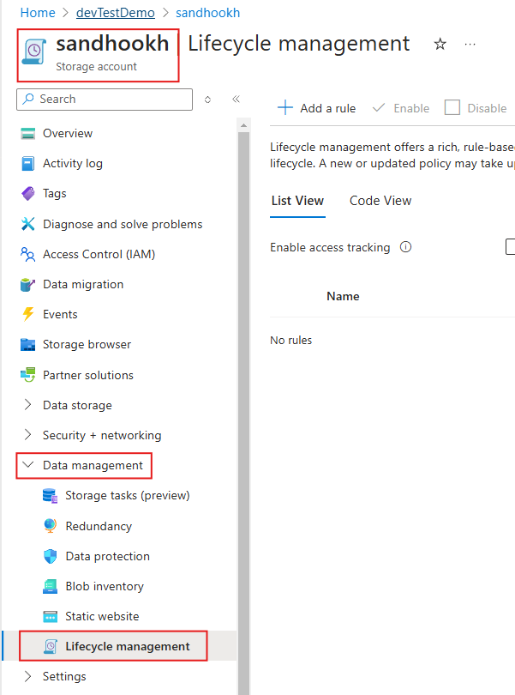

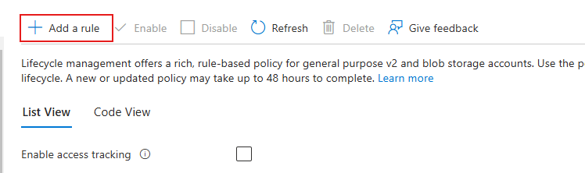

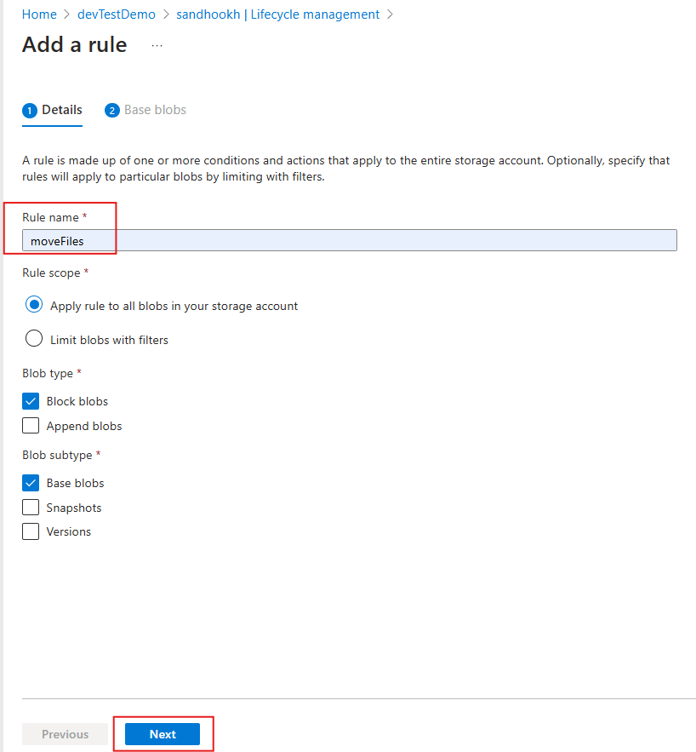

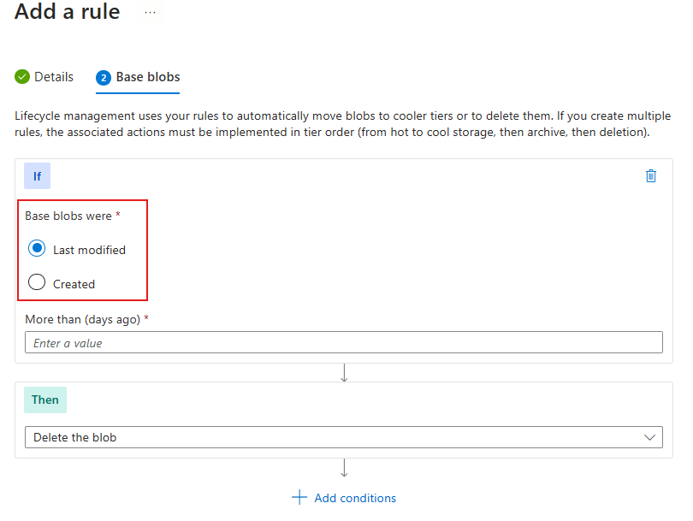

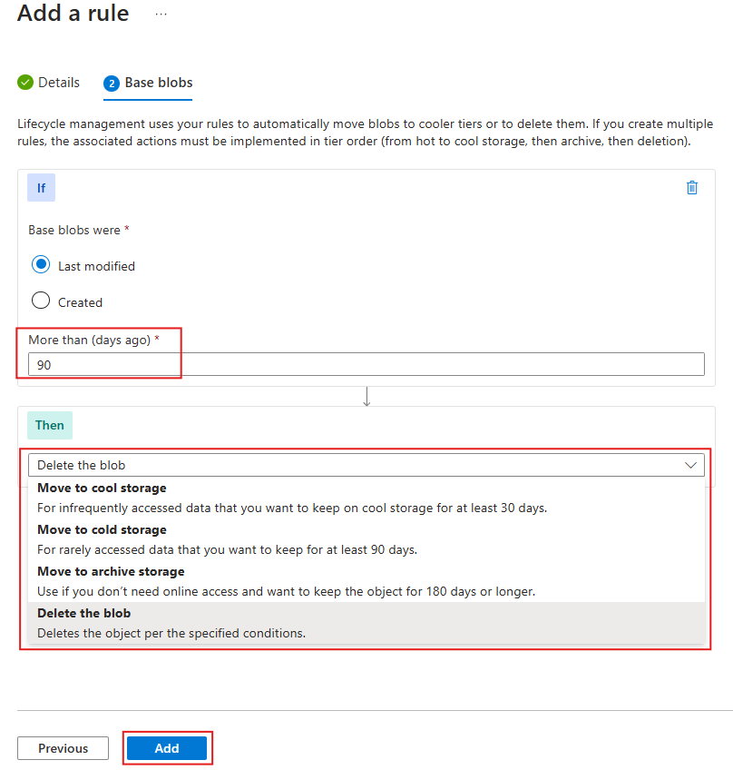

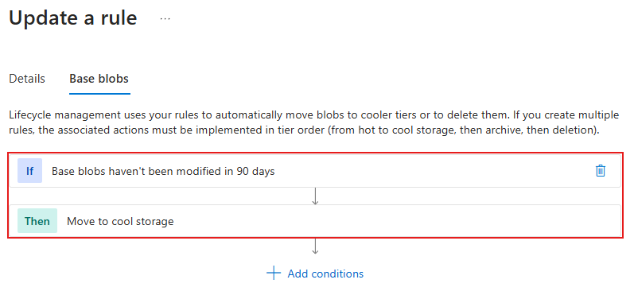

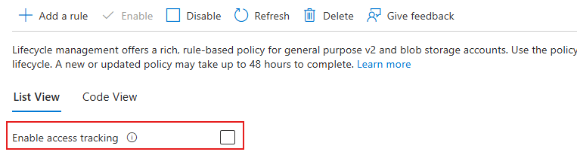

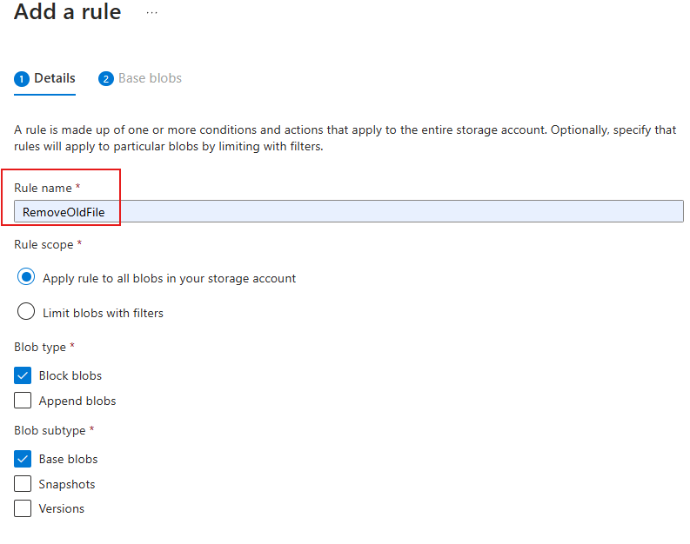

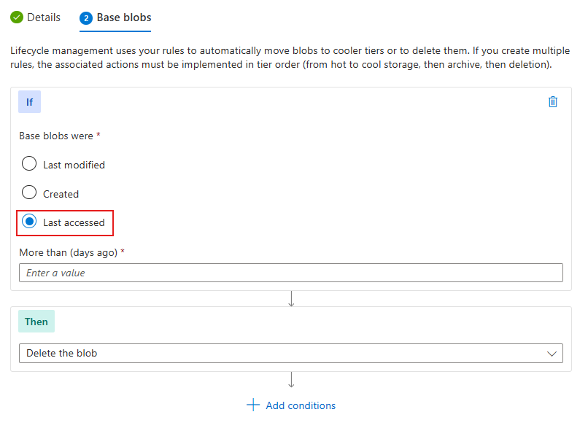

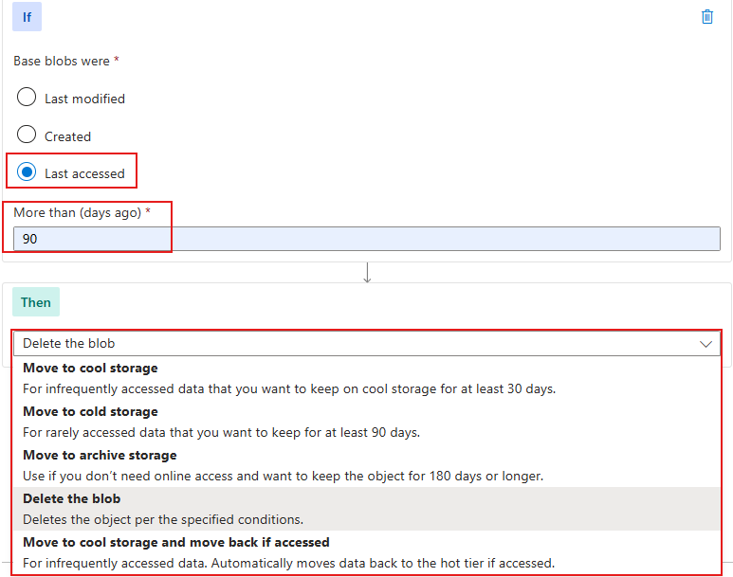

**Creating a Pipeline using Data Factory**

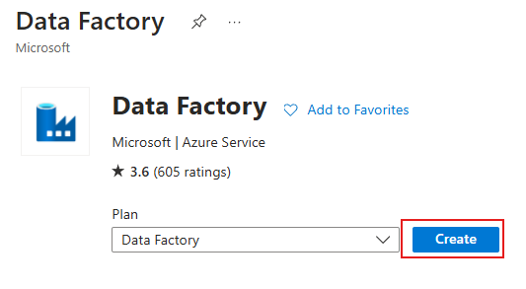

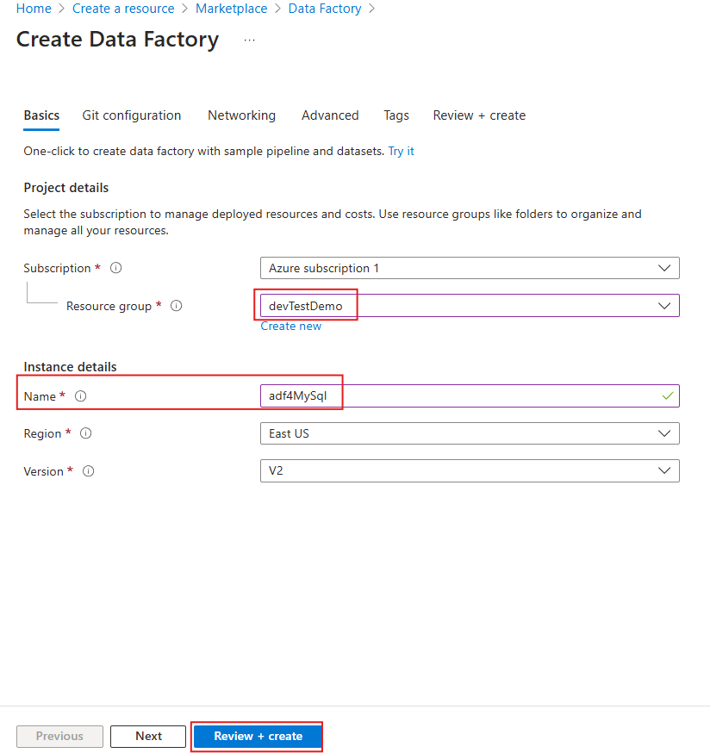

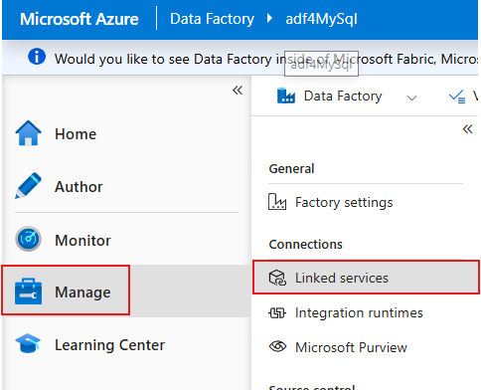

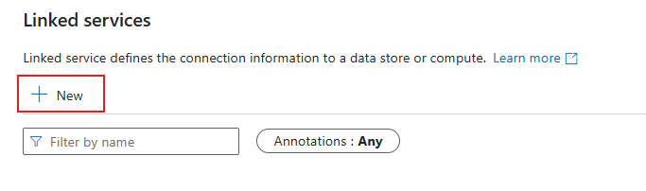

In this demo we will create a linked service for our on-premises MySQL setup

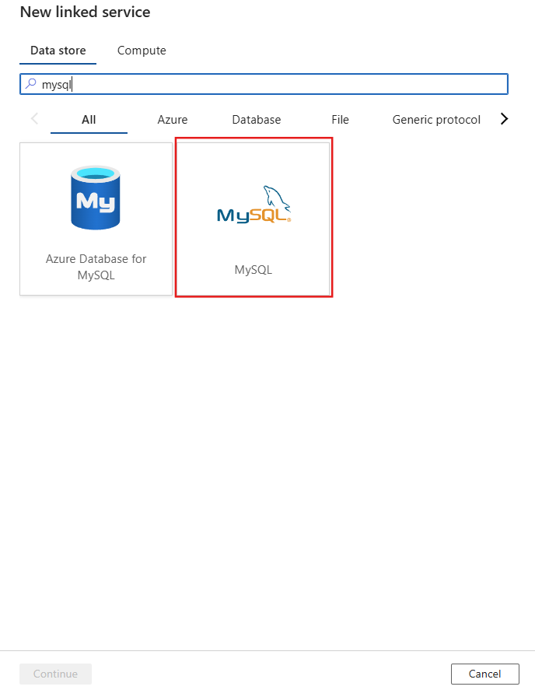

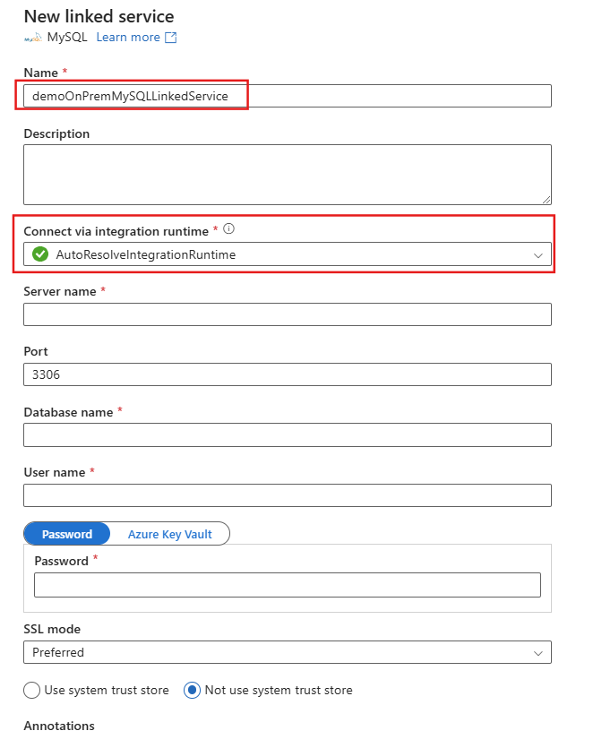

Since your source is MySQL and is an on-premises setup so in this case you cannot use AutoResolveIntegrationRuntime, because that IR is for migrating cloud to cloud data. So, in this case we go with Self-Hosted Integration Runtime.



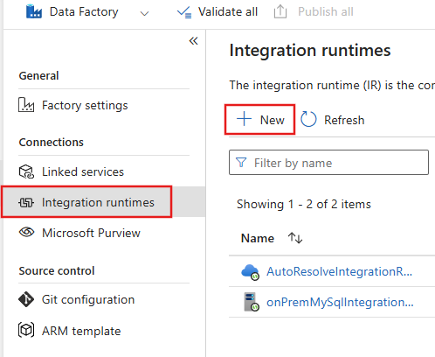

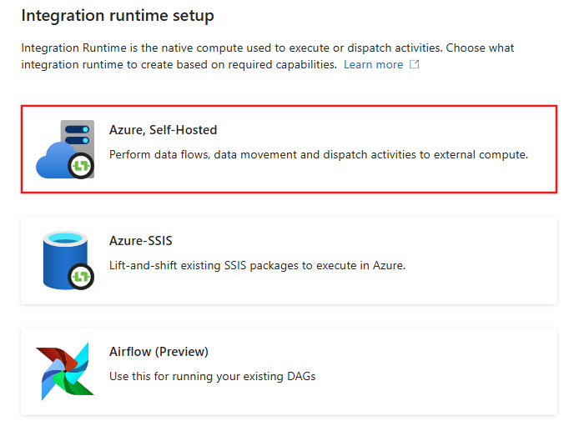

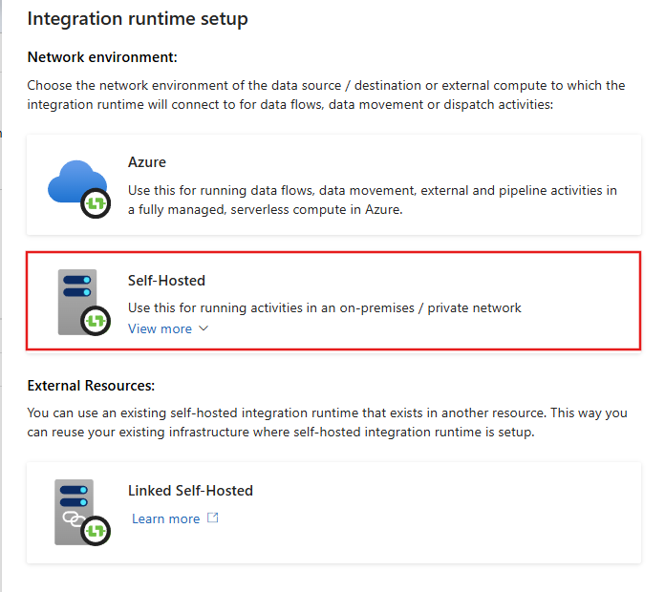

**Give it a Name and Description**

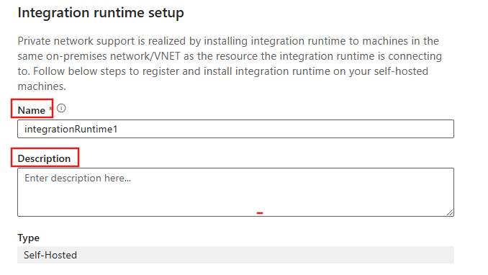

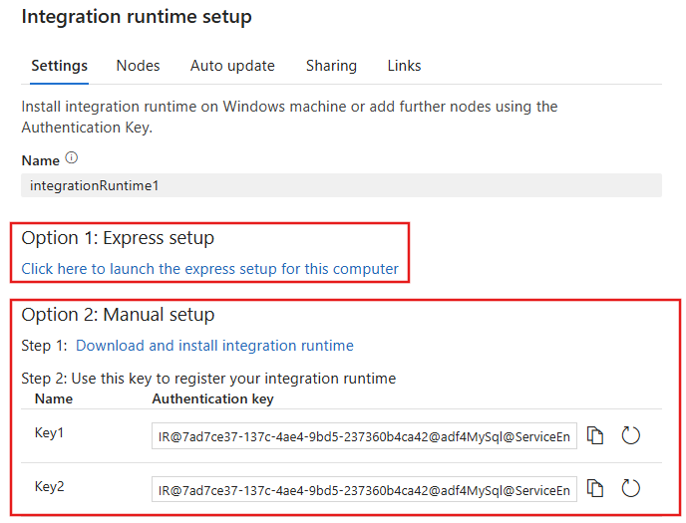

**Option 1:**

If you choose to go with this option, then you just need to install the express setup on to your local computer.

**Option 2:**

If you go with this option, then download the IR and register the IR anywhere you want with one of those 2 keys.

**Target Side Setup**

Inside the target Data Lake, make a container and name it as RAW. It will act as Raw Layer

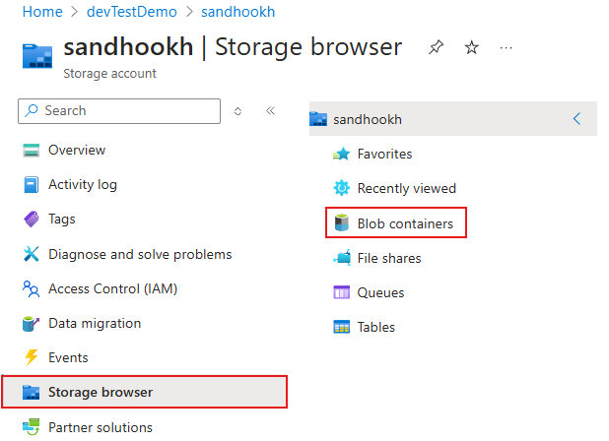

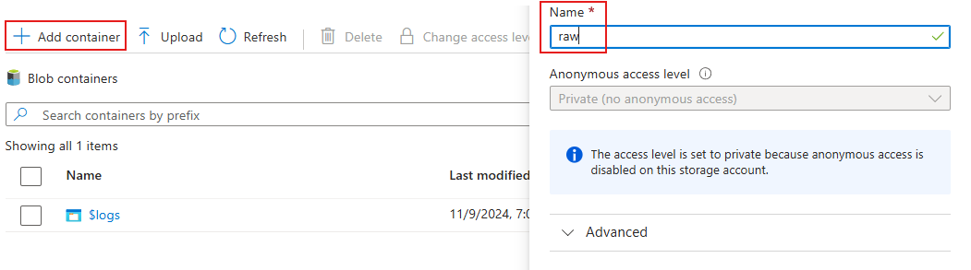

**Set Up Linked Service for Target**

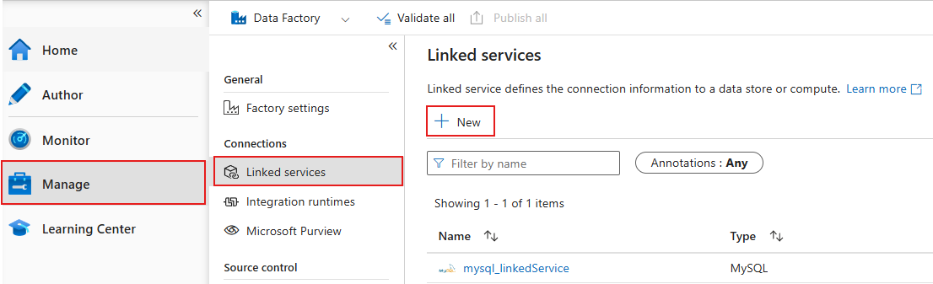

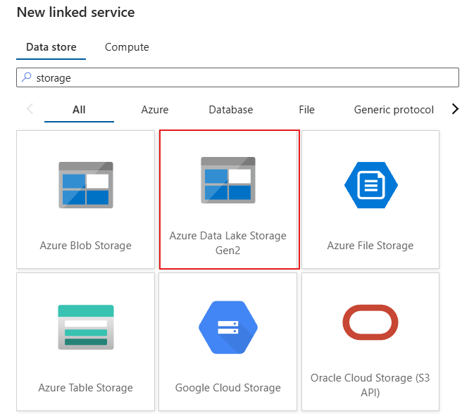

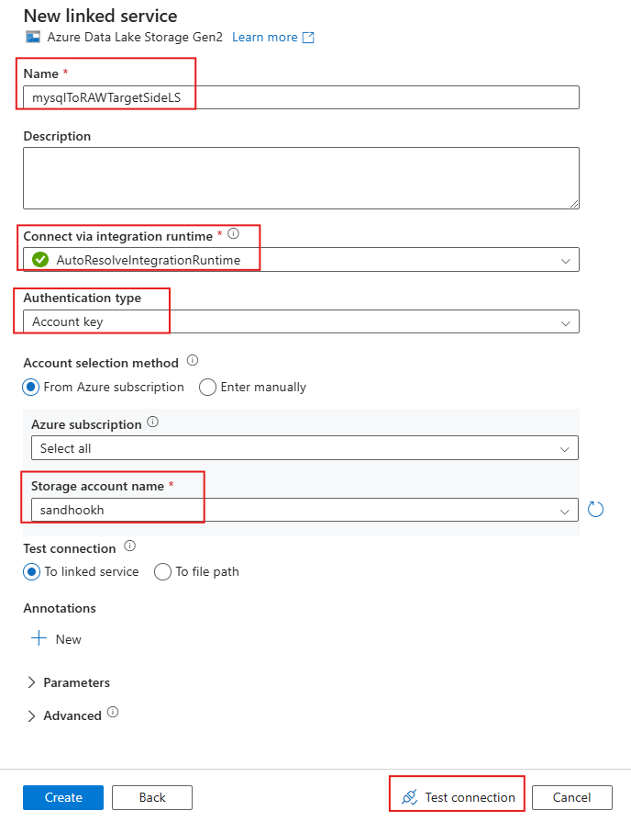

**Then Create Dataset for both Source and Target**

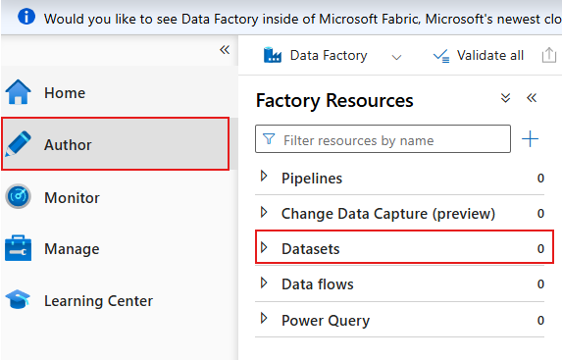

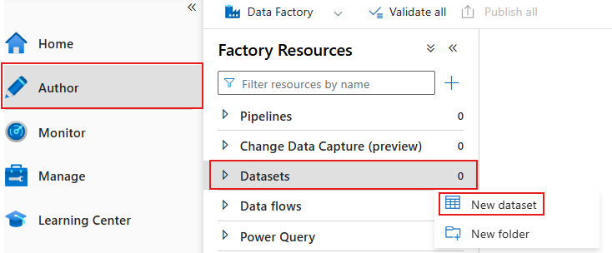

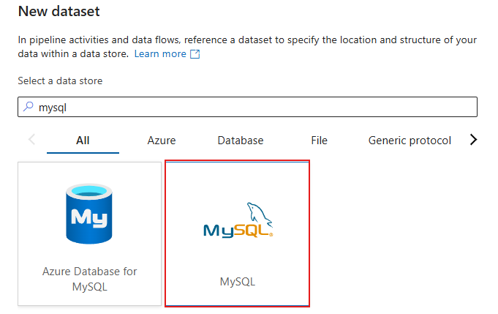

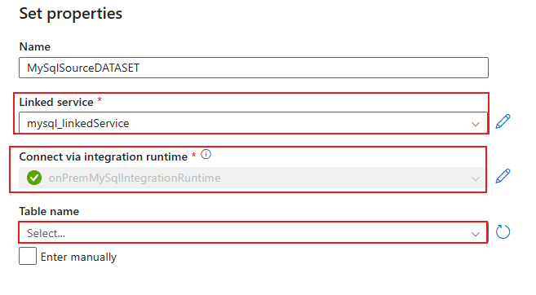

After setting appropriate properties, you will see that by selecting the dedicate Linked Service, automatically the dataset will detect which IR this Linked Service is using and then you will see the list of tables of the database that you had mentioned in the Linked Service

After that you can Preview the data

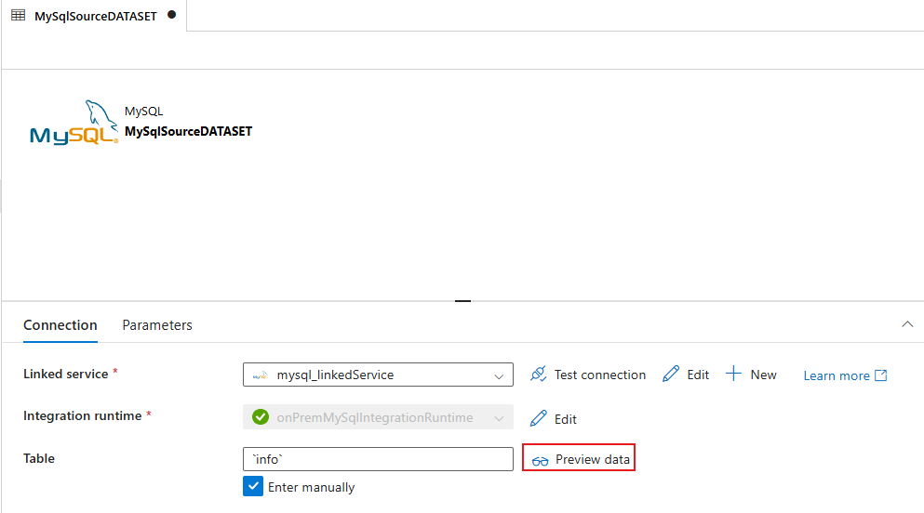

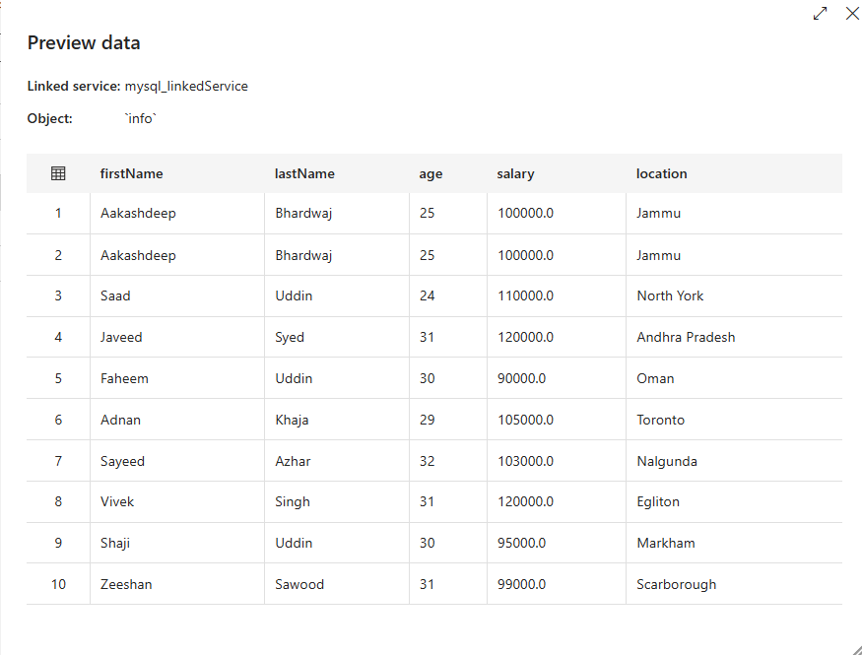

Now create a new dataset for the target side i.e. ADLSg2

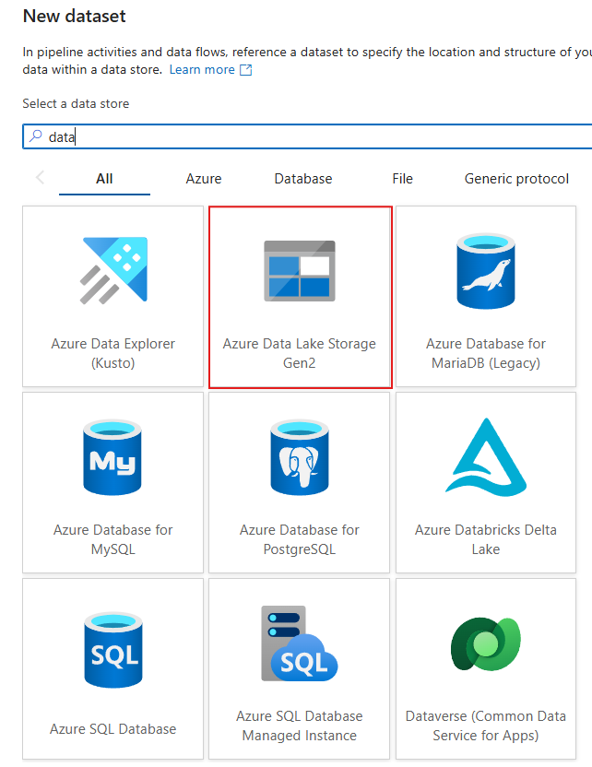

Select a file format

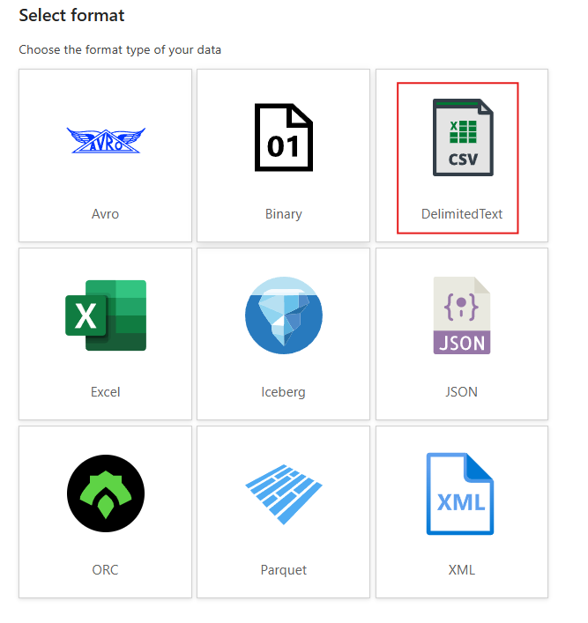

While you go with the option to stored data as csv you will require to provide File path as well

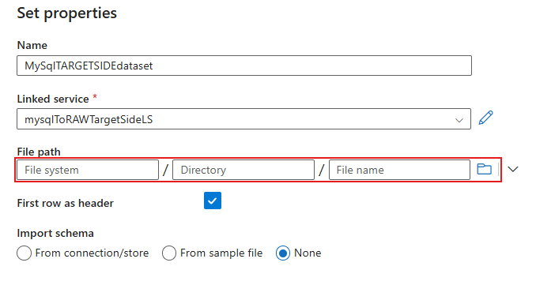

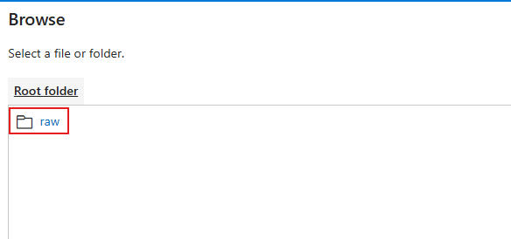

**Creating Managed VNet IR**

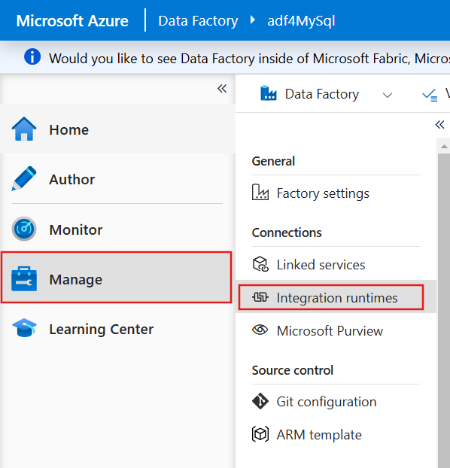

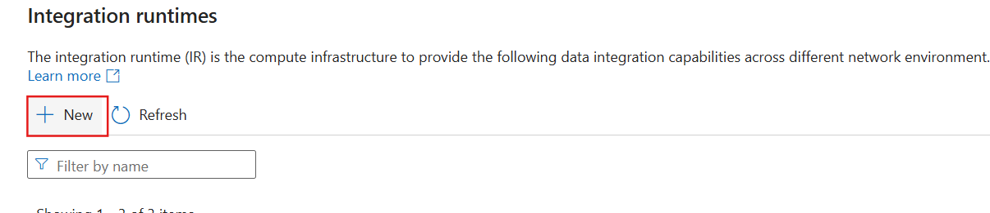

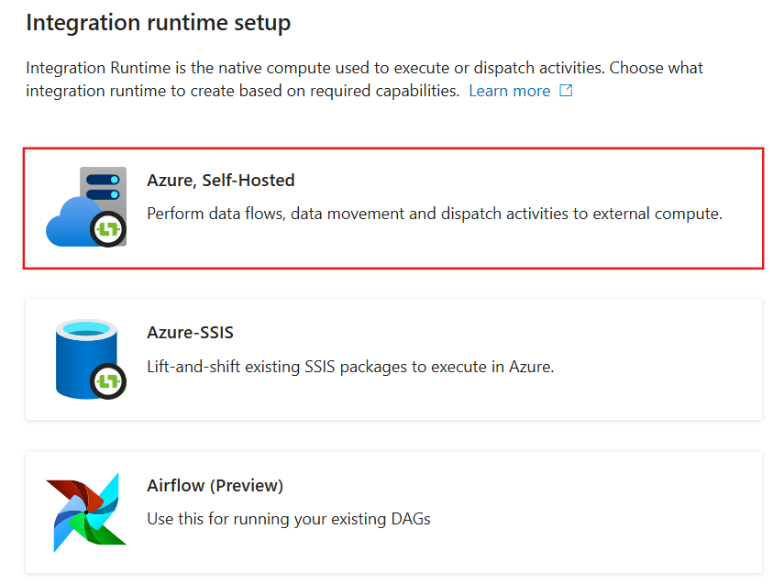

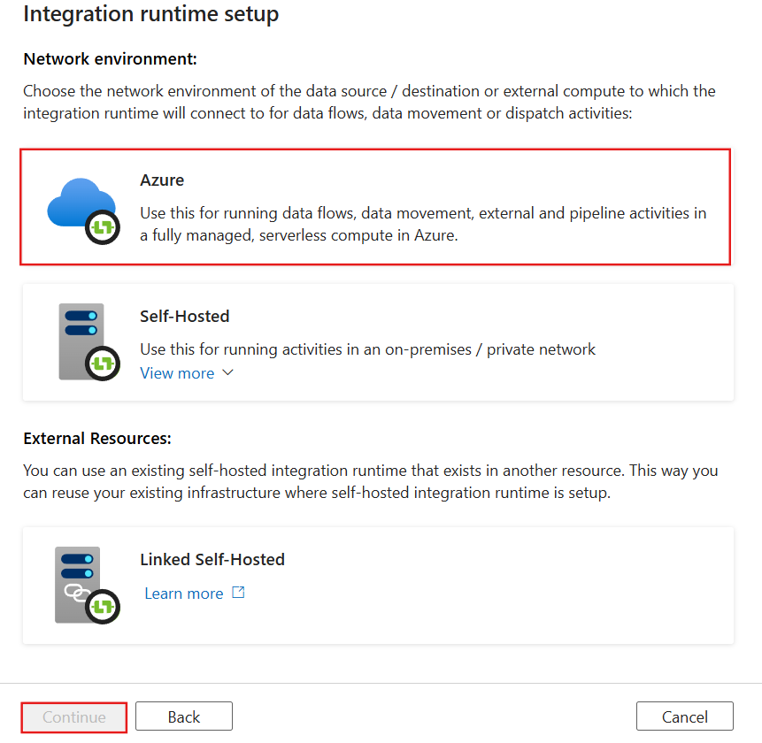

Configure as per the requirements

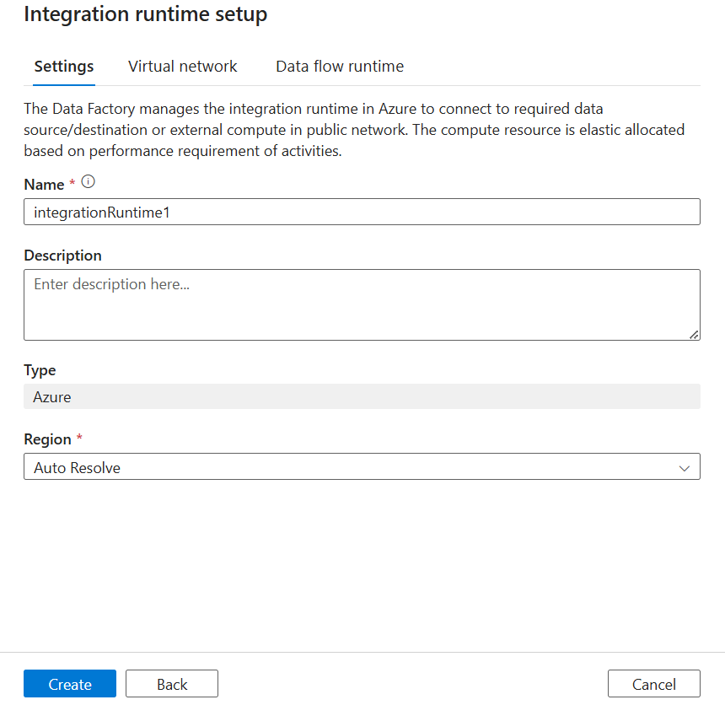

Go to virtual network

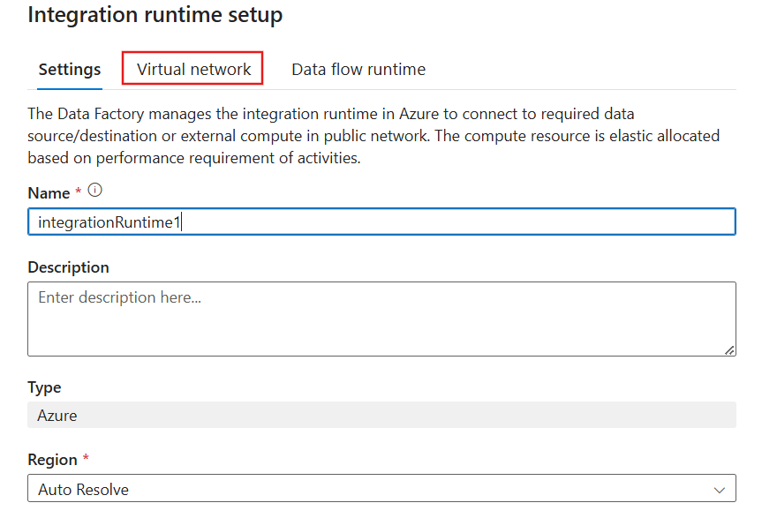

Enable and create

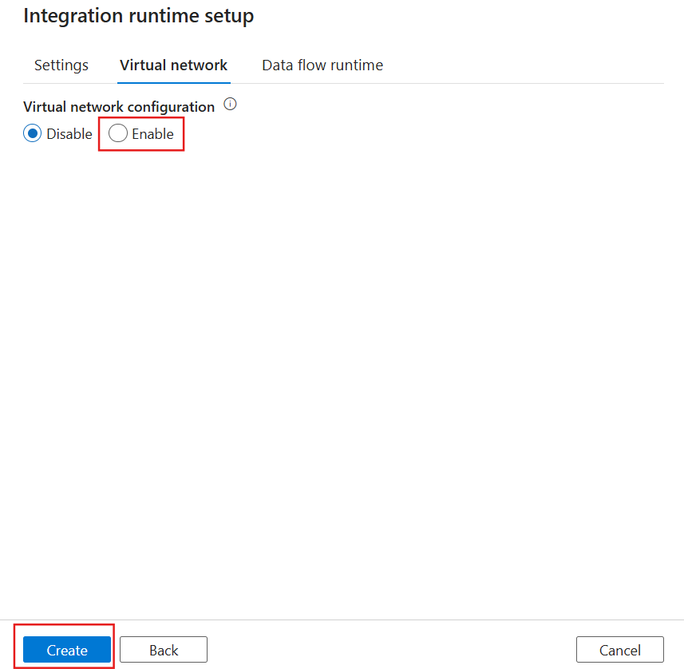

Now after creating the Manage VNet IR, utilize it in Linked Service

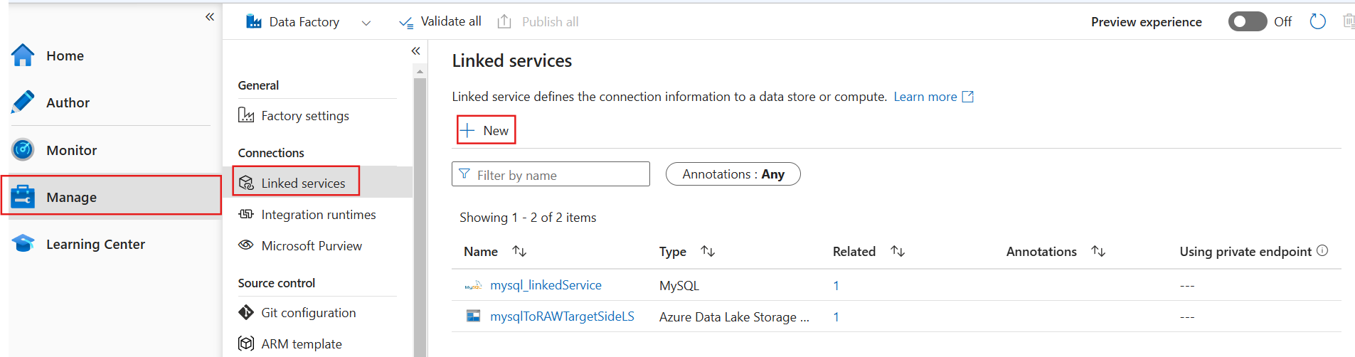

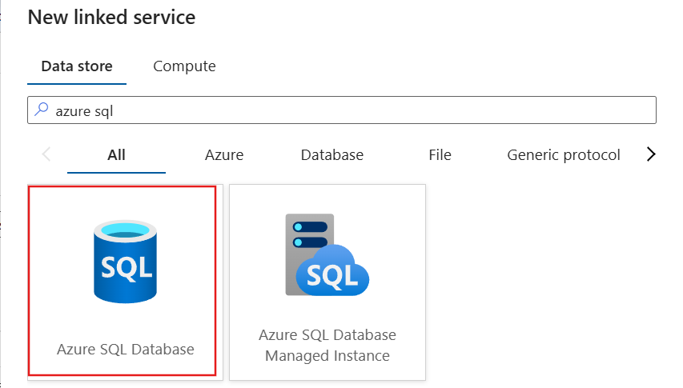

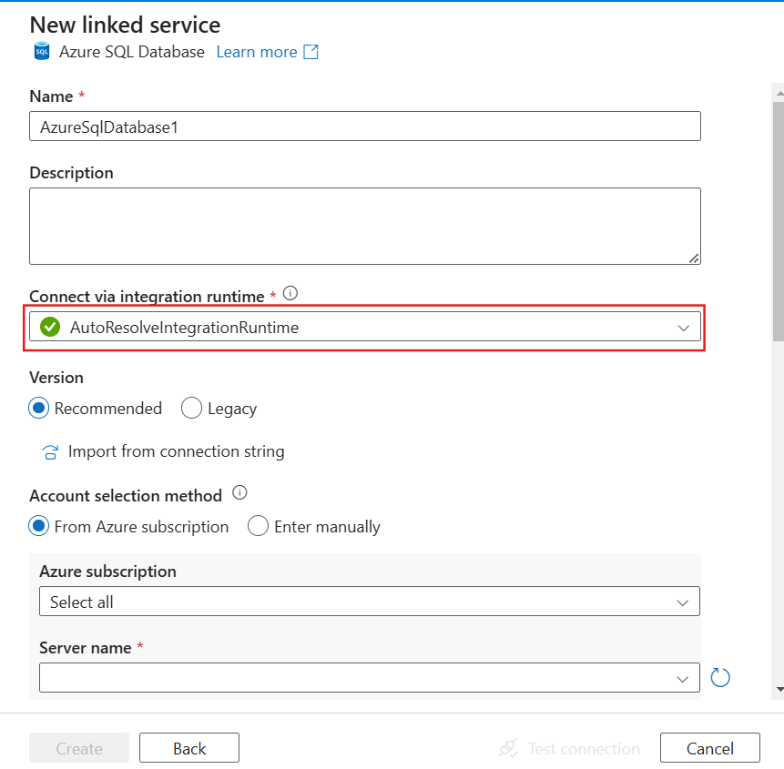

And from the drop down choose managed vnet ir

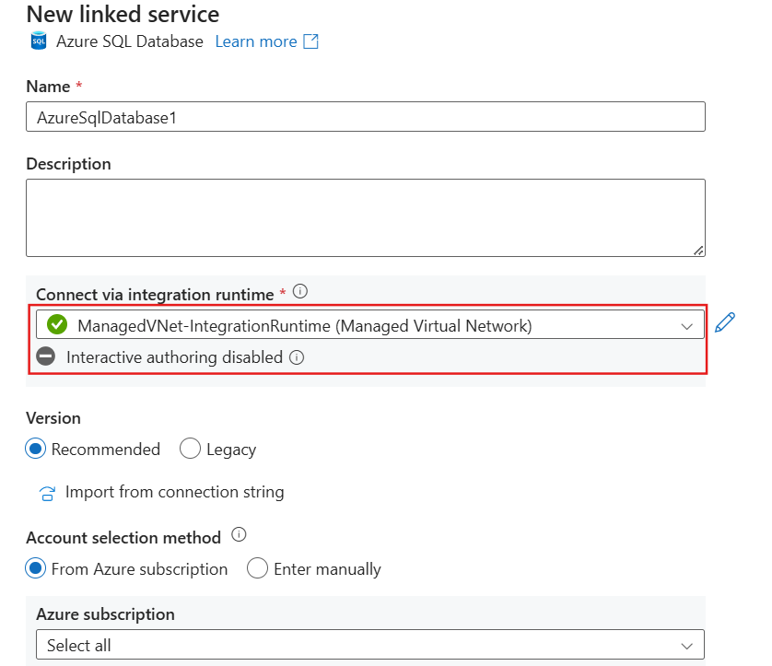

Both this IR requires private endpoints

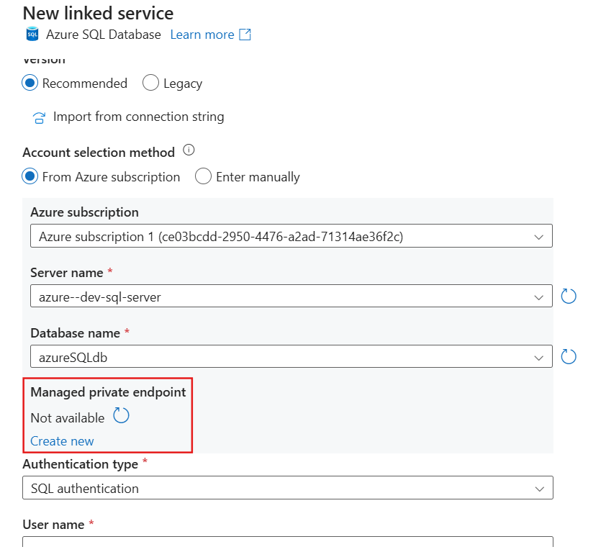

After selecting Subscription, Server and Database you will see there is no Managed private endpoint. So, create one

Either you can create from there as shown in the fig or you can create from the menu bar

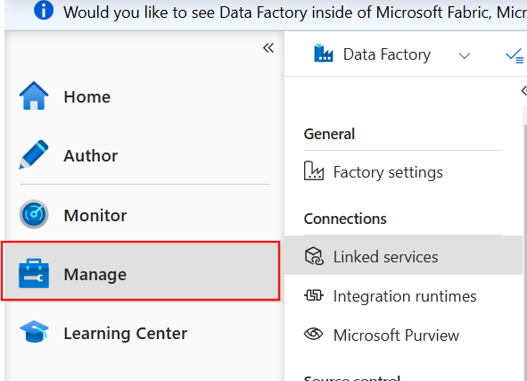

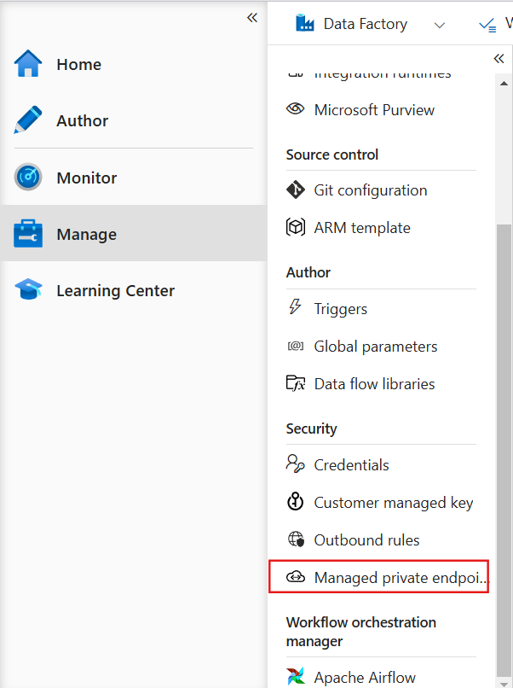

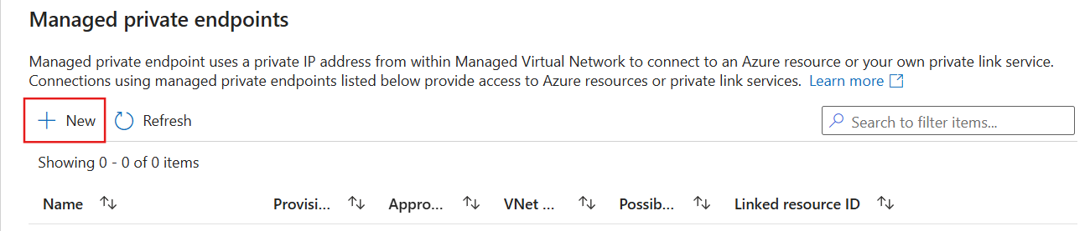

Choose for Azure SQL Database

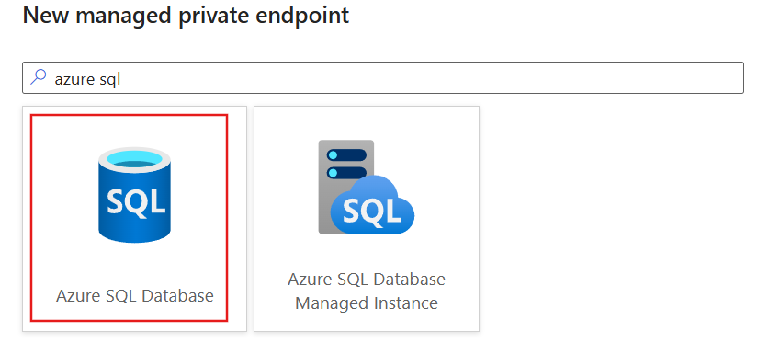

Choose subscription and server name

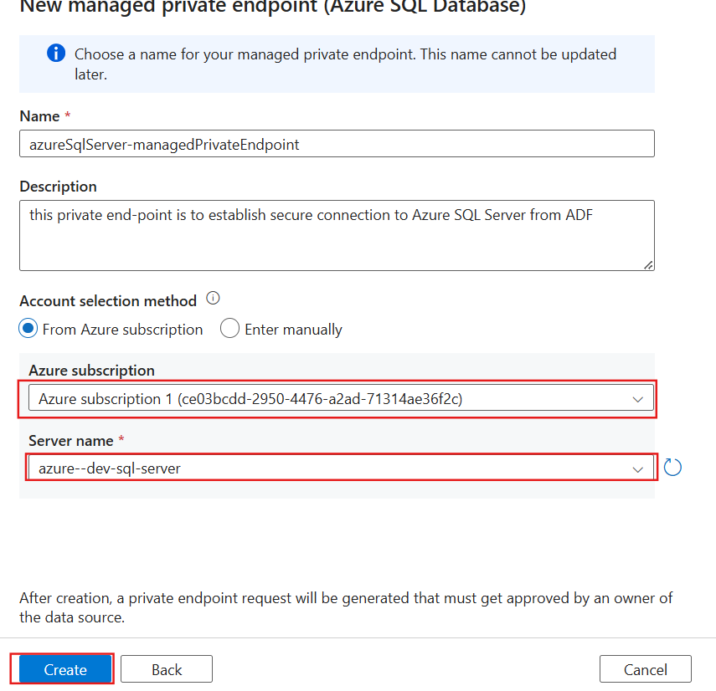

So far you create a MPE and inside that you specified the Server Name. In this way Azure SQL Server instance would detect that some application(ADF in this case) wants to connect to it securely using that MPE.

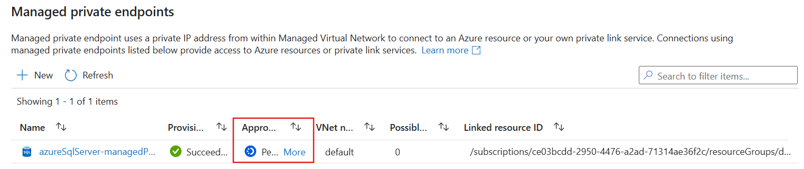

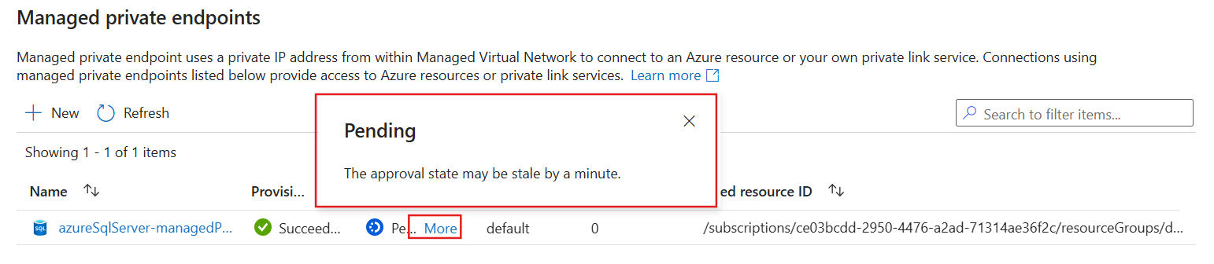

Go to your Azure SQL Server

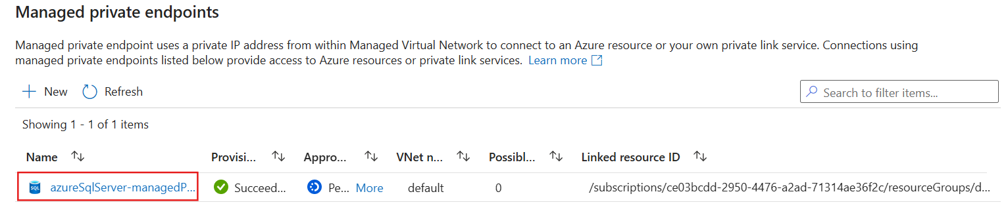

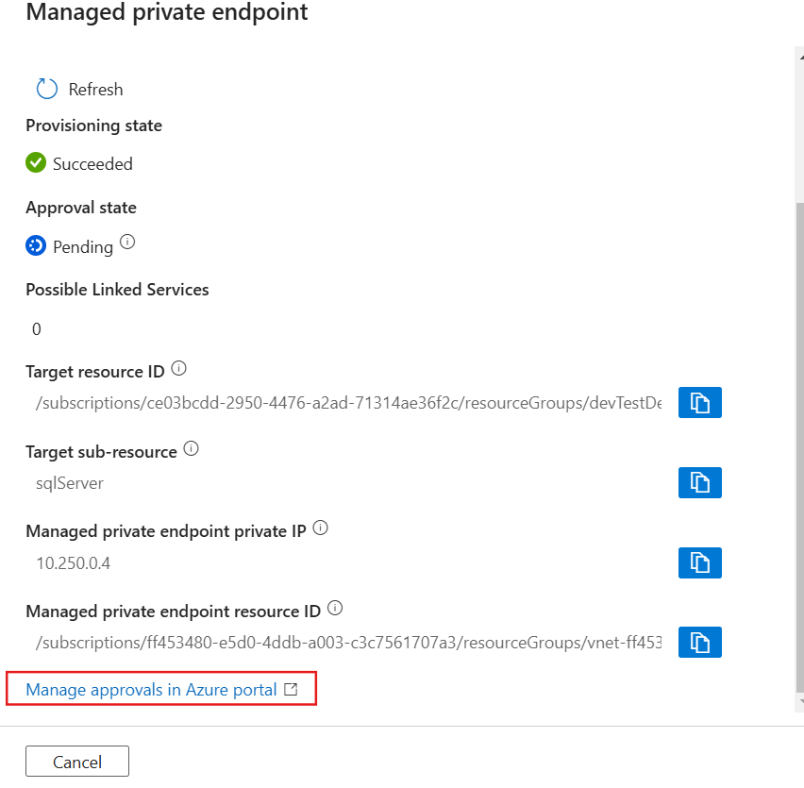

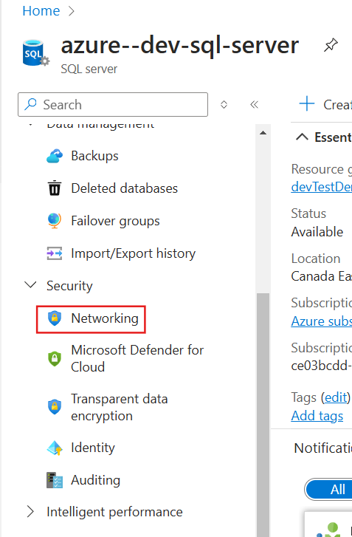

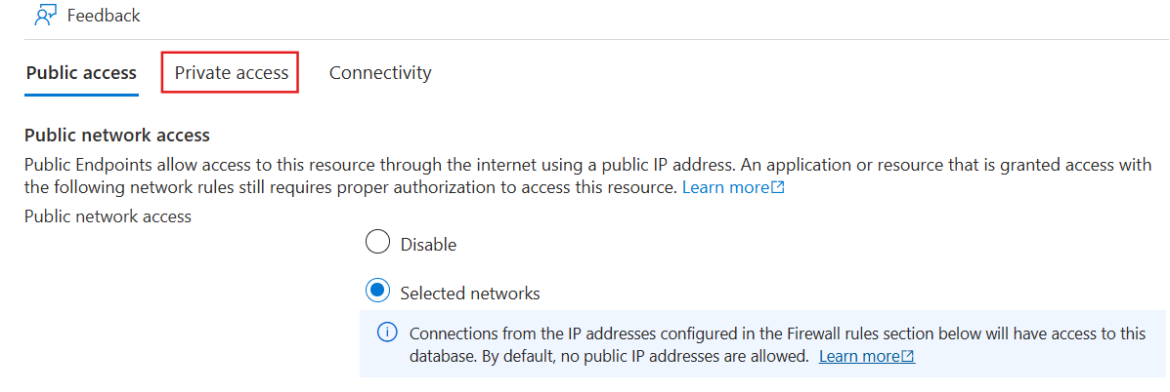

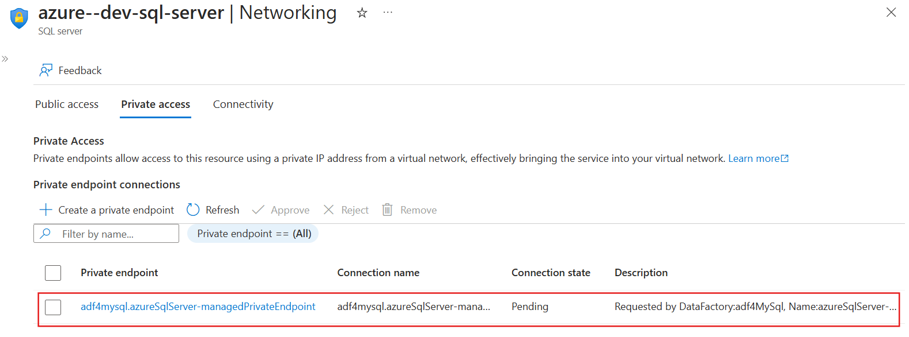

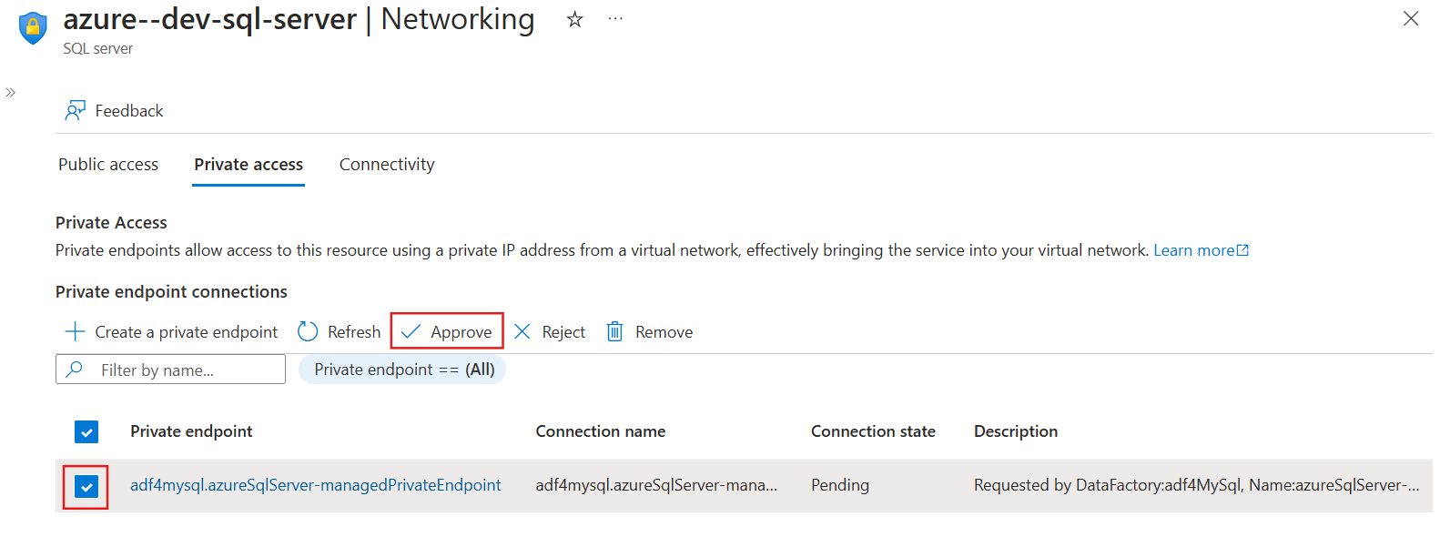

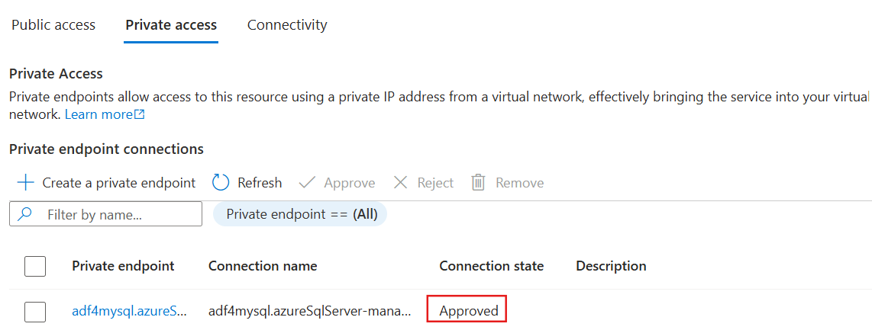

Now if you create a Linked Service and choose ManageVNetIntegrationRuntime, and provide with the necessary parameters you will see that Managed Private Endpoints are approved

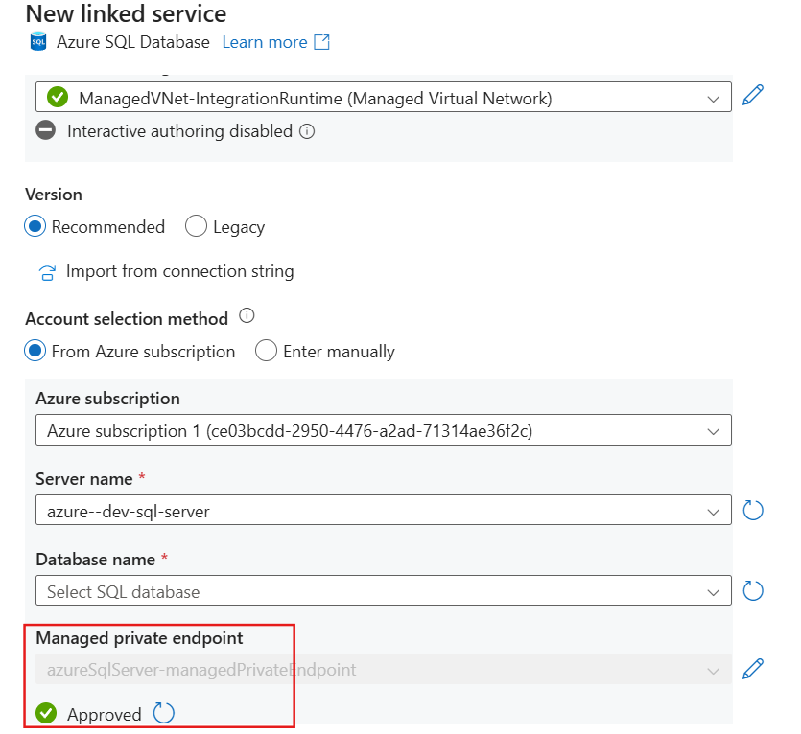

And create the linked service

**Data Lake Security**

Two ways to access Data Lake:

1. **Anonymous Access**
2. **Access with Identity**

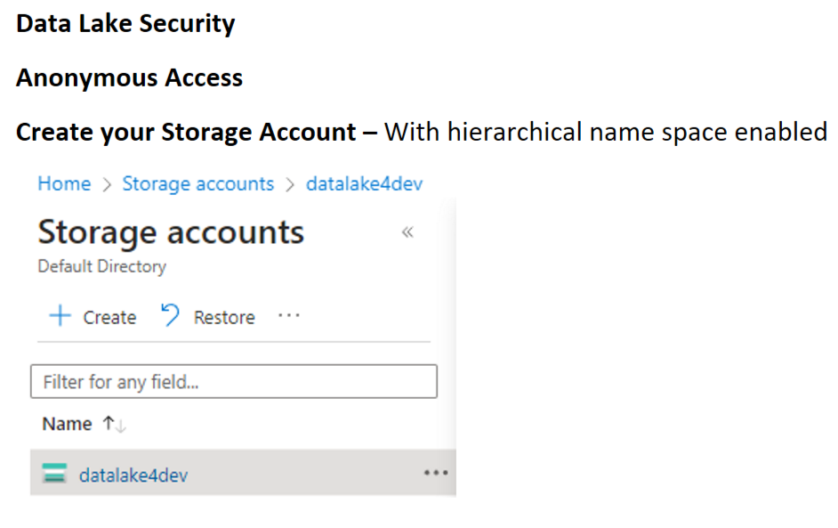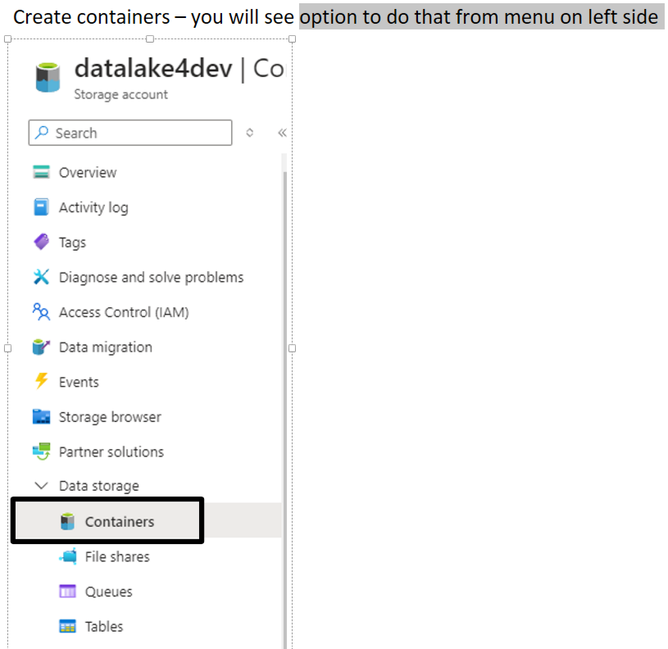

**Anonymous Access**

* From the Azure Portal search for Storage Account
* Enable hierarchical namespace
* After doing that, navigate to “Containers” on the left-hand side tab of Storage Account and create some containers

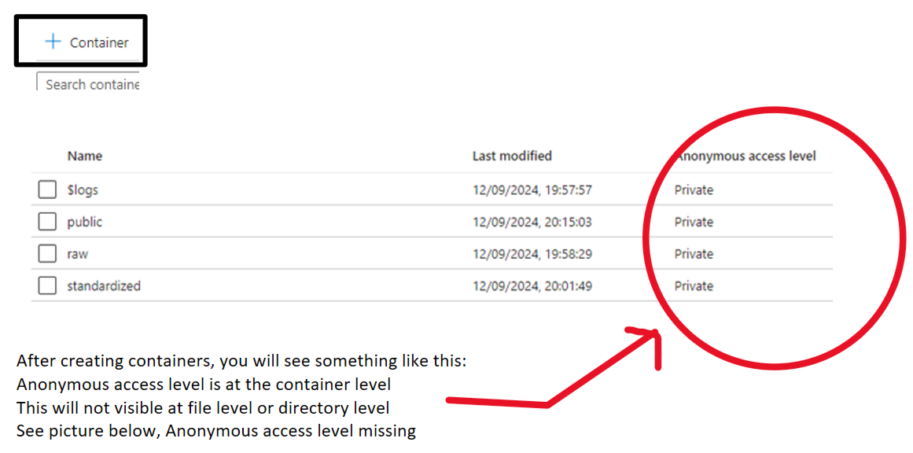

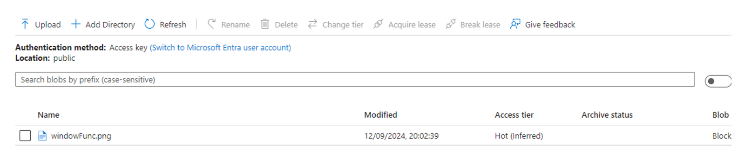

To make a container publicly accessible simply navigate to the container and click on the option above: ***Change access level***

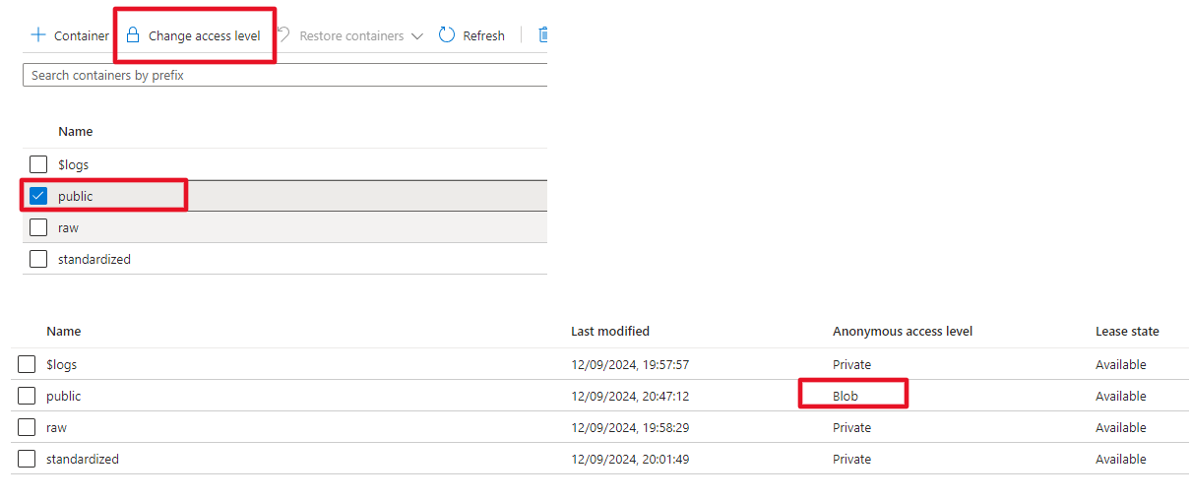

You can see the status has been changed. To give someone access you have to set permission globally at the Storage Account level as shown below. But always ensure that those settings are disabled because you do not need to have your data leaked

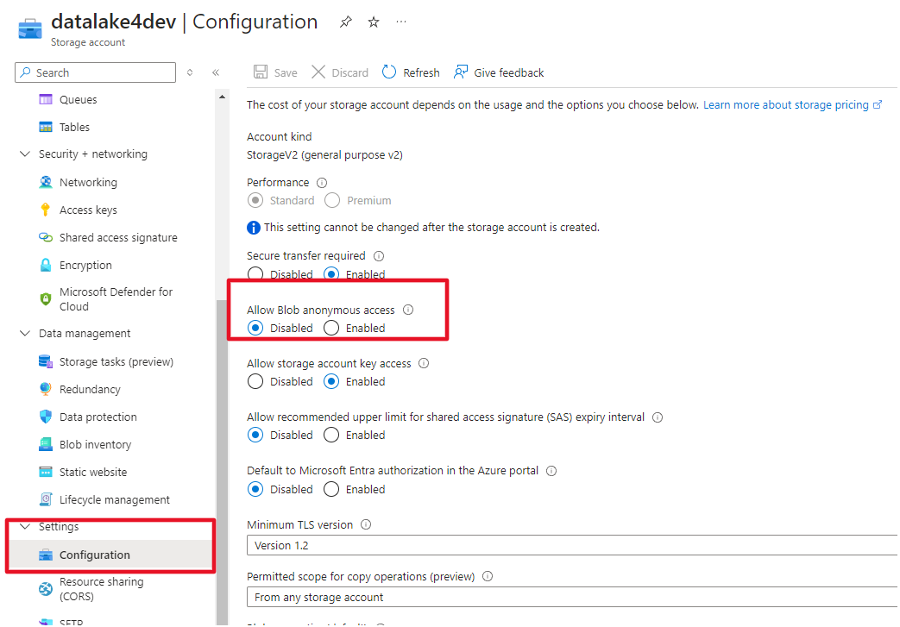

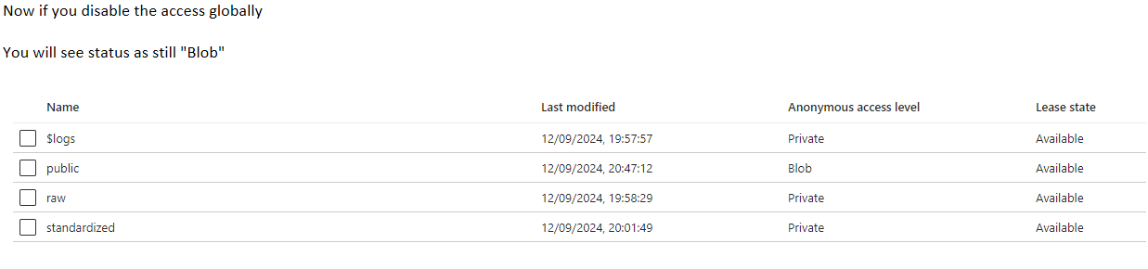

Even if the Anonymous access level for “public” container is shown enabled but you would not be able to see the content inside it because you just disabled the access globally at Storage Account level.

**A1) Access Key**

* On the left menu, under “Security + networking” you shall see “Access keys” option
* There will be 2 keys: key1 and key2
* You can use any one of the keys to establish a connection or you can save these keys as Secret inside a Key Vault

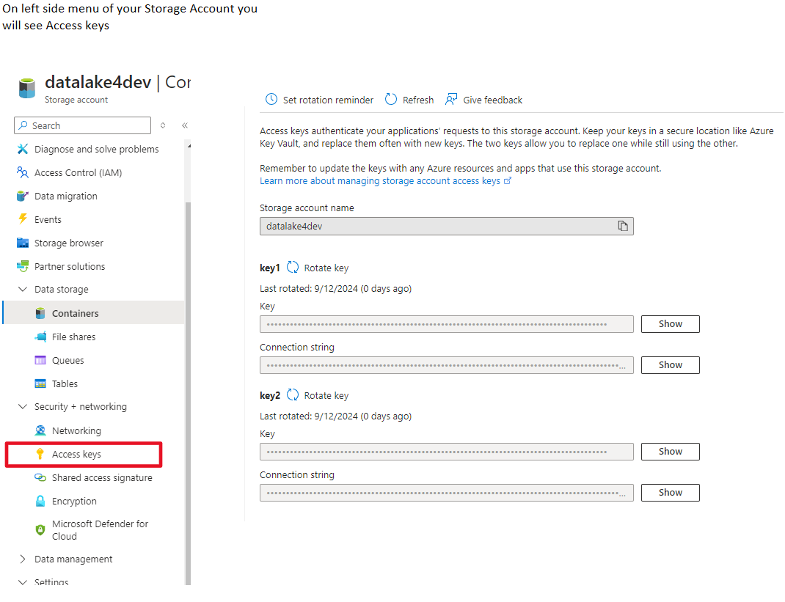

**Creating a Linked Service based on Access Keys**

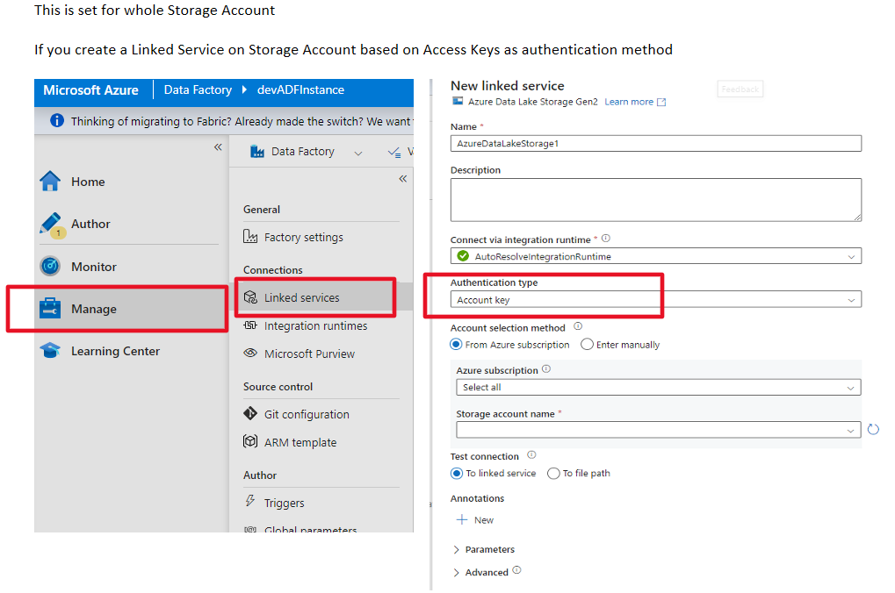

Mention your subscription and Storage account name

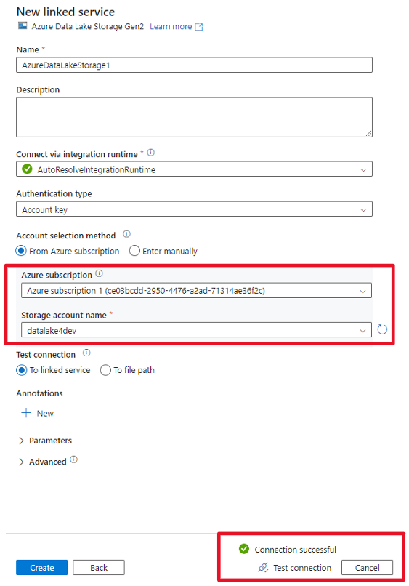

This method of using Access Keys gives full control over Storage Account. Also, if you go to json definition of Linked Service, you will see encryption details. Connection will successfully run because you are using Access Keys as authentication

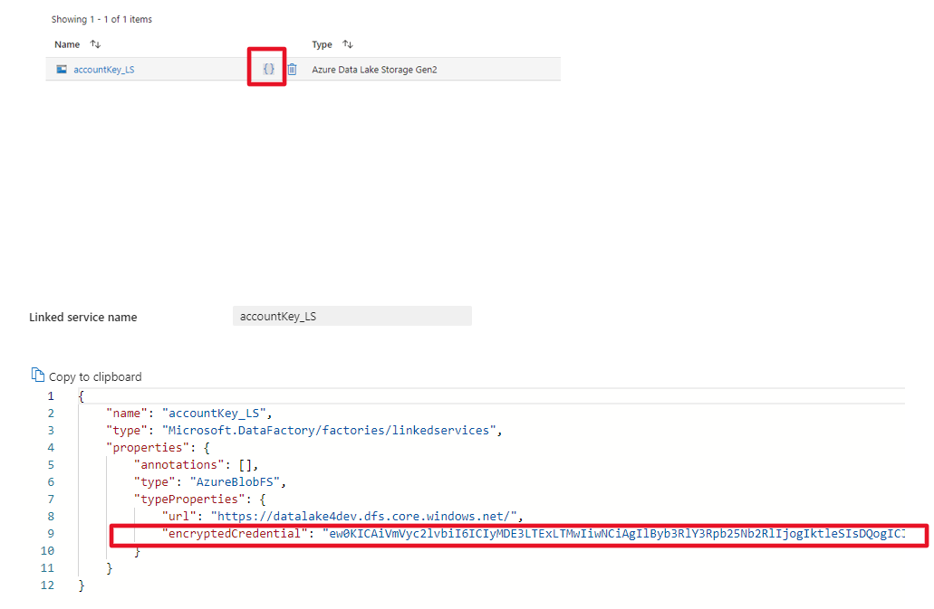

Now after successfully creating a Linked Service you can open the code view and could see the details of your Access keys under “*encryptedCredential*”. As this option gives full powers, so it is better to have it disable at Storage Level

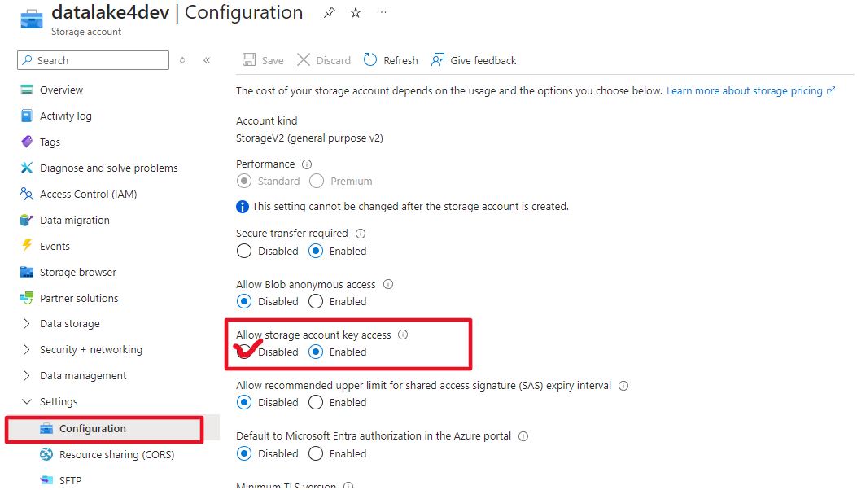

* Also, in case you have multiple linked services for a Storage Account and all the Linked Services are using Access Keys for Authentication. In such situation if you suspect that your key has been compromised then you would rotate the key. And those Linked Services that were configured earlier with the old key wont work. This means you will have to use the newly generated key in all the Linked Services that are connected to that Storage Account.

**Storage Account Level**

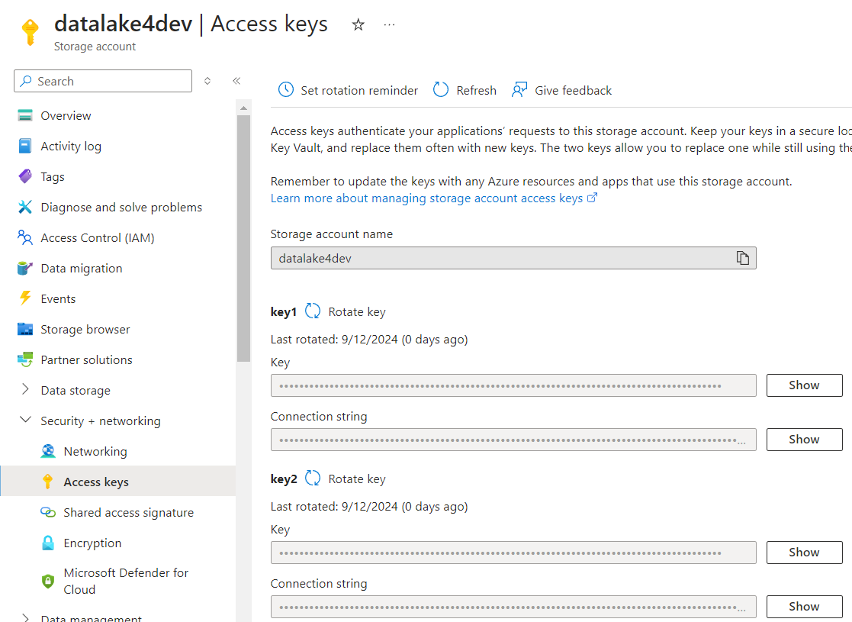

**ADF-Linked Service level**

The connection will not get established, and you will be asked to provide with new Storage Account key (Access key). Meaning you would have to provide this value in all the associated Linked Services

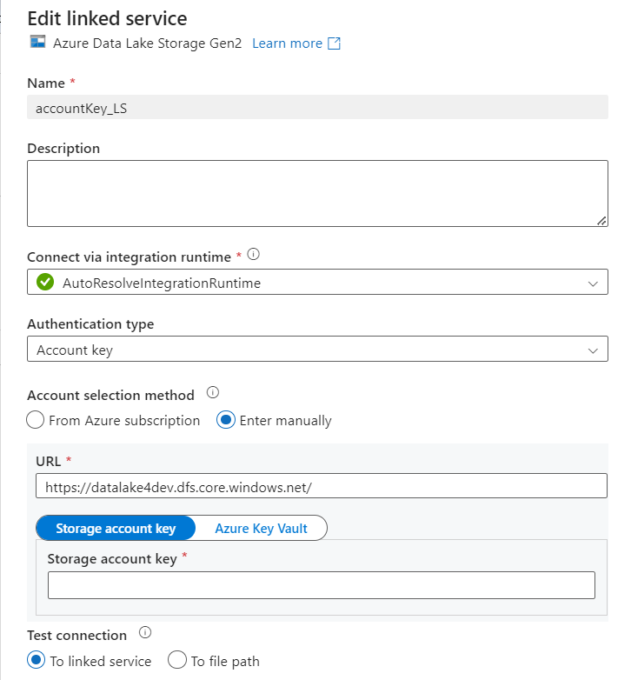

Best practice is to store all those Access keys inside a Key Vault so that you do not have to hard code your Storage Account keys explicitly in the definition of any Linked Service

Further, we will learn how to utilize a Key Vault to store Access keys or SAS token or anything that you would not like to hard code

**Key Vault**



* Create a key Vault
* Choose Subscription
* Choose Resource Group

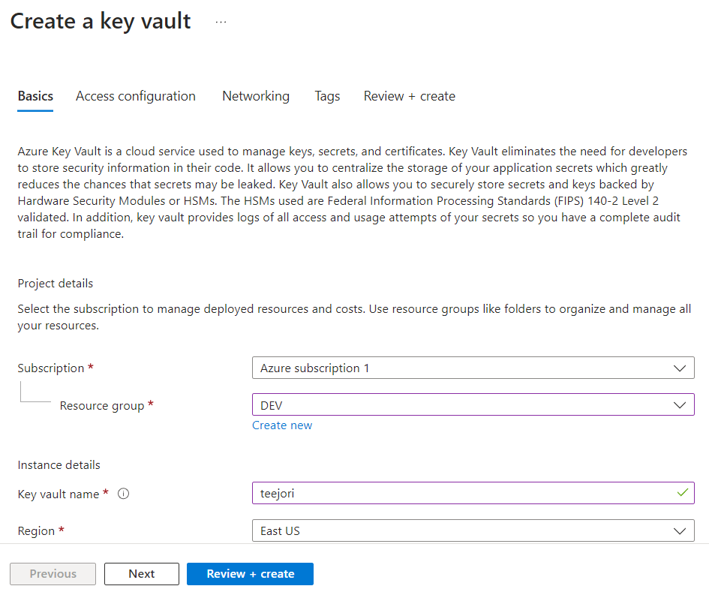

Another thing is how (what type of Authentication) some other services will use to connect to Key Vault. There are 2 types shown below under “***Permission model***”

***Access Configuration***: Choose “*Vault access policy*” for now. By choosing an option from there , Key Vault is telling all the resources that if anyone wants to connect with me, they will have to use the *Vault access policy* as an Authentication

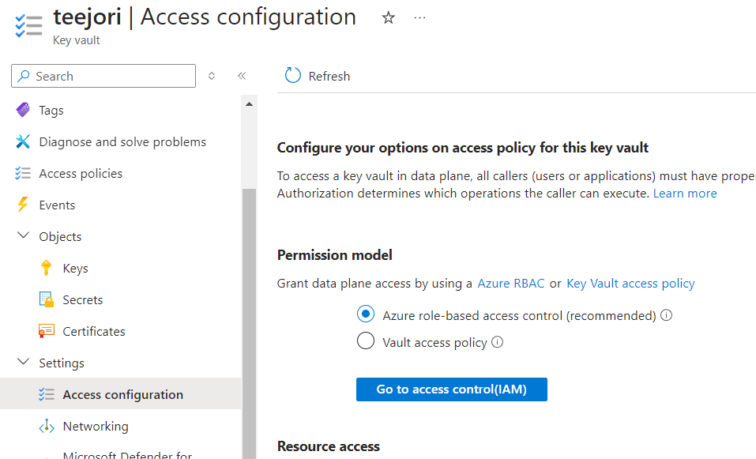

**How to save secrets inside a Key-Vault**

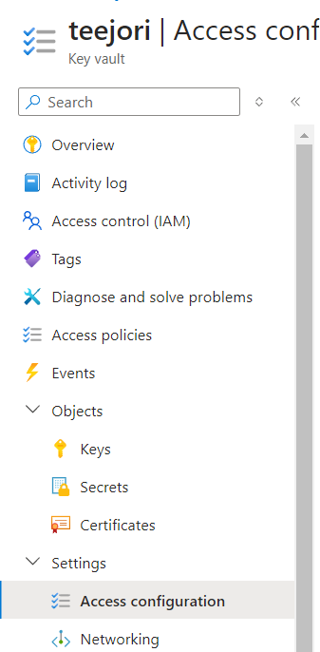

* Go to “Secret” on menu at left side
* Then Generate/Import a Secret



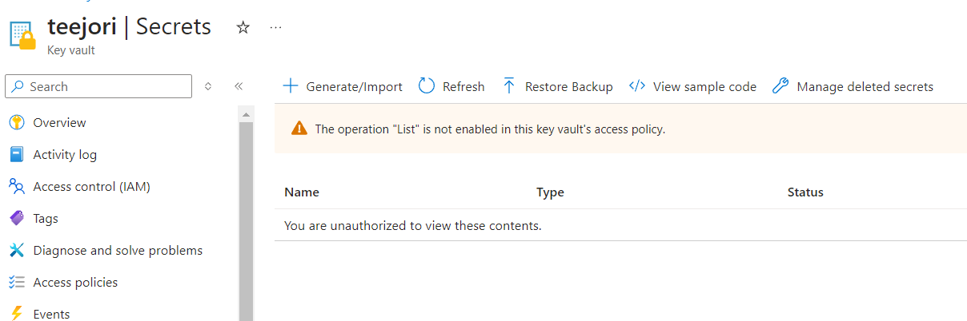

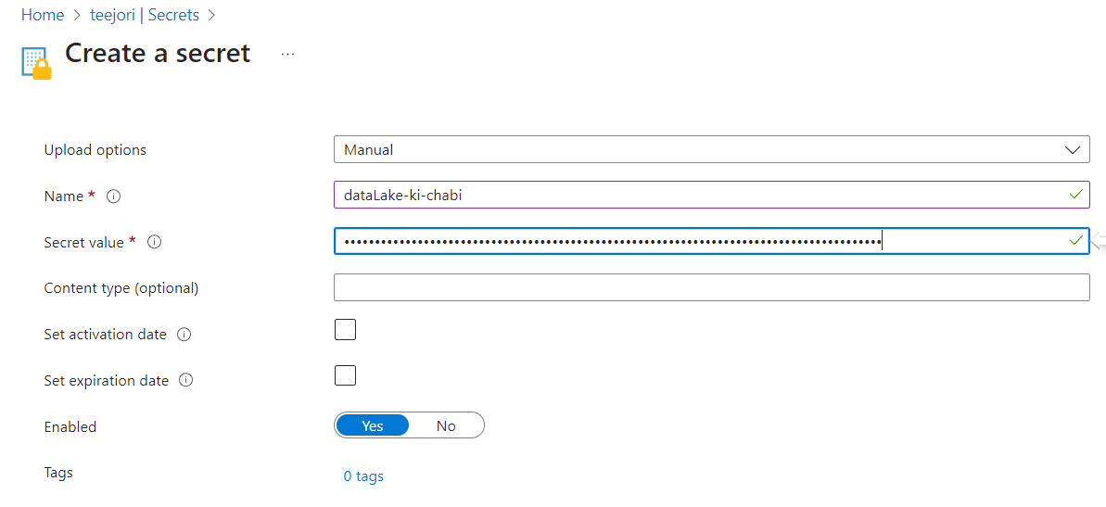

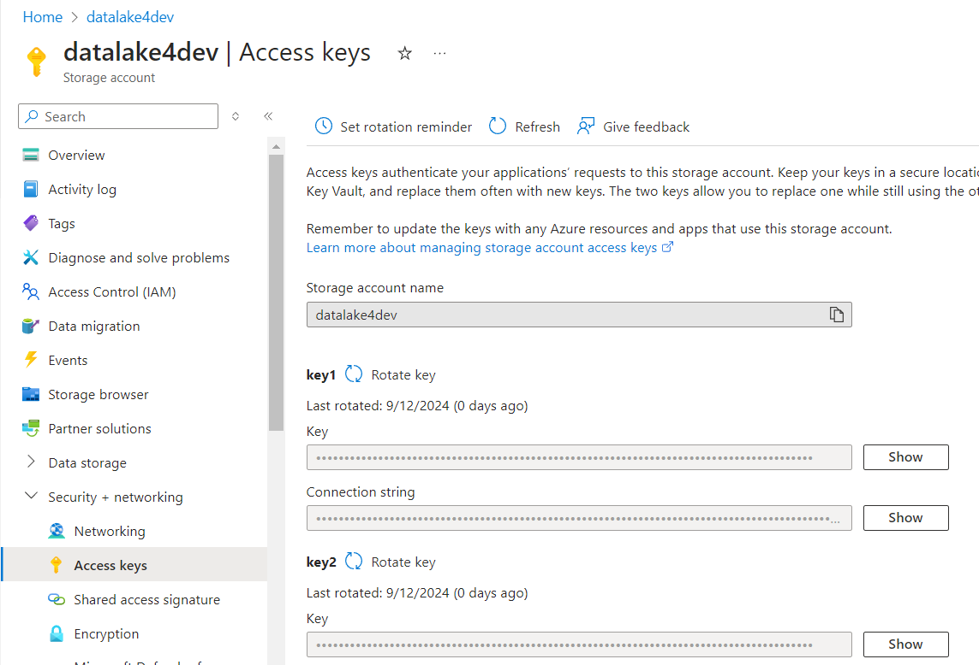

You will save one of the key values in a Key Vault. However, if you did not define any **Access Policy**, you will not be able to create a secret because Access Policy defines what a user can do with objects(Keys, Secrets, Certificates) inside a Key Vault.

**Access Policy for Key Vault**

Key vault supports up to 1024 access policy entries.Because of this limitation, it is recommend assigning access policies to groups of users, rather than individual users.



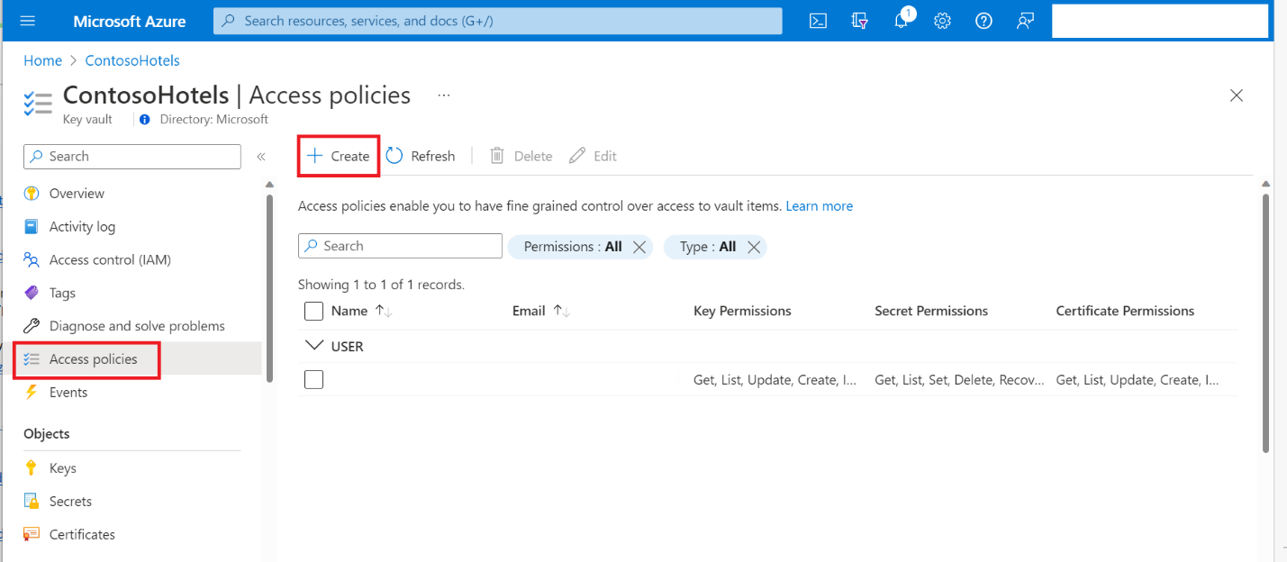

1. **Select the permissions you want under Key permissions, Secret permissions, and Certificate permissions.**

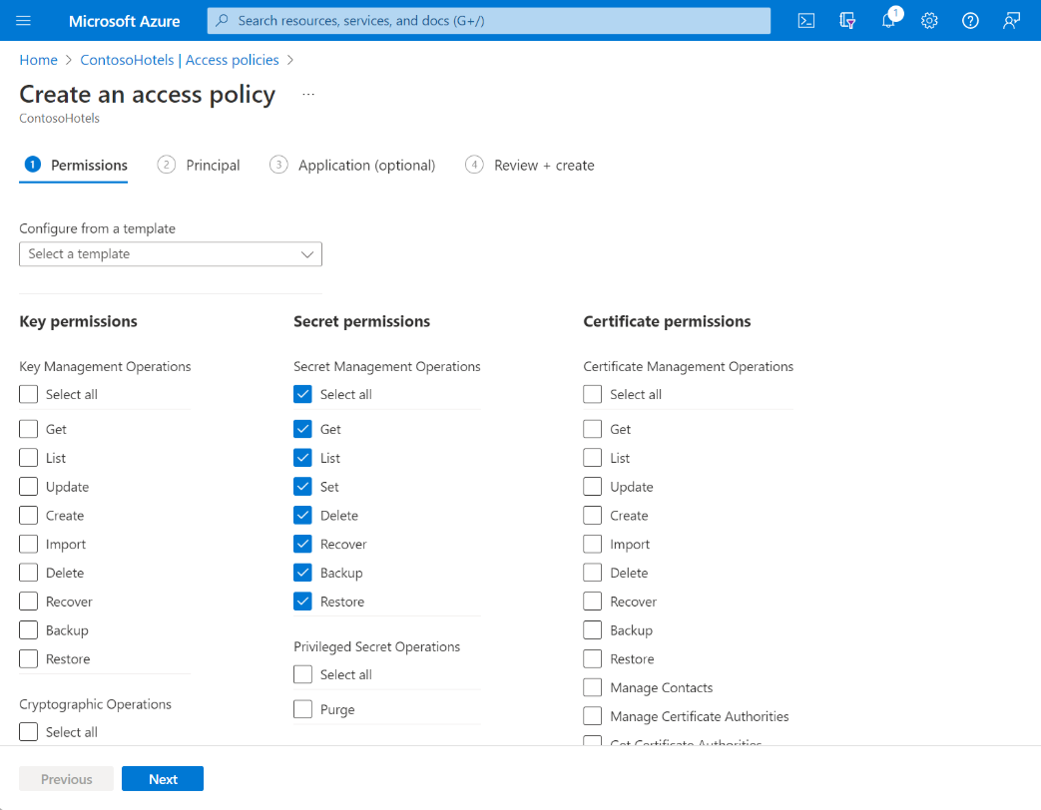

1. **Under the Principal selection pane, enter the name of the user, app or service principal in the search field and select the appropriate result.**

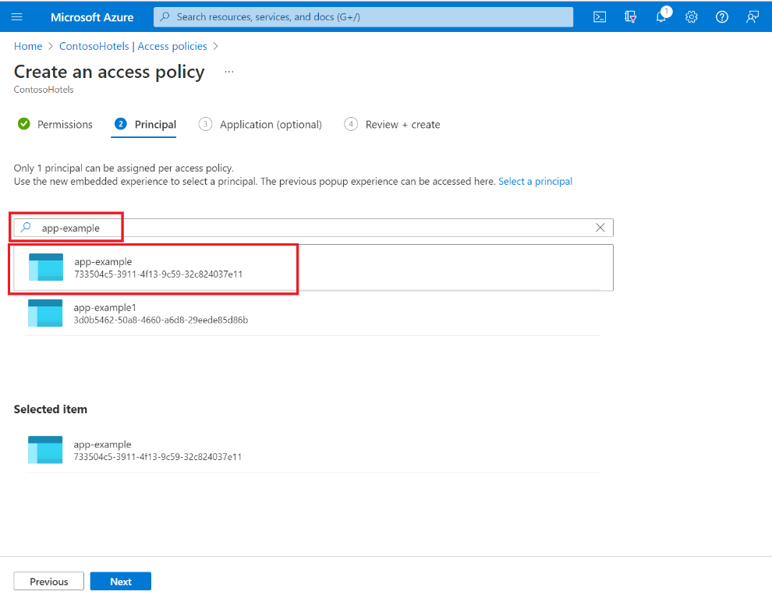

**If you are using a Managed identity for the app, search for and select the name of the app itself.**

1. **Review the access policy changes and select Create to save the access policy.**

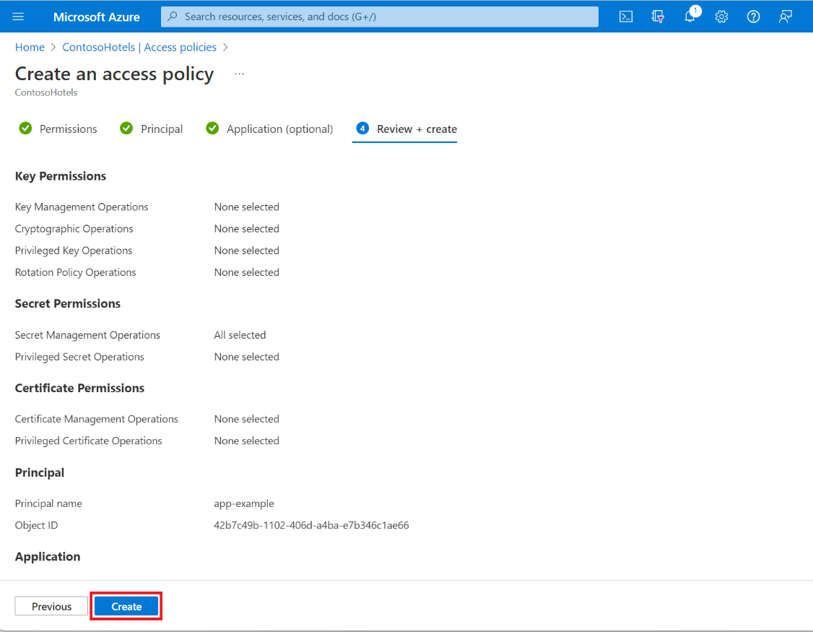

1. **Back on the Access policies page, verify that your access policy is listed.**

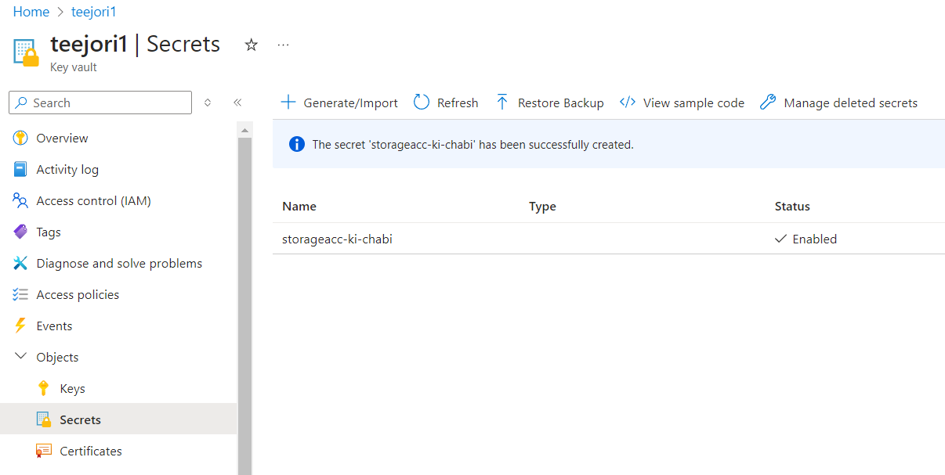

*Now you have all the secrets inside the Key Vault. Next thing is who will come to grab those secrets and how they should talk to Key Vault so that Key Vault could provide those secrets.*

**Managed identity**

**Where to look for it?**

**Go to any one of the created Resources**

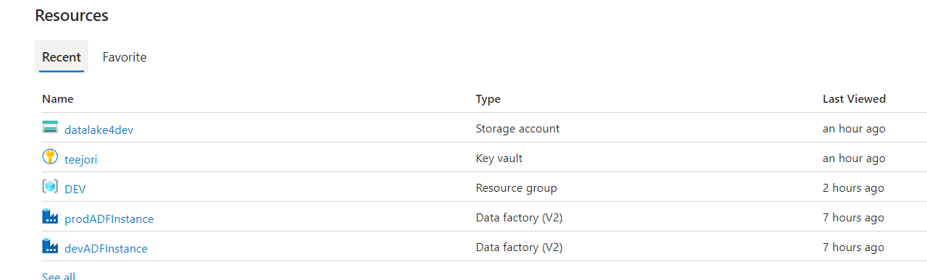

**On the menu at left side, you should see Managed Identity option**

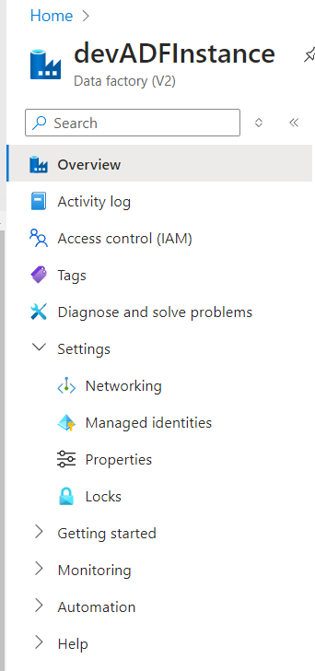

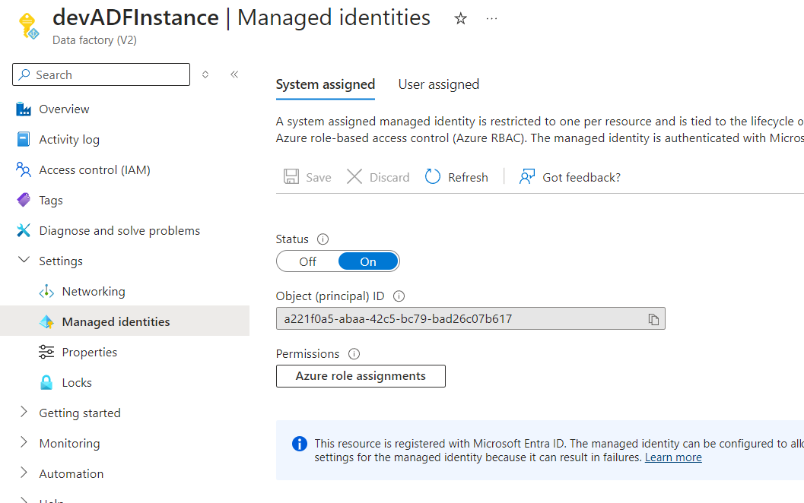

You can get Managed Identity from there. Both are identities and in addition, on the top, you can see there are two options: System-assigned and User-assigned.

Next thing is you go back again to Key Vault and inside the Access Policy add the Managed Identity of whatever resource who can access the secrets inside Key Vault

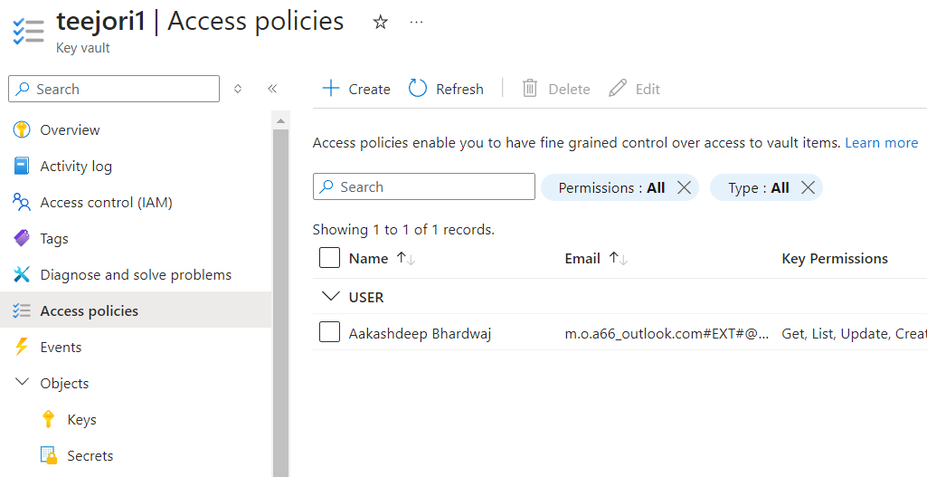

**Set whatsoever permission you want to grant to the Managed Identity**

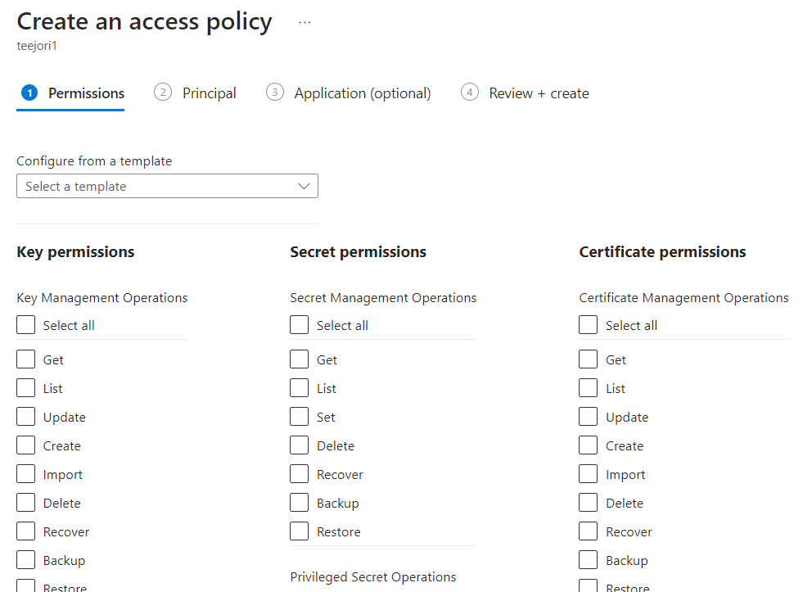

**Choose the Managed Identity as Principal**

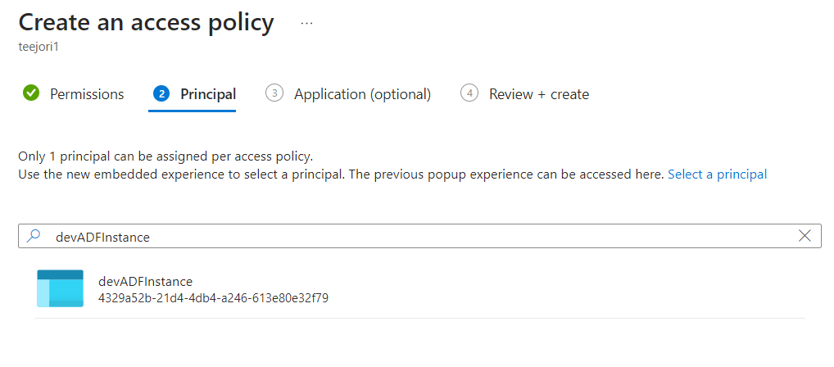

But this is not the best practice. We would like to have a separate group created (inside Microsoft Entra ID). Then as a Principal, you choose that group.

**Creating a group in Microsoft Entra**

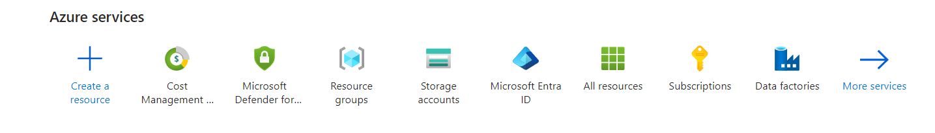

**Go to Manage 🡺 Groups 🡺 New group**

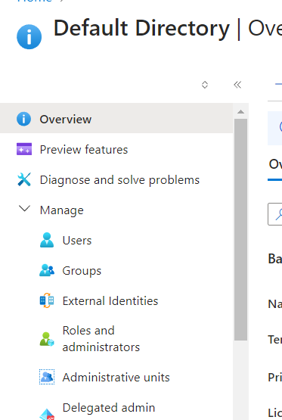 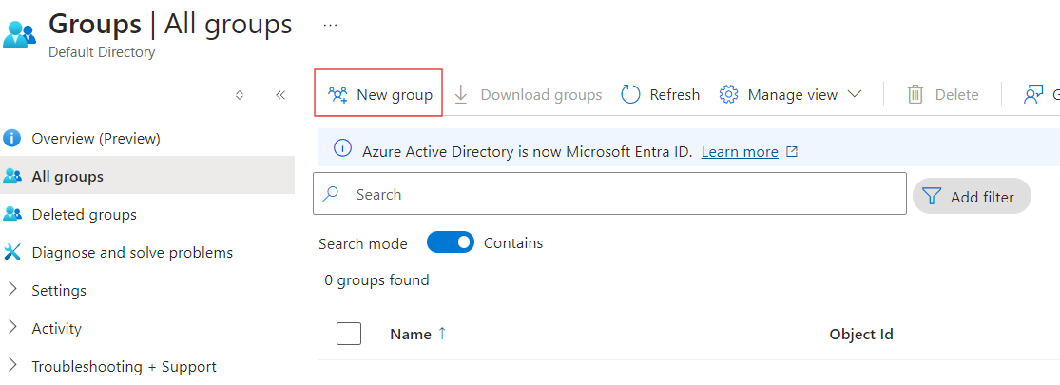

**Give some name to the group**

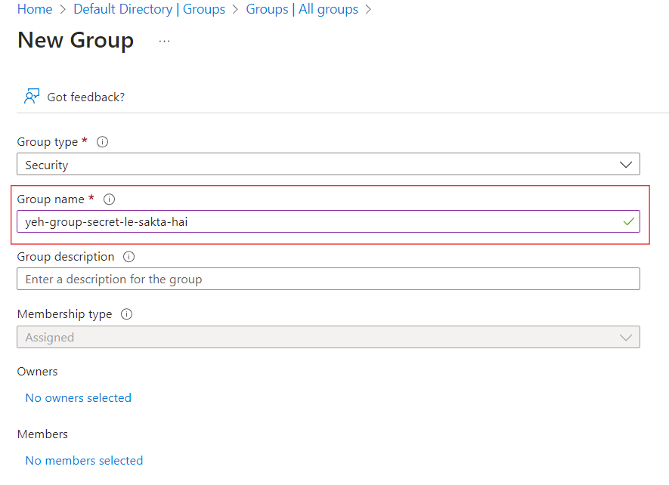

**Make yourself the owner of the group and add the Managed Identity of ADF as a member to the group as shown below**

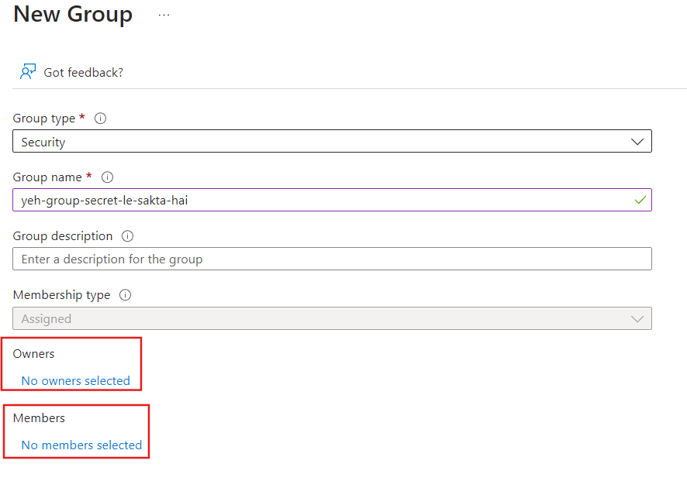

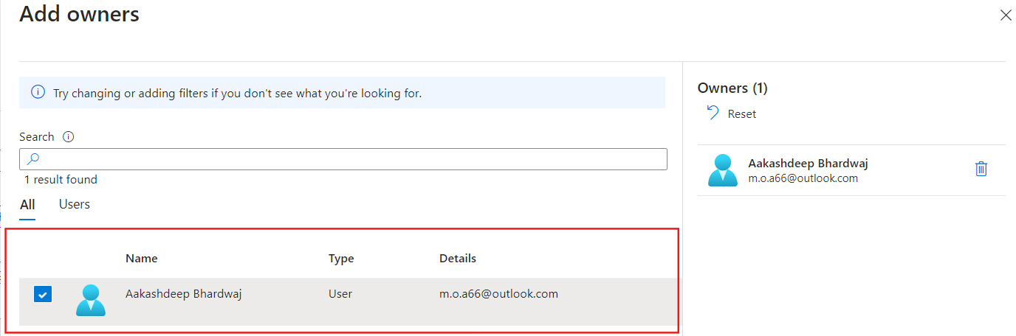

Because we wanted our ADF to read secrets from Key Vault. Therefore, we put ADF inside a group and we create an Access Policy for this group inside the Key Vault. Because ADF is already inside the group, so indirectly we gave permission to ADF(but in better way )

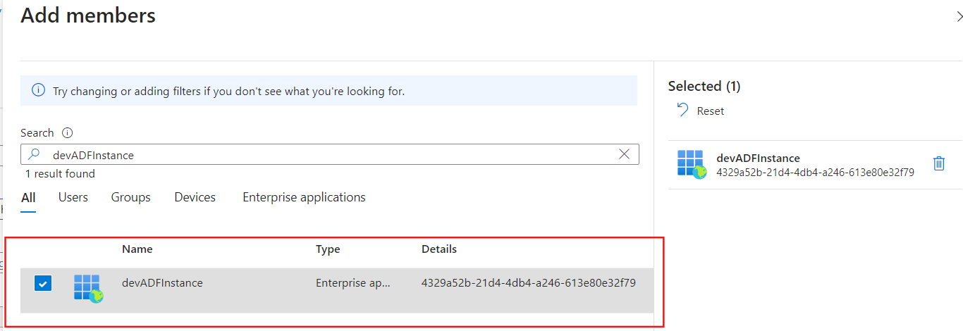

Therefore, you should see the name of the group you created

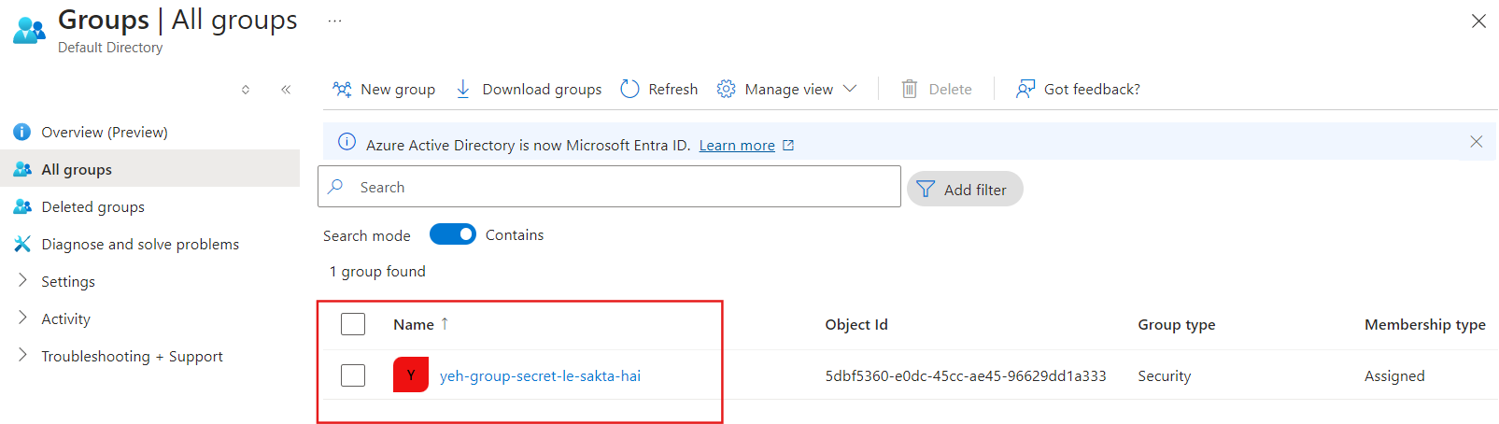

Now, finally go back to Key Vault and create an Access Policy with necessary permissions and add group that you created inside Microsoft Entra.

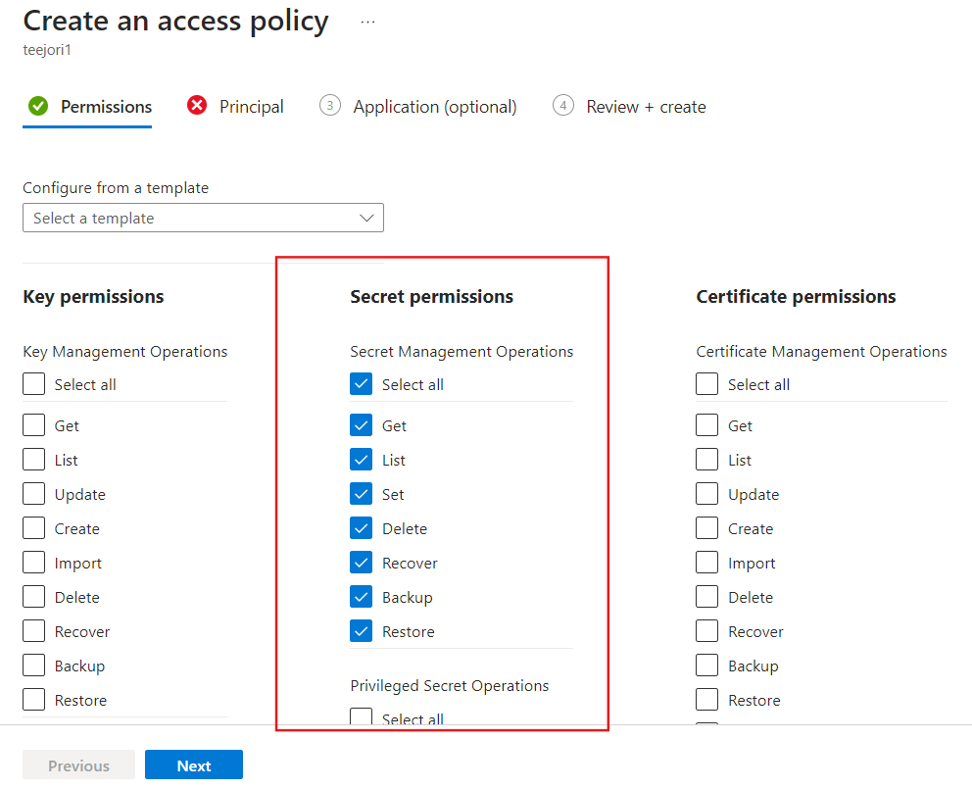

In Principal, give your group that you created inside Microsoft Entra ID

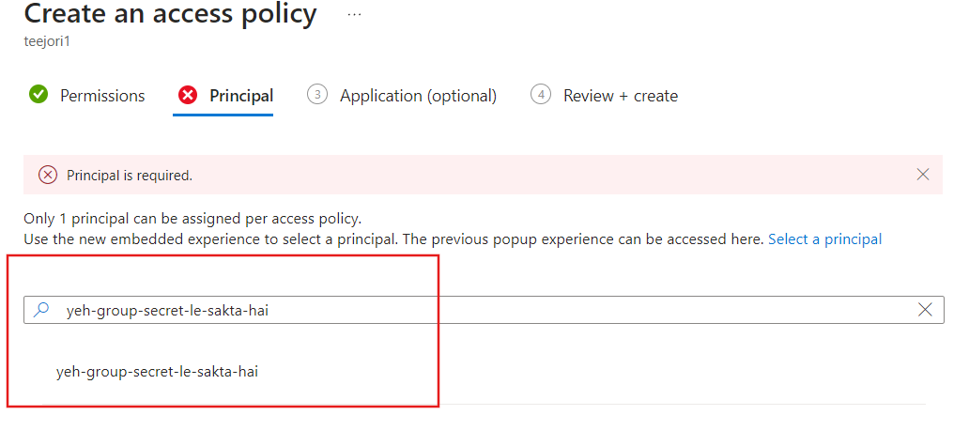

Now you should see your group inside the Access Policy of Key Vault

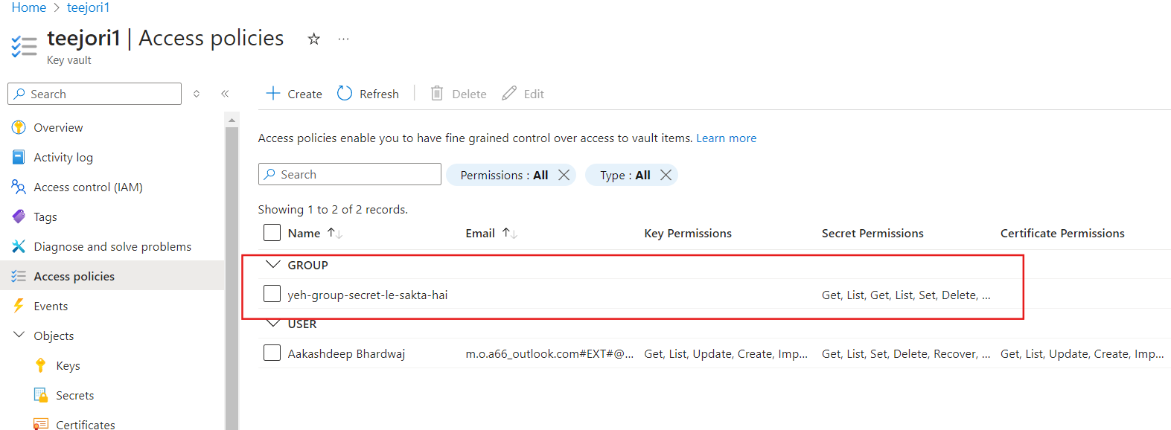

So, long story short, we want our ADF to access Key Vault so we will create a Linked Service pointing to the Key Vault

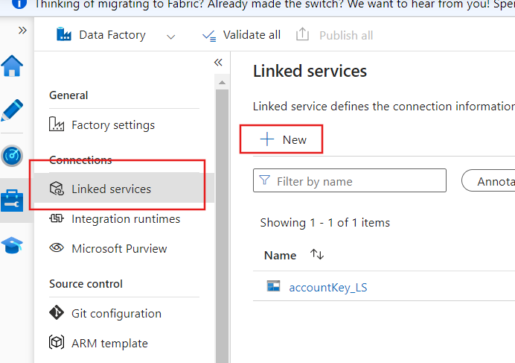

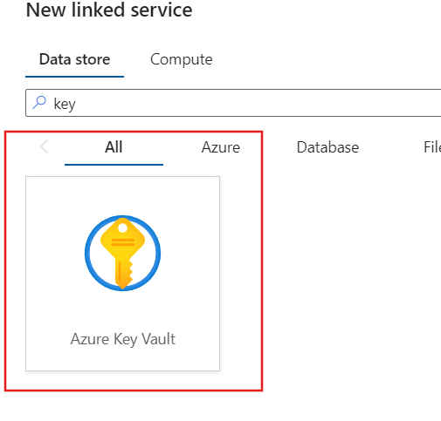

* Provide your Key Vault name
* As you are using a System-assigned managed identity, select that option

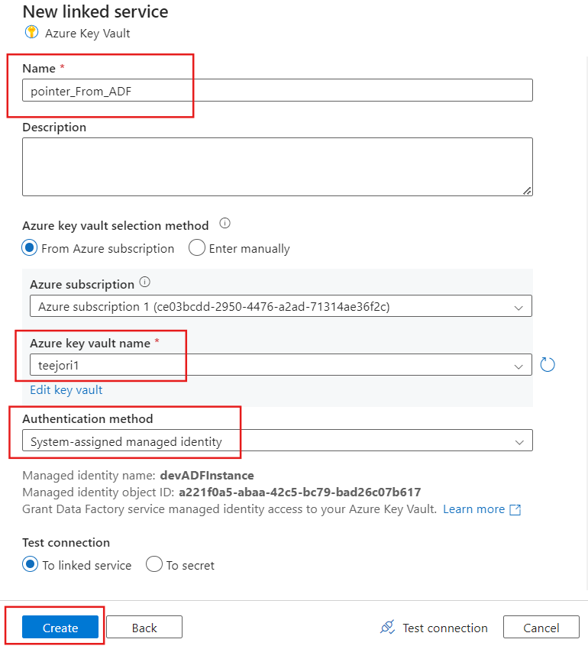

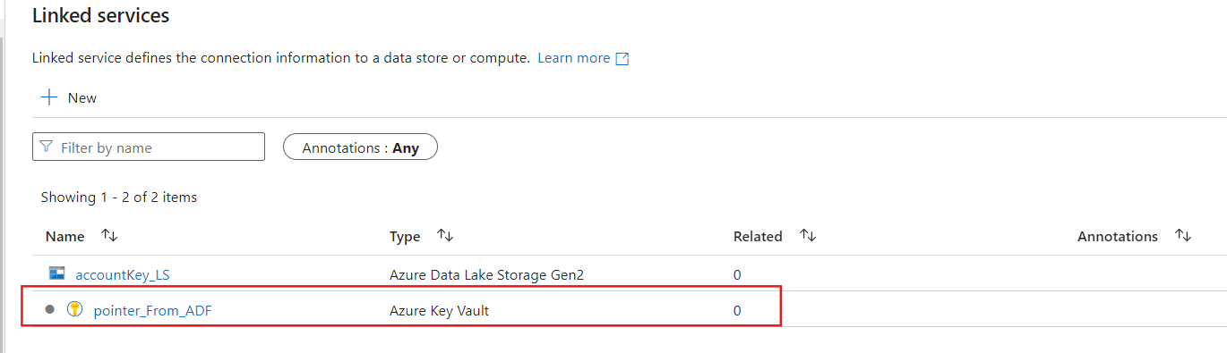

Now, this linked service is pointing towards the Key Vault already, we will make use of it. It is like a scenario if you want to access the Key Vault and do not know its location you will ask the Linked Service that is pointing towards the Key-Vault.

In real life, if you do not know the location of a place you open Google Maps and search for that location. This linked service is something similar. Our ADF will ask this Linked Service about the location of the Key Vault.

Now, let us create Linked Service to Data Lake but at the same time, ADF will ask Linked Service pointing to Key Vault to go grab secrets for me. The Linked Service pointing towards Key Vault will only grab those secrets that ADF is eligible to see.

**Create a Linked Service**

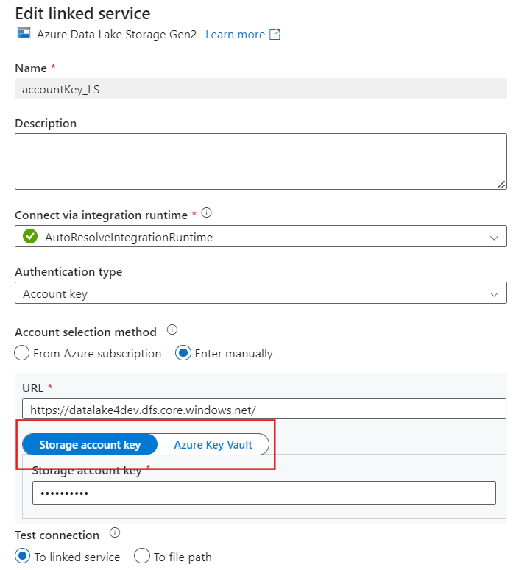

**Change the Account selection method to Azure Key Vault**

The moment you switch to Azure Key Vault, you will see that ADF will automatically detect that there is already a Linked Service that will show ADF path to go grab secret. So ADF can establish a connection with Data Lake using that Linked Service

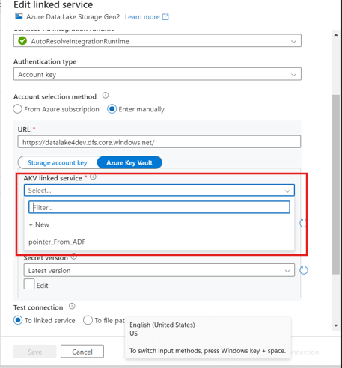

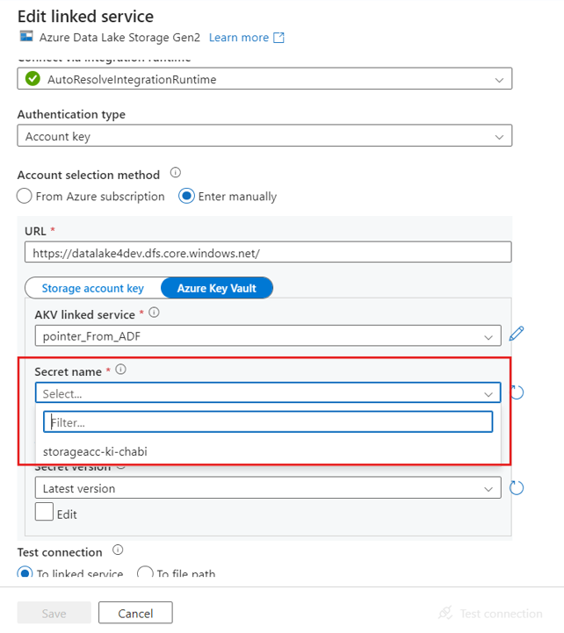

See! When ADF asked the Linked Service(that was pointing to the Key Vault) for a direction to the Key Vault, the Linked Service went and automatically provided the options ADF has (in the form of a Secret name)Then finally using the secret the connection was established successfully.

**Access to Data Lake using SAS Tokens**

This is taken from inside the Data Lake.

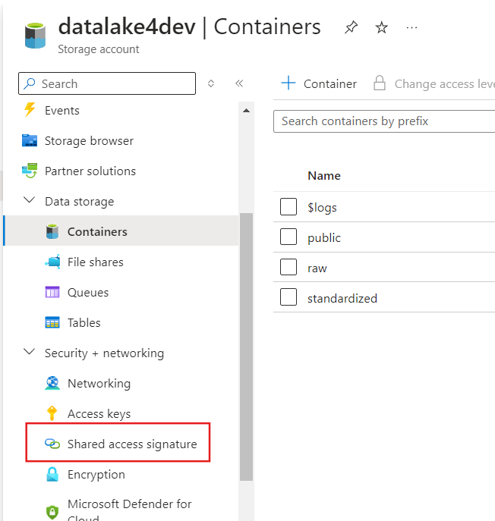

This is what the Account Level SAS token looks like, why Account Level SAS? Because you are grabbing it at the Account Level.

Granular as compared to Access Keys because of these options

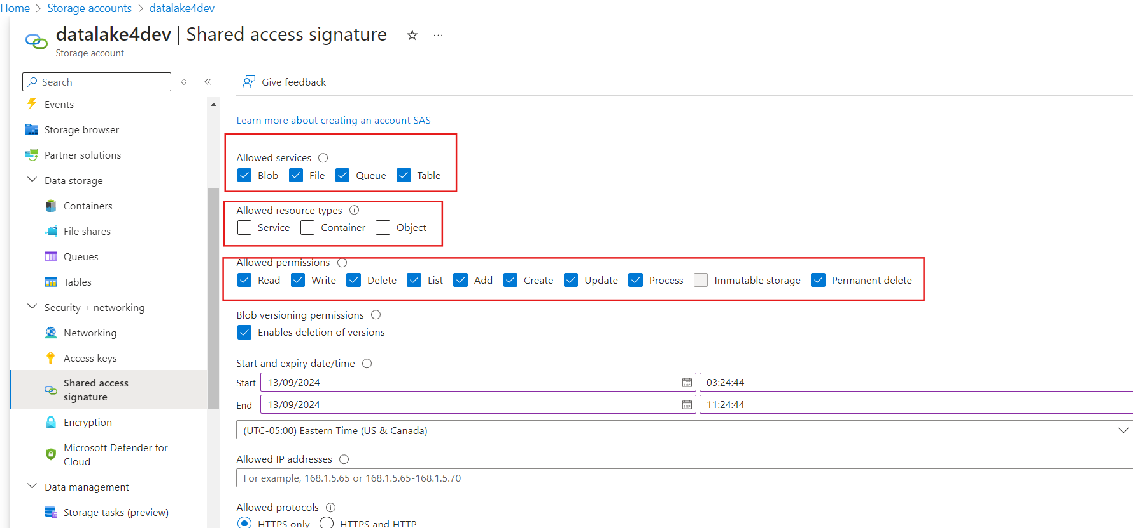

You can choose for what service you want to generate SAS tokens for, e.g., Blob, File, Queue, and Table.

**What resources type? (Service, Container, Object)(Did you notice one thing? It does not provide us with an option on which container in specific)(meh! not really granular) Anyway, let’s generate one SAS**

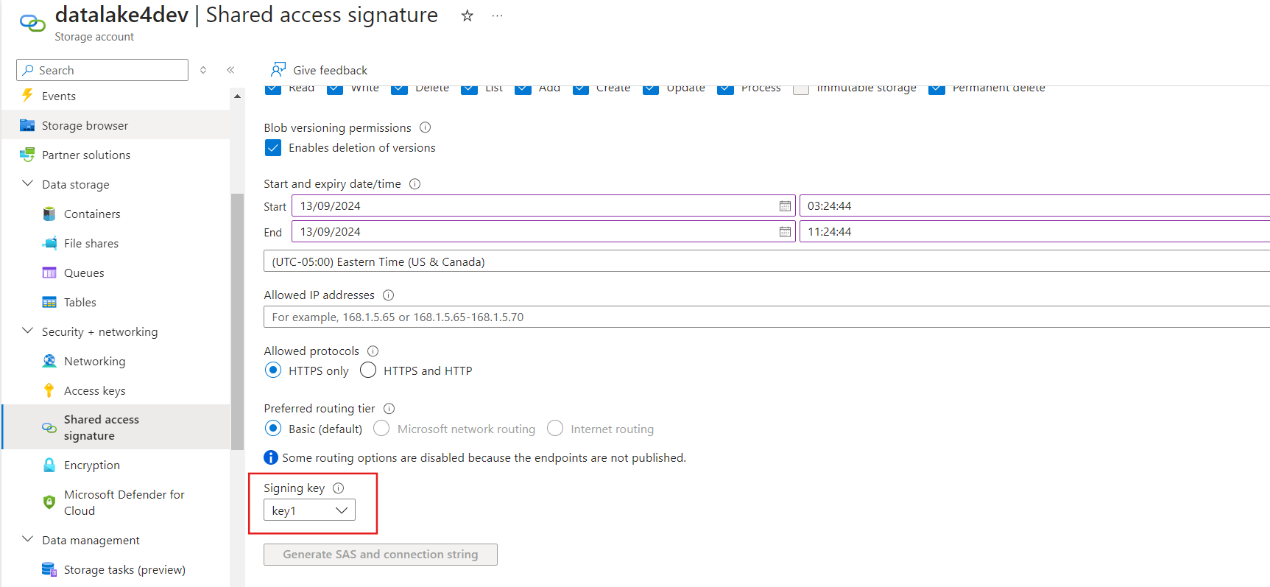

**Oopsie! SAS under the hood requires Access Keys to sign-in!**

**One more hint as to way it is called Account Level SAS**

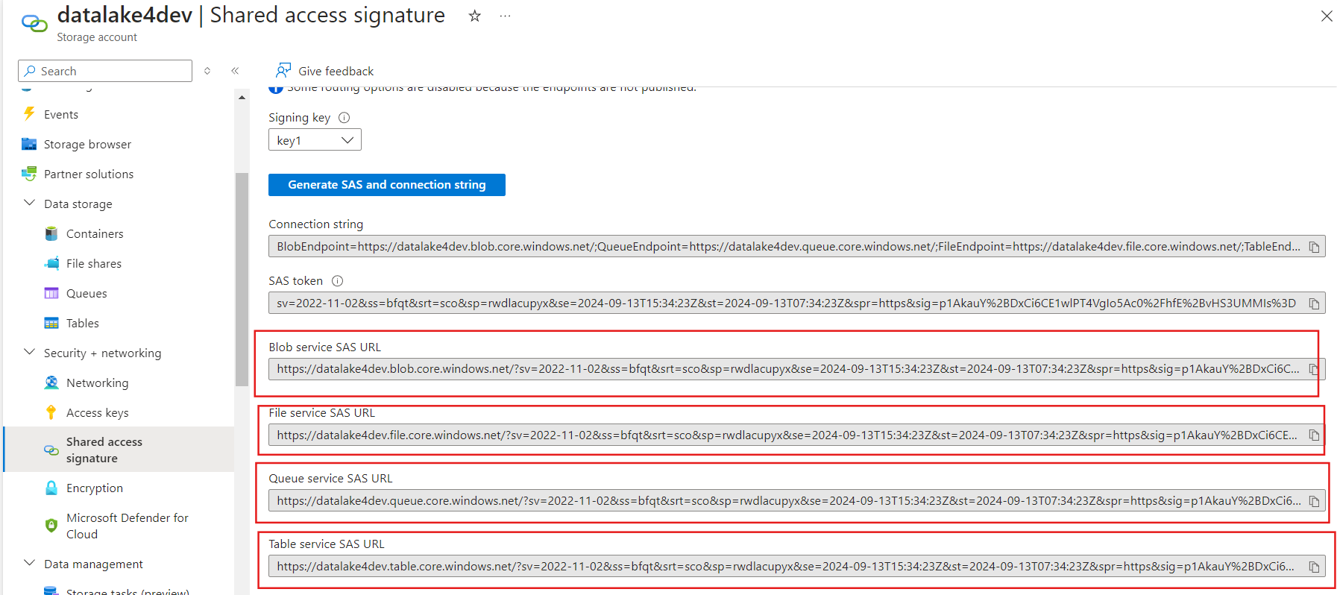

Because at account level SAS tokens can be generated for Blob, File, Queue and Table but not for any specific container of directory.

Get the Blob service SAS URL: but we want to have Data Lake SAS token

Just simply replace “blob” keyword with “dfs” keyword.

**Create a new Linked Service (Configured to use SAS to connect with Data Lake)**

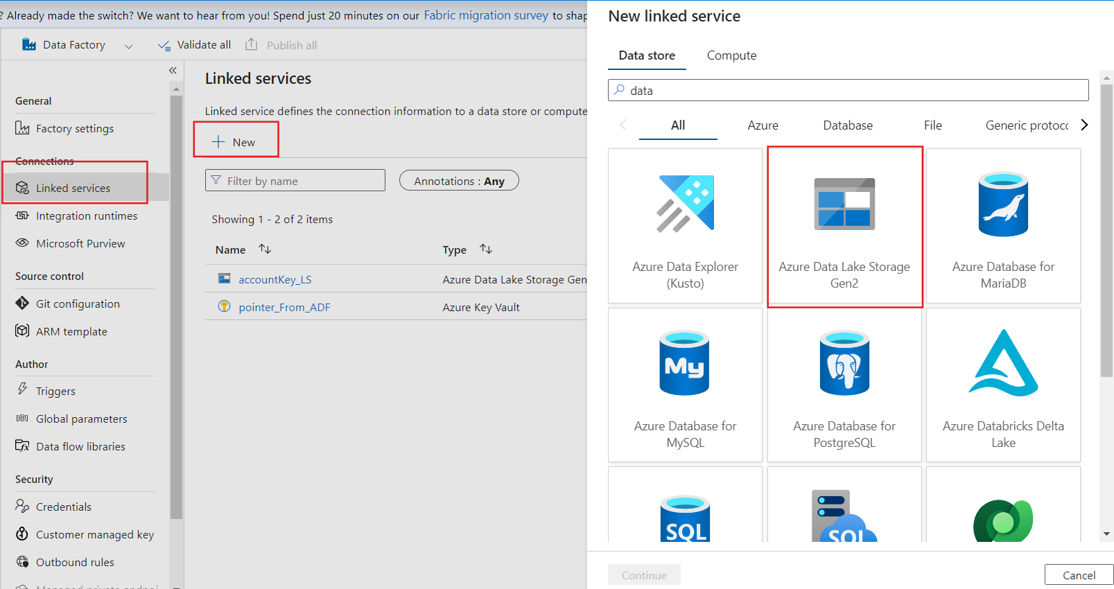

**Authentication type: choose SAS URI**

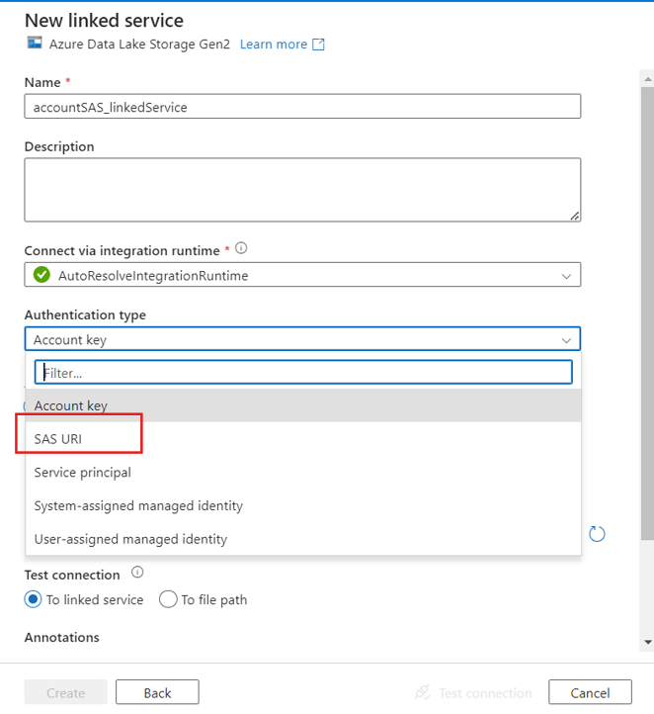

**Paste URL in the below section**

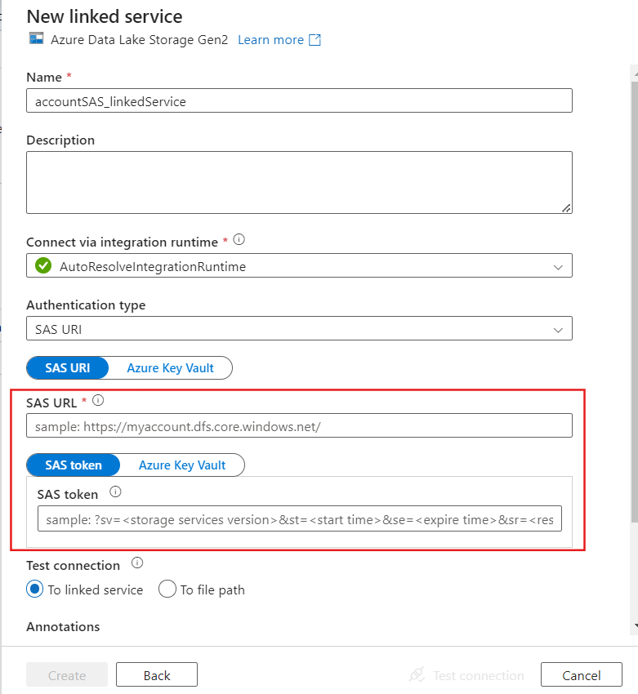

Do not forget to replace “blob” with “dfs”

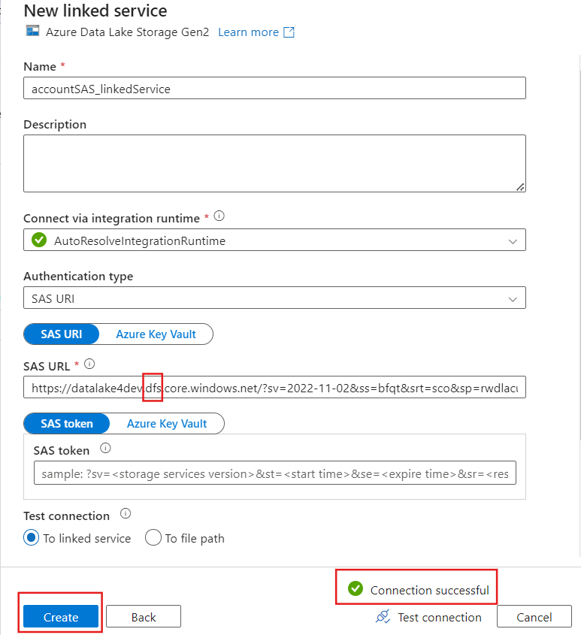

**Service SAS (actually granular)**

Now, we created a new directory and inside that, two images are there.

We want to generate an SAS token just for one image

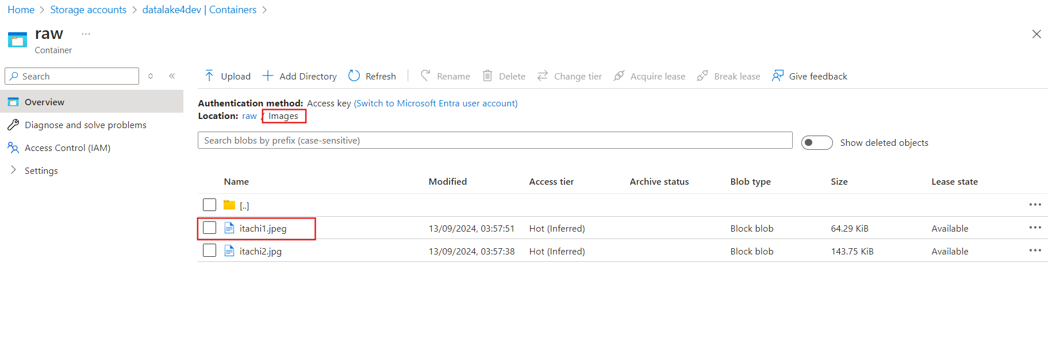

**Click on those 3 dots in the right side**

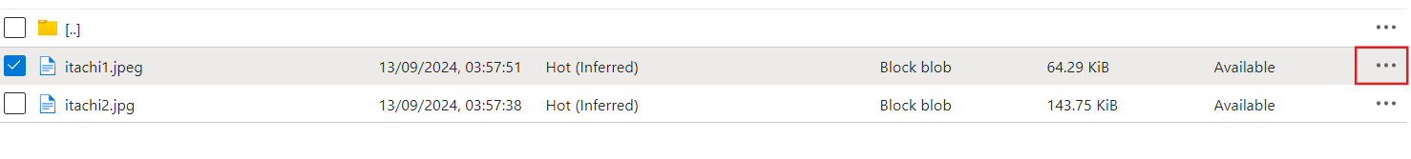

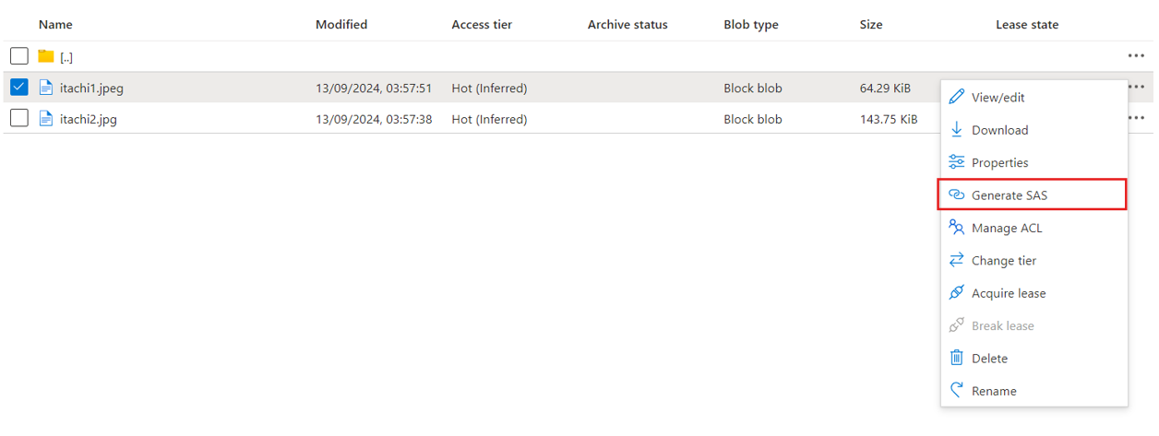**Click on Generate SAS**

*Under the hood, of course, these SAS would also be using Access Keys*

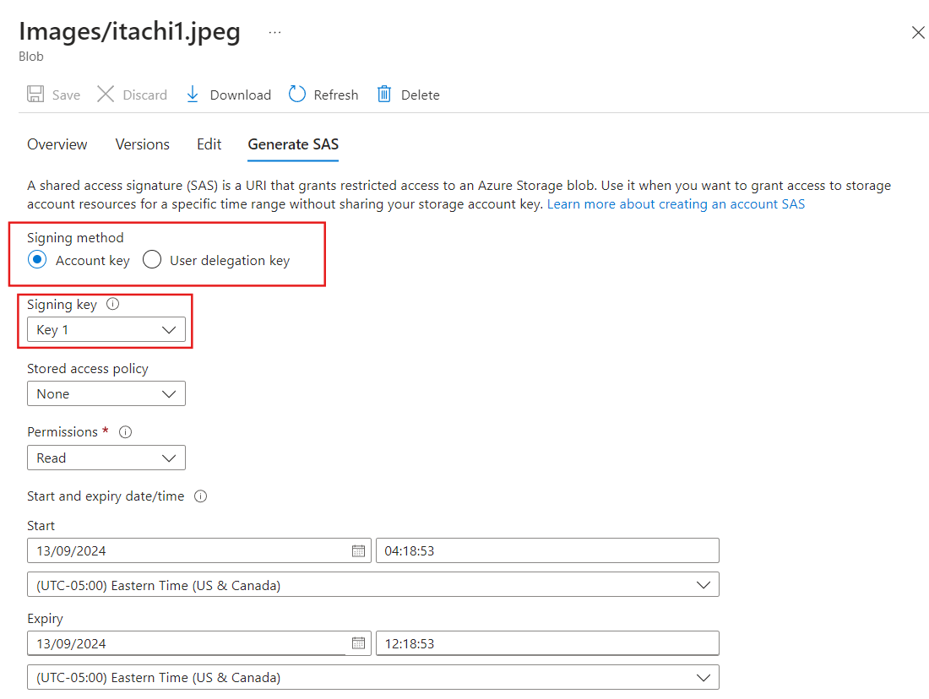

**But what is this “Stored Access Policy” thing?**

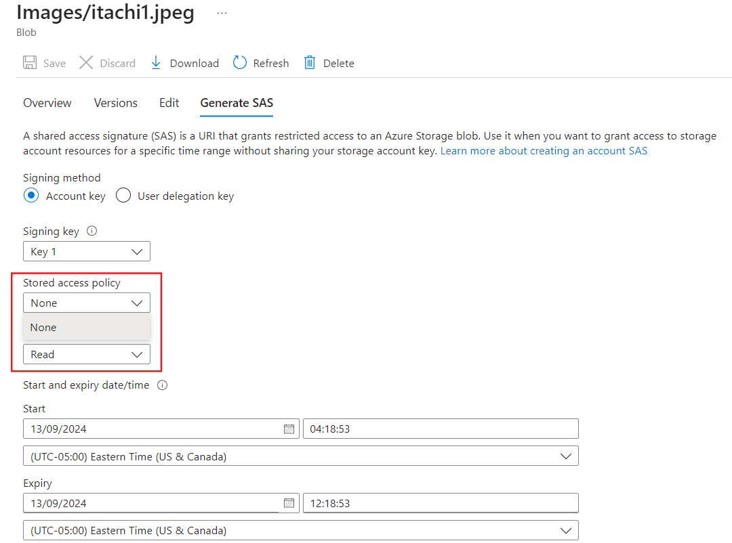

This is the Policy that you define at Service level (containers, directories)

And then when you generate a Service SAS token, you provide the Policy

But we did not create a Policy yet.

**How to create a Policy?**

Let us create a Policy for Raw container

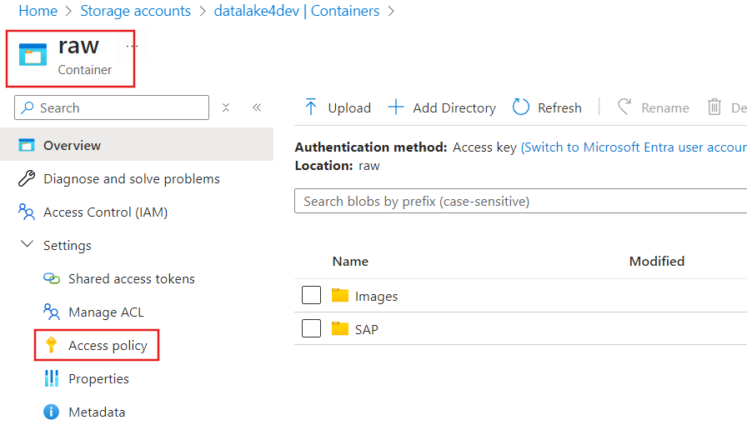

**Add policy**

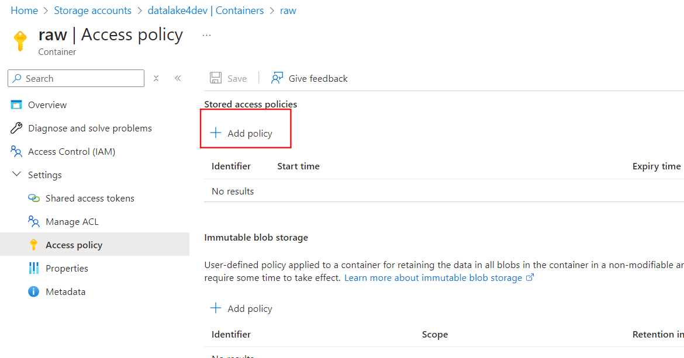

**Then you can grant whatever permissions you want to be automatically inherited by SAS token in there**

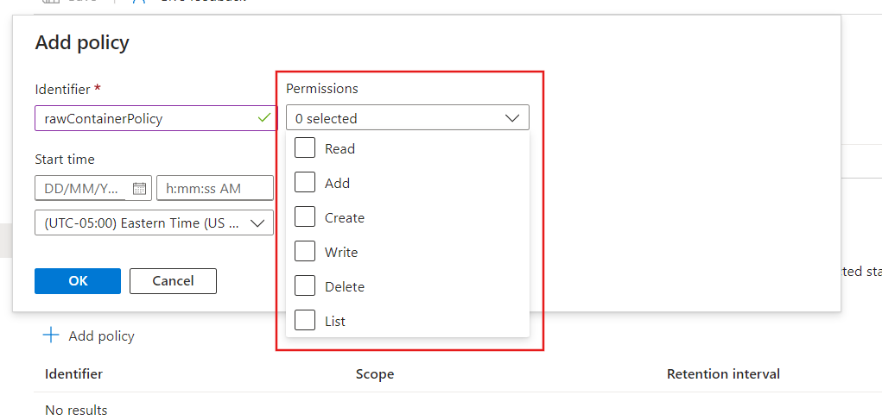

**You should see your created Policy for the RAW container**

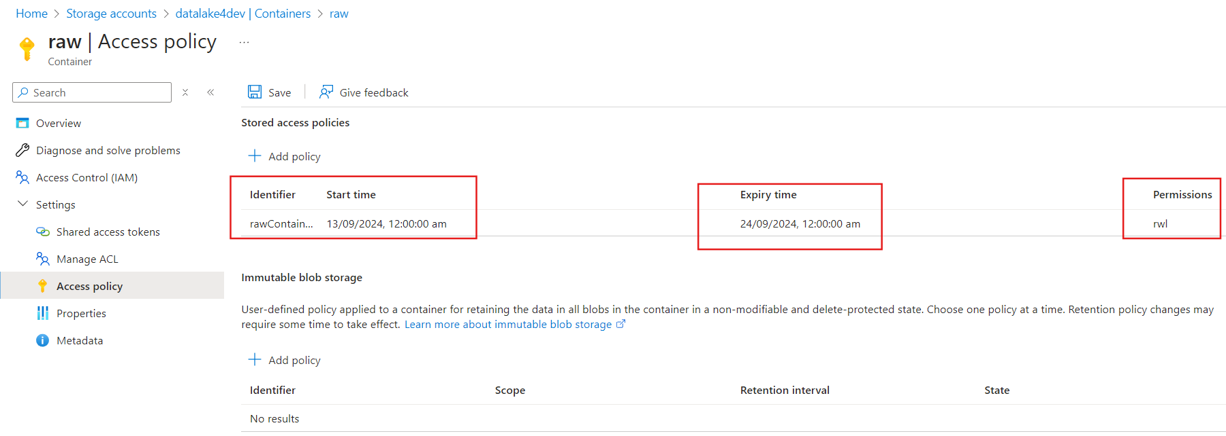

Now, let’s go create a Service Level SAS token by passing this Policy inside the token

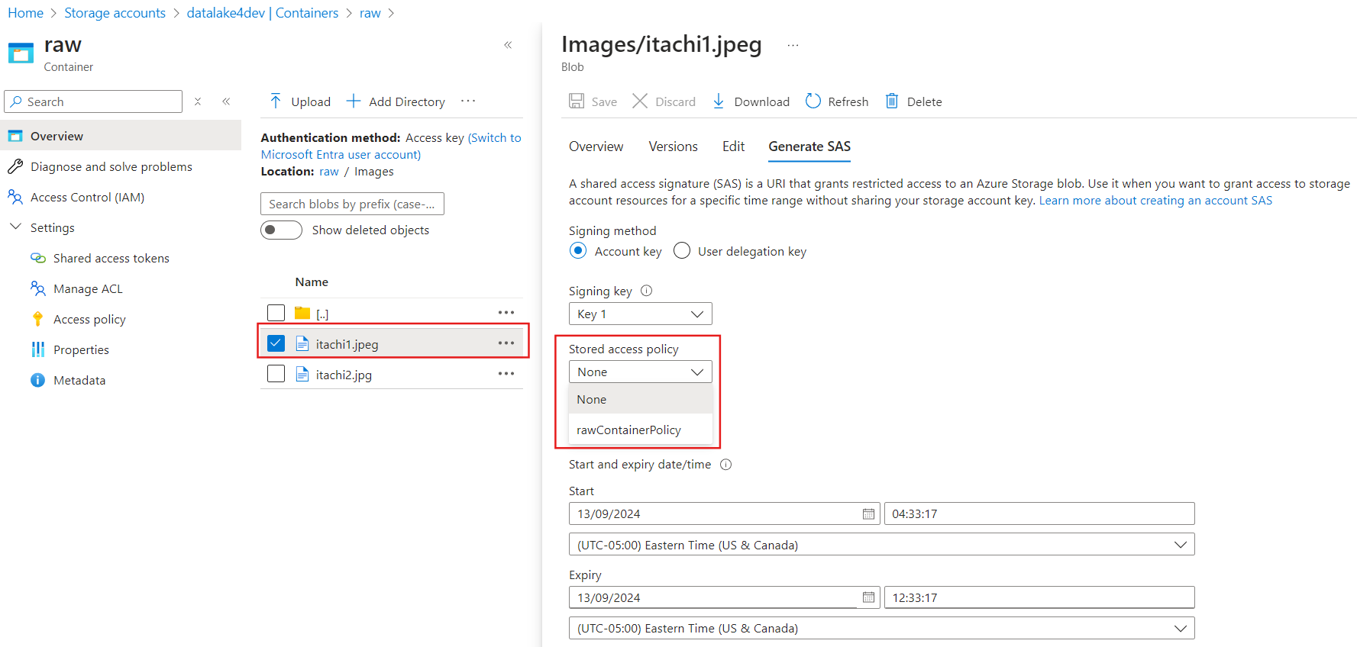

You can see that our created Policy appeared to choose from the options

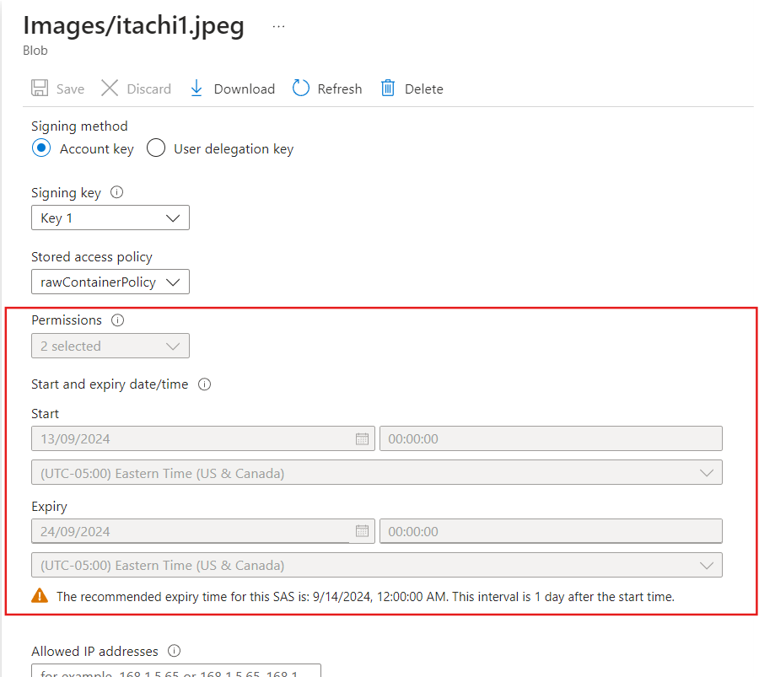

Can you see whatever Policy you defined at container level is automatically inherited by this token.

Talking about the high-level overview, when you define an *Access Policy* at container or directory level you grant some permissions to it. It signifies what an Access Policy can do in the container or directory. So, if you are generating a Service SAS token by making use of an Access Policy, then whatever user/application/service principal is using that SAS token, the container or directory will understand to what extend or what piece of work a user can perform on me with that SAS token.

**User Delegated SAS**

* This doesn’t use Access keys
* You generate User Delegated SAS at the same place where you create Service Level SAS token.

**Let me show you what I am talking about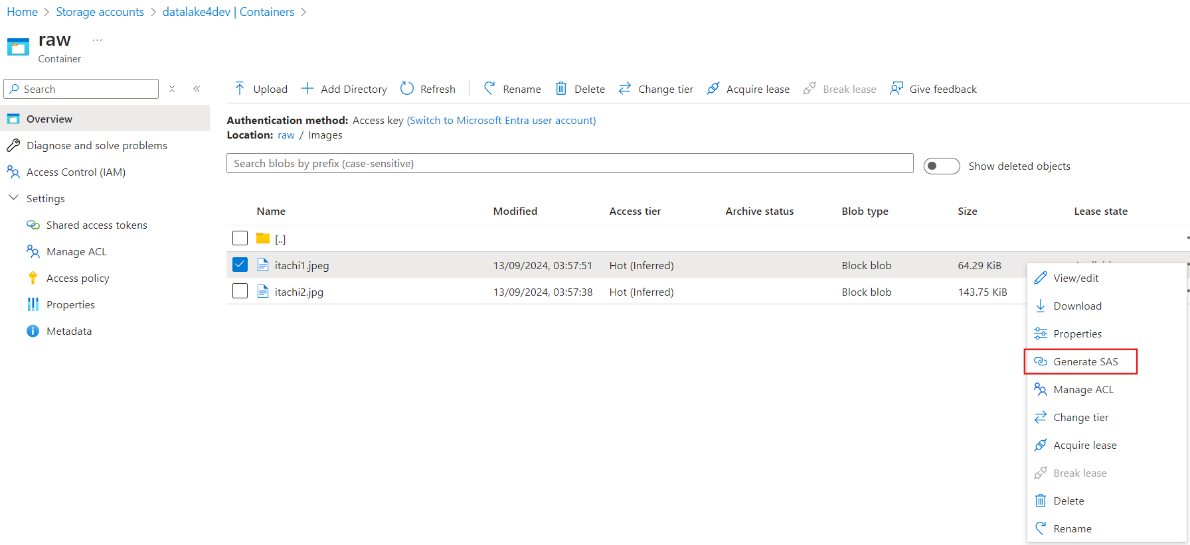Just switch to ‘User delegation key’**

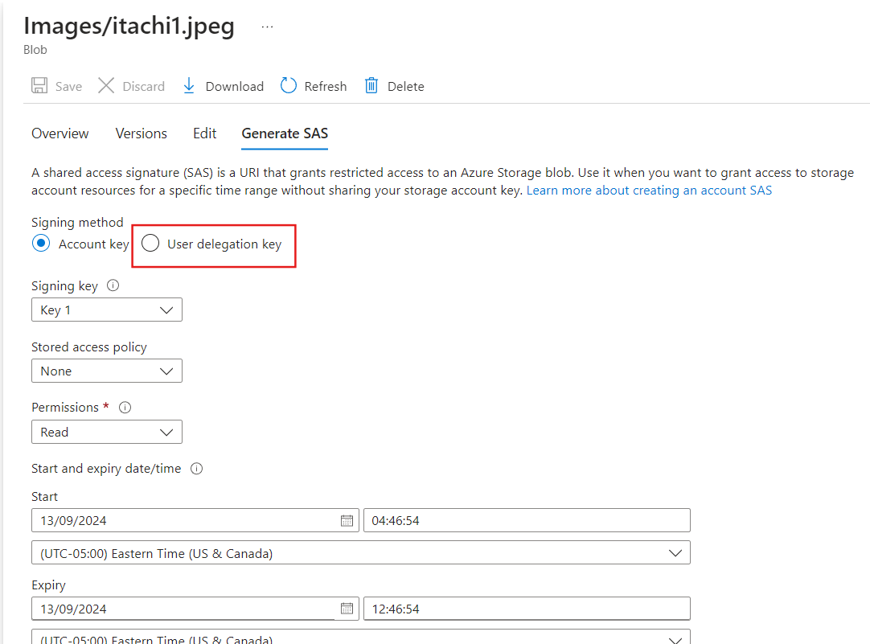

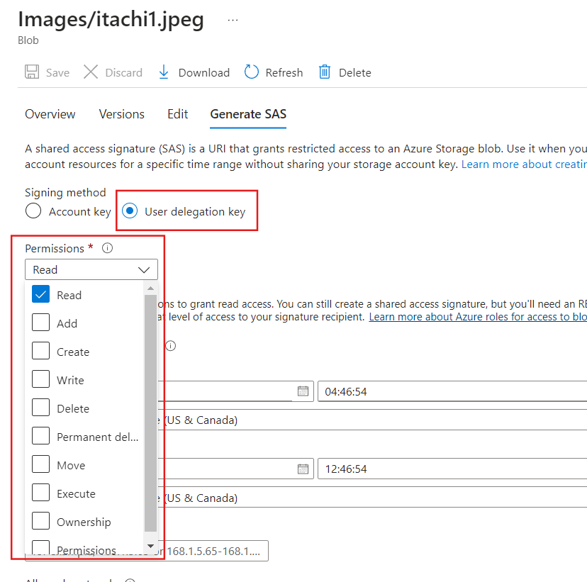

From permission tab, you can choose what type of permissions you want your SAS token to have. Please, notice that there is no usage of Access Keys at all.

**Role-Based Access Control(RBAC)**

Where to check Roles

Resource Group level 🡺 Access control(IAM) 🡺 Roles

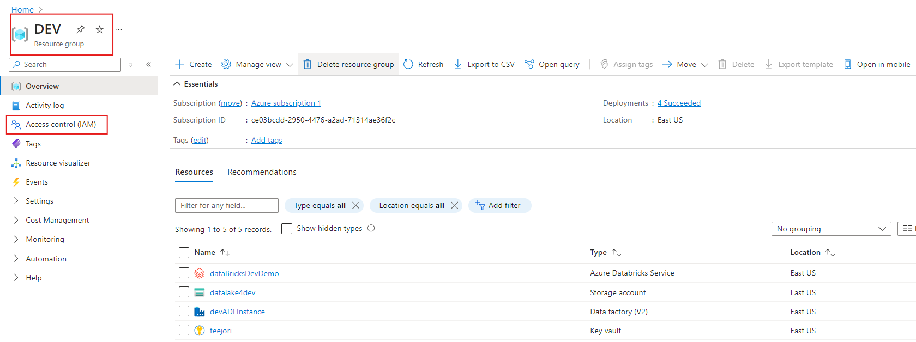

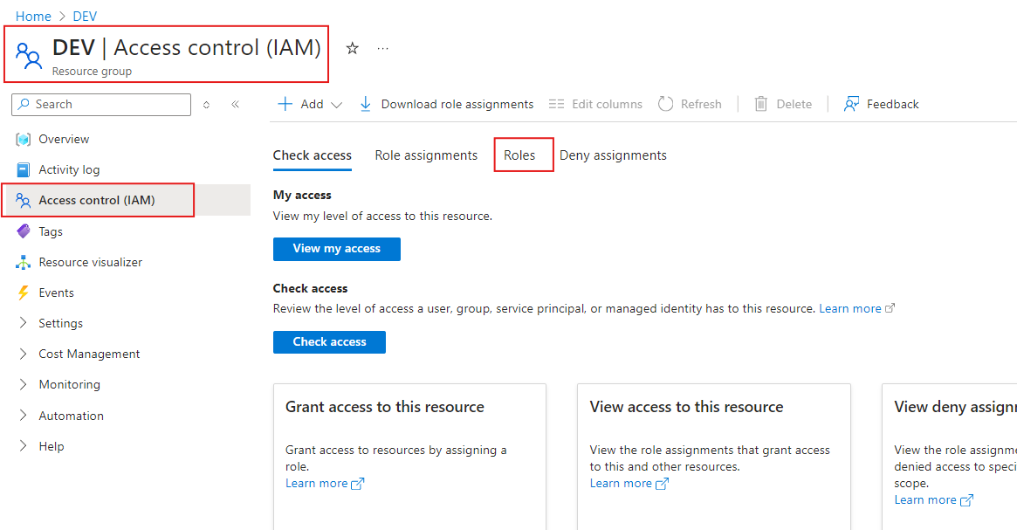

And if you want to see set of permissions available default roles, you can navigate to the “**View**” option and can then see the json format of the code.

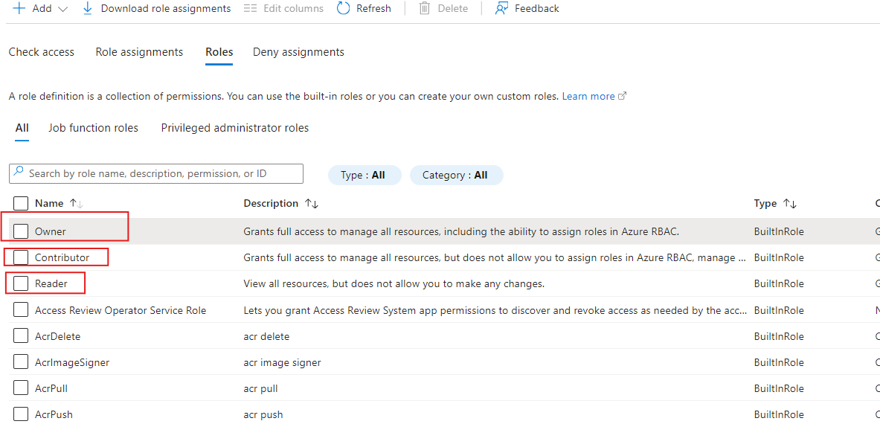

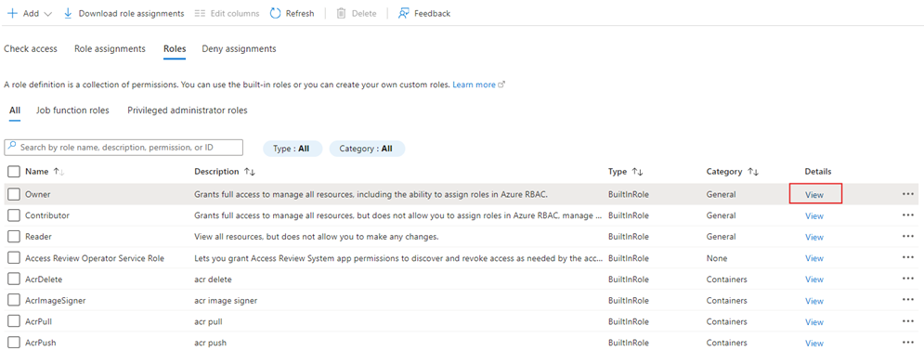

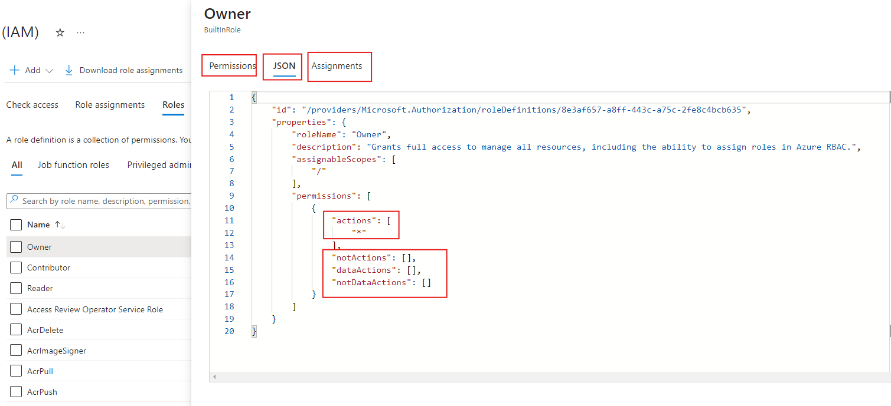

In the fig above which is in the form of json like structure: *actions* are what an owner can do and inside *notActions*: list of the things that owner cannot do

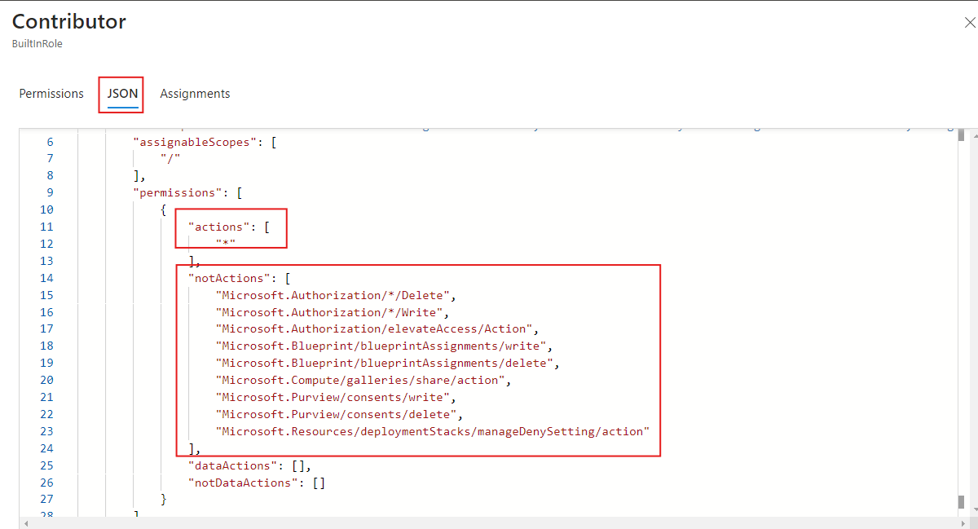

For example, in case of Contributor role

* Actions = what he can do
* notActions = inside this is what a Contributor cannot do

In a similar way we can create our own customize role by defining set of permissions under *actions* and *notActions*.

**How to assign Roles**

Resource Group Level 🡺 Access control(IAM)

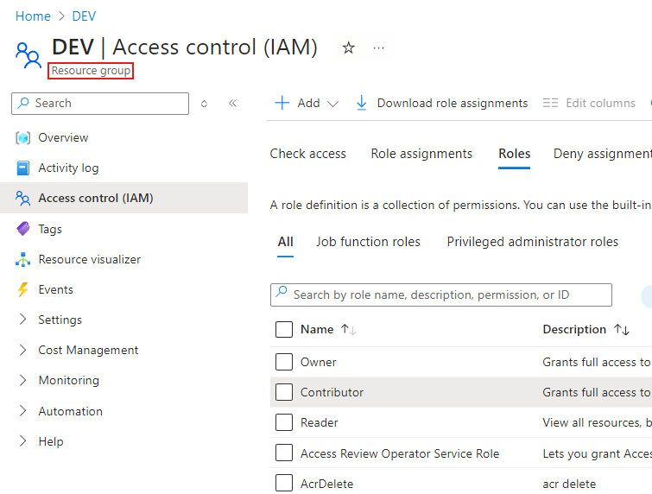 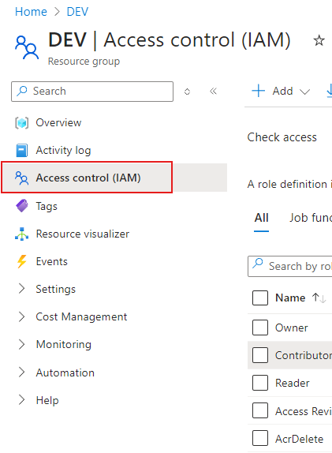

Navigate to Role assignment

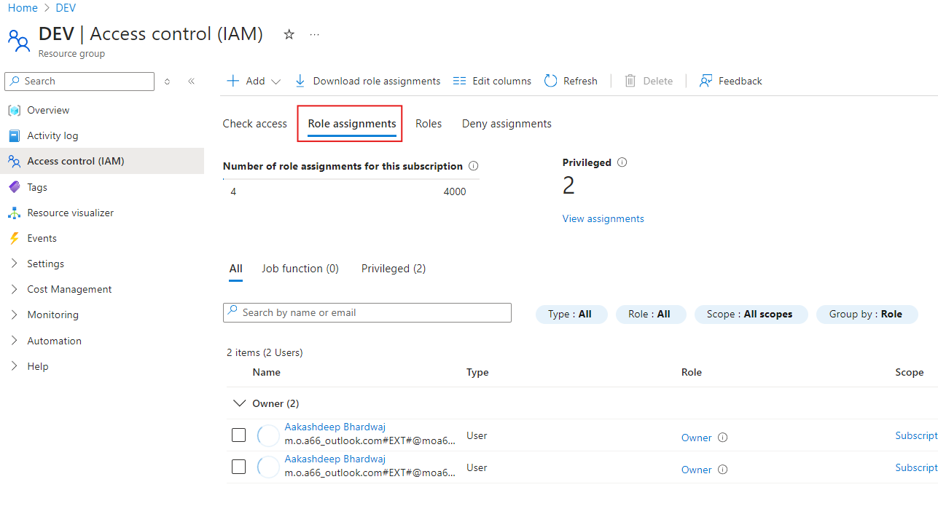

Then select “Add”

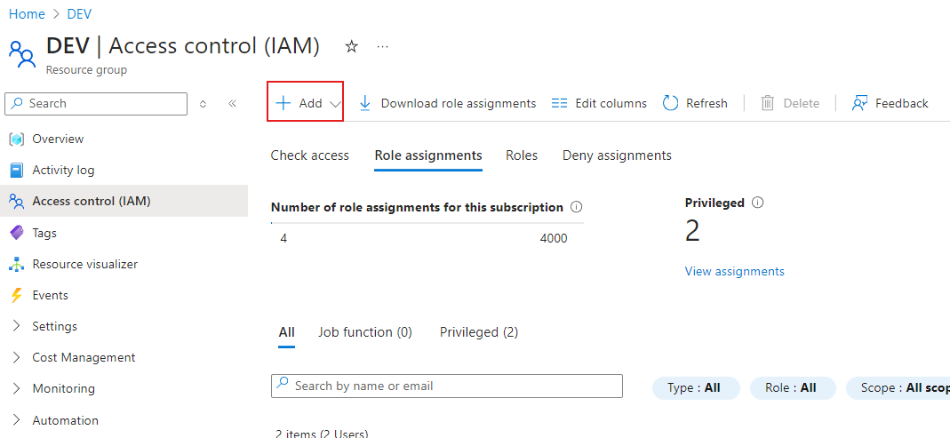

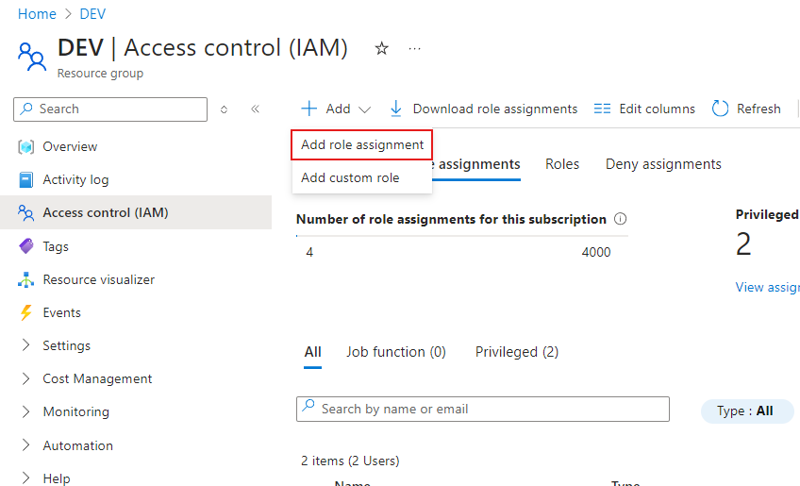

Choose “Add role assignment”

And let’s say you want to assign someone a Contributor role

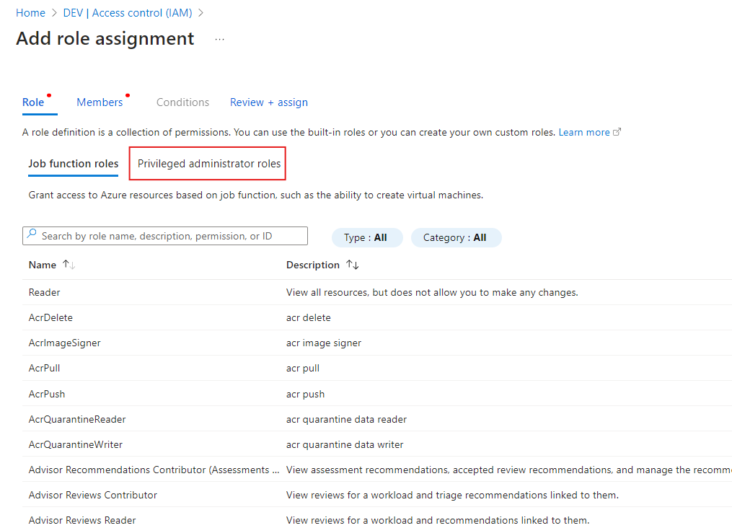

Choose “Privileged administrator roles”

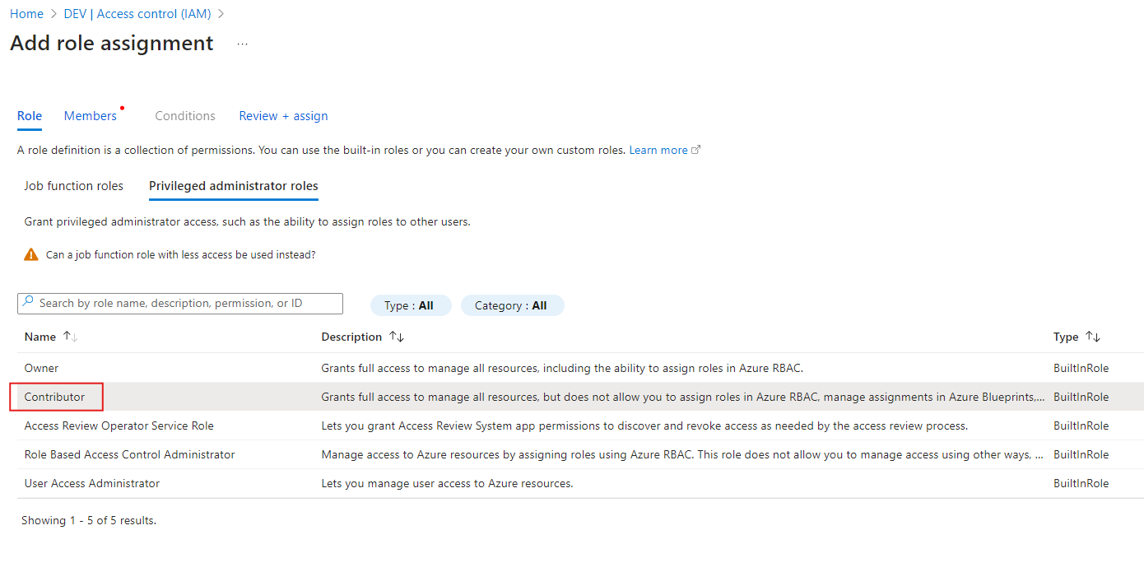

After that you will see 3 options

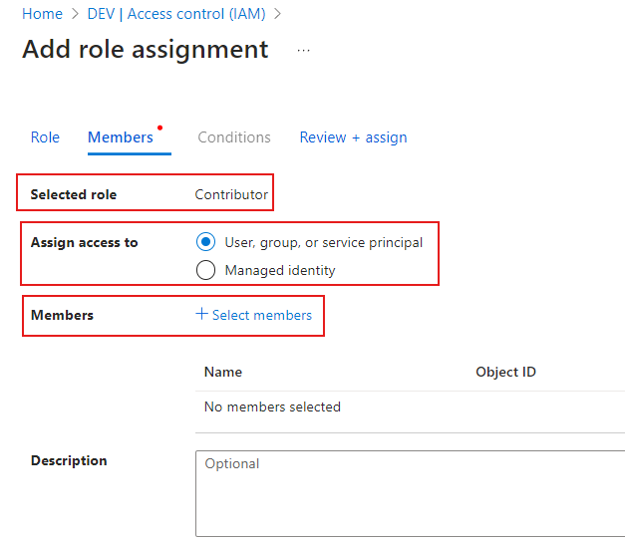

* “Selected role” is what Role you want to assign
* “Assign access to” is to who you want to assign role to
* “Member” adds members who should have that role

**To check different types of Roles defined on a Scope(e.g. Resource Group)**

Go to a particular Scope 🡺 Navigate to “Access control (IAM)” 🡺“Role assignment”

Then you can see list of Security Principals along with their roles as shown in the figure below.

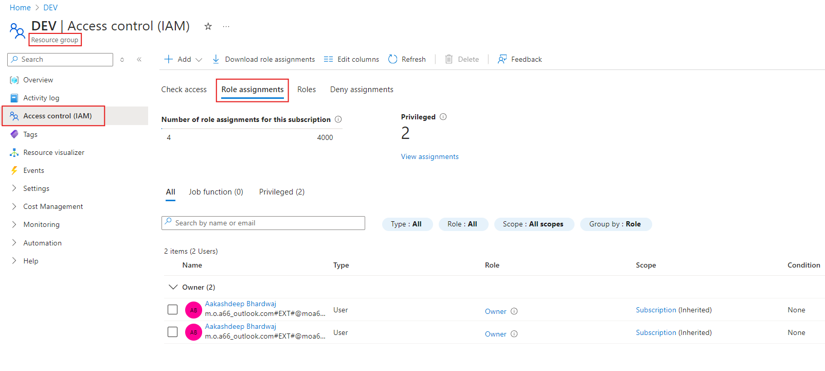

**To check your access/permissions**

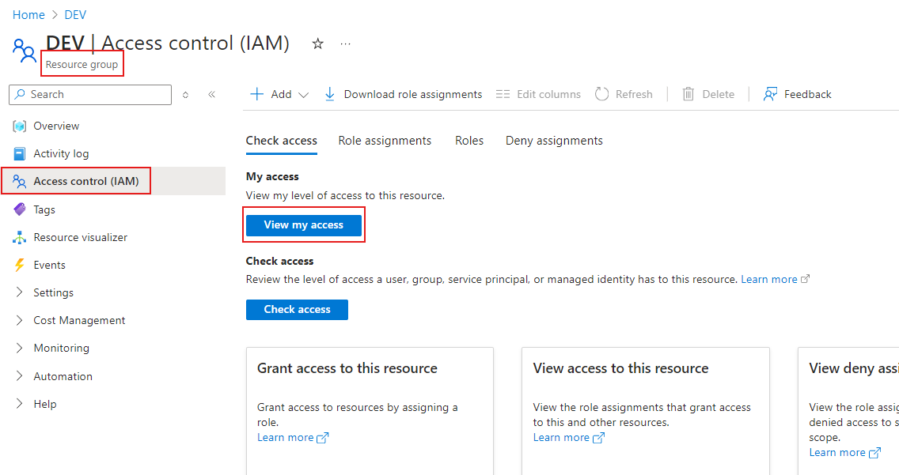

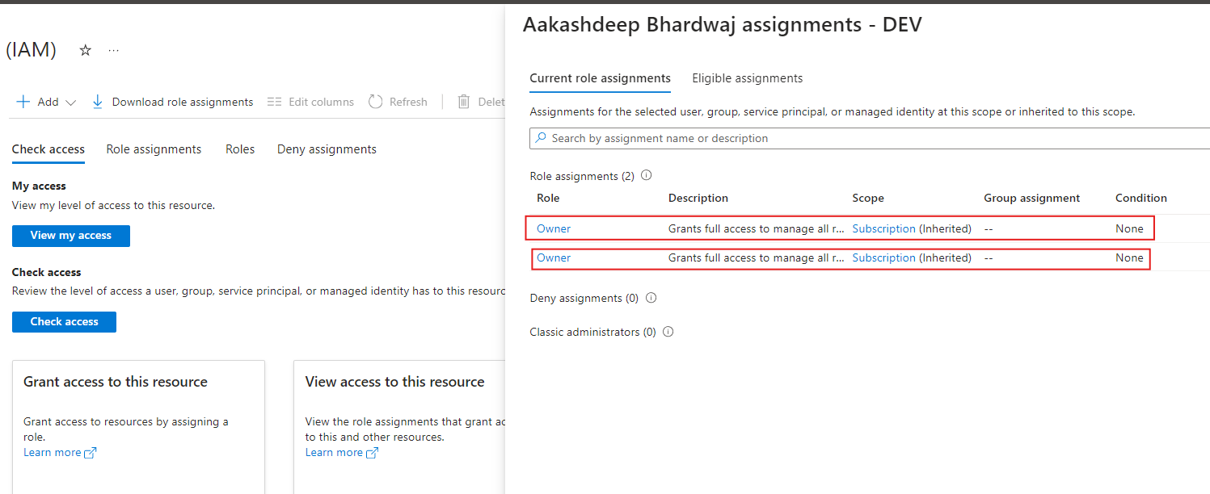

**To check someone else’s permissions**

Go to the Scope on which you want to verify access permission

Go to Access control (IAM)

Go to “Check access”

Search the Security Principal

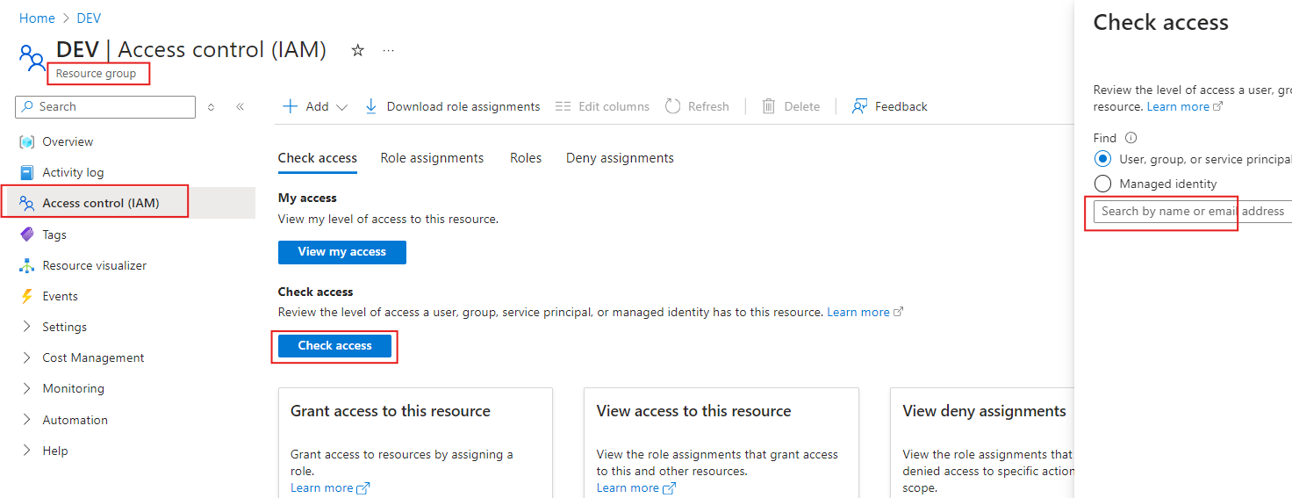

**There are 2 splits in plane**

**Control Plane** : don’t have access to data

**Data Plane**: has access to data

**To access data in Data Lake:**

**Roles**

Storage Blob Data Owner

Storage Blob Data Contributor

Storage Blob Data Reader

**Assigning RBAC to ADF(Managed Identity)**

We want to grant access to ADF on DataLake

Therefore, **Scope** = DataLake, **Security Principal** = ADF, **Role** = Data Contributor

This can be broken down in two phases:

In Microsoft Entra ID create a group and add Managed Identity of ADF as a member.

At the Storage Account grant Storage Blob Data Owner/Contributor/Reader role.

Create a group -> Add ADF as a member to the group -> Grant RBAC to that group

Go to your Microsoft Entra ID

Navigate to Groups

You will see list of Groups that had already been created

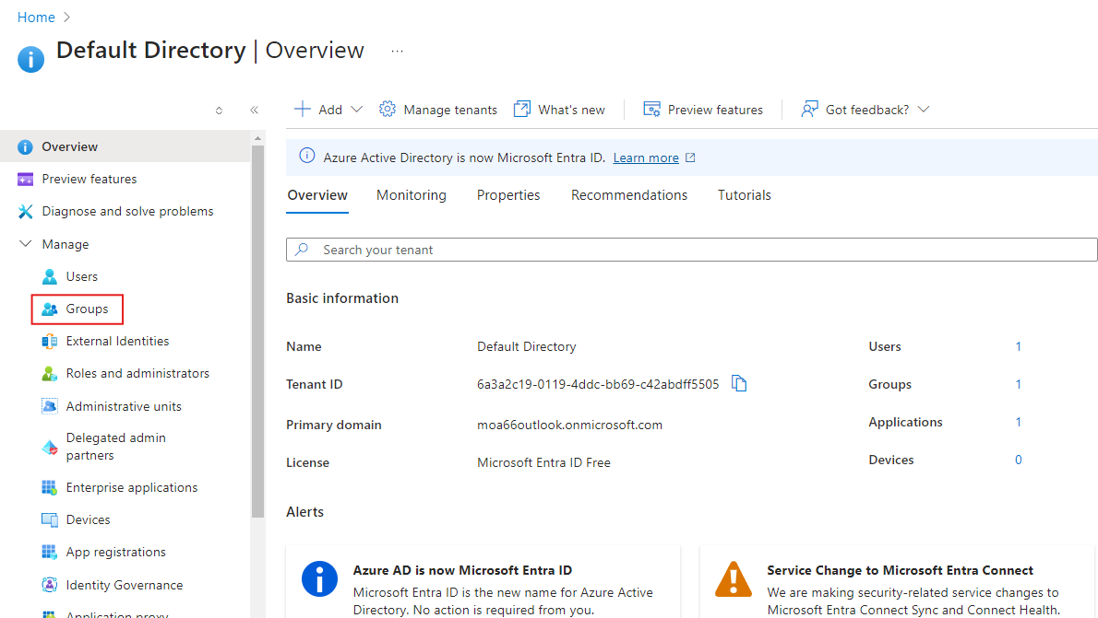

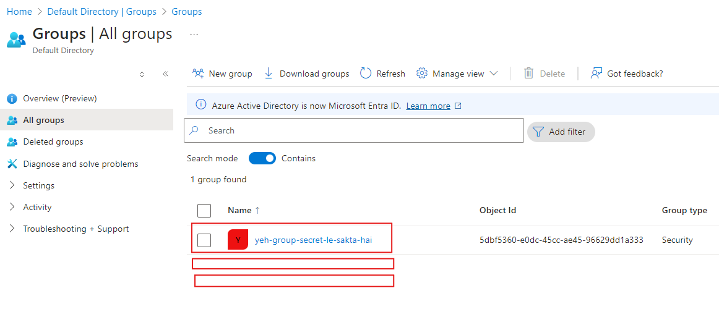

**Add a new group**

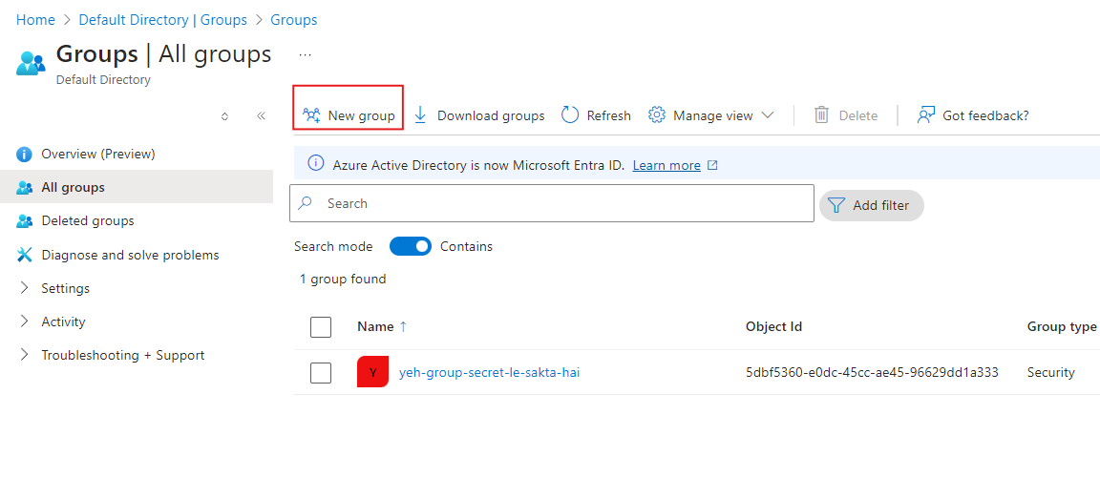

**Give it a name**

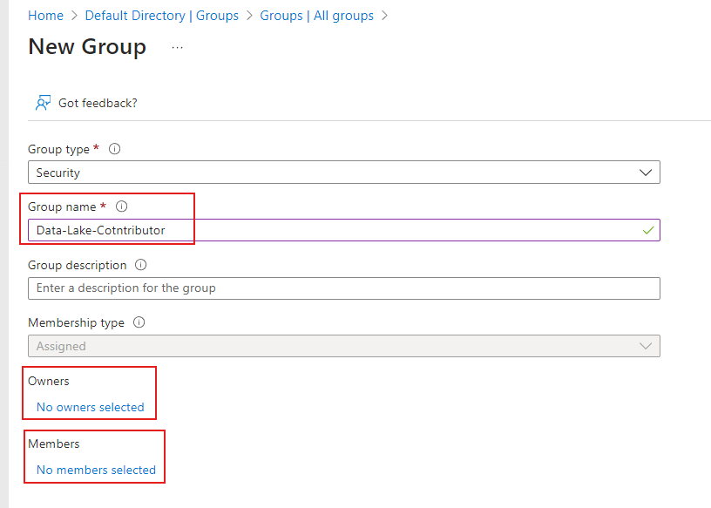

**Add yourself as Owner**

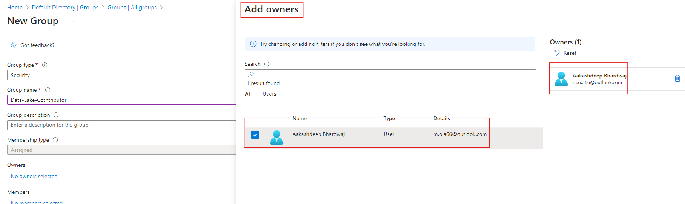

**Add Managed Identity of ADF as member**

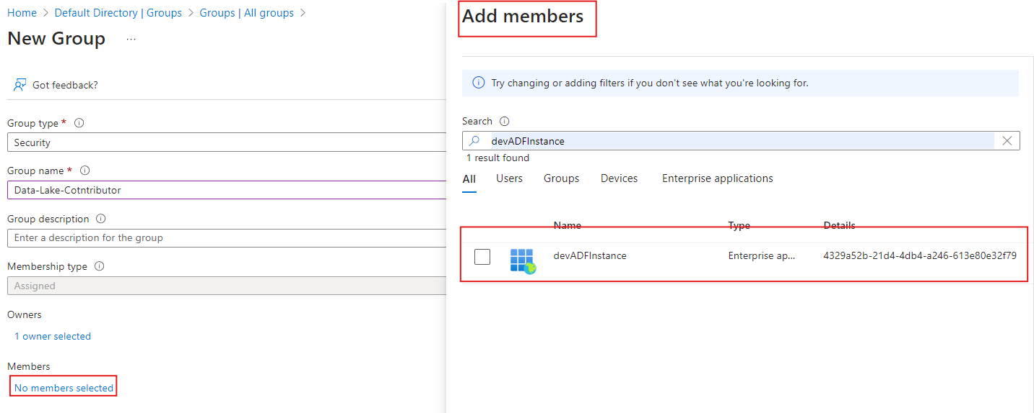

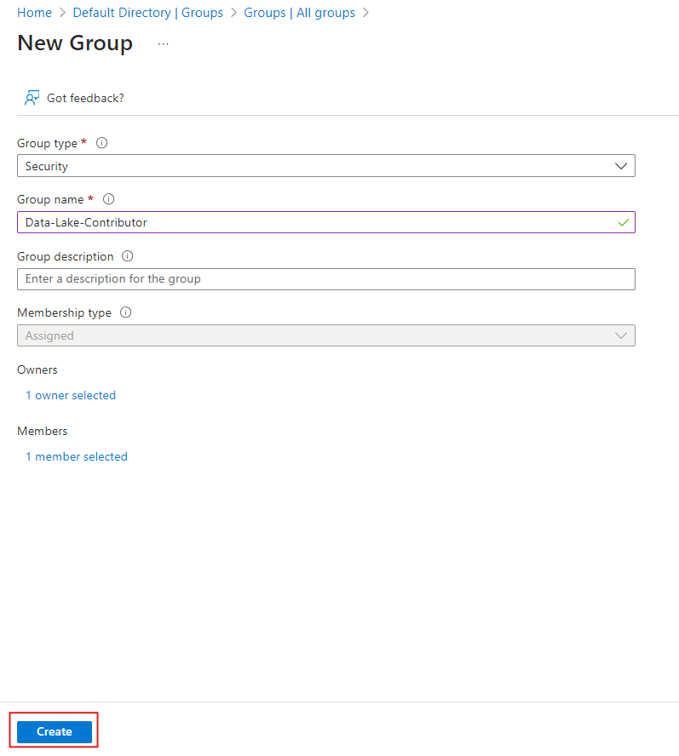

**After creating the group, you should the group in main menu**

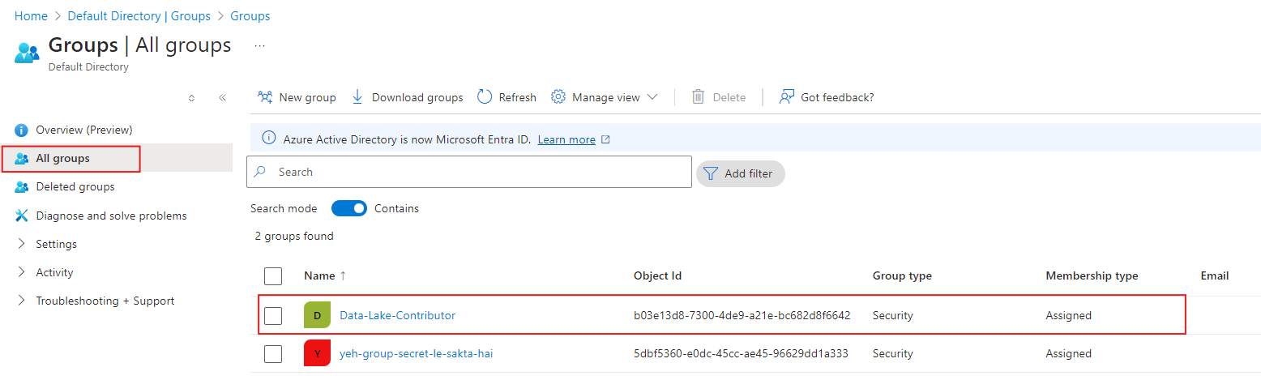

* Now, go to the Scope(Resource Group/Storage Account/Container)
* Navigate to Access Control (IAM)
* Grant Data Contributor role to the recently created group

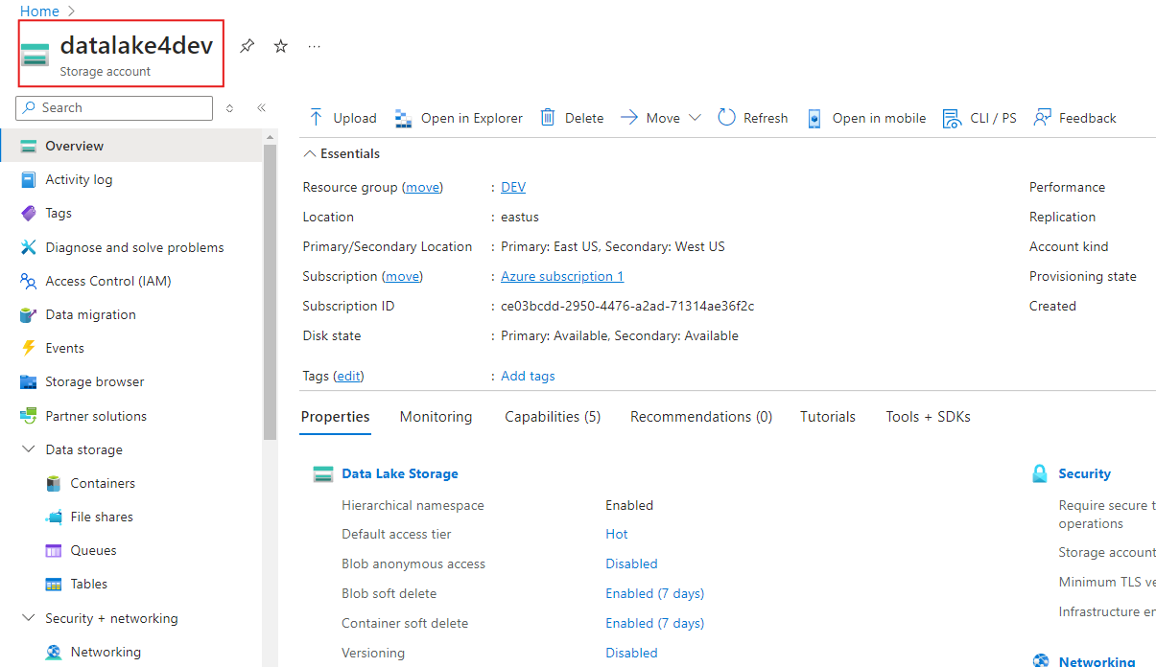

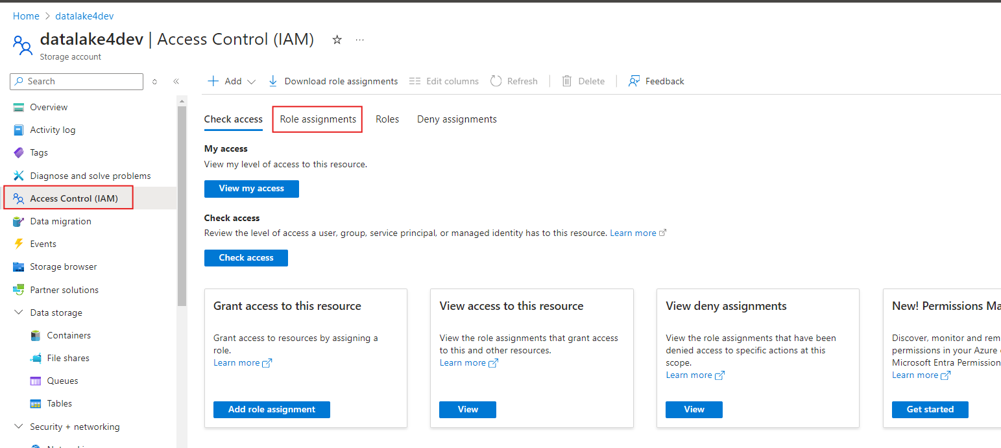

Access Control (IAM) 🡺Role assignments🡺Add

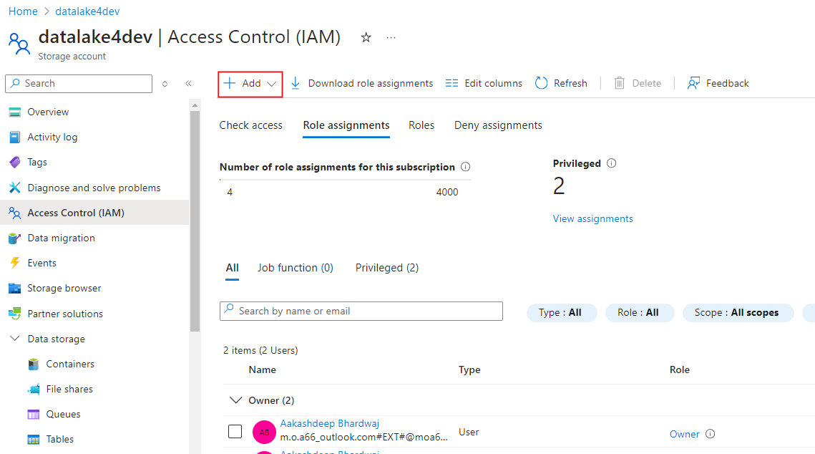

Switch to “Privileged administrator roles”

Search for Storage Blob Data Contributor role

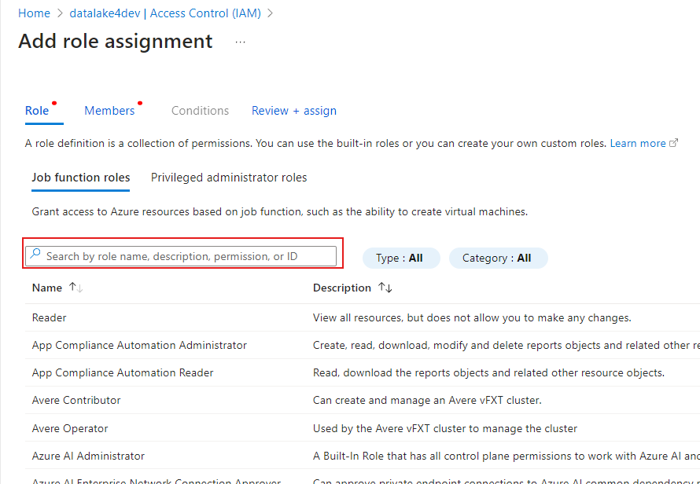

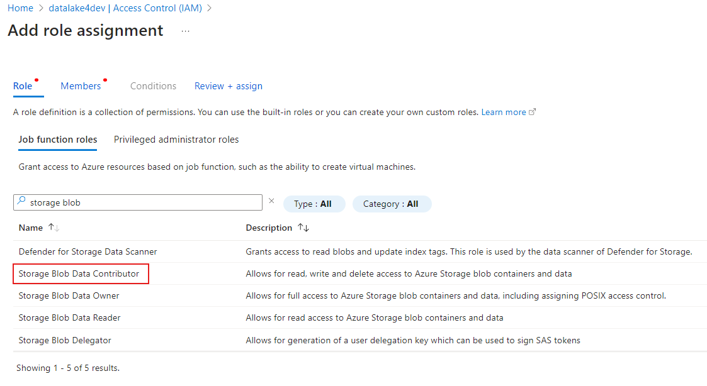

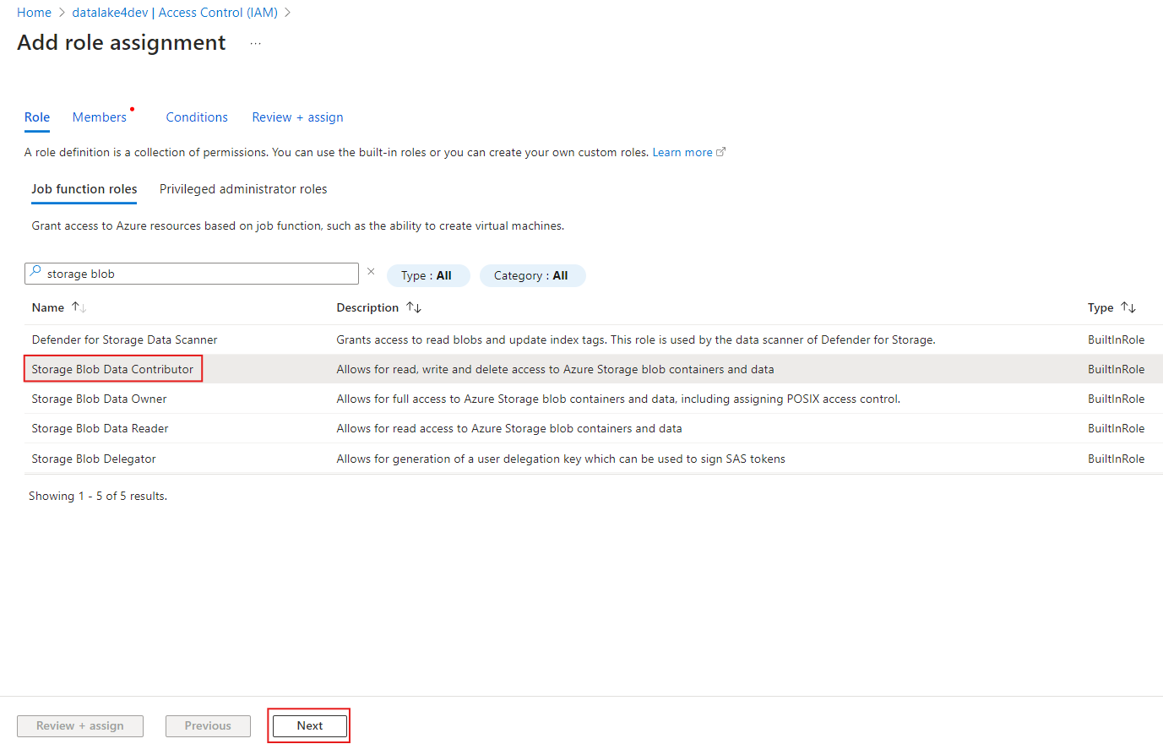

As you know you already created a group so settings should be like below

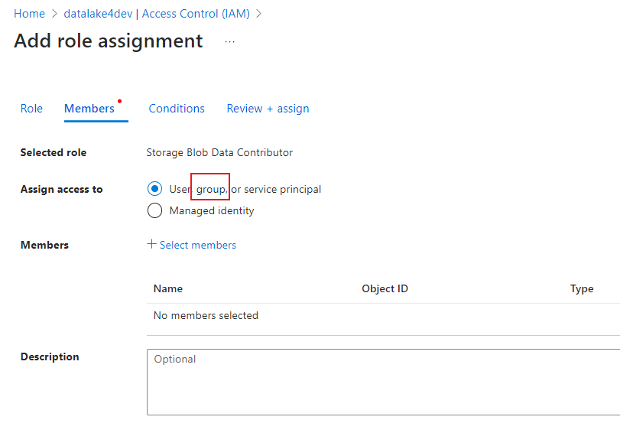

If you did not create a group, you would have to choose “Managed identity” again and again

Select member as the recently created group

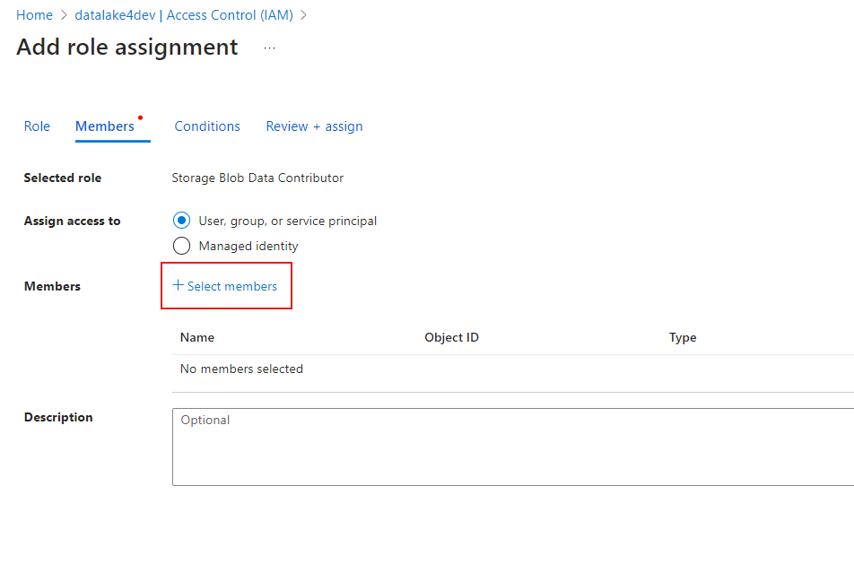

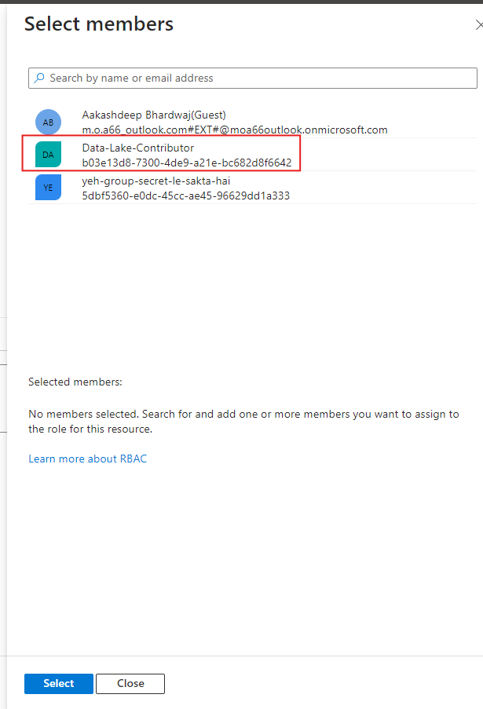

Now to verify if our ADF could access the Storage Account

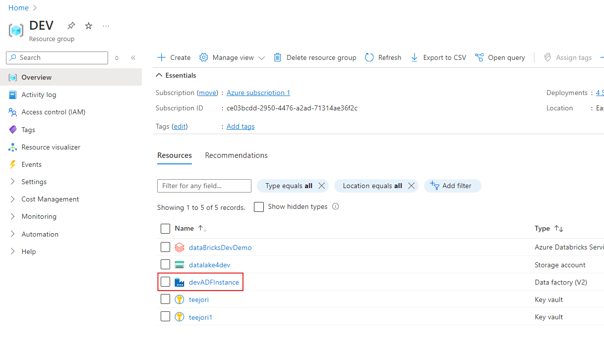

Let’s create a New Linked service from ADF to Data Lake that uses RBAC

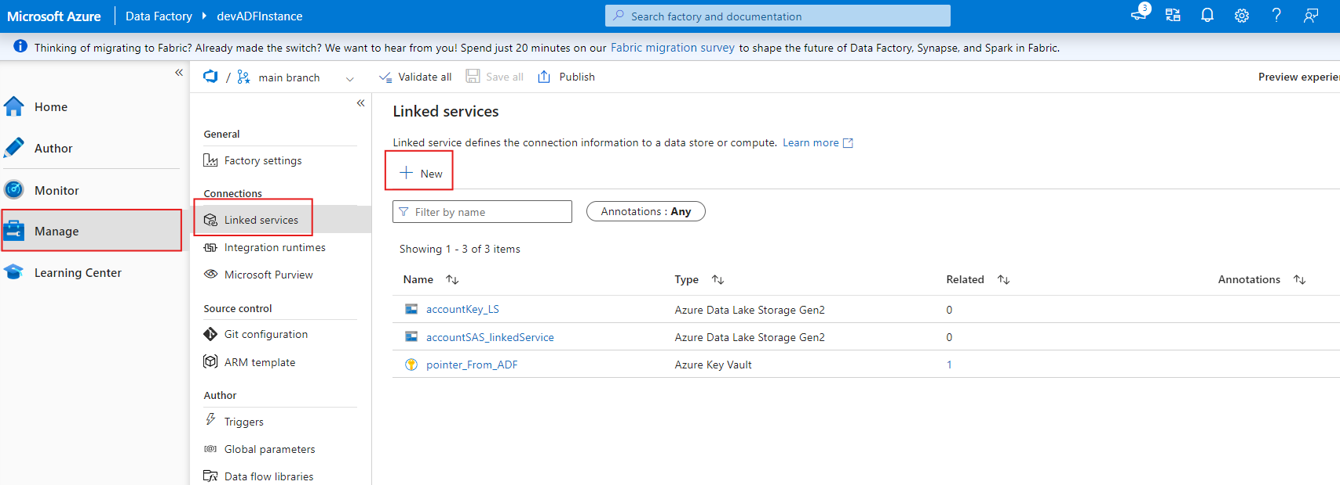

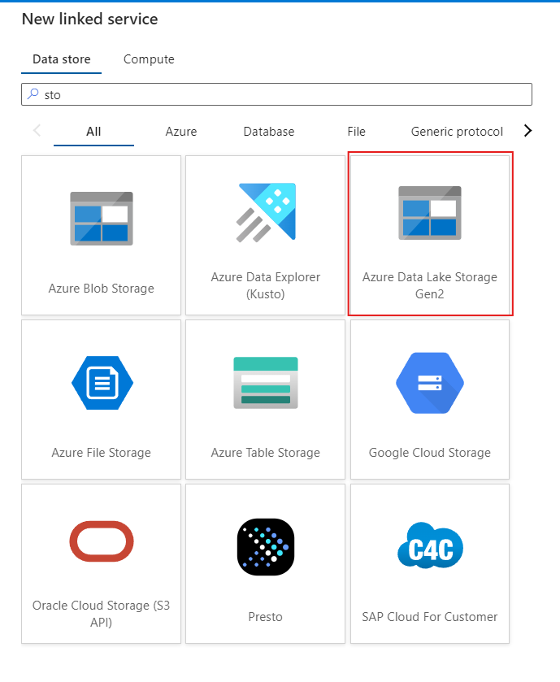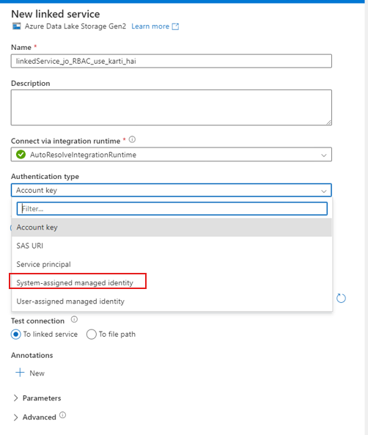

Choose “System-assigned managed identity”

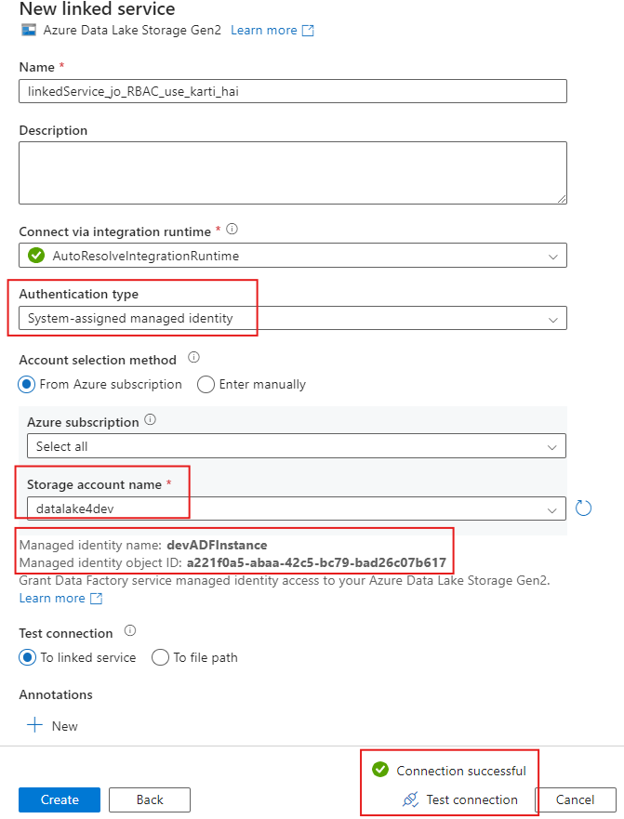

Here you will see that you just provided “Storage Account Name”

**How is it working?**

When you give Storage Account name, the intelligence will see that you are creating a Linked Service from that instance of ADF to which you already granted RBAC on that Storage Account

**To enforce RBAC you must utilize Microsoft Entra.**

**Setting up CICD for Data Factory**

we only want our Dev instance of ADF configured, not the Prod instance of ADF

Go to ADF that you will use for Dev environment

Click on Manage.

Click on Git configuration option

Click on ‘Configure’

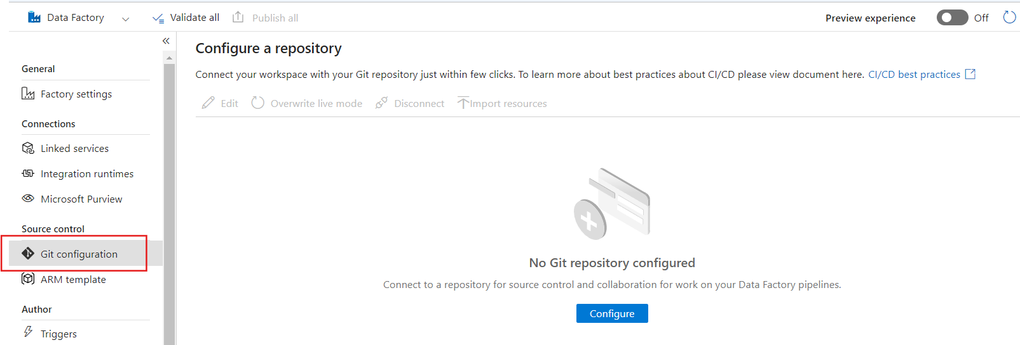

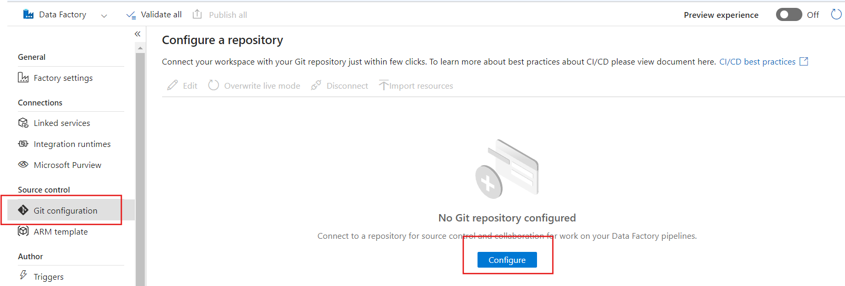

**Then choose Azure DevOps Git as Repository Type**

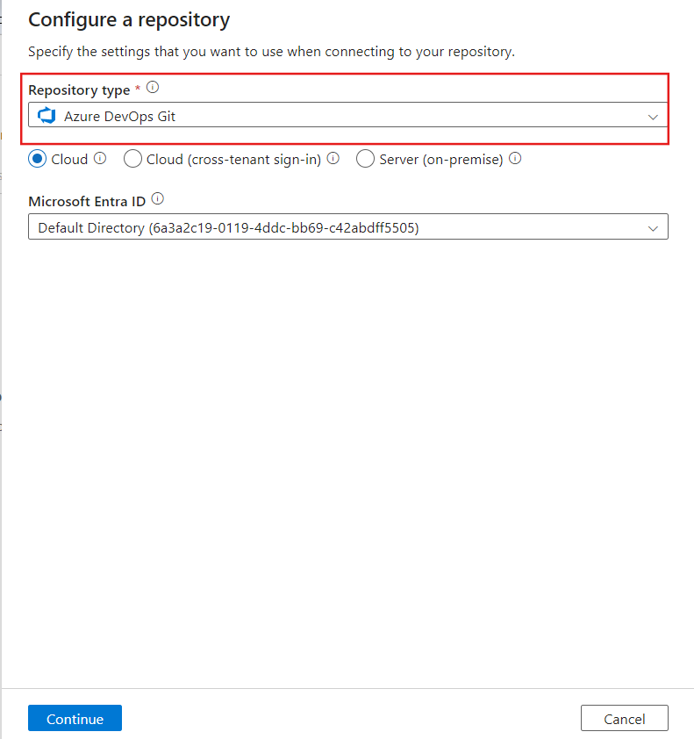

**Also choose your Microsoft Entra ID**

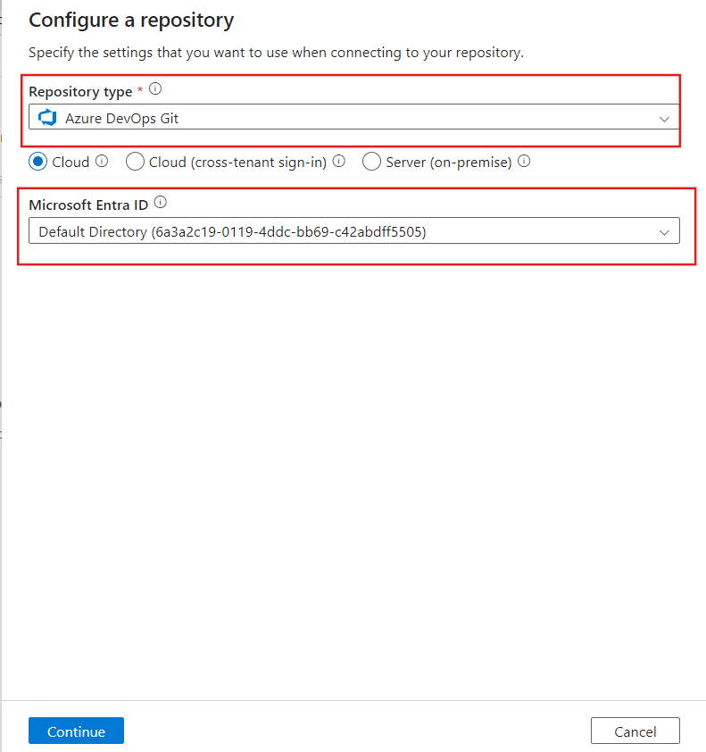

**Provide name of organization that you created inside Azure DevOps**

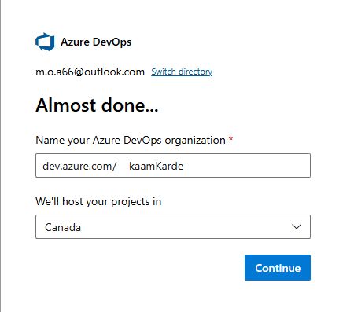

Give an appropriate name to you project and click on create

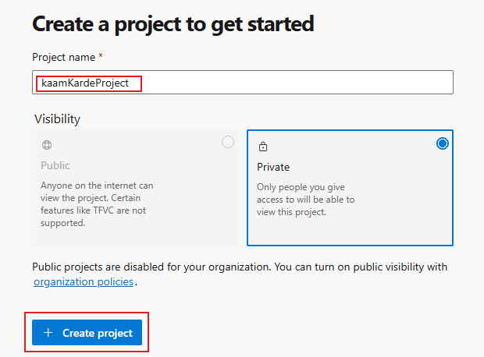

**Entra ID Association with Azure DevOps Organization**

* Confirm that your Azure DevOps organization is linked to the correct **Microsoft Entra ID**.
  + Go to **Azure DevOps** → **Organization Settings** → **Azure Active Directory**.
  + Check if the Azure DevOps organization is connected to the correct Microsoft Entra ID tenant.

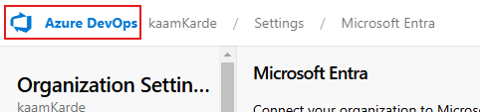

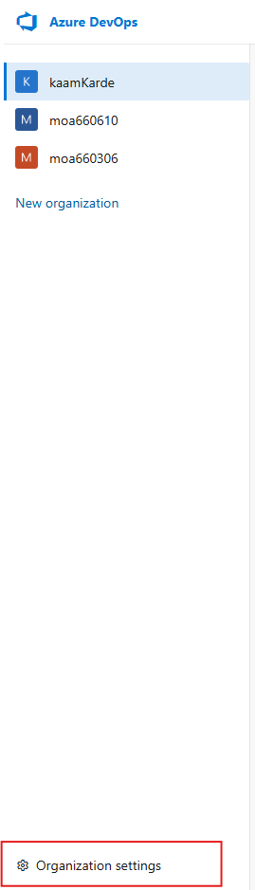

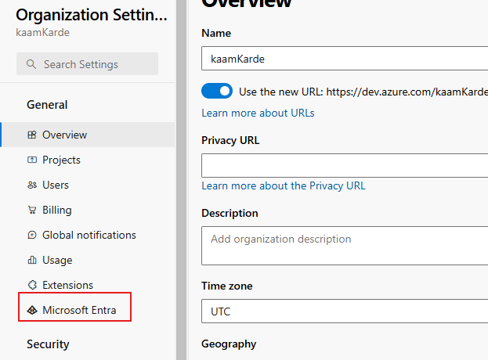

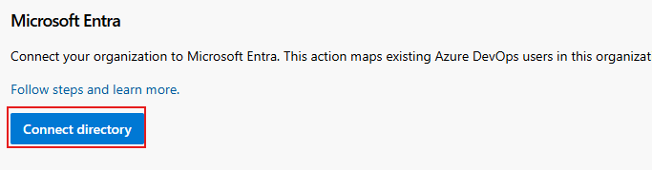

Note: You will be logged out automatically. To login back use *https://dev.azure.com/<organization_name>*

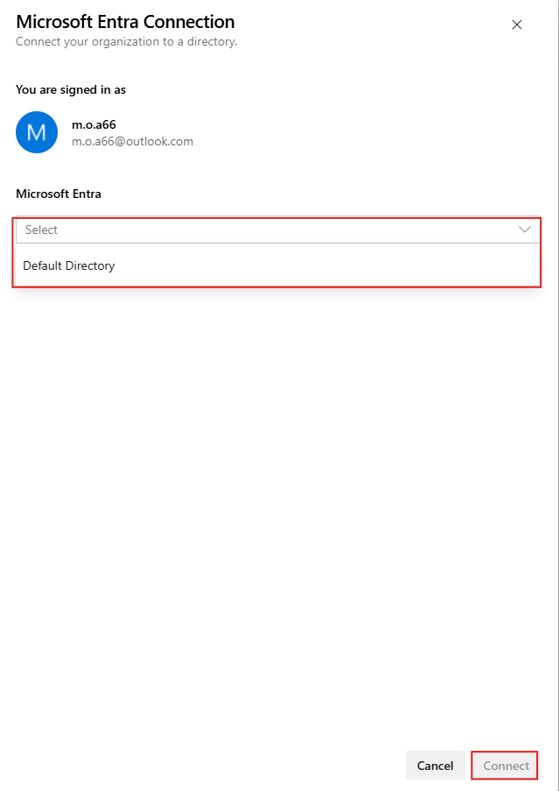

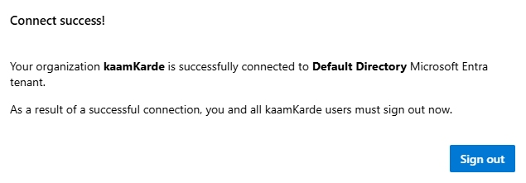

After this if you try to choose an Azure Organization name, you shall see kaamKarde on the list.

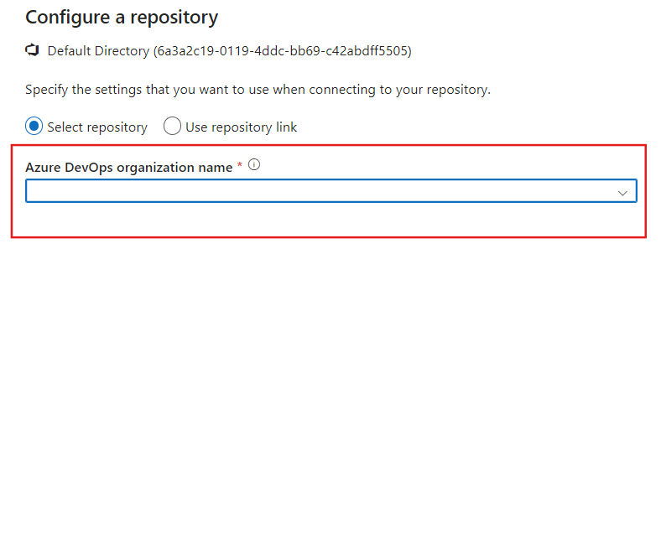

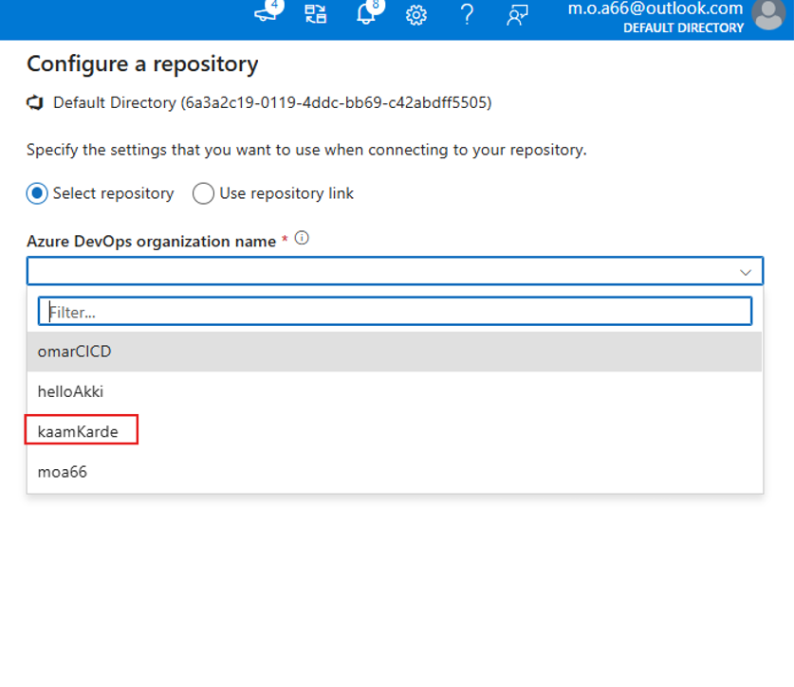

But you cannot see any project

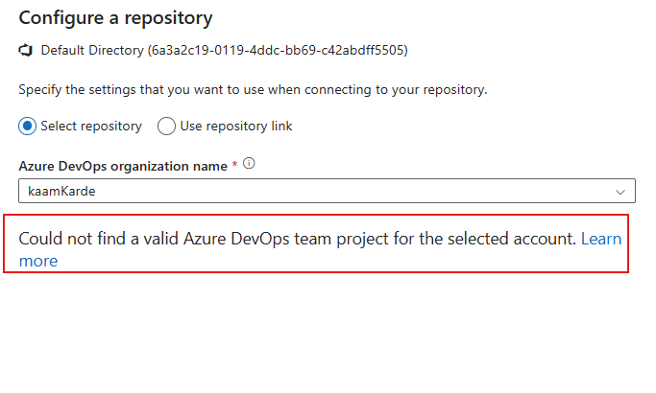

**Check Azure DevOps Project Visibility**

* Ensure that the project visibility settings in Azure DevOps allow it to be detected by ADF.
  + Go to **Azure DevOps** → **Project Settings** → **General** → **Visibility**.
  + Set it to **Public** or ensure your account has access if it's **Private**.

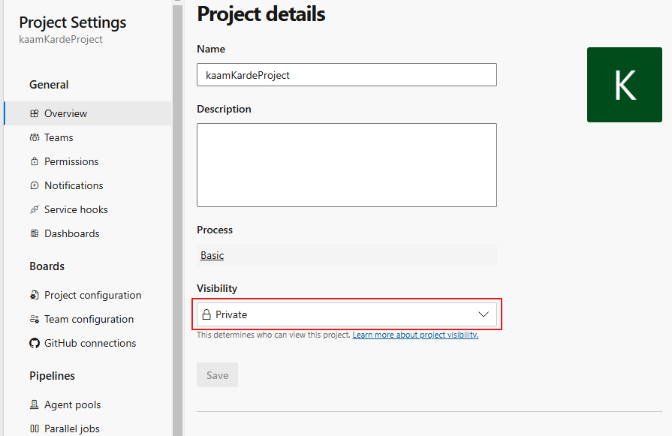

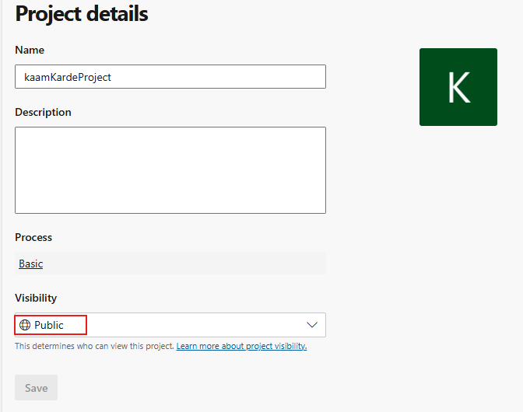

**If it still doesn’t work**

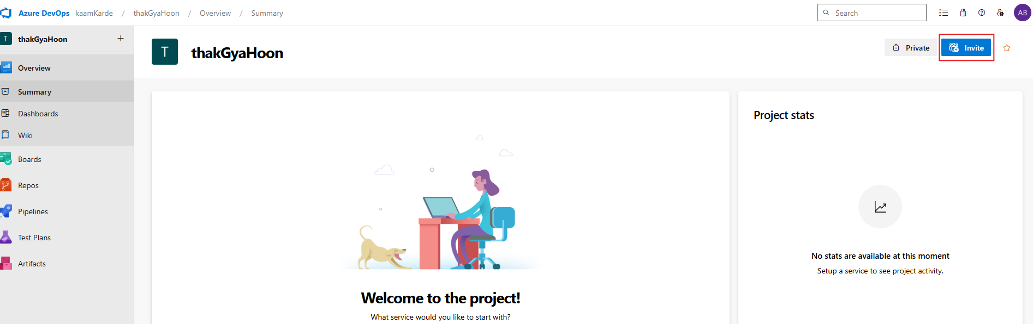

**Add your ADF**

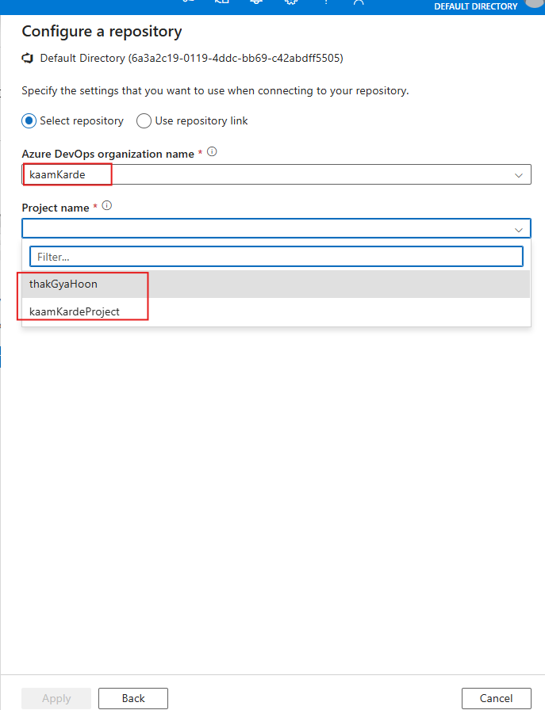

**Collaboration Branch:** give name of your Main Branch

**Root folder:** give its name according to documentation

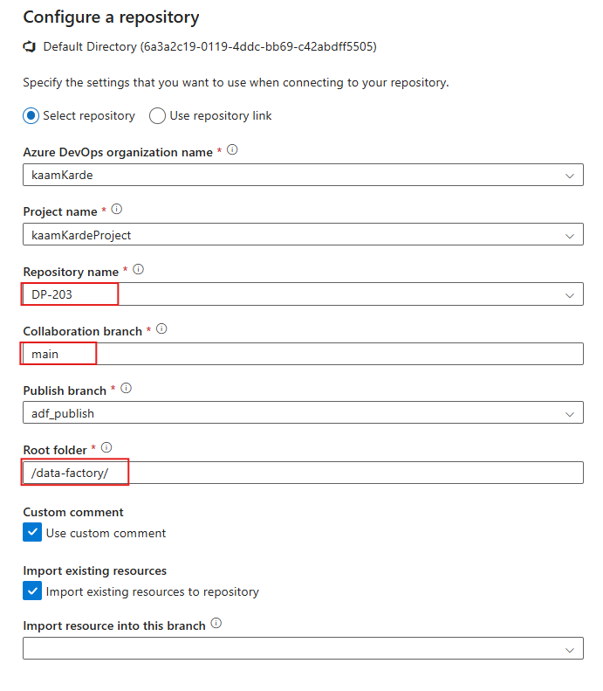

**If you are seeing something like this that would mean your Dev instance of ADF is Git configured**

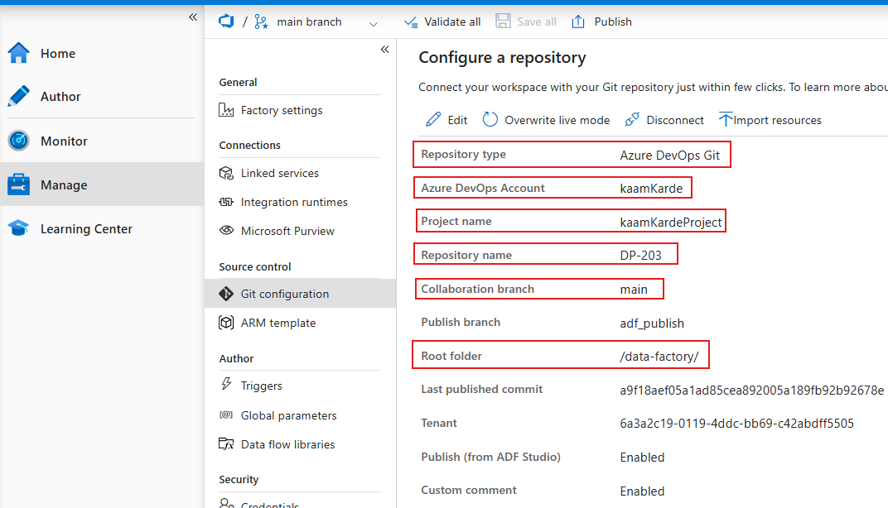

Now to verify is you made this setup correctly, go to Azure DevOps and see if any folder with name “/data-factory/” was created or not

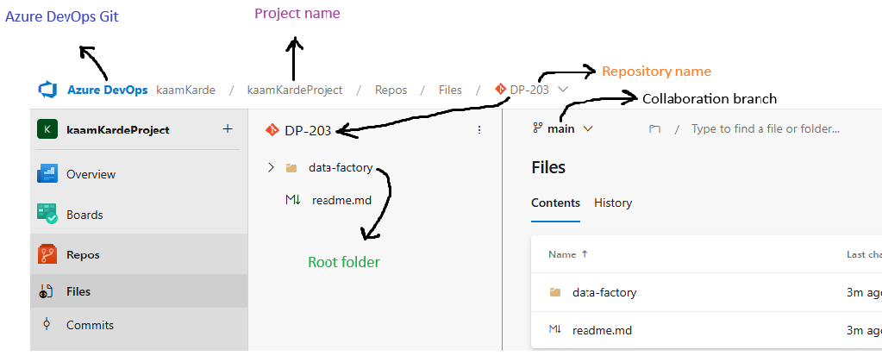

And yes, it indeed got created

Also, inside the folder you should see json definition of your Data Factory

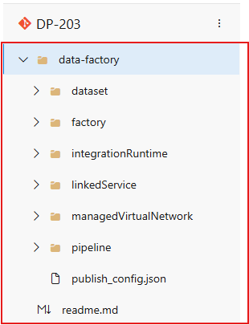 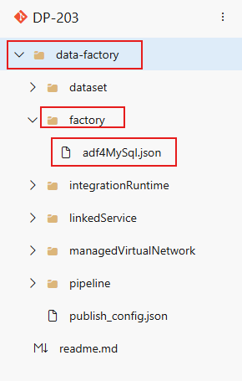

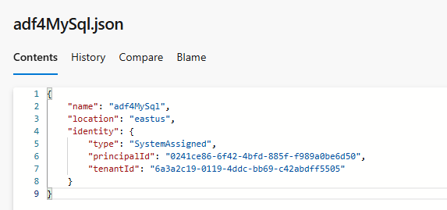

Next step is to make sure to include Global Parameters inside ARM template

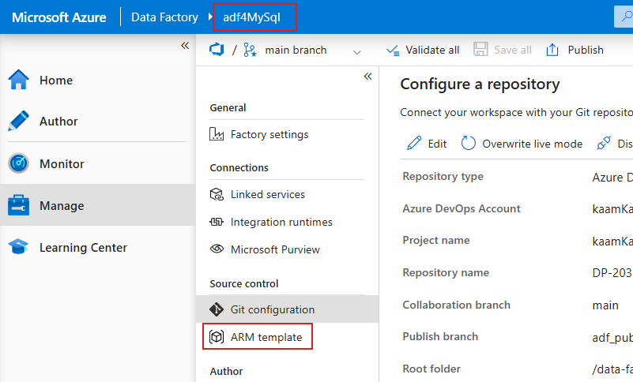

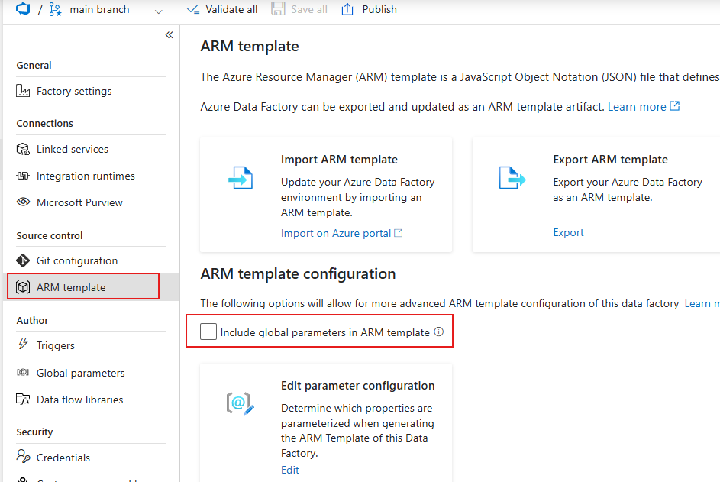

**In Azure DevOps:**

Create a folder **/devops/** and then, in that folder create following files:

* package.json
* adf-build-job.yml

**Go to your repository and click on 3 dots**

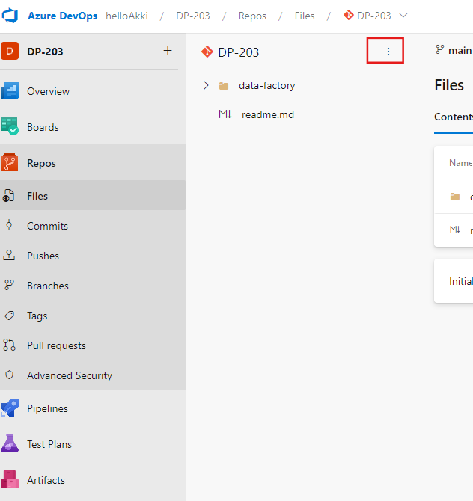

**Create this file, but inside a folder as indicated above**

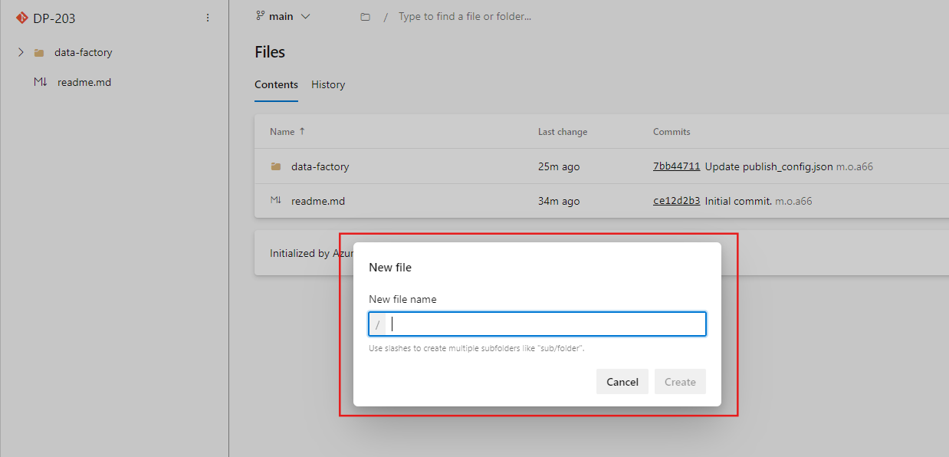

**Provide the folder and name of the file**

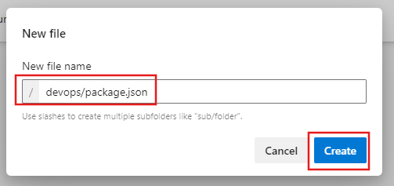

**Paste the json script and hit commit**

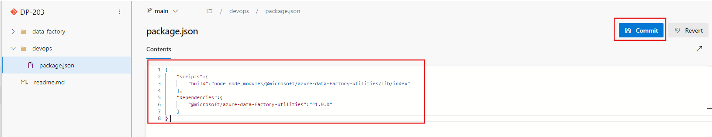

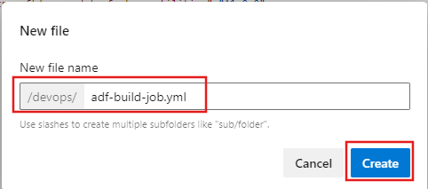**adf-build-job.yml**

**Copy the json script and hit commit**

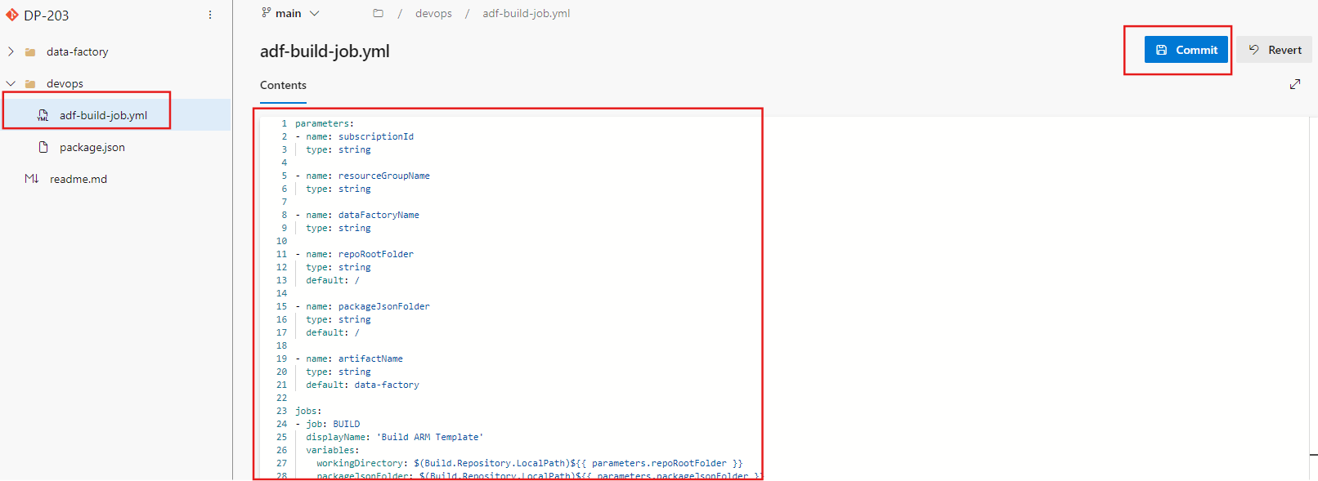

**After this create a script for pipeline(adf-azure-pipeline.yml). This file is the definition of our CICD pipeline**

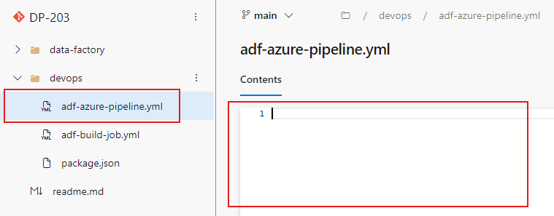

**Now paste the json script**

**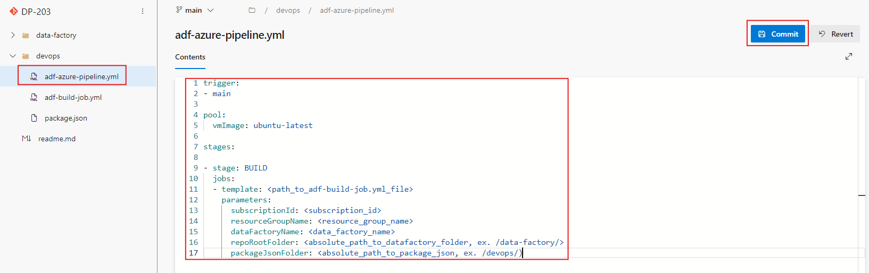  
in the json code replace the template variables provide path to adf-build-job.yml file**

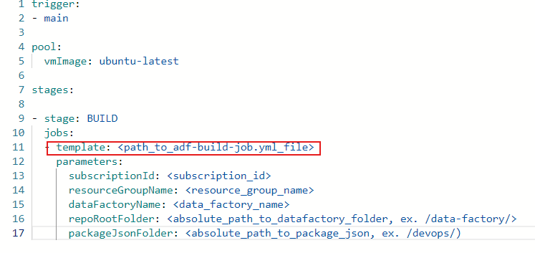

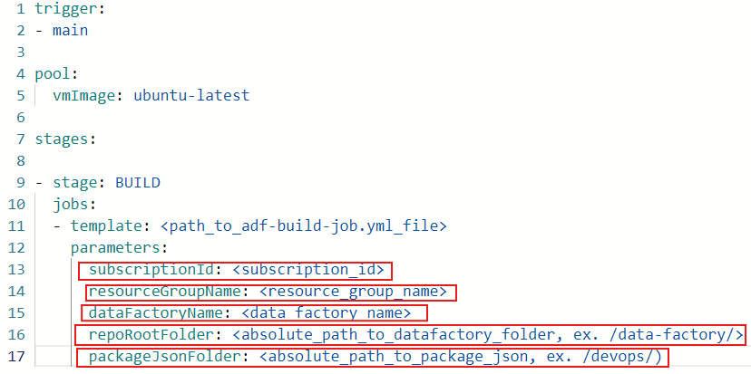

**subscriptionId :** Dev Resources Group ID

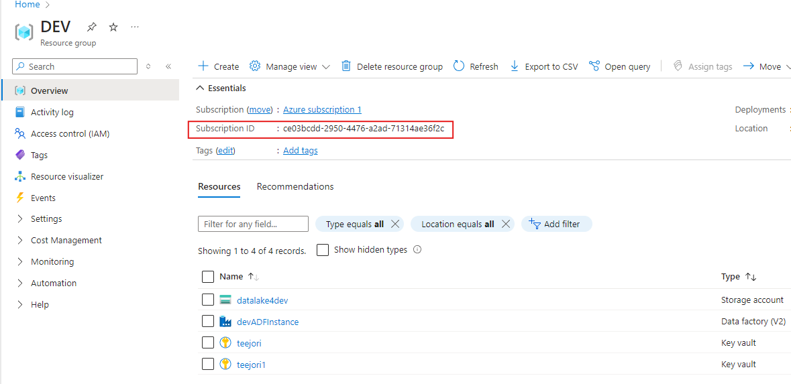

**resourceGroupName:** Resource Group name of Dev Env.

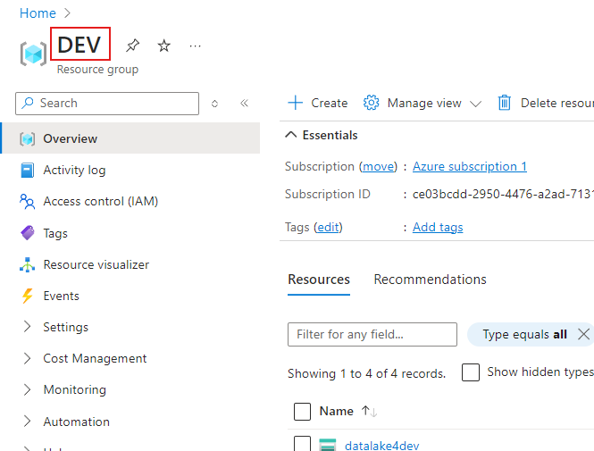

**dataFactoryName:** Dev instance of Data Factory name

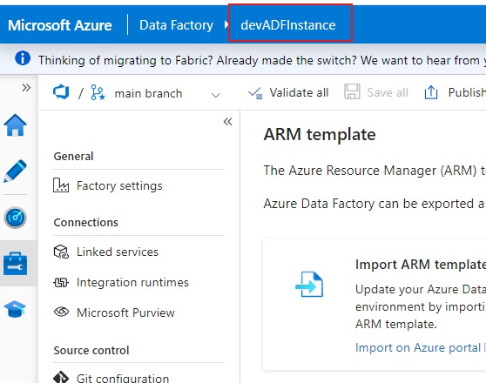

**repoRootFolder:** path to datafactory folder where definition of datafactory is stored

**packageJsonFolder:** path to folder where package.json form is stored

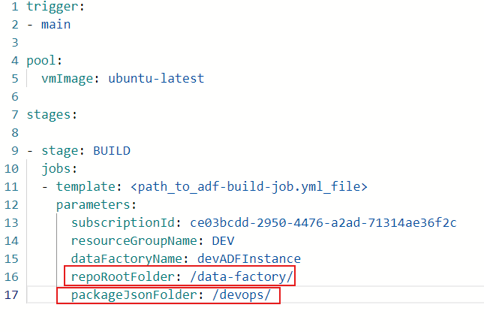

**After this create a Pipeline on Azure DevOps**

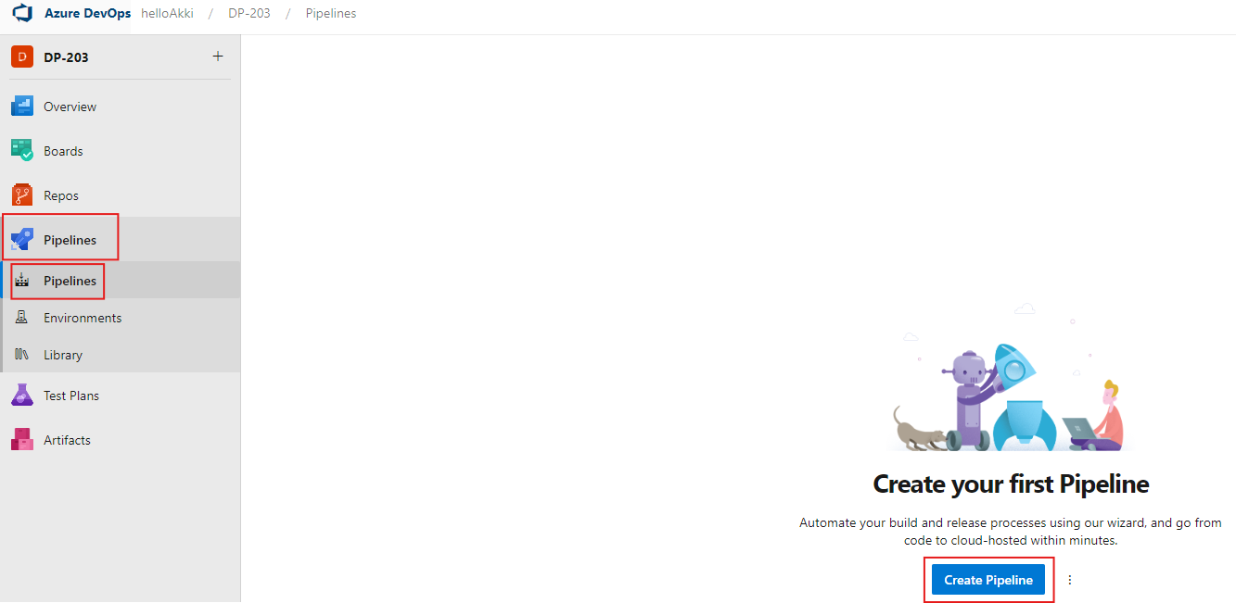

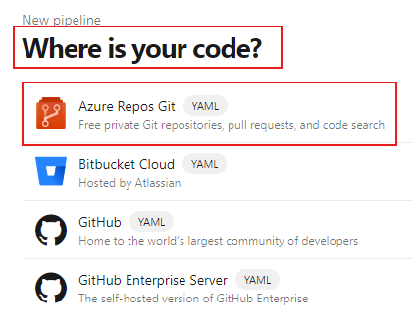

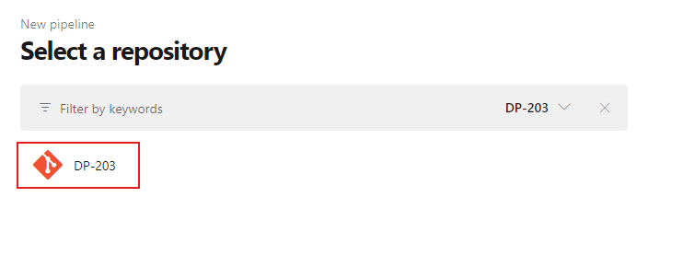

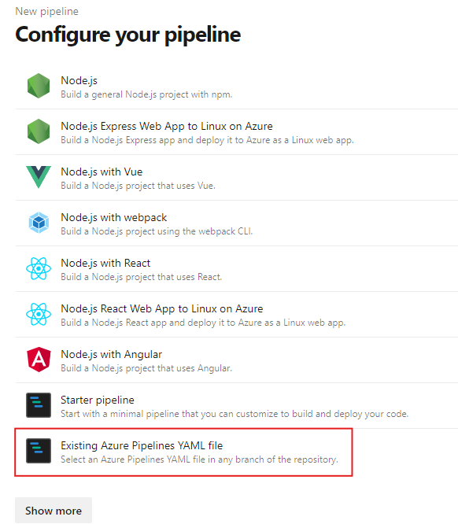

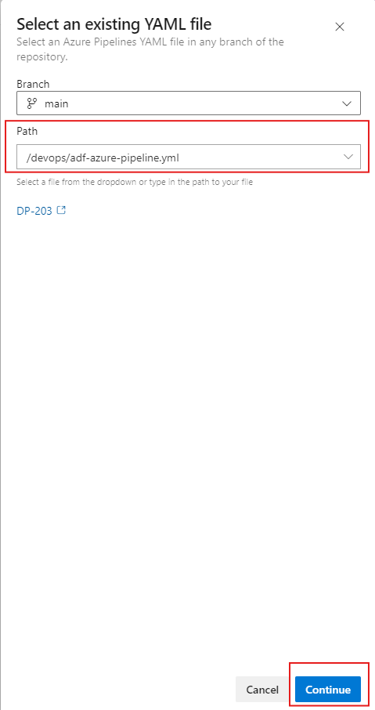

**After this just run the pipeline manually to check if it is building a package**

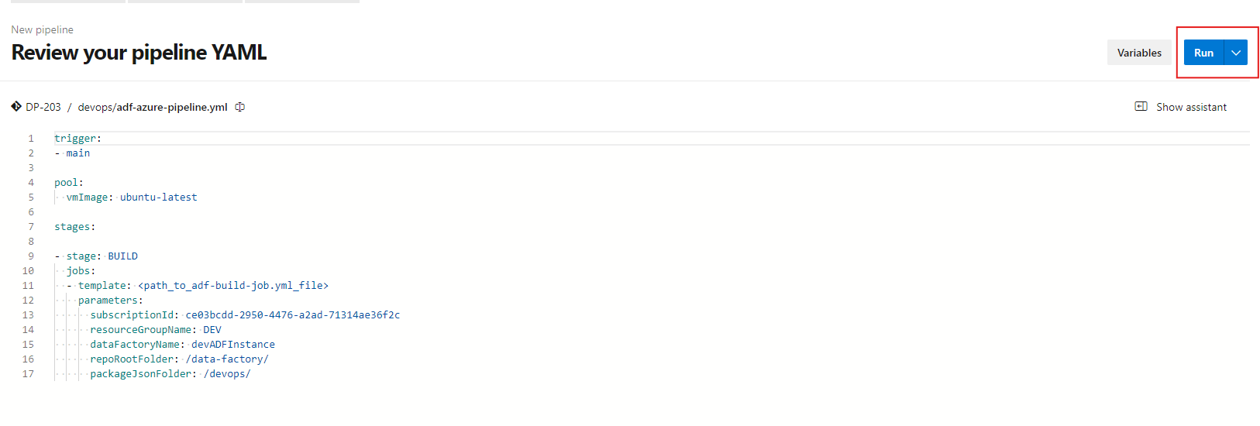

**Azure Databricks** 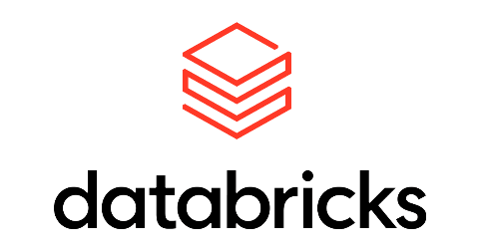

**It is a Data and Analytics platform**

**Use cases:**

* Build enterprise Data Lakehouse
* ETL & Data Engineering jobs
* ML, AI, Data Science
* Data Warehousing, Analytics, BI
* Data Governance and Data Sharing
* Streaming Analytics

**Where does Databricks fits in the BI flow?**

* We have different types of sources viz. files, DB, API etc. and we dump the data into our Data Lake.
* So, the data is ingested into DataLake using tools like ADF, Logic Apps or pipelines in Synapse.
* We also split our data inside DataLake to avoid total mess.
* Once we have data in RAW layer, we want to start transforming our data, apply business rules, handling null/duplicates/anomalies etc. We do that with Databricks.
* Therefore, Databricks read data from RAW layer of DataLake, do some transformation and write data back in DataLake.

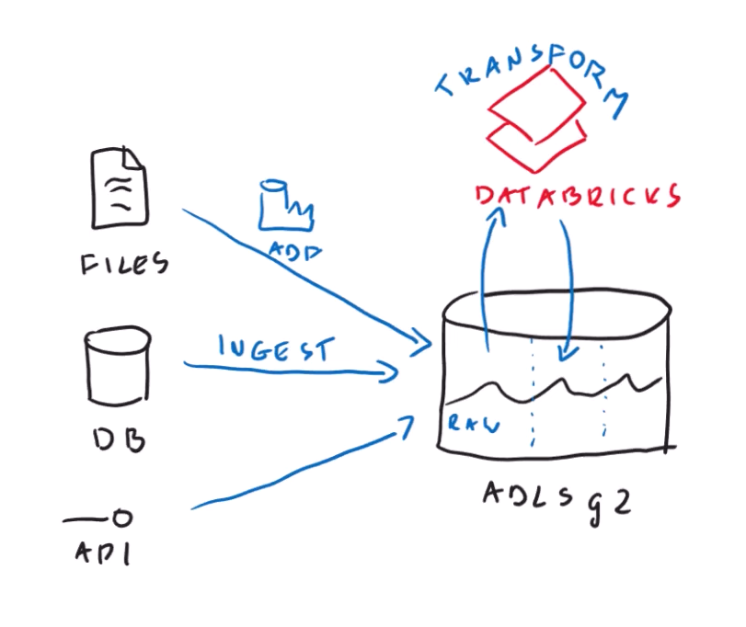

**Why to use Databricks when we were transforming data inside the Database only?**

Earlier, the transformation was happening inside the database itself. So, the storage and compute infrastructure were tightly coupled. And with increase in data volume, the same database was being overloaded and processing was not happening within the desired time range. So, companies started to scale up, moved their database to powerful serves that can do their job. But scaling up is quite costly.

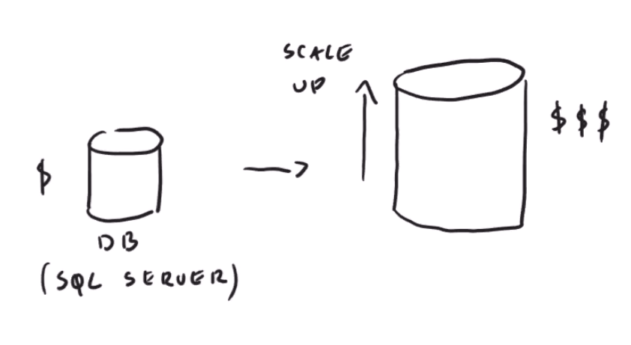

* So, a time reached where we could not scale up our resources further because it was not practically, physically and economically possible.
* So, a solution was developed where instead of scaling up, we did scale out, where task was distributed among several worker nodes.
* Since each worker node was getting small portion of the whole work, it should be faster and cheaper.

**Illustration of Spark Architecture**

* Because Databricks was developed on top of Apache Spark, so its architecture is important to look at.
* Distribution of work happens automatically.
* Instead of scaling up single machine we scaled out.

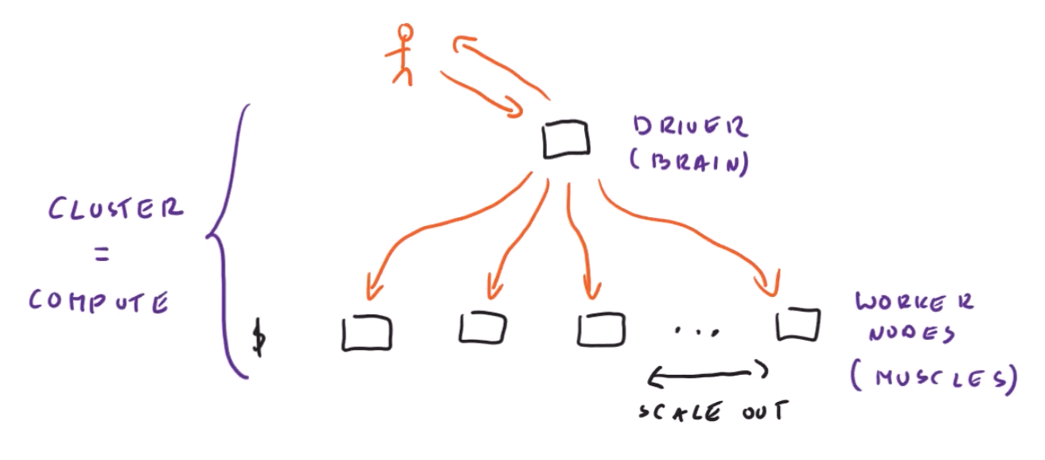

* In Spark we have separation of compute from storage.

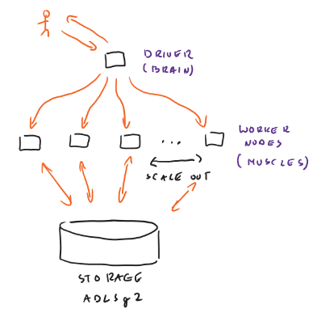

**Provisioning Azure Databricks**

* Select Databricks
* Create a Workspace

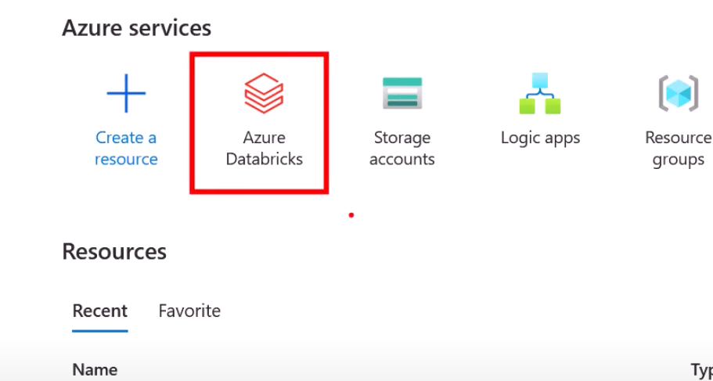 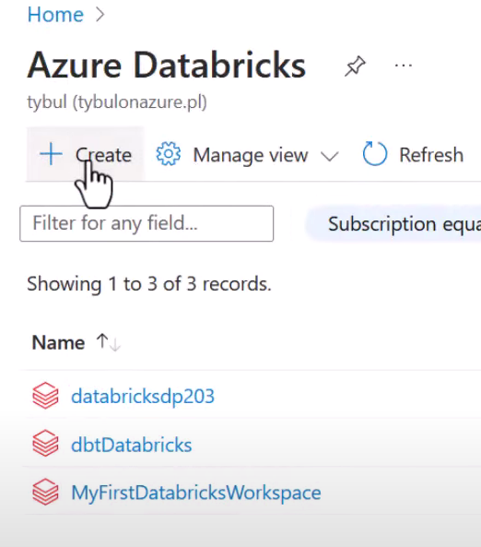

**Fill appropriate fields**

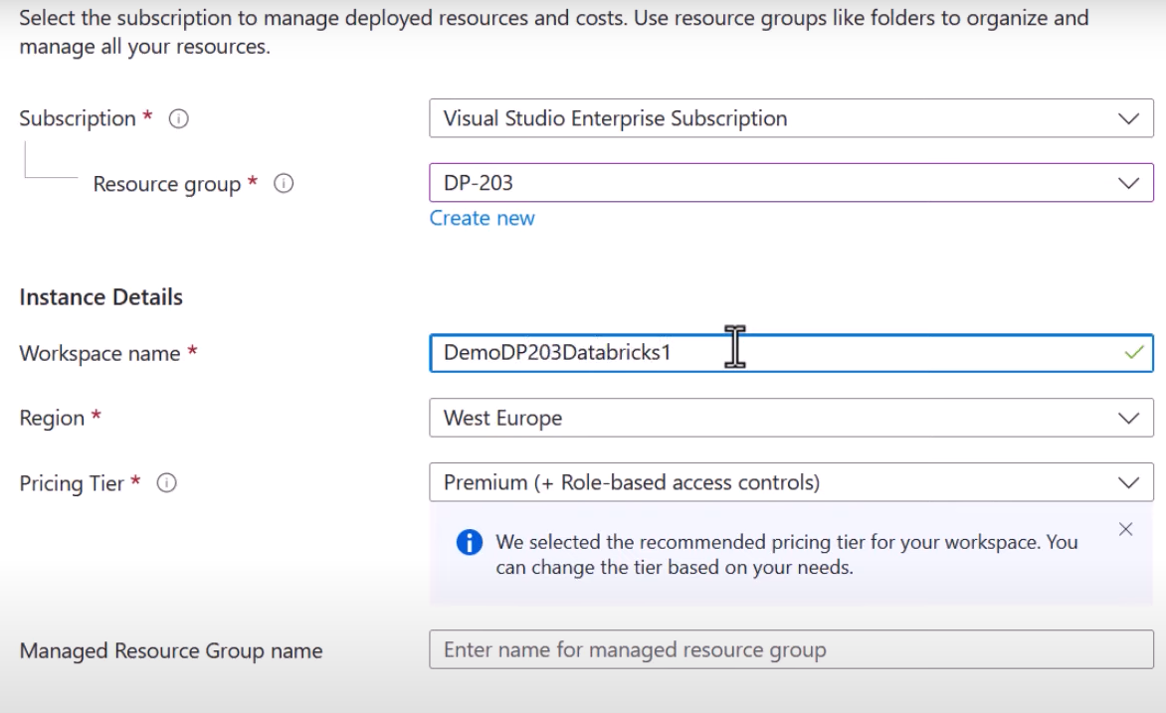

**Pricing Options**

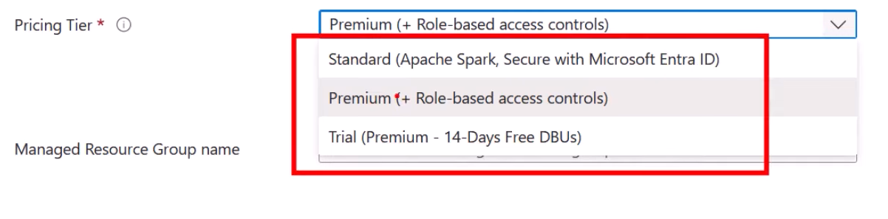

**Then create your workspace with default settings for now**

**Go to Resources Launch Workspace**

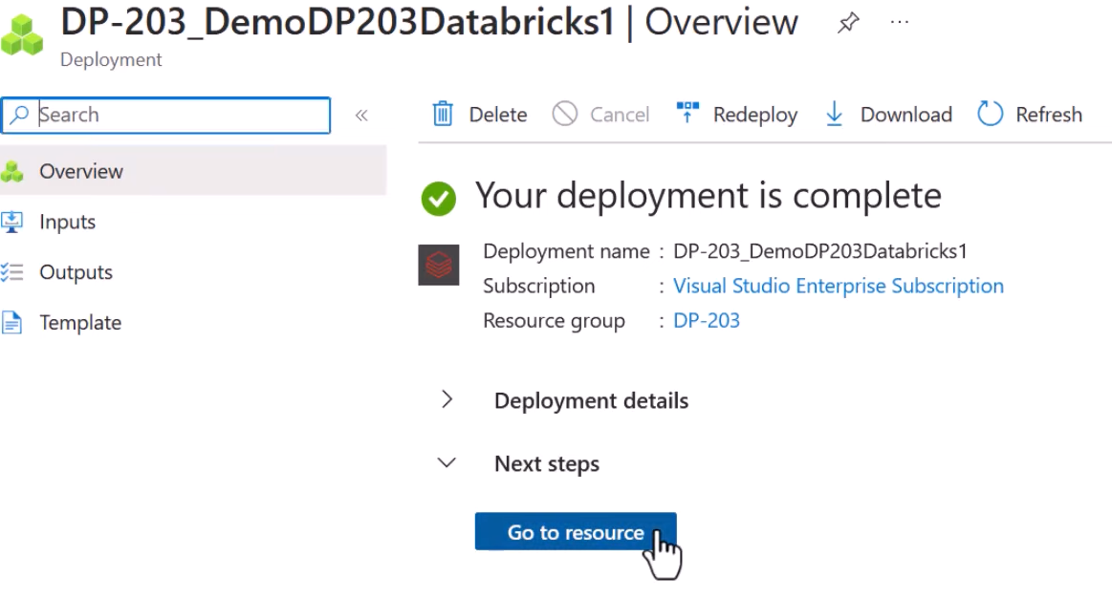 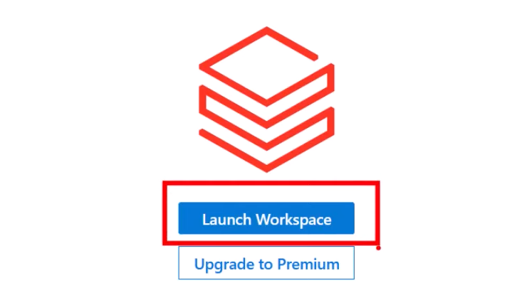

**Databricks UI**

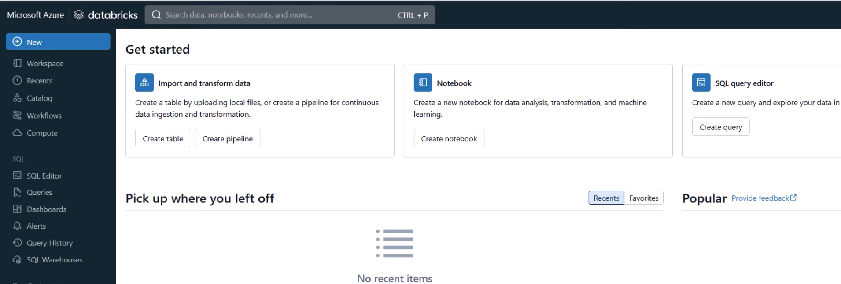

**How to create a cluster?**  
Go to Compute

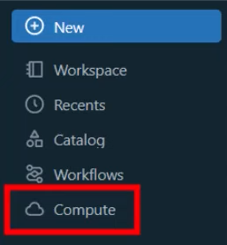

Then top right corner hit “Create compute”

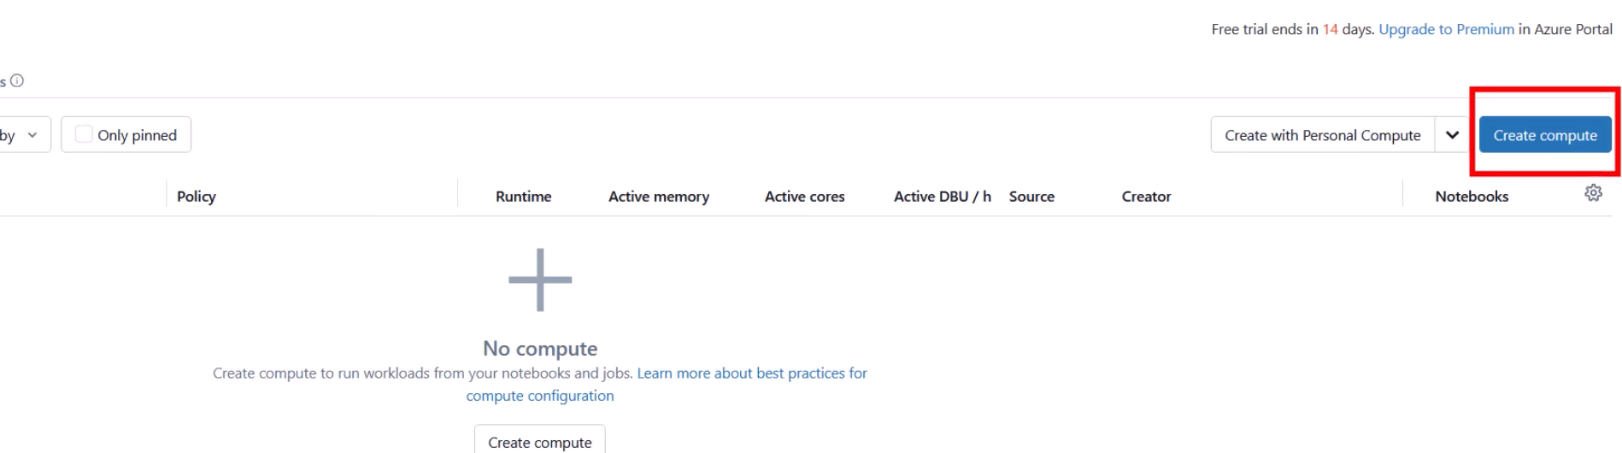

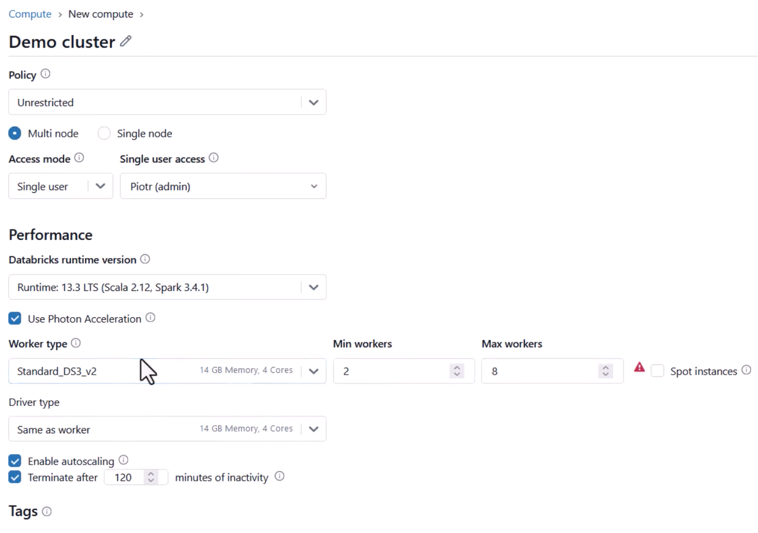

Name of Cluster

* **Policy** - you can set policy which say how many nodes a user can deploy
* **Multi-Node/Single-Node** - with Multi Node you will see options including Worker type, min worker, max worker but this is not the case for Single Node. In single node setting UI will look something like this:

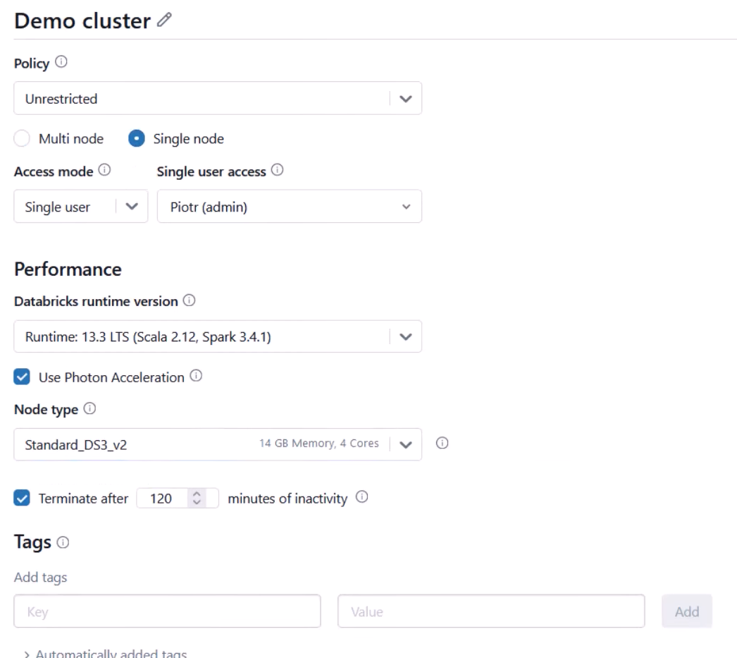

**Node type** = it is talking about the driver node

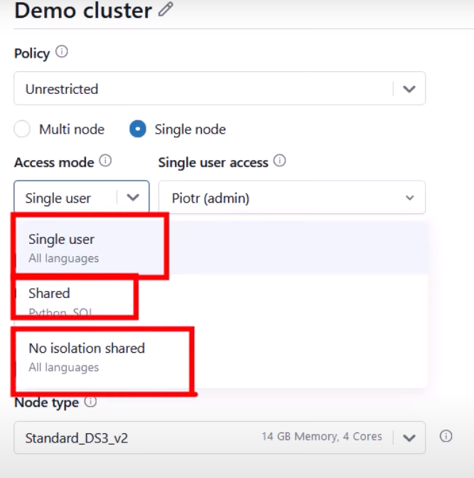

**Cluster Access Mode**

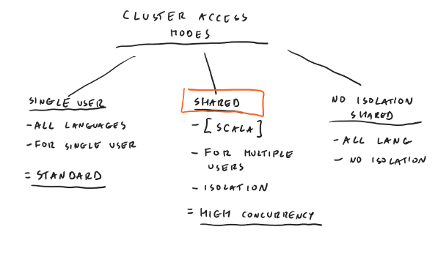

**Performance**

Which S/W version of Databricks you want to use? Select from there

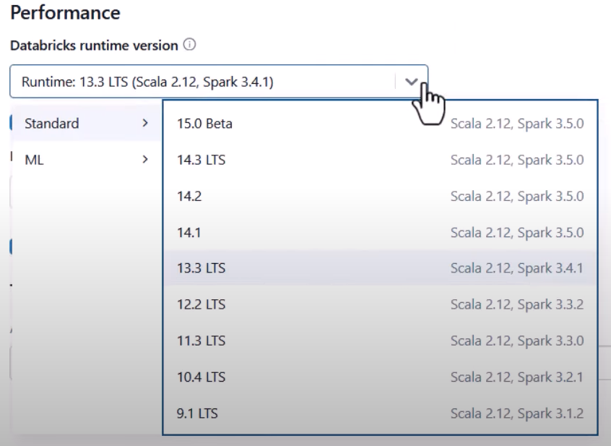

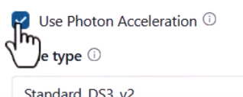

this makes your workloads run faster

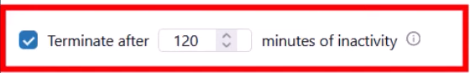

When you want to shutdown your cluster after being used

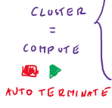

After all settings are done hit Create to create your cluster.

**Spot instances in case of multi-node cluster**

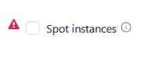

Depending on customers who ask for VMs Microsoft must be prepared upfront to address their request and deploy those VMs. So, they must have some free VMs. But somehow Microsoft pays for those VMs. So, Microsoft offers those free VMs in cheaper price in that orange area. But suppose in case of high demand, Microsoft would obviously address first to their regular customers so you will be kicked out and those VMs will be taken away from you and will be handed over to the regular customers.

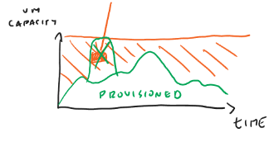

But Databricks say your spot instances will be replaced by a regular VM. So, spot instances mean VMs in that orange area.

This is ok in dev env.

**Creating a Notebook**

New 🡺Notebook

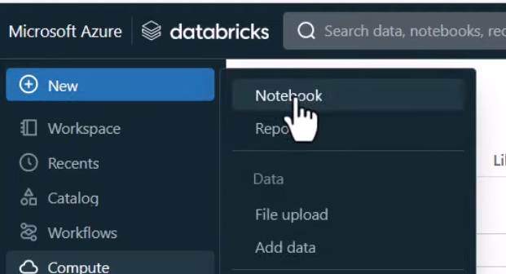

Multiple cells in notebook

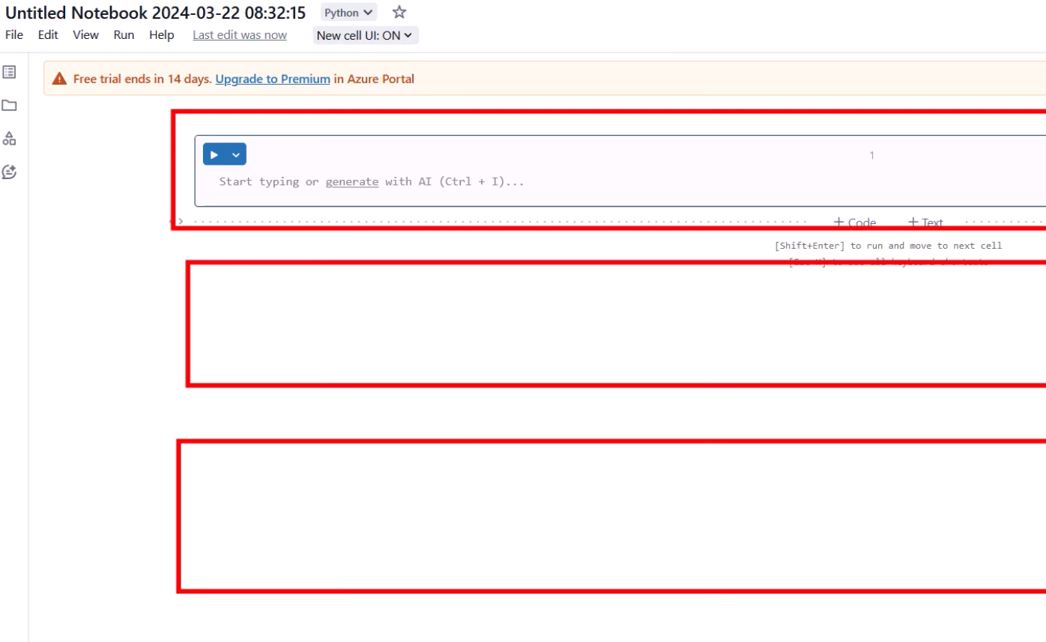

**Languages supported**

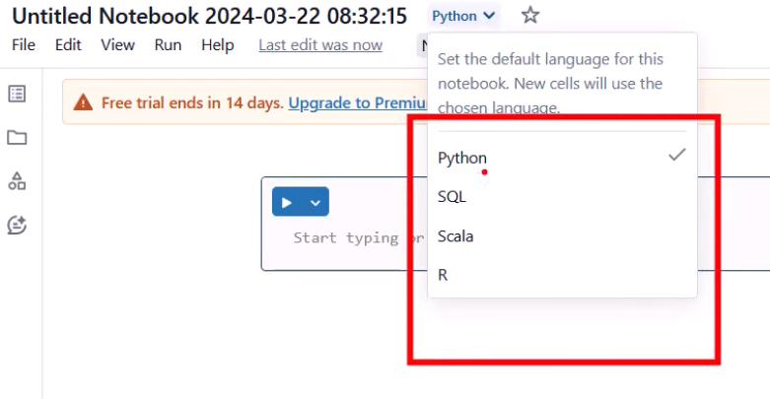

**WE WILL IMPLEMENT THIS**

Read the data from DataLake by establishing connection and then save it back to the same DataLake in delta format.

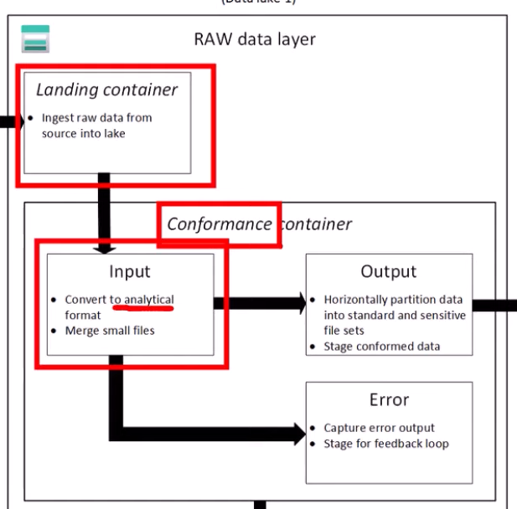

**Connecting Databricks to DataLake**

[**https://learn.microsoft.com/en-us/azure/databricks/introduction/**](https://learn.microsoft.com/en-us/azure/databricks/introduction/)

[**https://learn.microsoft.com/en-us/azure/databricks/connect/storage/azure-storage**](https://learn.microsoft.com/en-us/azure/databricks/connect/storage/azure-storage)

**Using Account Keys:**  Fastest and Worst method

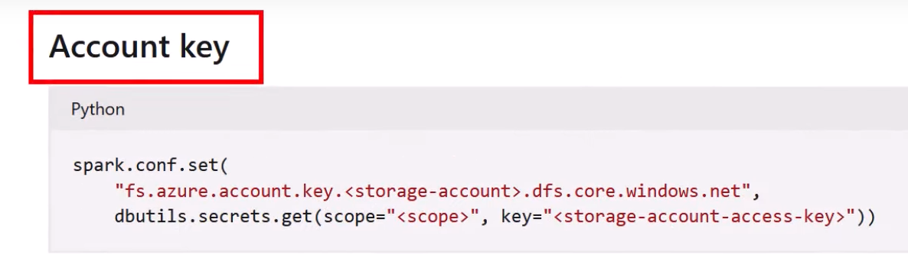

Copy it

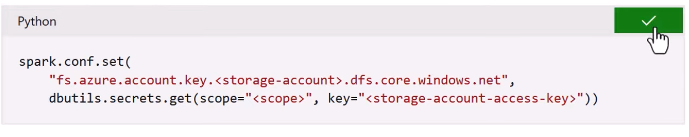

Configure the component of the code:

<storage-account> 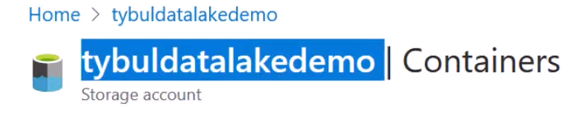

Grab the Access keys from the Storage Account and paste it inside the notebook

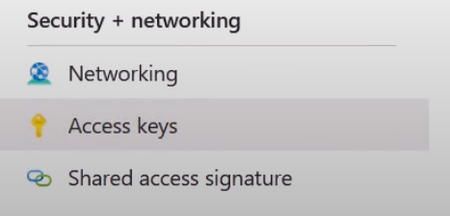

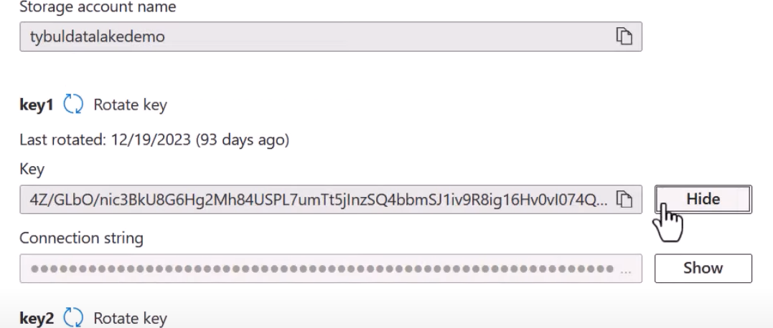



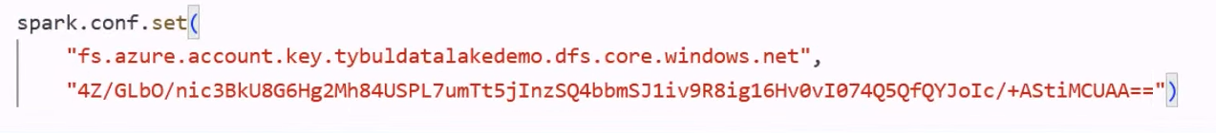



Execute the cell

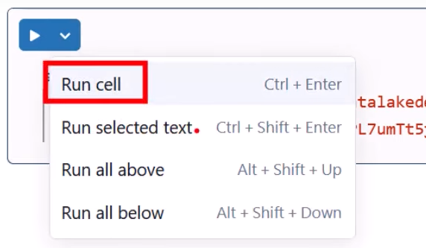

Make sure the notebook is attached your cluster

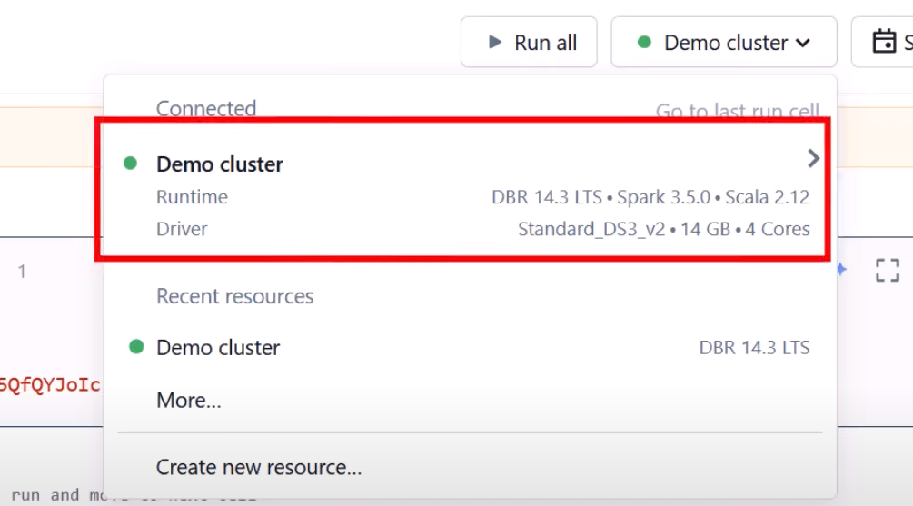

So far connection is being established

**To grab the data**

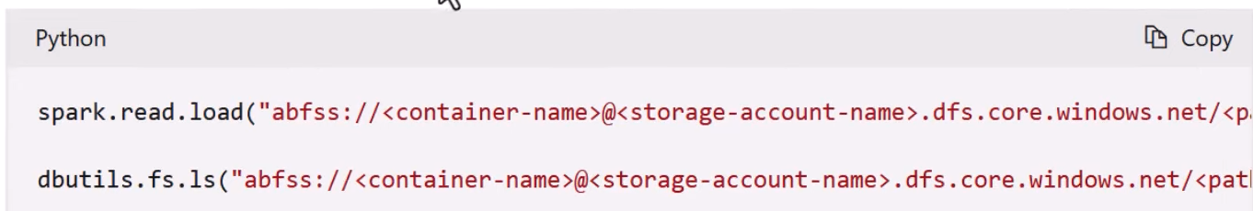

* Provide path your data
* Storage-account-name
* Container-name

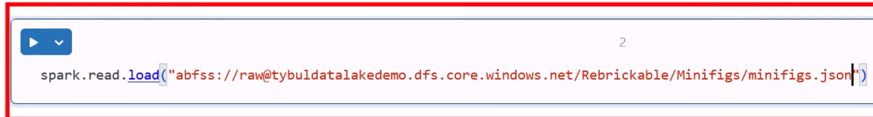

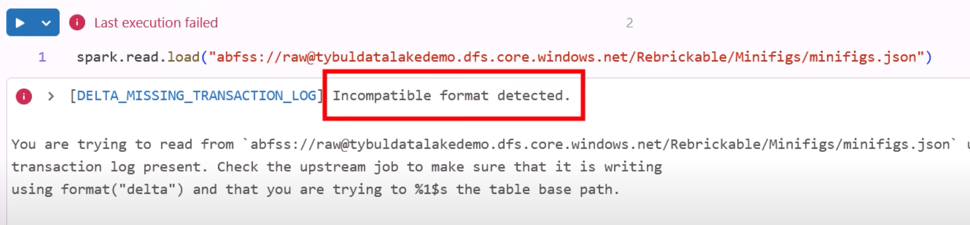

Because Databricks by default supports Delta Lake format. So, tell the Databricks explicitly that the data is in json format

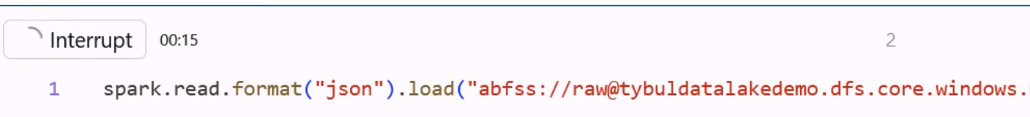

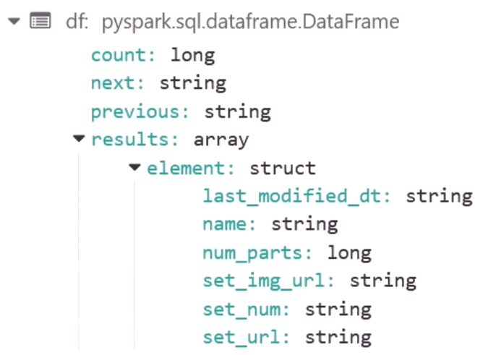

Saving data back to DataLake as Delta



Create a new container to save data

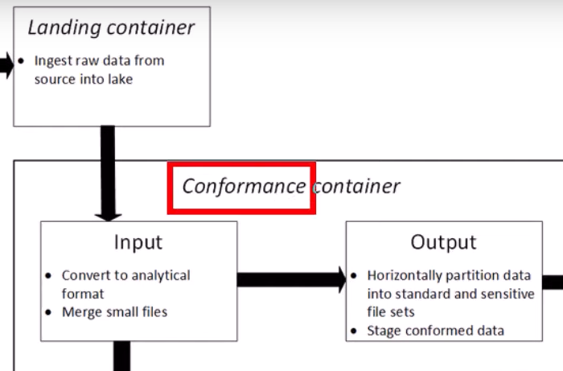

Create the conformed container manually inside DataLake

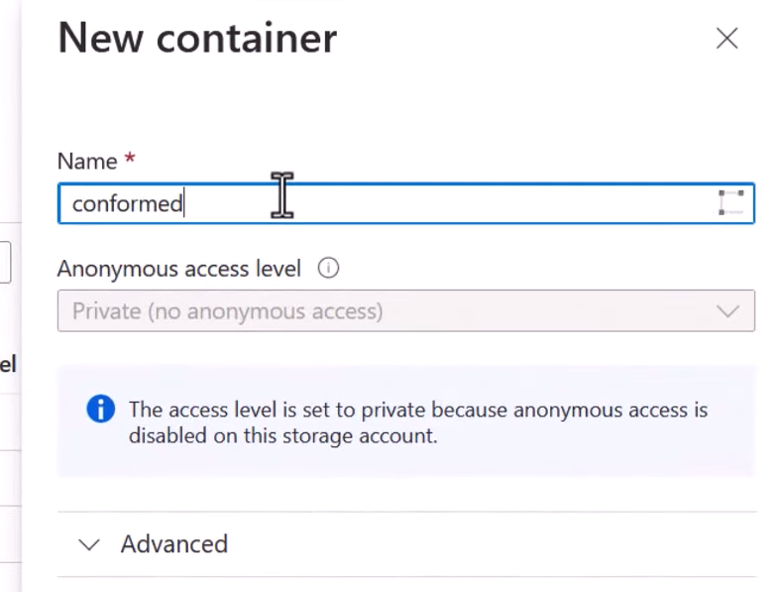



**Lecture 32**

**Pin Cluster**

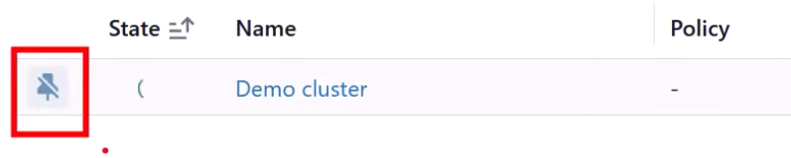

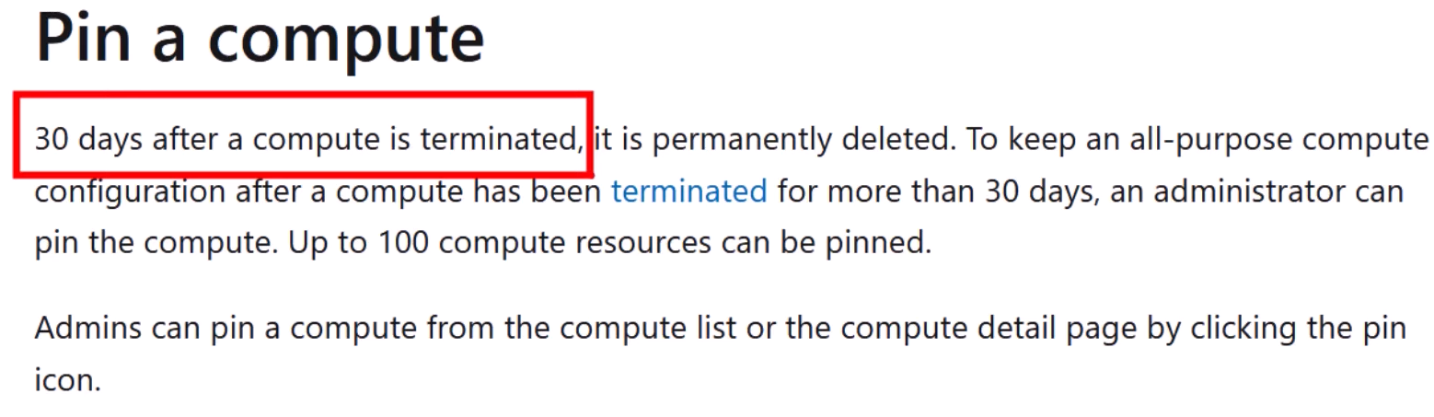

**Multiple Cluster**

* You can create different cluster whose configuration can be different, whose work will be different depending on workload. And then its up to you on which cluster you want to create your notebook.
* If a cluster is terminated or stopped, you will not pay for it.

Workspace Menu

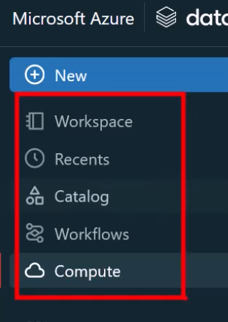

Workspace

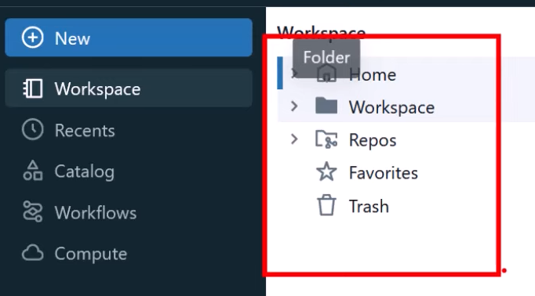

You can organize your notebooks in some logical order

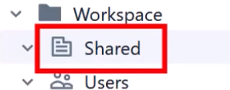

* Shared: accessible to everyone
* Users:

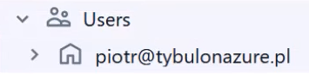

If you would like to organise your notebooks in some folder

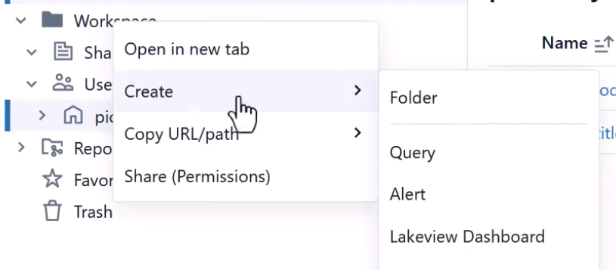

Create a new folder

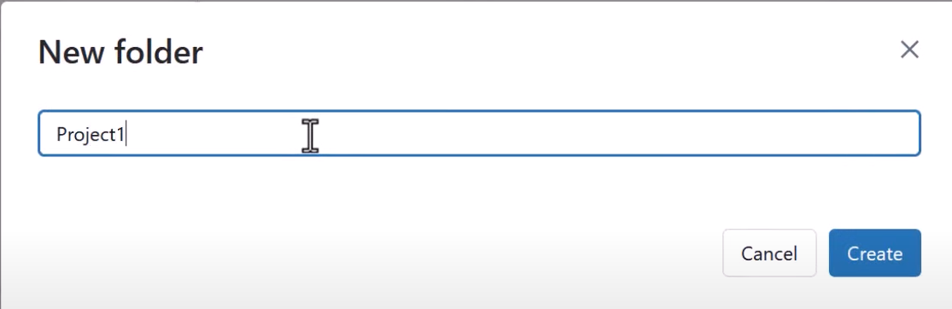

Inside the project create a notebook

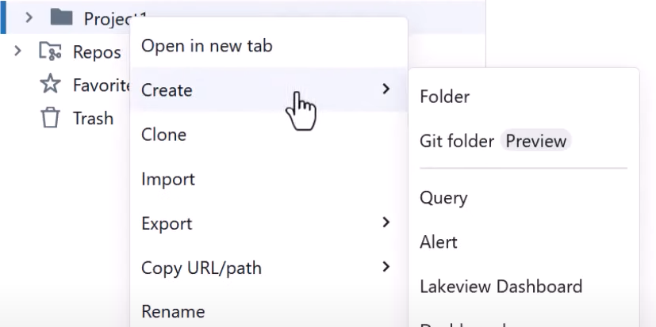 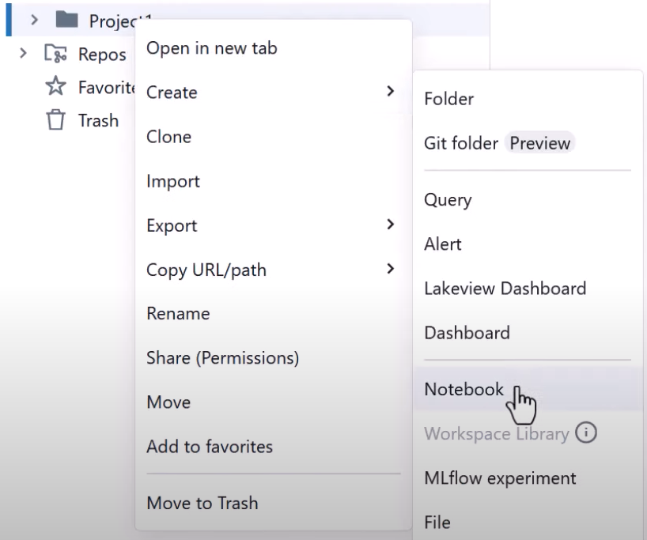

So, after the creation under workspace, under Project you will see your notebook

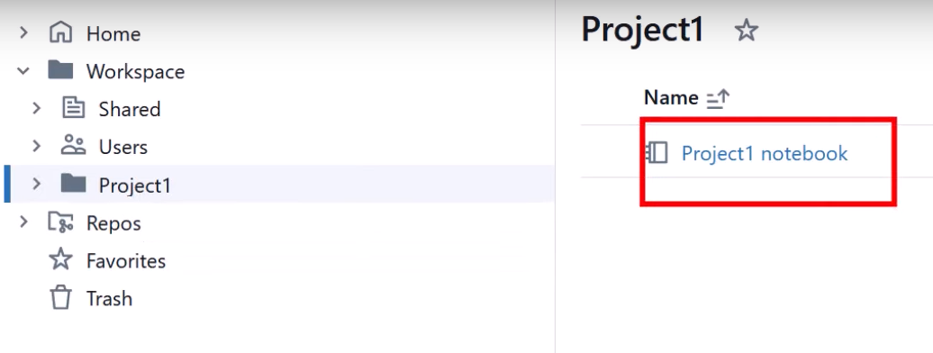

Then you can set permissions by right click on the Project Folder like who should have access to this Project Folder and content inside it

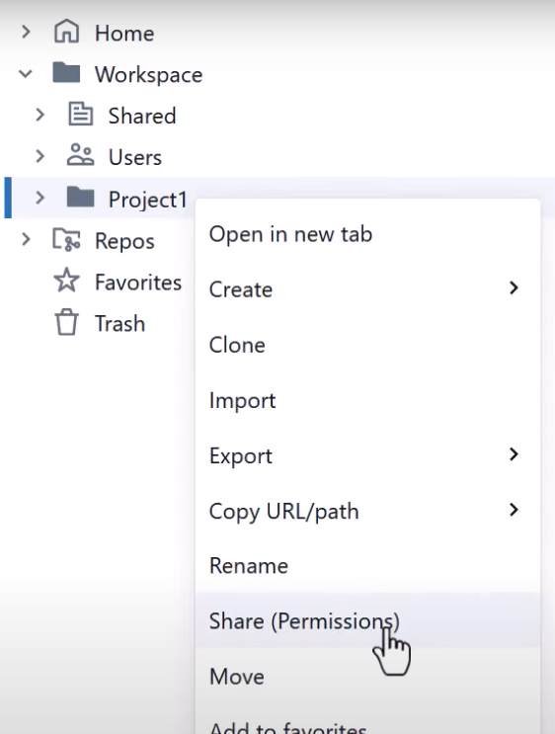

Apart from this all the users will have their own workspace

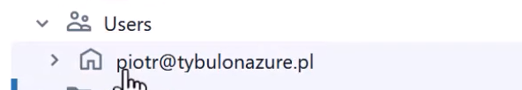

So, you can also create folders, notebooks within your workspace

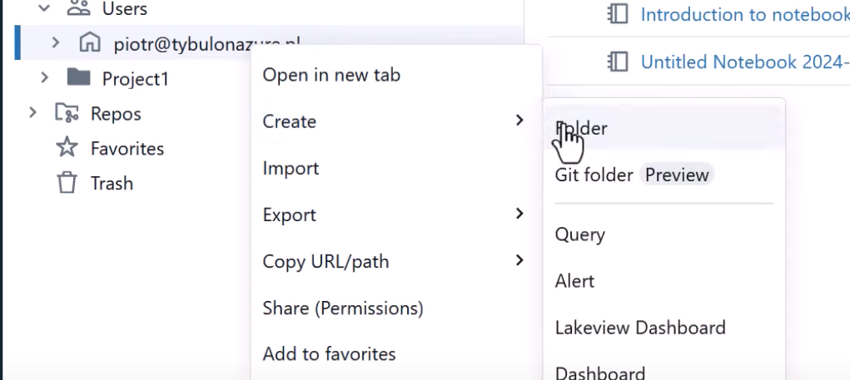

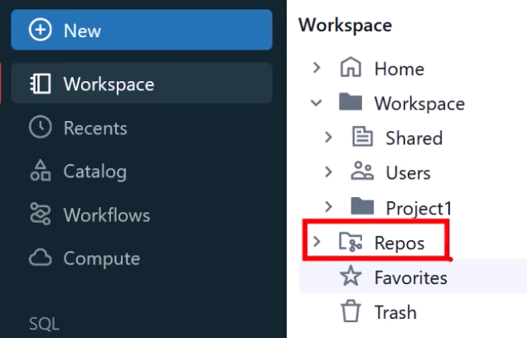

If you want to version control your notebooks

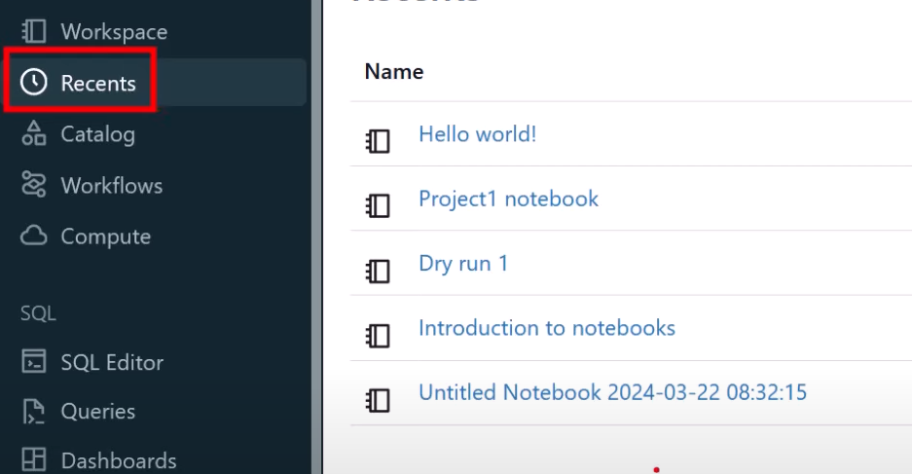

Recent will have the notebooks who have been working recently

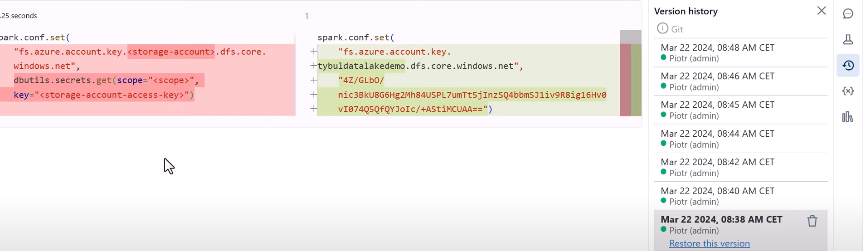



You can see every change made to your notebook from there

Databricks Utilities

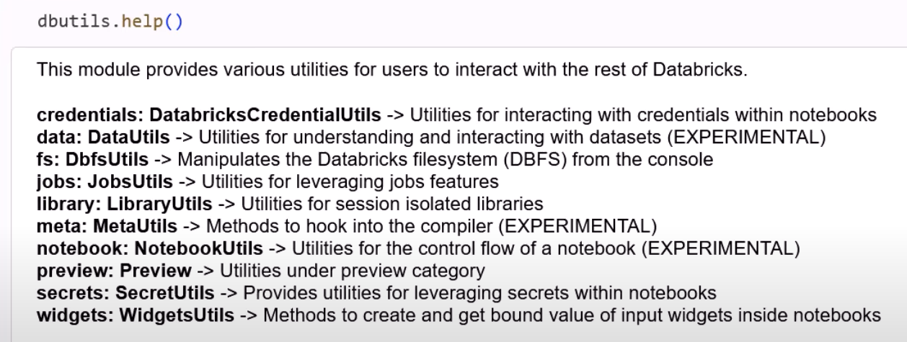

**Most commonly used**



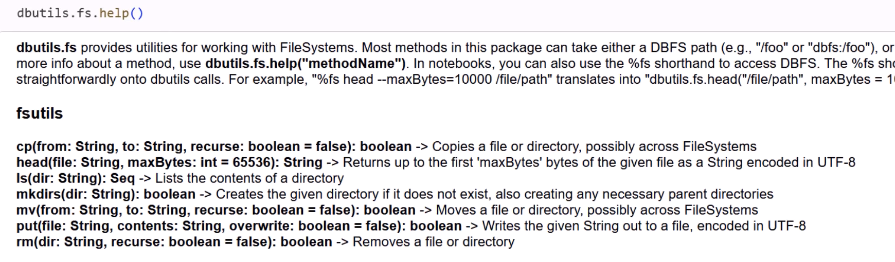

**Sample Datasets**

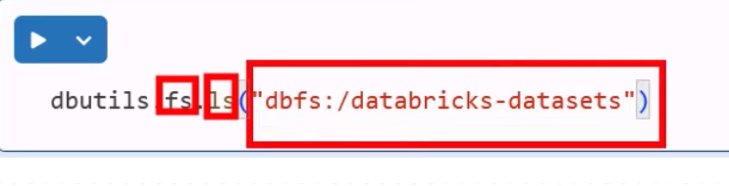

**Reading some of those datasets** 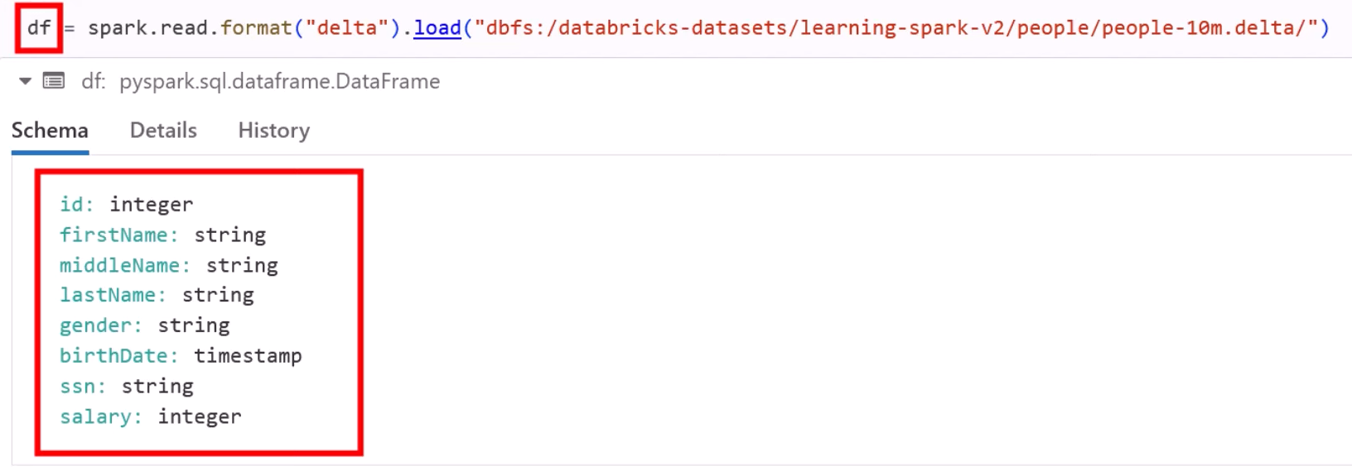

**But the thing is where all those sample datasets coming from?**

Databricks managed RG

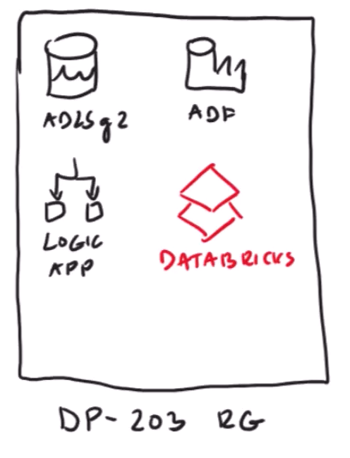

While provisioning Databricks workspace we must indicate some RG inside which Databricks workspace would be located. Maybe that RG will be consisting of many resources like ADF, logic apps. ADLSg2 etc.

But if you go in Azure portal

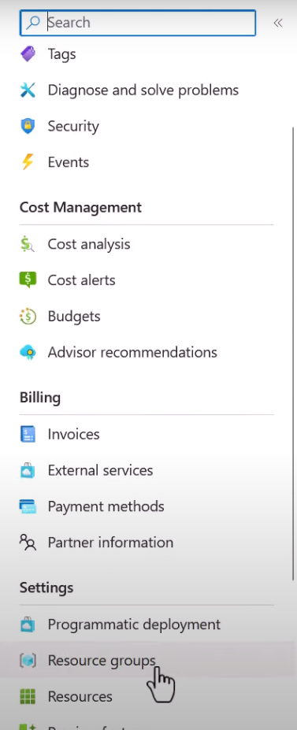

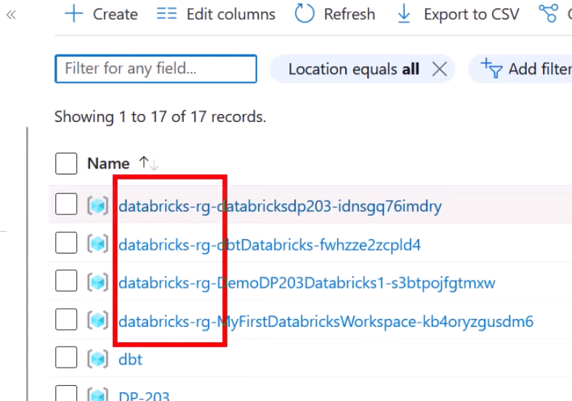

You will see some RG begins with Databricks name. Which means that workspace in Databricks is also creating Secondary RG which will create many resources.

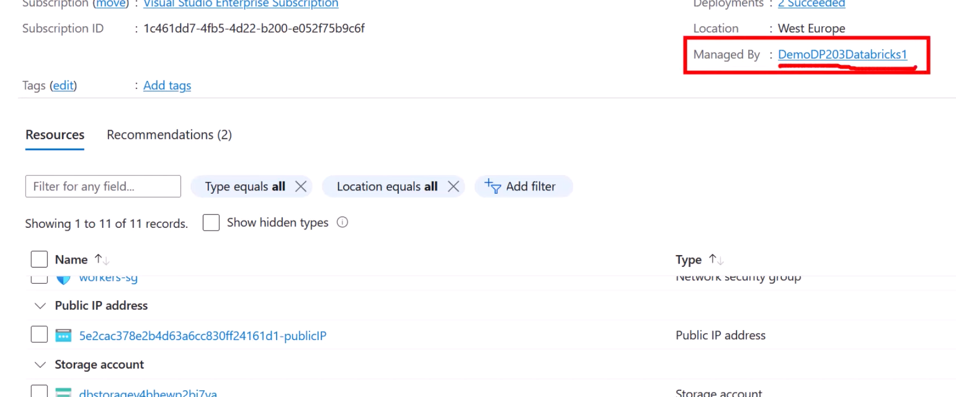

If you go inside that Storage Account which is managed by Databricks

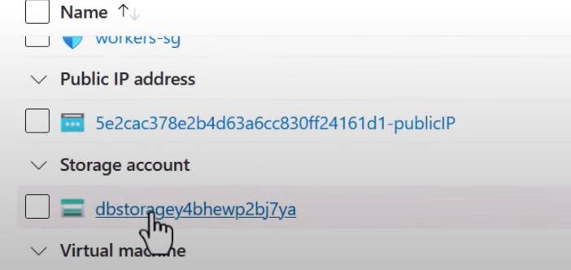

Indeed a DataLake

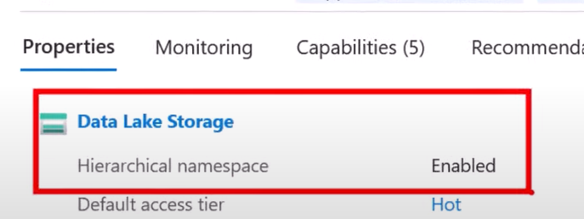

Inside the containers

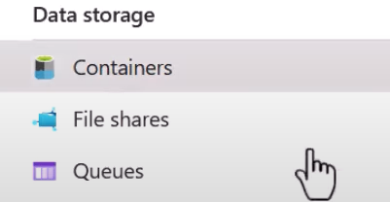

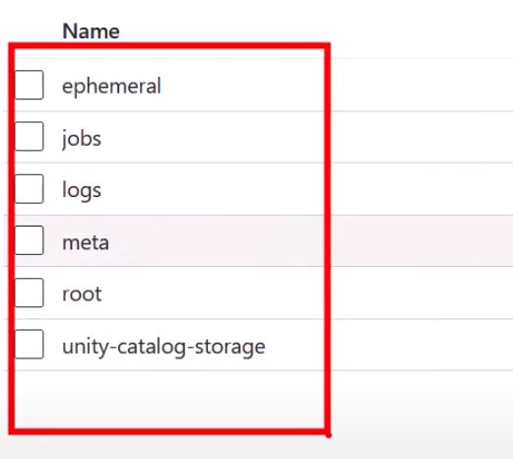

You will see some containers

If you go inside any one of those containers

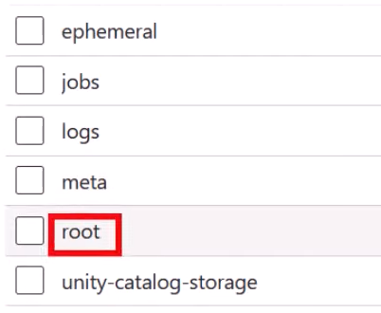

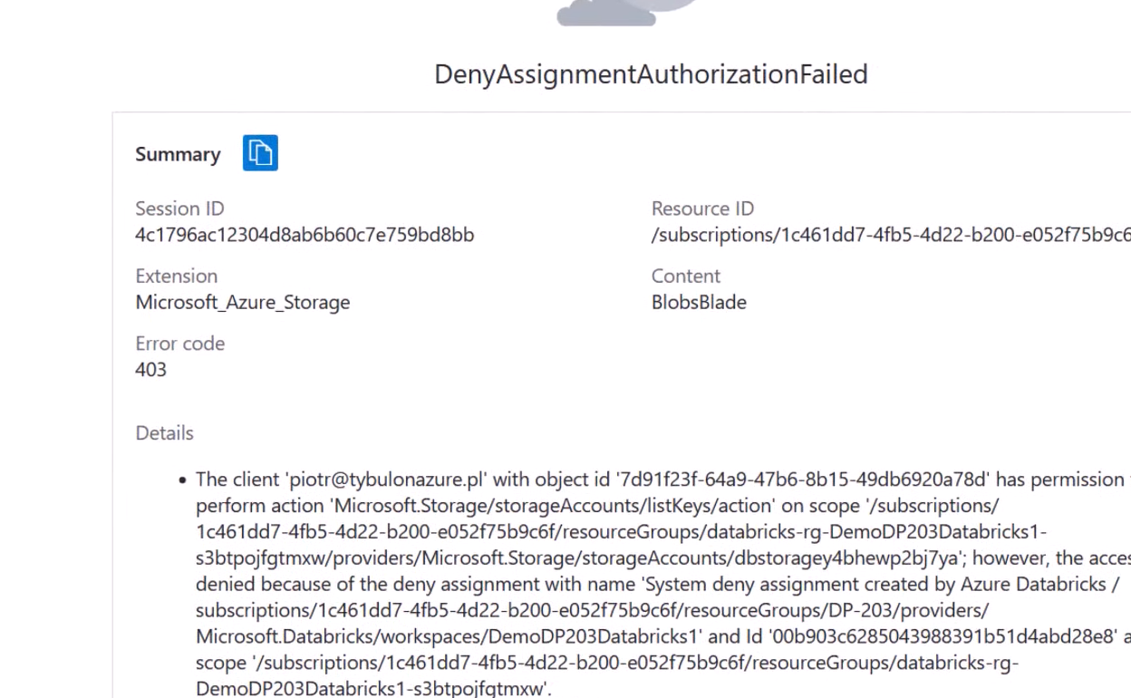

You will see an error like this. You cannot see what is inside. Because this RG is given to the Databricks’ workspace to deploy all the resources like VMs , networking stuff, interface cards etc. Also, all those sample datasets are coming from that Storage Account container(from root specifically).

**Loading CSV data from Storage Account to Databricks**

**Establish connection with Storage Account**

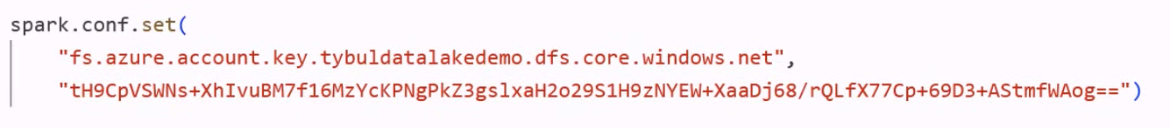

Go to Data Lake and grab primary endpoints

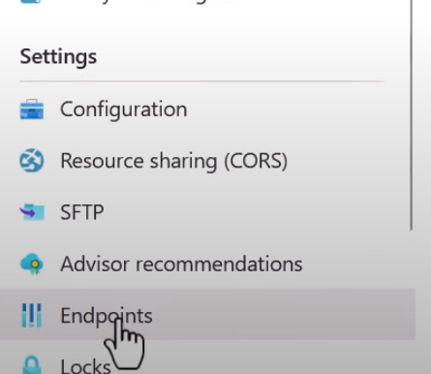

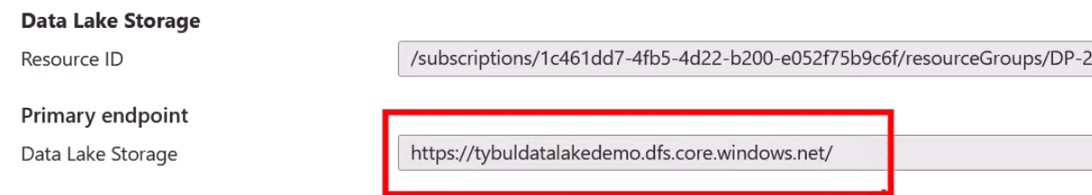

Paste it

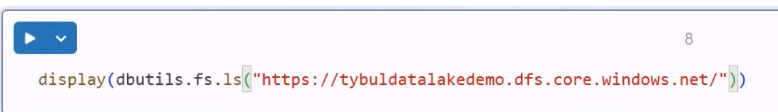

Change the protocol and indicate which container you want to use

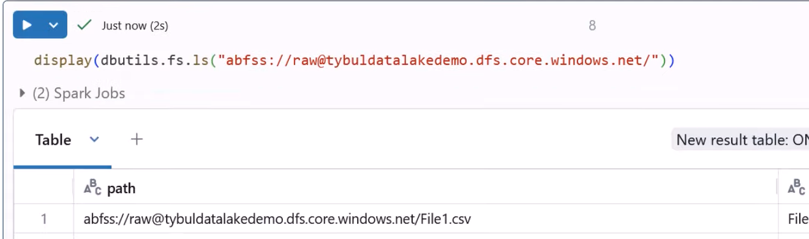

This *dbutils* will display content of your Data Lake

Now to read the content of CSV file

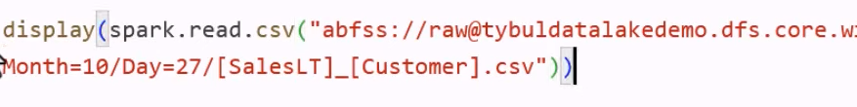

You will see this error

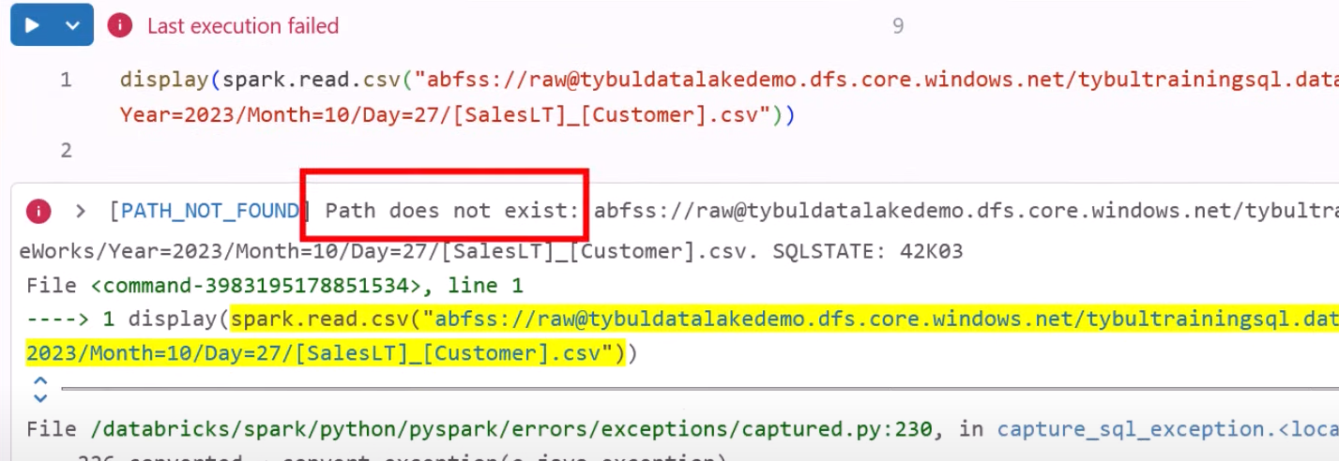

Issue is you used square brackets. So, escape them

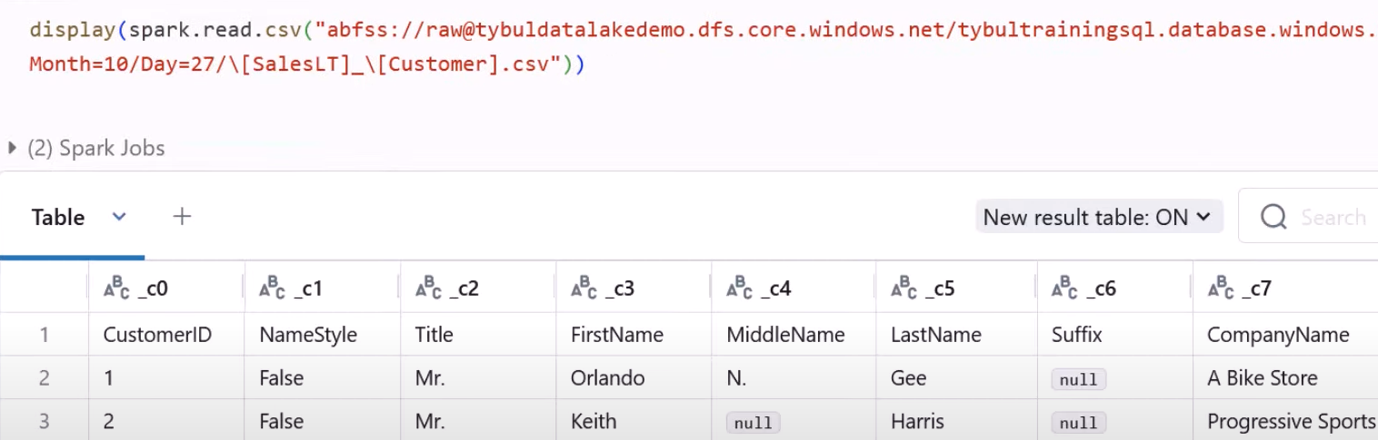

Problem

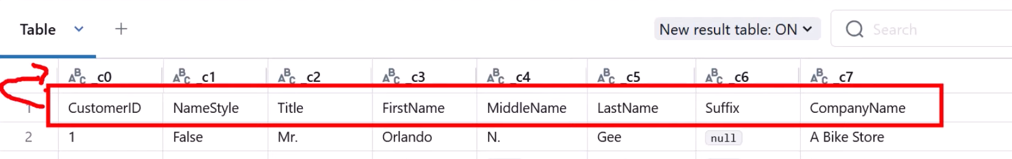

Solution

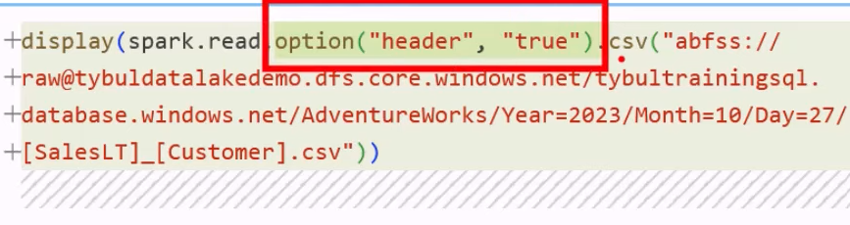

Verify the schema of csv

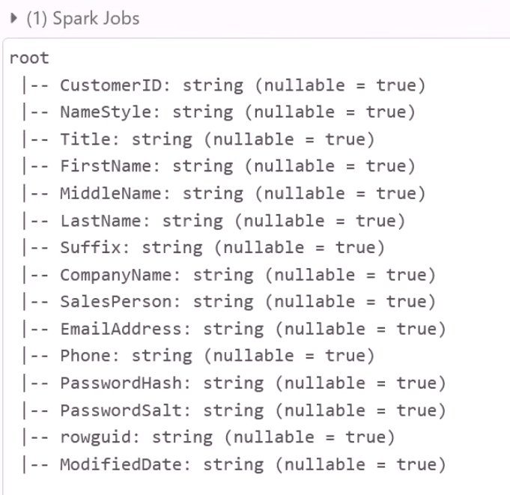

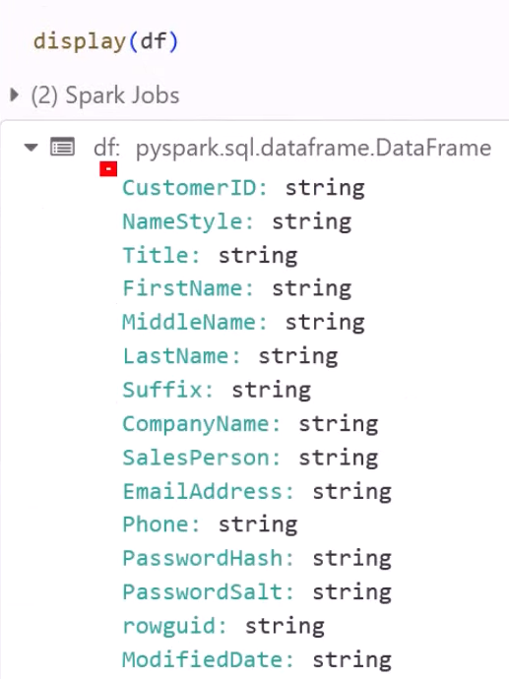

To define schema explicitly

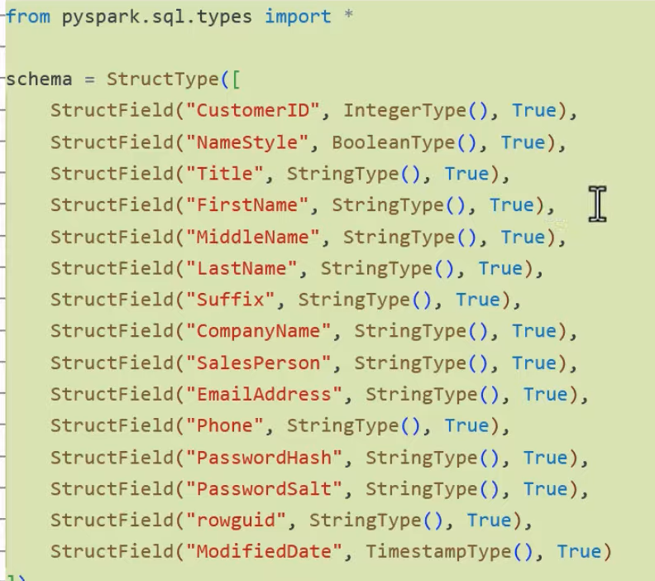

Loading CSV using SQL

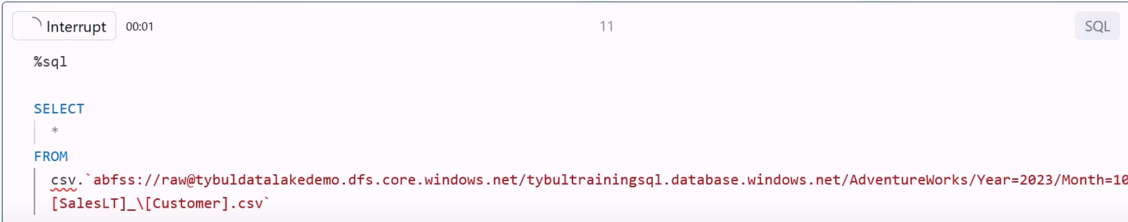

Exchanging Data between languages

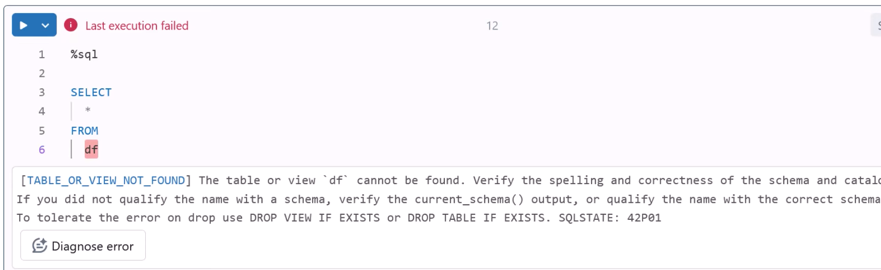

This will fail

So, you have to register the dataframe as a table first

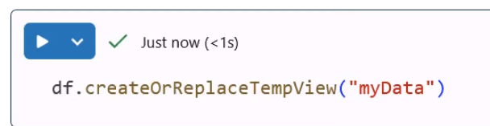

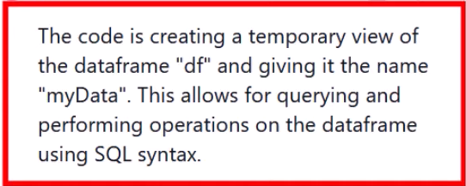

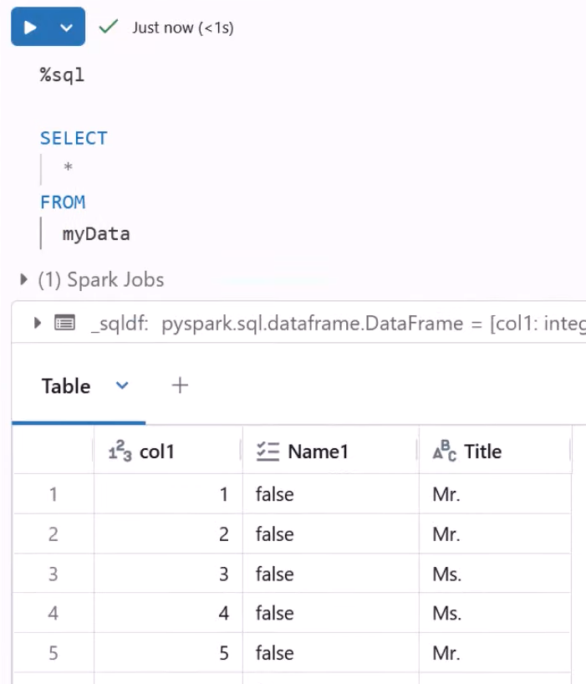

**SQL to Python**



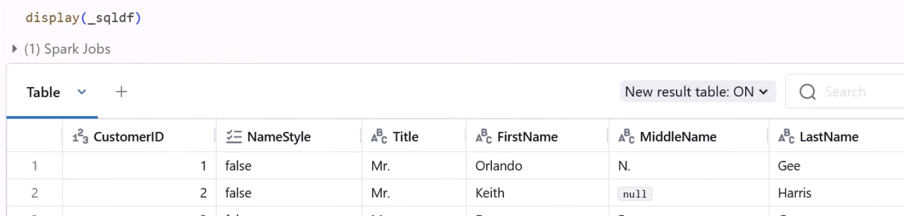

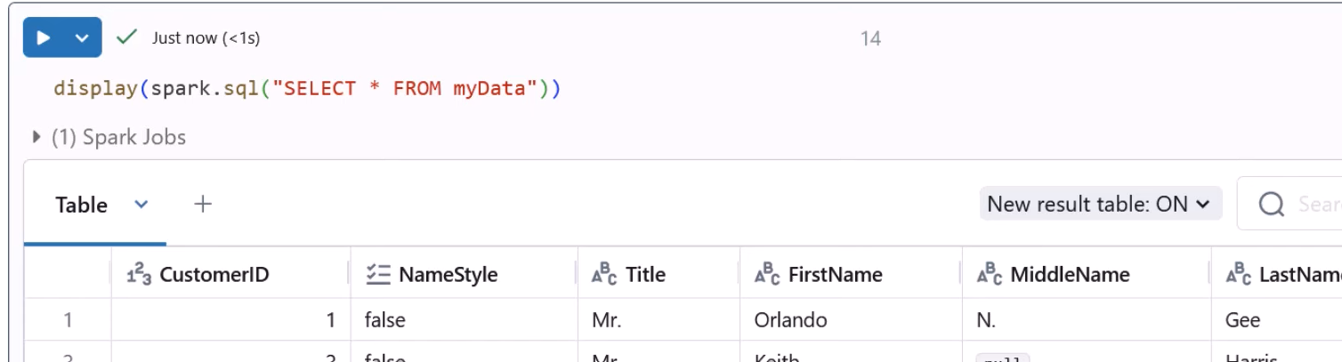

**Transformations:**

Suppose you want to group the rows by last name

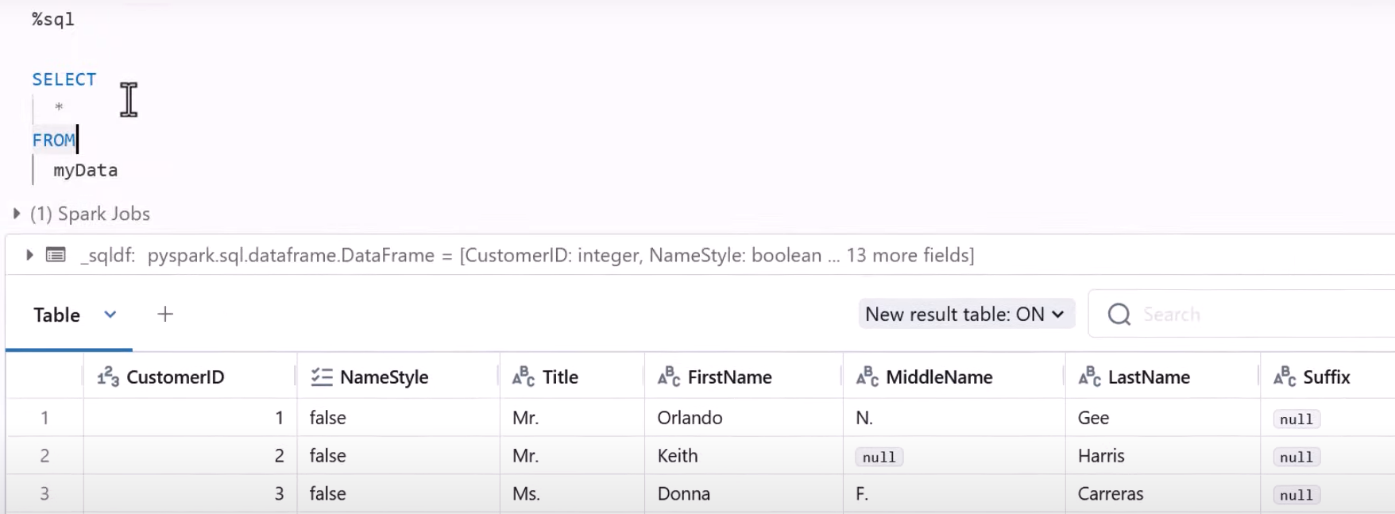

First 10 rows:

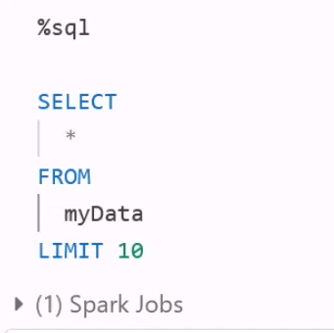 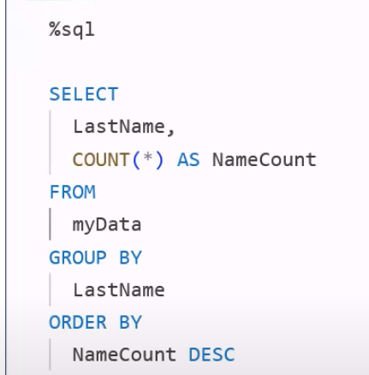

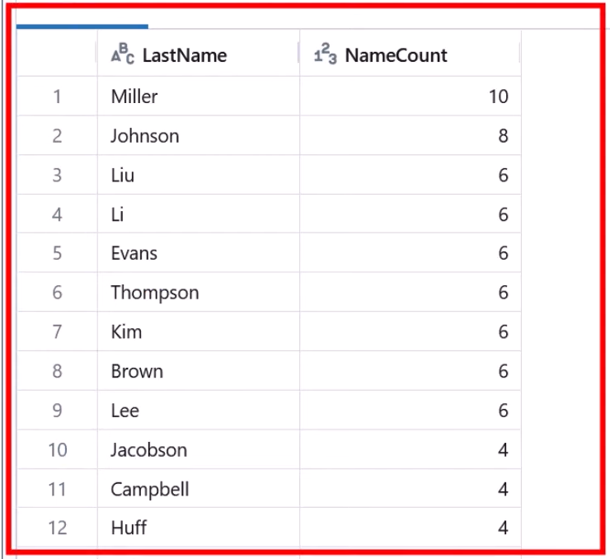

**Lecture 33**

**Connecting to ADLSg2**

1. **Unity Catalog**

Databricks is promoting this method. They think it is best for data governance.

1. **Legacy Method**

**other methods that were existing prior to existence of Unity Catalog**

1. ***Access via Account Key***

just a string that give full access to a Storage Account(DataLake).

1. ***Access via Service Principal***

Simply an account explicitly created in Azure that you can later use to grant some permissions.

You will create a Service Principal, and grant it access to DataLake. For this you can either use RBAC or ACL

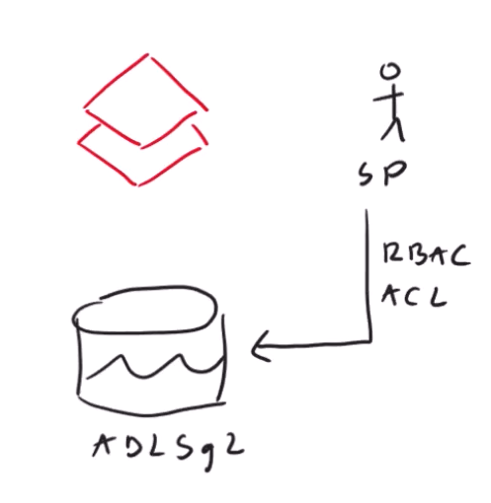

**Go to Azure Portal -> Microsoft Entra ID**

Inside the Microsoft Entra ID you can create Service Principles

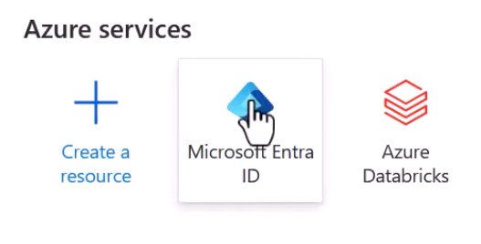

**Go to App Registration**

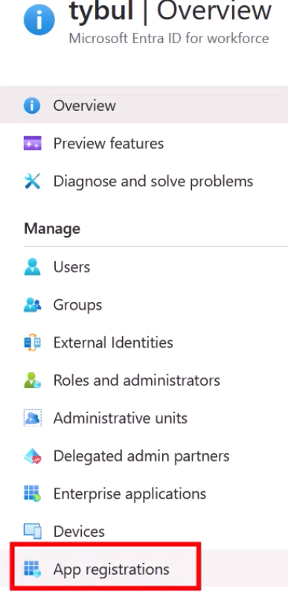

**Then click “New registration”**

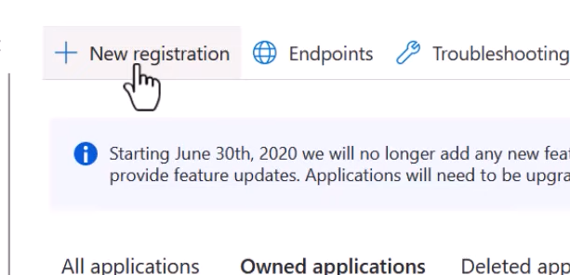

**Give name to it**

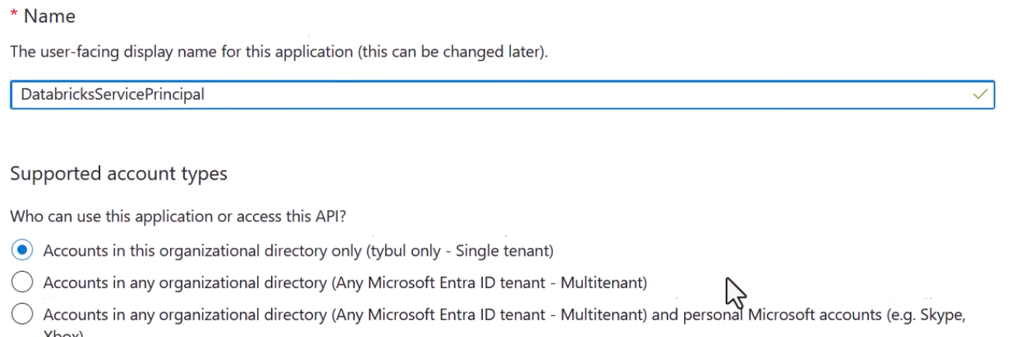

**And hit “Register”**

You can create several types of Access with this Service Principal. But here we are using Secrets

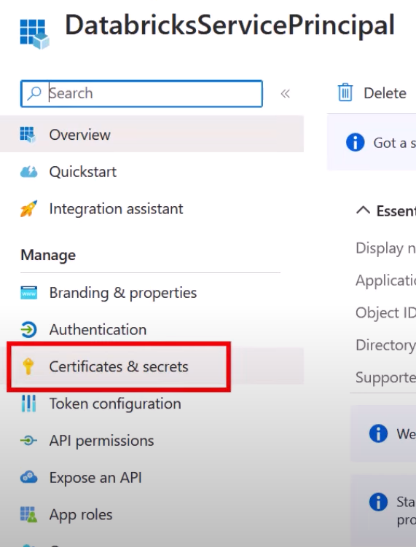

**Create a new Client Secret**

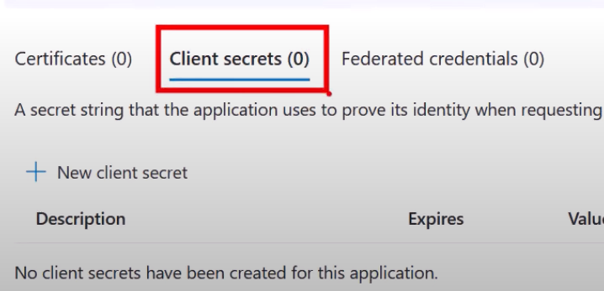

**Give it a name**

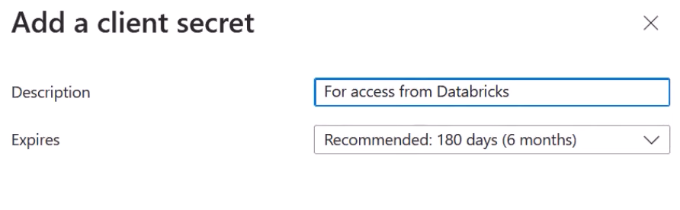

**You will get some value that can be used later**

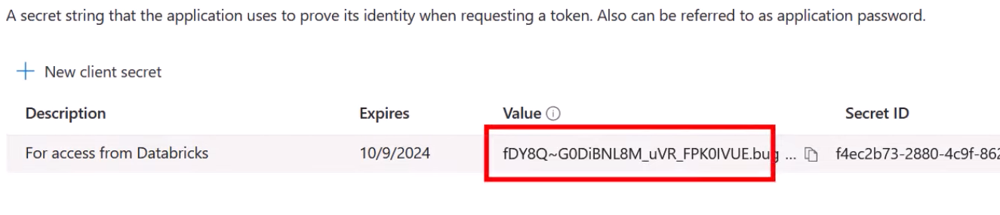



So, far Service Principal is created. Next part is granting this Service Principal RBAC to Data Lake

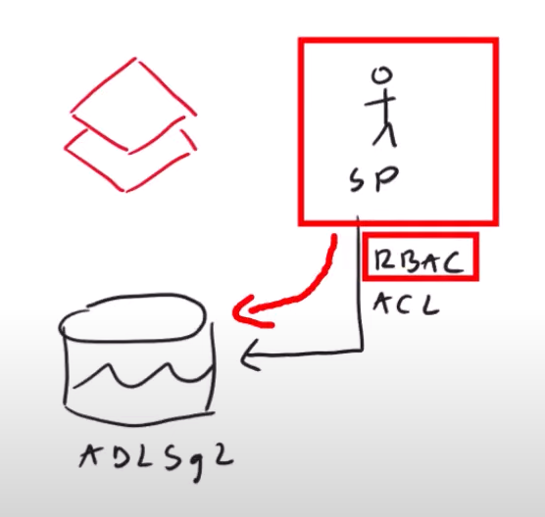

**Storage Account Level**

**Go to Access Control -> Role Assignment**

You will see all the roles under this. If there is already some group present in there which already had same set of permissions that you want your newly created Service Principal to have(Storage Blob Contributor Role in this case) then you simply add your Service Principle to that group. To do this you have to go to

**Microsoft Entra ID -> Groups -> find your group -> add a new member(Service Principal in this case) to the group**

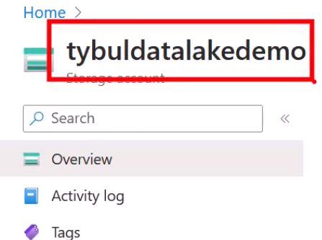 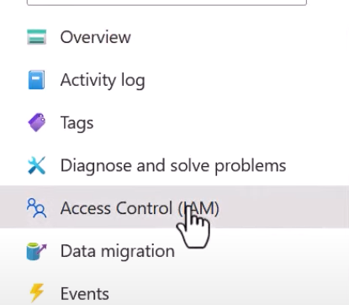

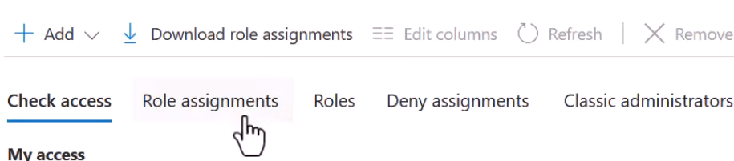

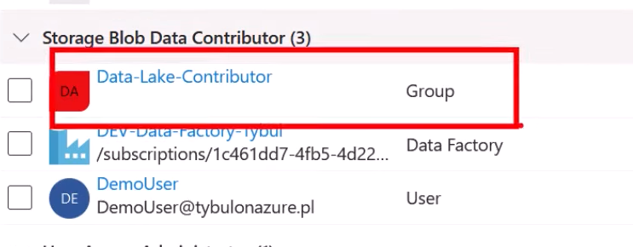

This proves that there is already a group called “Data-Lake-Contributor” that has permissions that we want to include to our Databricks notebook

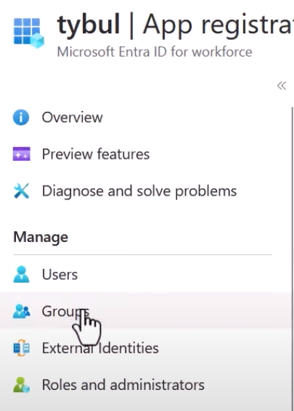

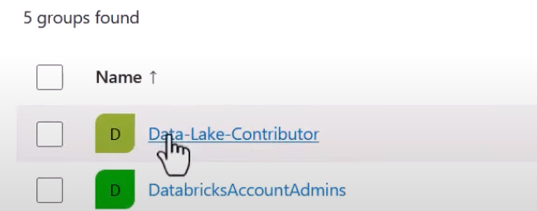

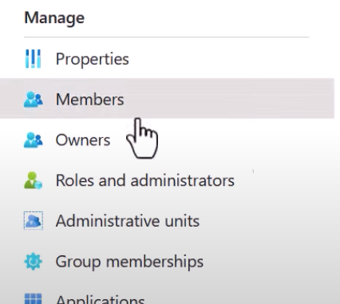

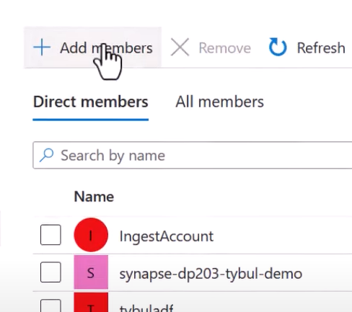

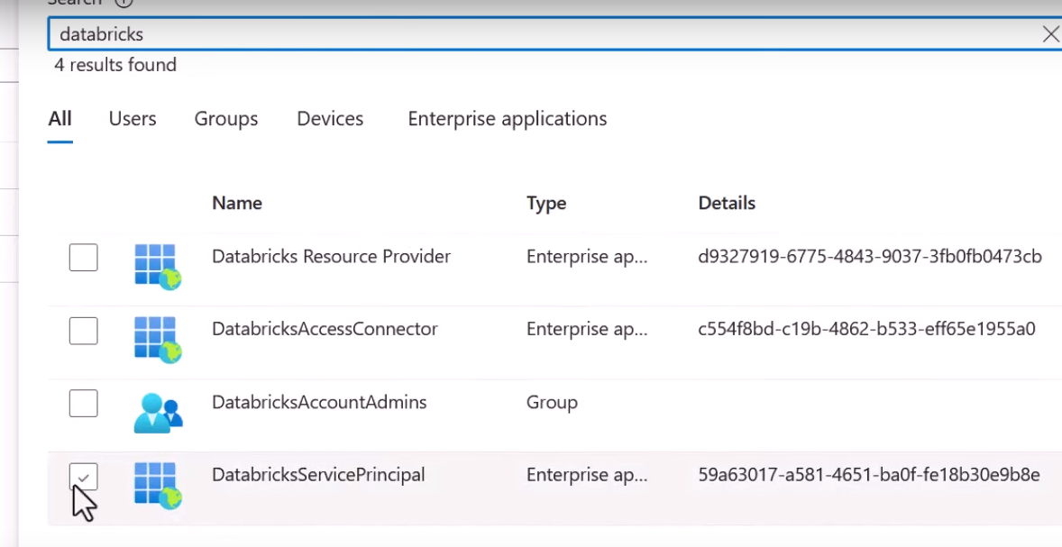

Now if you go to Databricks and create a new notebook and then try to connect to the DataLake, the connection should fail because you haven’t configured the Databricks yet.

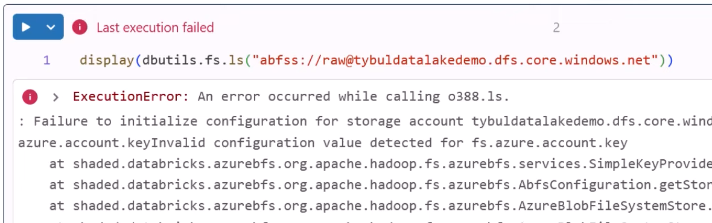

As per the documentation

<https://learn.microsoft.com/en-us/azure/databricks/connect/storage/azure-storage>

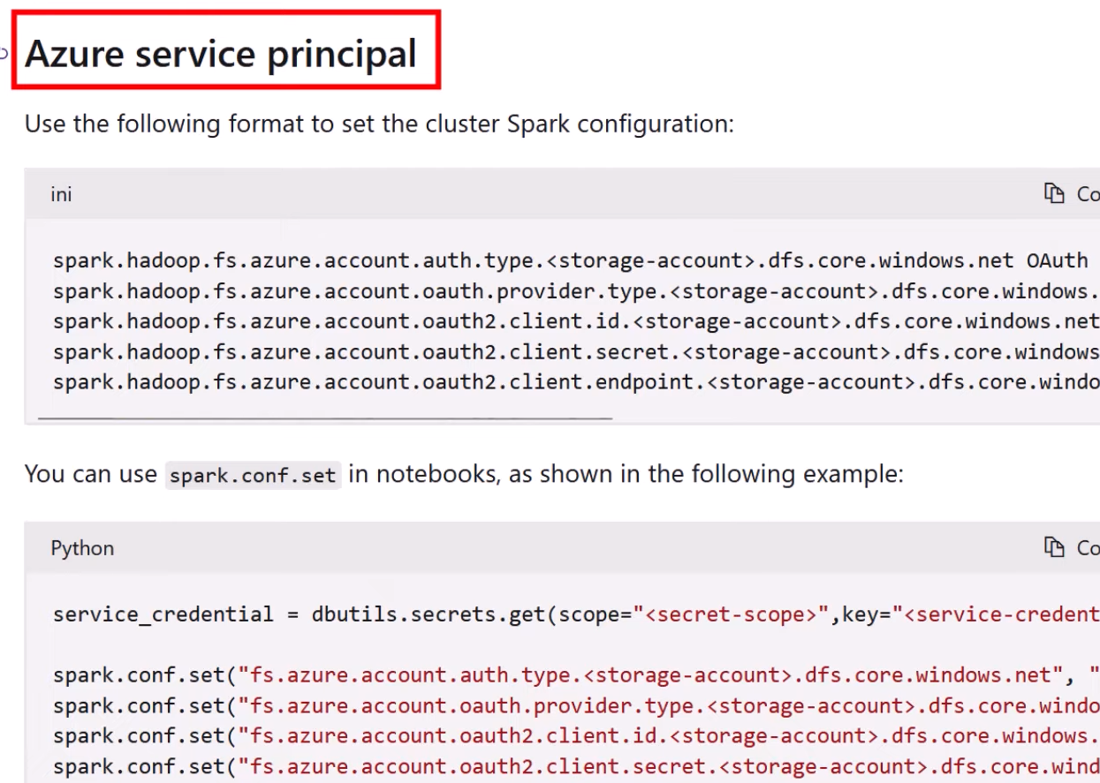

You can do configuration in 2 ways, either just to the scope of the present Notebook or for the whole cluster. For the whole cluster meaning whatever notebook you create will already have this configuration.

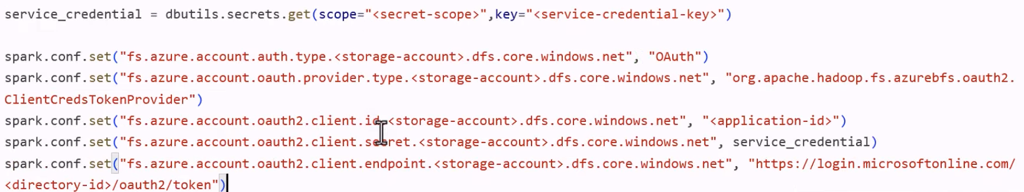

Fill the *service_credential* part: this will hold the secret of Service Principal you created earlier in Microsoft Entra ID when and remember you created App Registration of this





And in place of storage-account give name of your DataLake

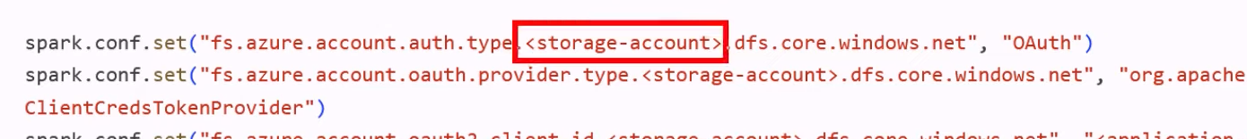

Then provide application-id

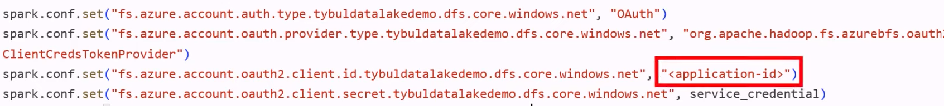

This is just the identifier of the Service Principal

To find it: Microsoft Entra ID -> App registration -> All applications -> your service principle-> Application ID

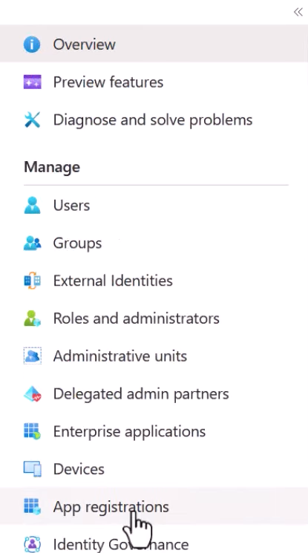

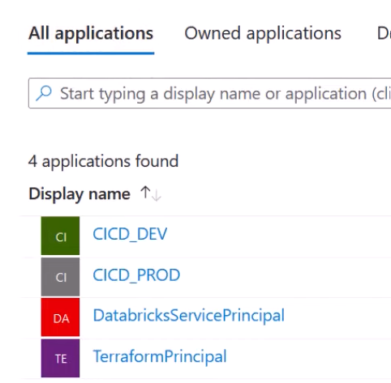

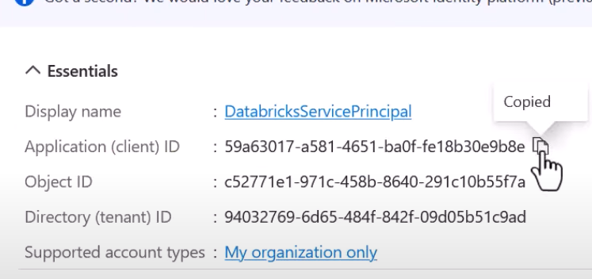



Finally mention directory-id

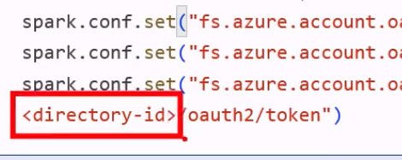

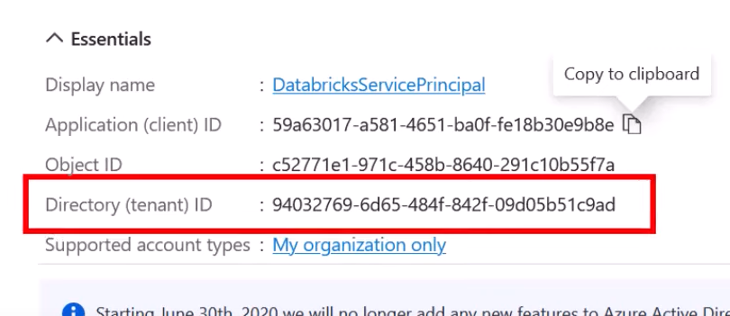



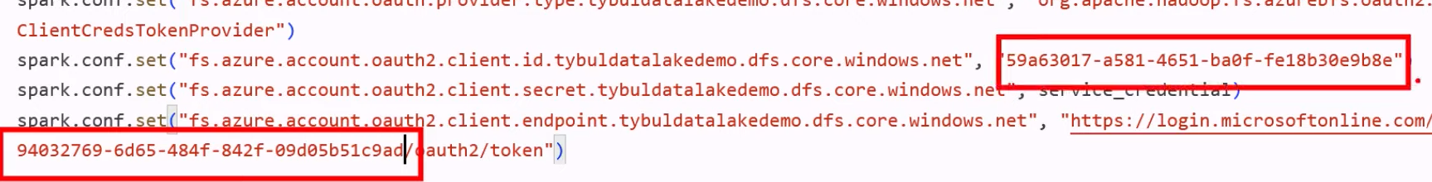

Both are not secrets, so it is fine to have them there

1. **Access via SAS tokes**

Go to Storage Account -> Shared access signature

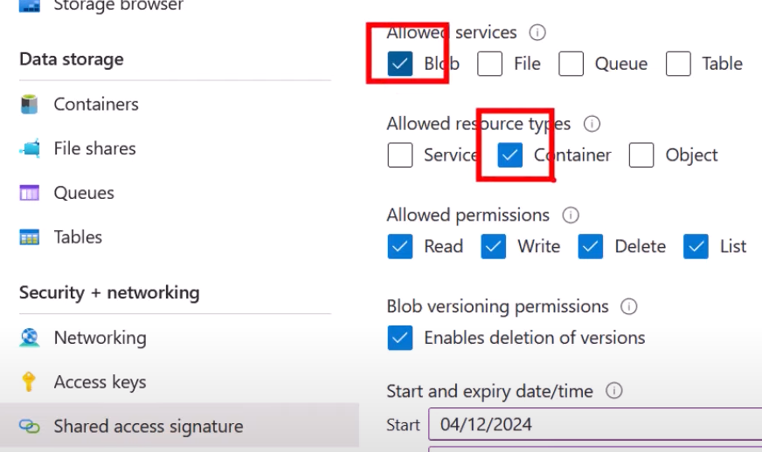

Generate SAS token

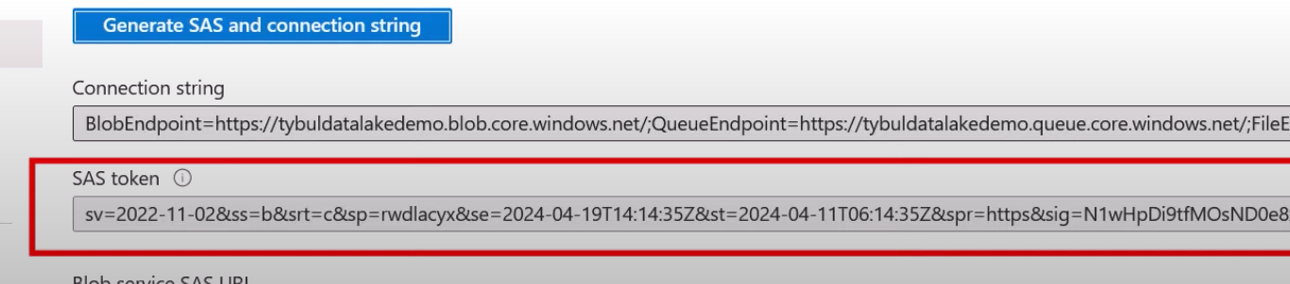



Copy the code from the documentation

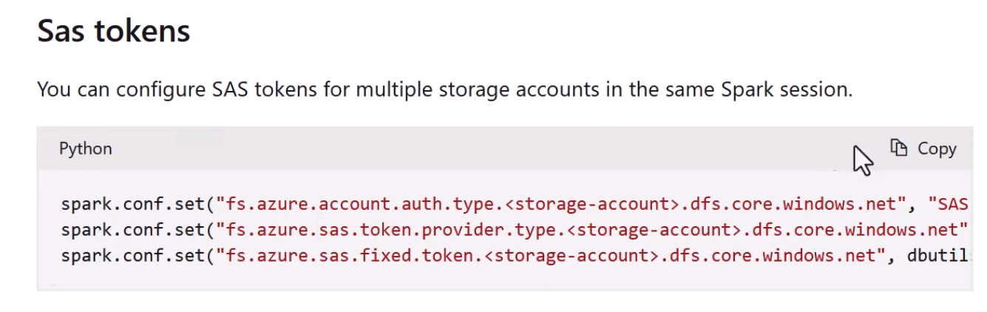

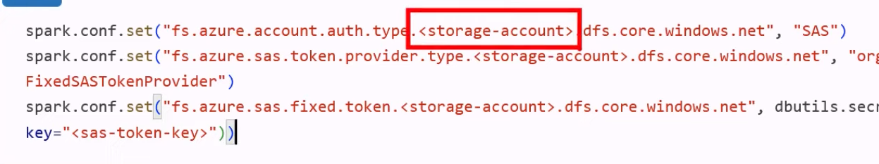

Fill storage acc name

And provide the value of SAS token



1. **Secret Scopes**

In this you utilize Azure Key Vault

Then inside it you save secret of your Service Principal

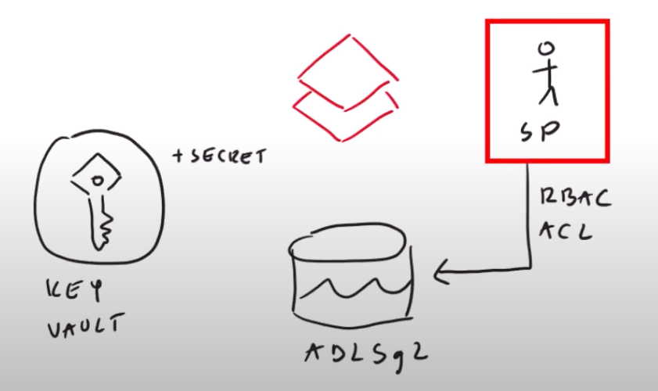

Then inside Databricks you create a Secret Scope. It is just a way to access Azure Key Vault from Databricks

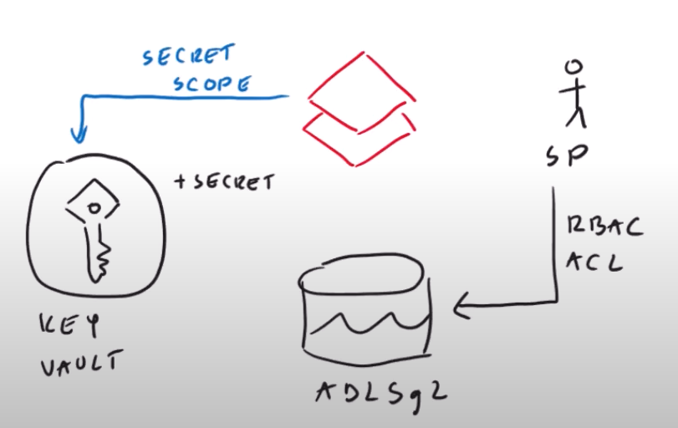

Those Secret Scopes works only if Key Vault is configured by using Access Policy mode

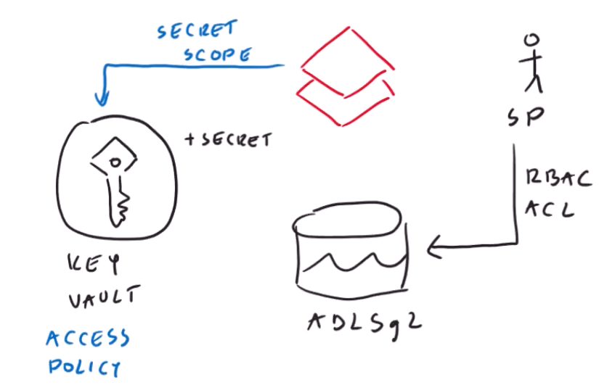

Go to Key Vault

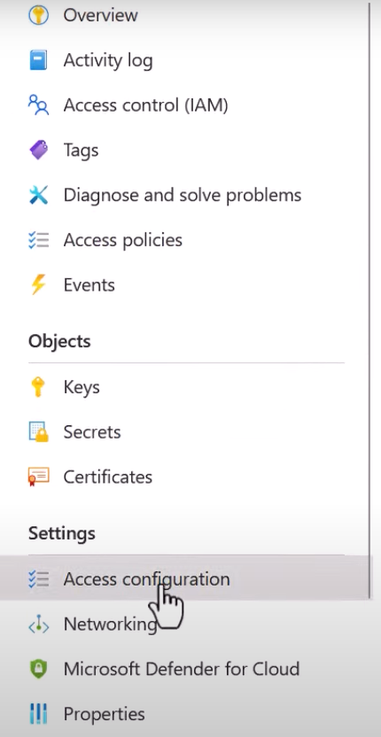

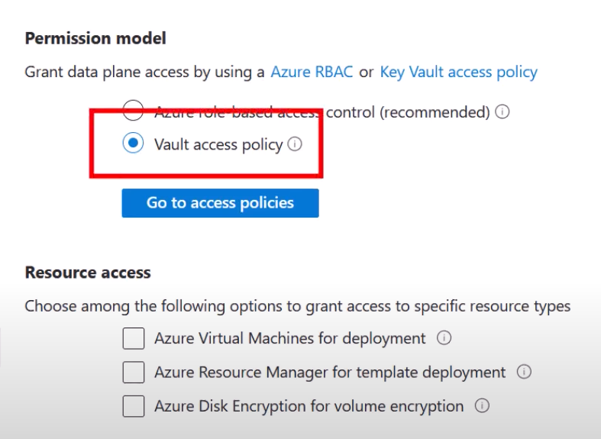

Add your Secret to Key Vault

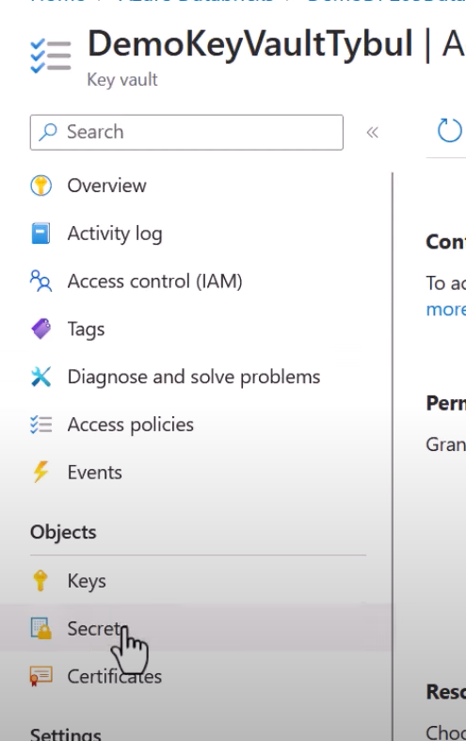

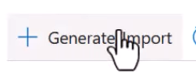

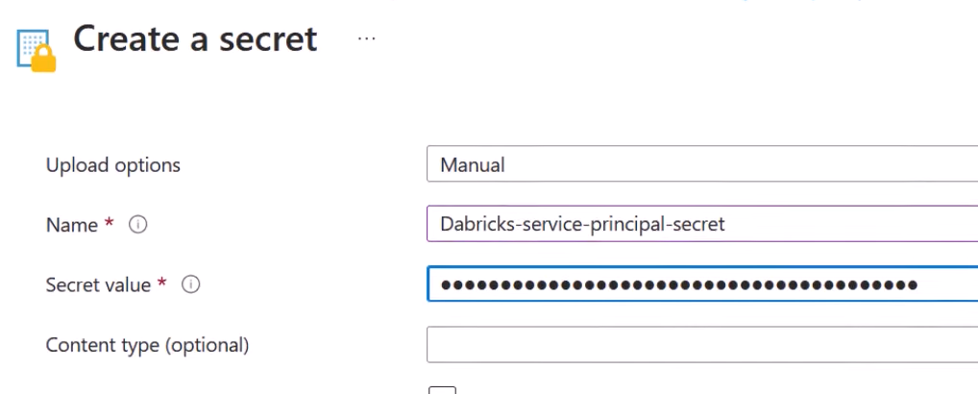

Inside value give secret of Service Principal that you had created earlier inside Microsoft Entra ID while App Registration

**From Databricks side**

[**https://learn.microsoft.com/en-us/azure/databricks/security/secrets/secret-scopes**](https://learn.microsoft.com/en-us/azure/databricks/security/secrets/secret-scopes)

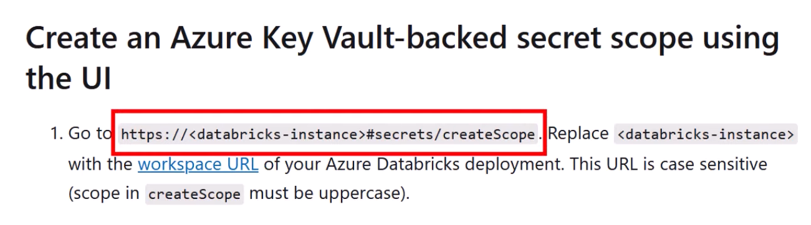

First part is address of your databricks workspace instance and second part is secret

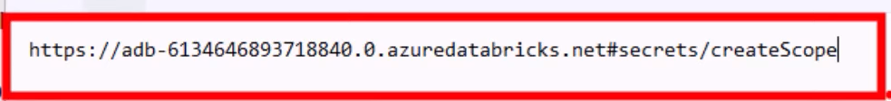

Copy paste URL

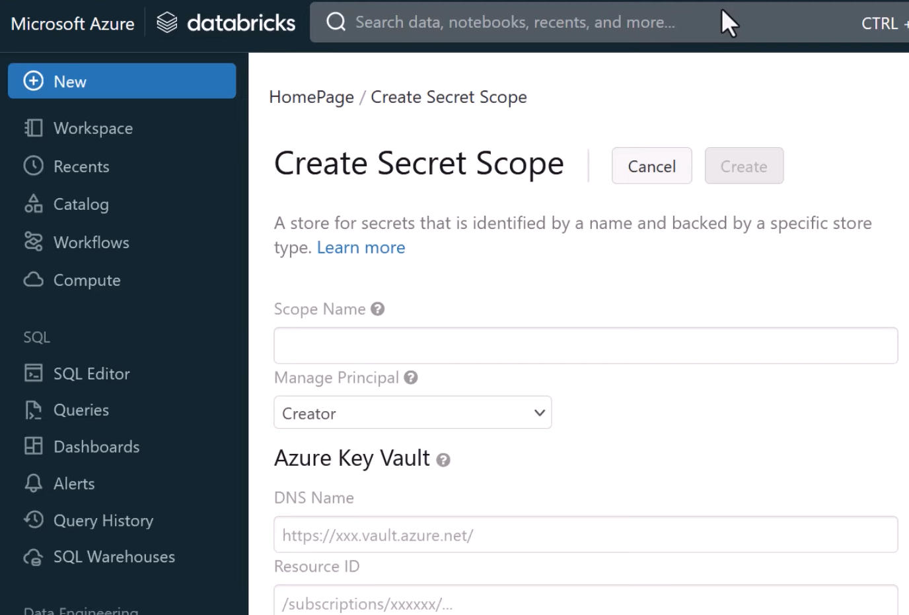

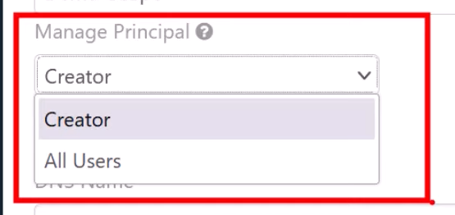

Meaning who will be able to set permissions and access to the key vault

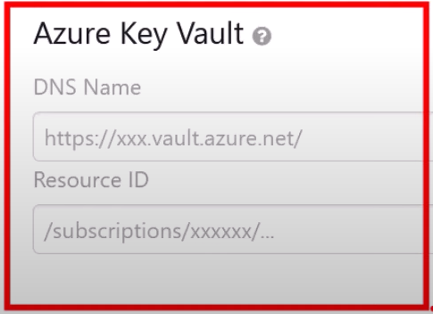

This will tell Databricks what Key Vault you are talking about

Key Vault -> Properties

DNS Name = Go to Key Vault -> Properties -> Vault URI



Resource ID = Resource ID of Key Vault



**Create Scope**

Go to Key Vault -> Access Policy

You will see new policy created as shown below

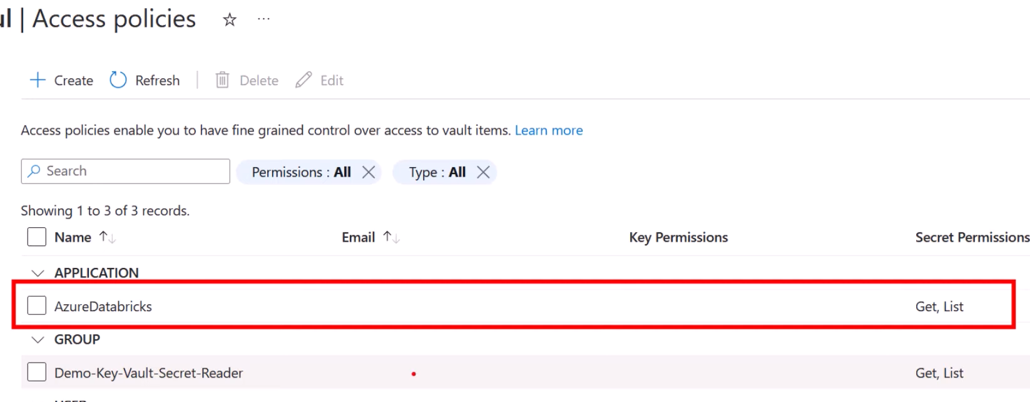

Now go to documentation to grab the code

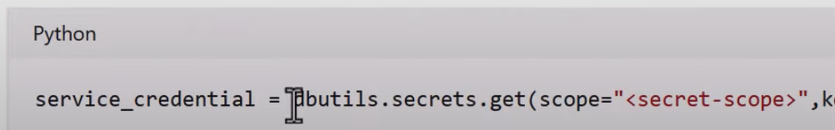



Secret-scope = name of your secret scope that you created

Key = and what secret you want to read from it.

**List all the secret scopes**

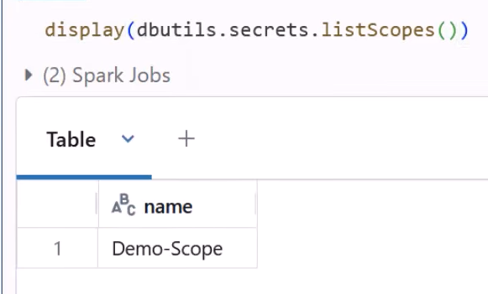

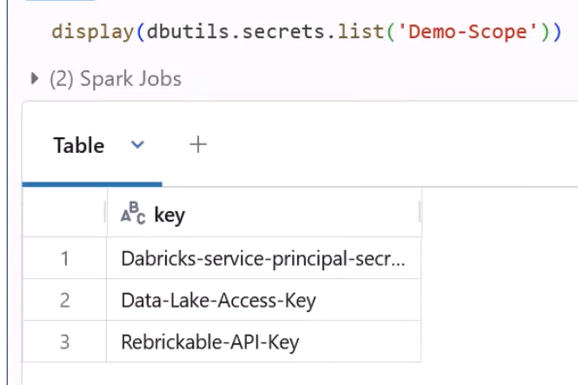

This will list all the secrets available in the Key Vault

**3. Deprecated Method**

**a) Access via Mount Points**

earlier you had to provide the protocol(*abfss*), container(*raw*) name, path to your storage account(*tybuldatalakedemo*), suffix by dfs.core.windows.net



They simplify access patterns to our data on a DataLake with Mount Points

It has lots of disadvantages. It is not supported with Unity Catalog

Our ADLSg2 will have some hierarchy.

When you are creating a Mount point:

* provide a location to which it should point. E.g. our mount point should point to our DataLake
* Indicate which protocol(driver) to be used to connect to DataLake. In our case we are using abfss
* Credentials(how to connect to DataLake)

So, basically all these 3 things altogether will be encapsulated inside the Mount Point. so, end users later on will not have to care about those 3 things while using Mount Point as a regular point

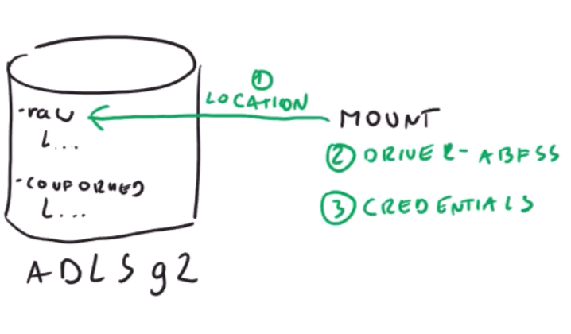

**How to create it?**

https://learn.microsoft.com/en-us/azure/databricks/dbfs/mounts?source=recommendations

From Documentation

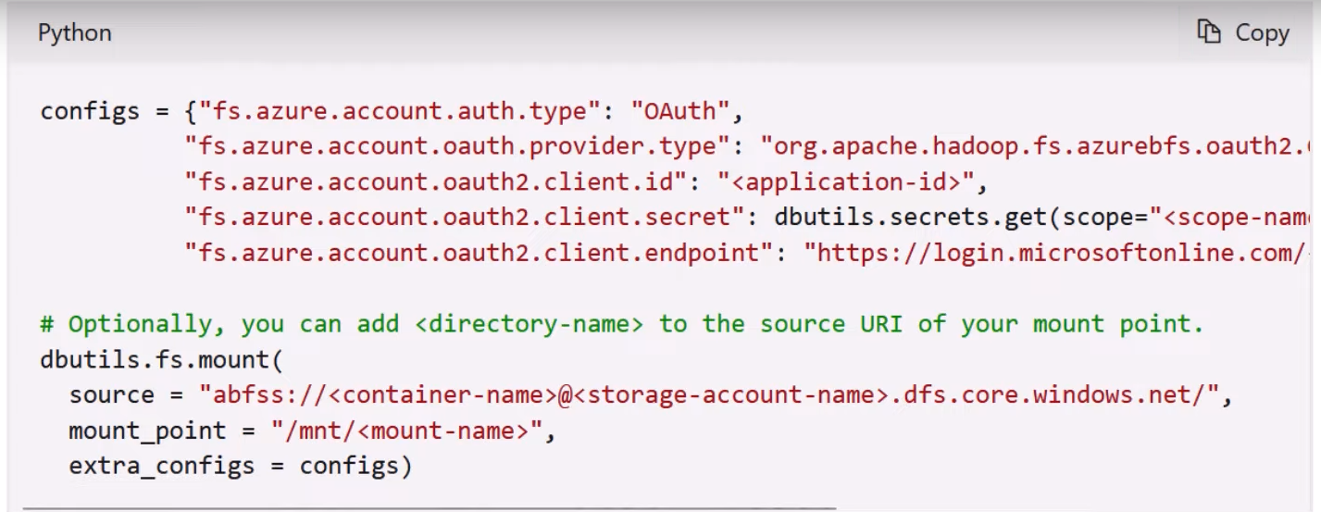

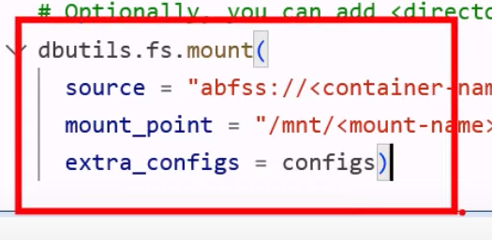

**Source = Provide a path where your Mount Point should point**



Provide your container and storage account

**Mountpoint :**



mount_point = How do you want mount_point to be called



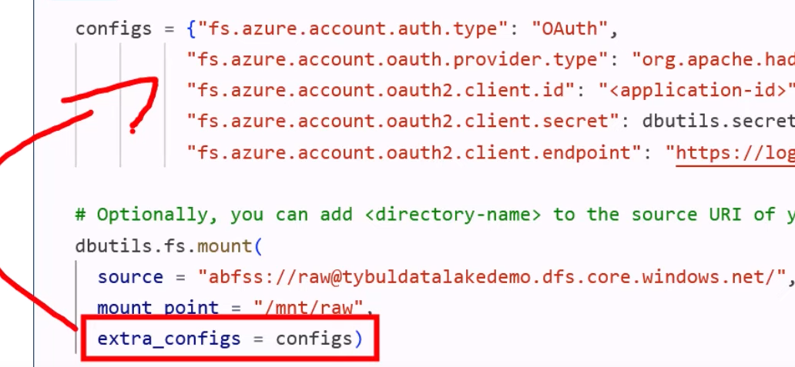

This thing specifies how you want to connect to DataLake:

We are using Service Principal based authentication like we did earlier

Provide application-id , directory-id and secret

Listing Mount-points:

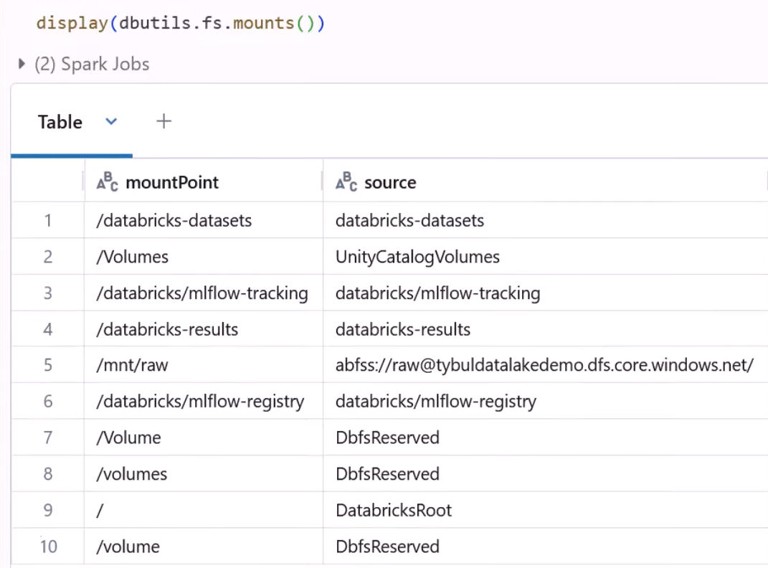

**Querying Mount-point:**

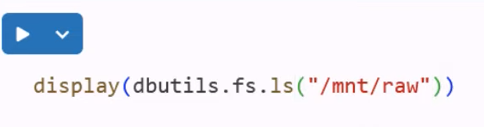

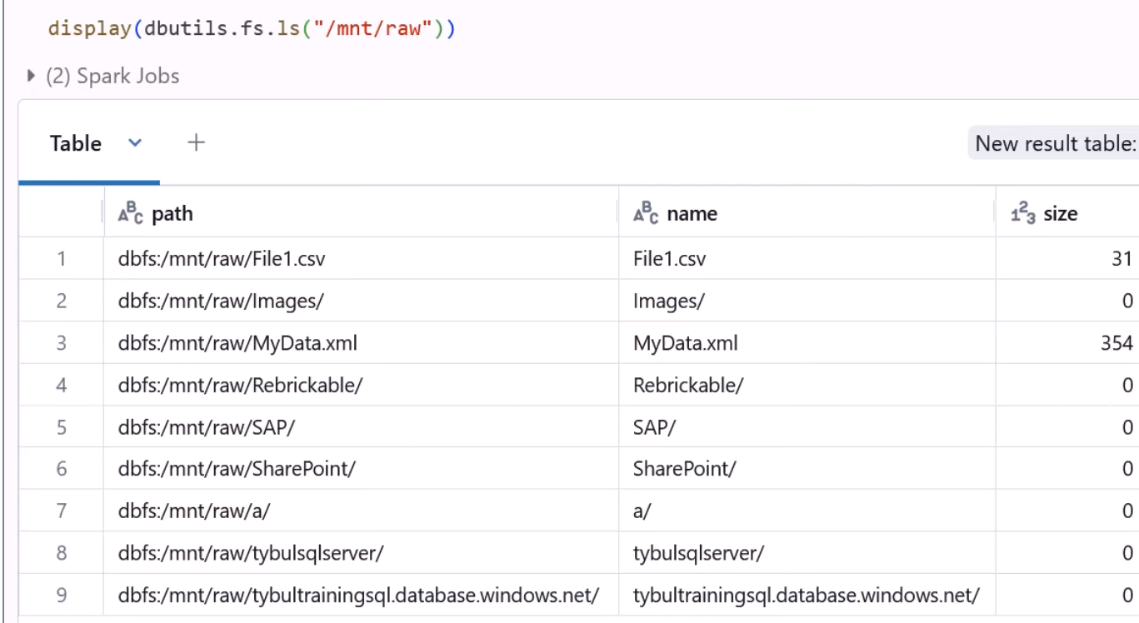

They point towards



**b) AAD Credentials Passthrough**

* Available with Premier tier
* Requires some configuration in cluster
* While creating a cluster under Advanced options

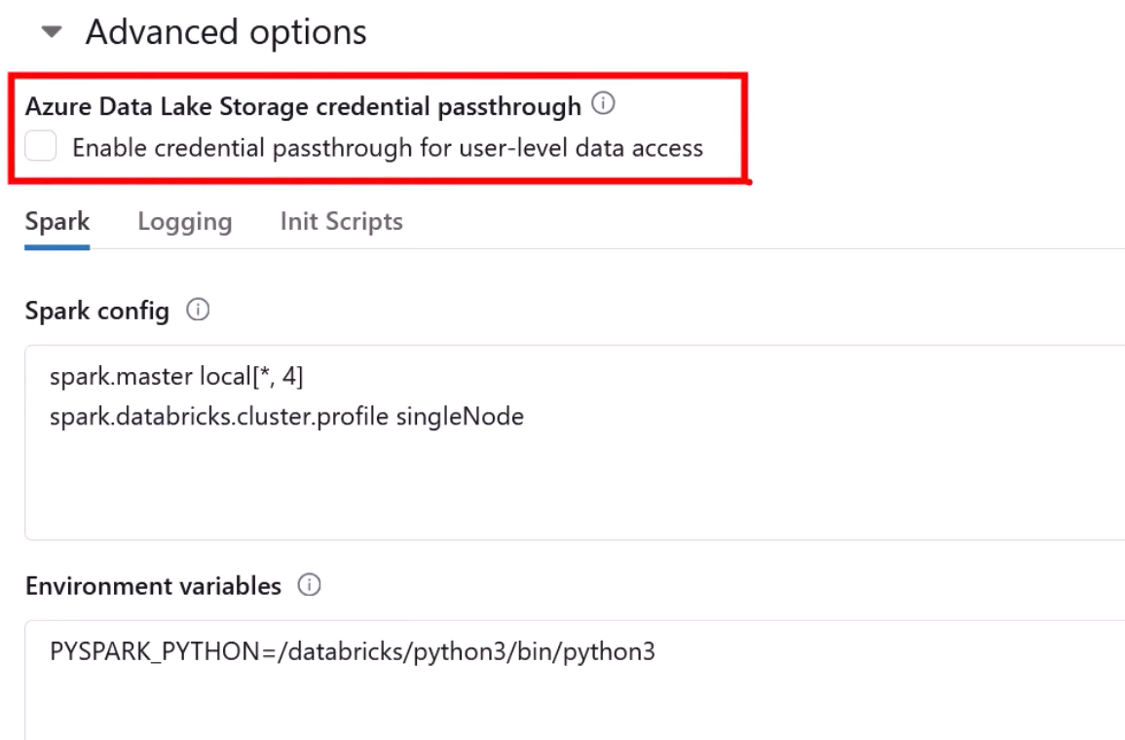

Users are granted some access on Storage Accounts and whenever those users are connecting to Databricks to do their job they should be given same permissions that they have on Storage Account(Data Lake)

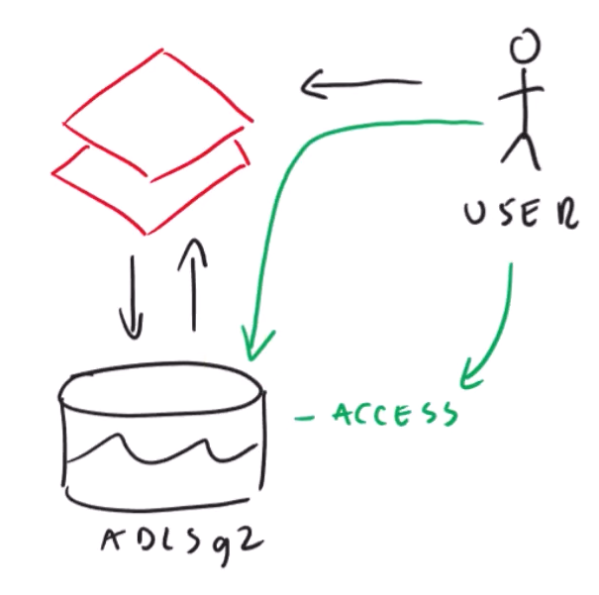

Therefore, permissions of user are checked based on what permissions he has on Storage Account

In this way each user will have different type of permissions on Storage Account based on which they can have different level of control on data. Meaning different users have different versions of data.

**Databricks:**

Create a New Notebook -> make sure you connect to your new cluster

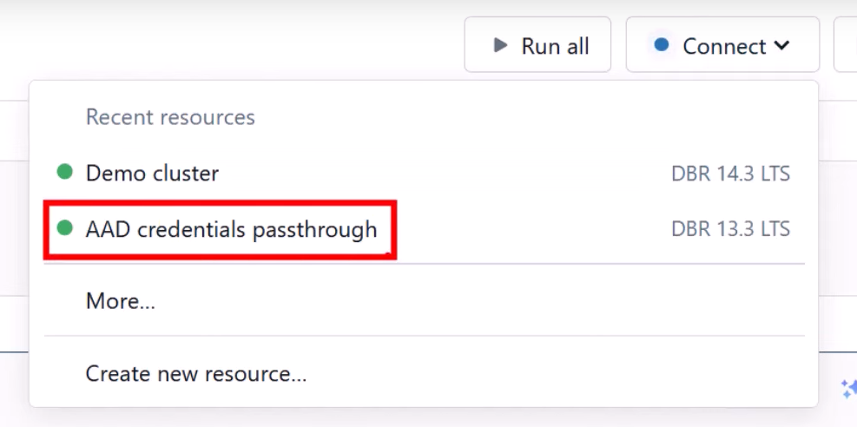

**Disadvantage:**

Doesn’t work with ADF

Not supported with workflows

**Lecture 35**

We want to save our results of our Data Transformation

In this demo we are saving the transformed data back on DataLake.

Whenever you have to connect from Databricks to DataLake you have to configure your notebook in one of the above discussed method.

In this we are using access type as Access via Service Principal method

Earlier you were pasting the Python code in first cell of the notebooks. But in this method, you will put above code inside the cluster as shown below

**Cluster Configuration:**

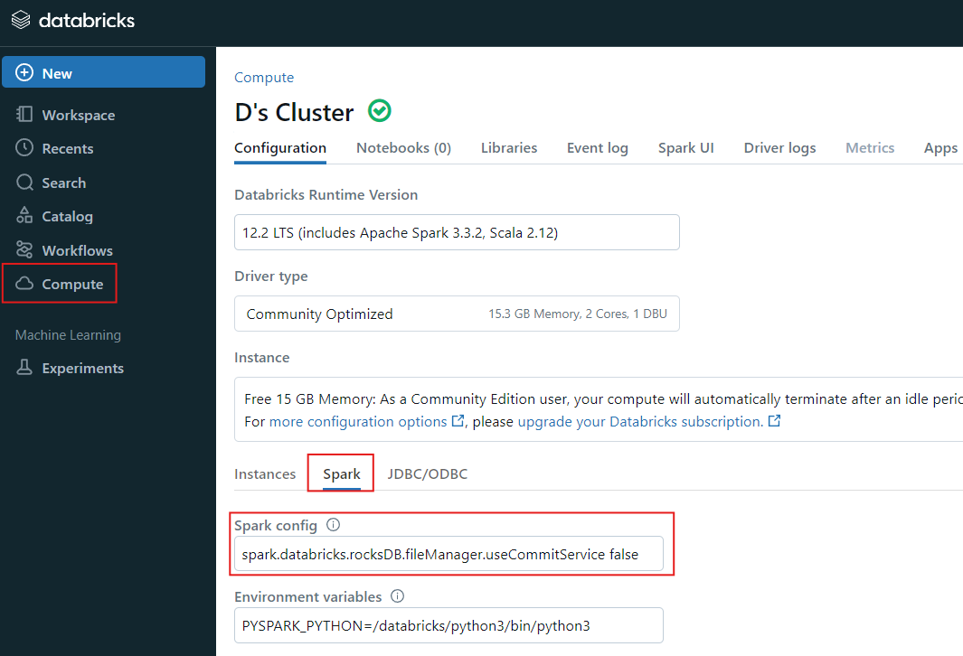

Go to compute

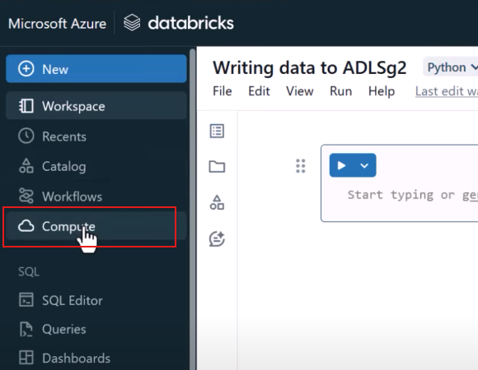

Then to your desired cluster that you wish to use

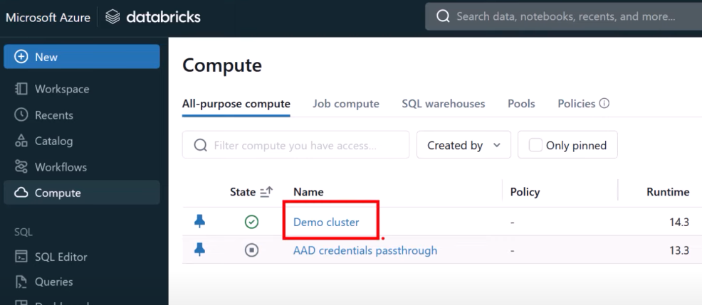

Navigate to “Edit” at top right corner

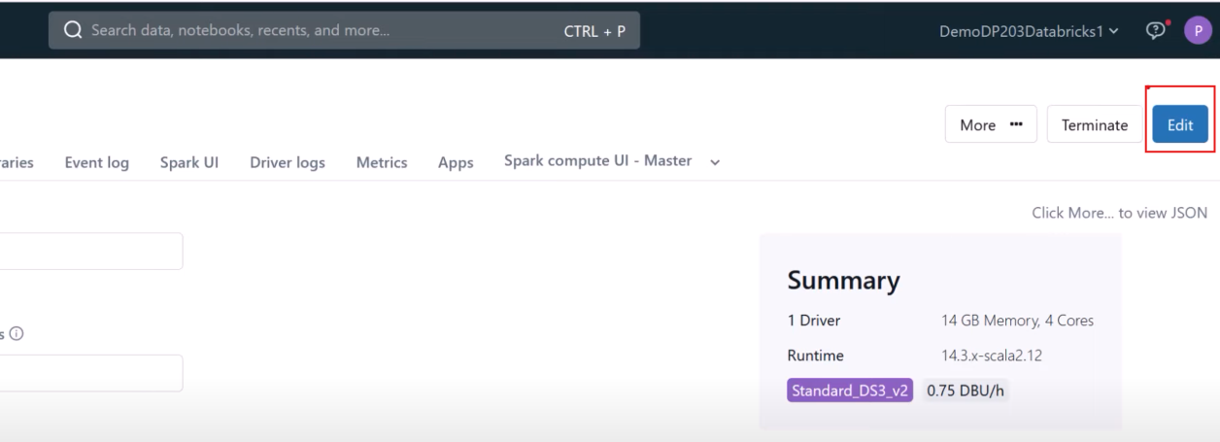

Navigate to “Advanced options”

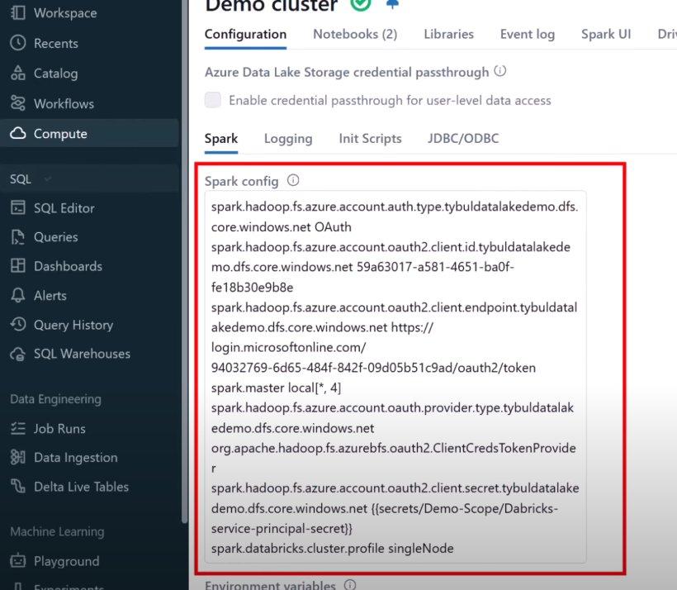

This is the place where you must paste the code. And then you would have to restart the cluster

Then go back to your notebook to verify that connectivity worked fine

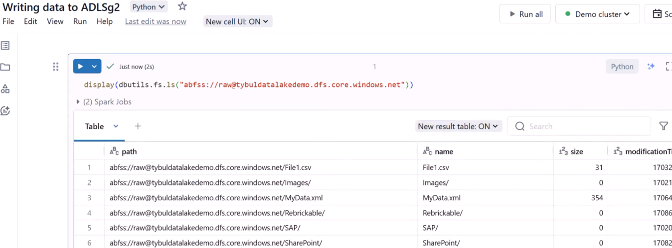

You could see that you are able to list the content therefore connectivity is established.

In this demo we are configuring the access settings not at notebook level but cluster level.

**Preparing the data:**

In this step, read whatsoever data you want to read but at the end make the data in form of dataframe and then register the dataframe to convert the dataframe into a table. Once its in table form you can use SQL like queries

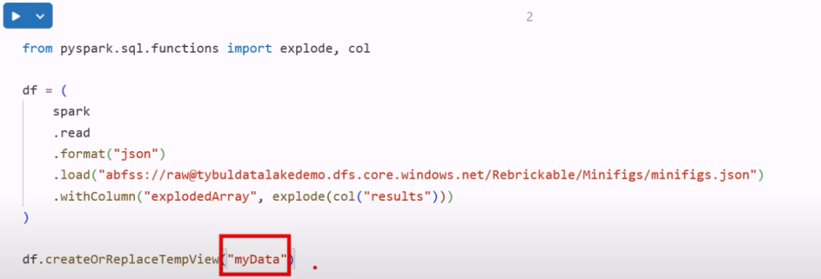

**Transform your data**

**In this apply whatsoever transformation you want to apply**

**Saving the data to ADLSg2**

Create a new container(curated)

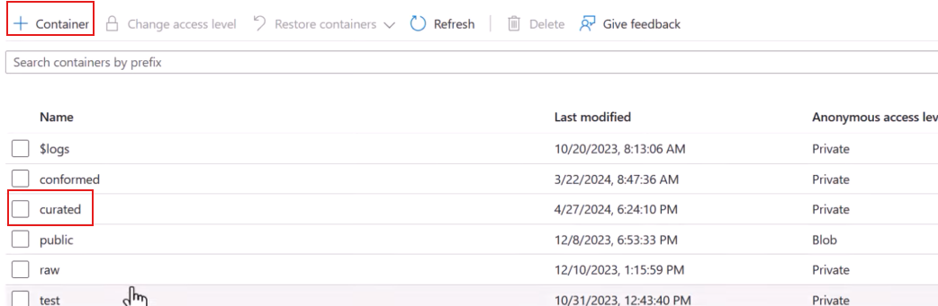

We will use this container to save the transformed data.

There are multiple ways to save data to DataLake. But we will save our data as delta format

Well just grab the data and save it as delta format

The result of SQL transformation is available in _sqldf

You will use python command as:

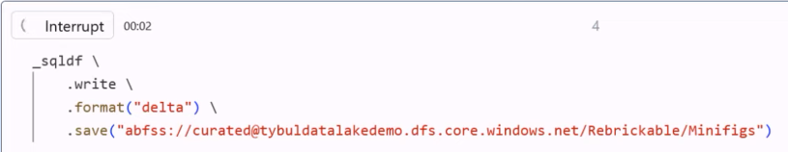

If you revisit your curated container, you would see parquet files along with the _delta_log folder.

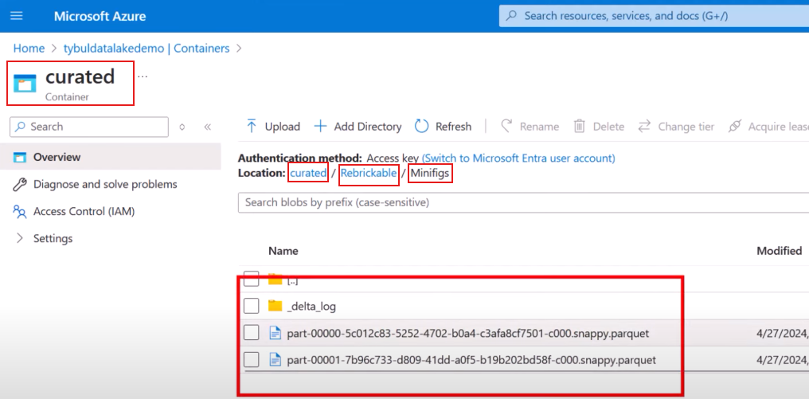

Then to verify if you can read that curated data you simply read it on Databricks using pyspark command.

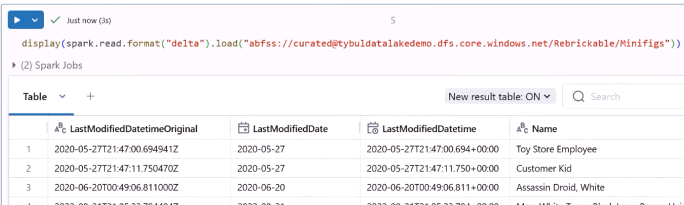

Therefore, we are able to read data

**Save the data as managed tables**

You had to provide the full path to location where data is stored and the format to be specified. But if you want to make other developers’ life easier. Maybe you would like to hide all those details and expose an object with user friendly name that they could use in their queries.



Register your table in Catalog, in a metastore THAT WILL ALLOW SOME OTHER USER TO USE IT

**How to do that?**

You create a database(a logical container that store definition of your objects)

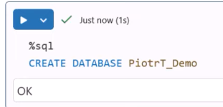

At this moment our database is created somewhere

Then you create a table. You have to indicate which database you want it to be put in. Then name of the table. Then write a query that will populate the table

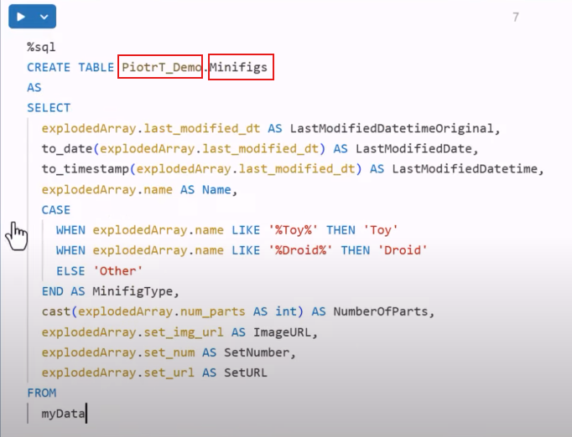

The benefit of creating this table in database is:

Any end user can read this data without explicitly mention the path of source in your datalake:

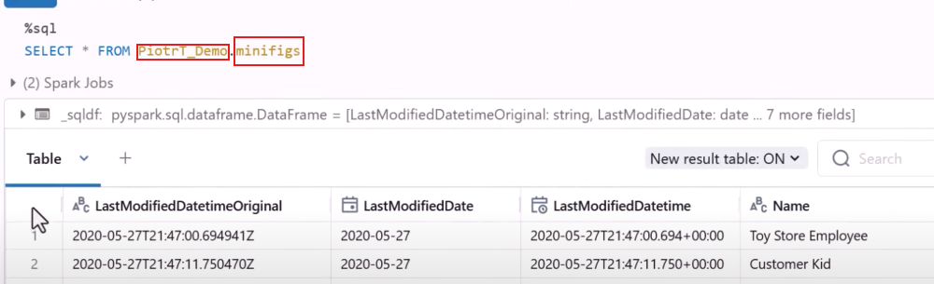

Therefore, you have your data that persisted somewhere.

How to see what databases and what tables are available in our environment:

Go to Catalog

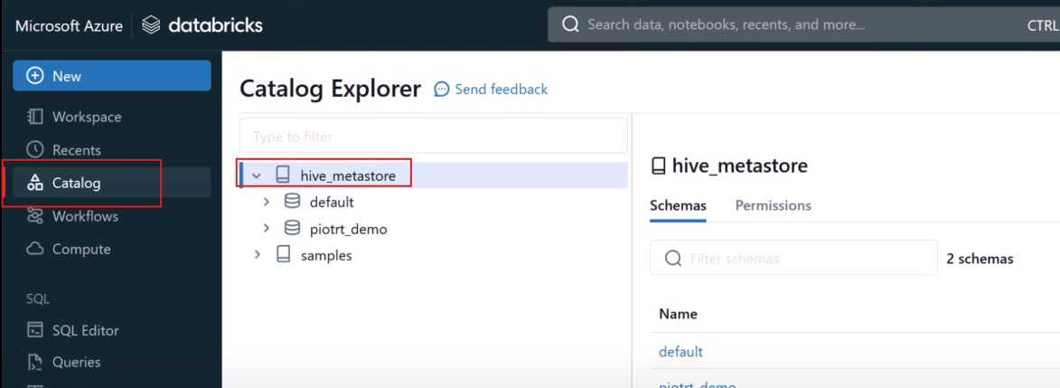

You can also see you created database

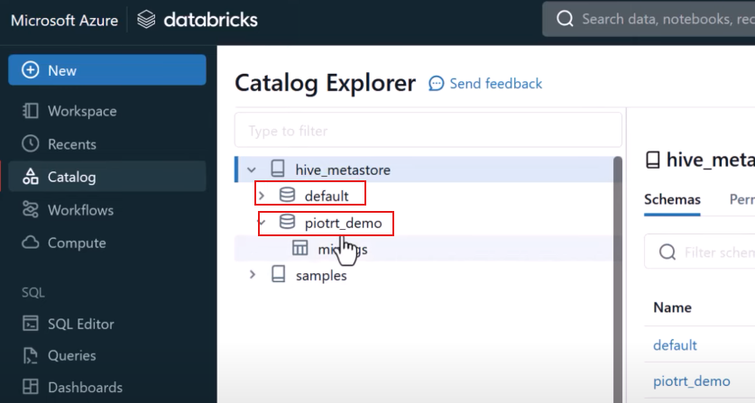

Also, the tables available

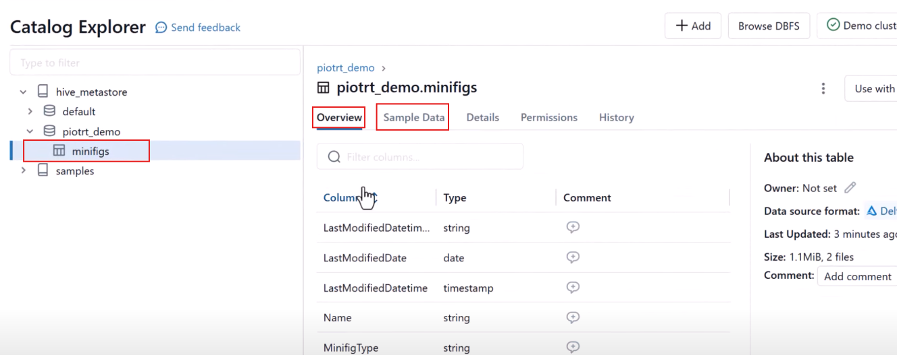

In the Overview you can see some structure of the table, Sample Data

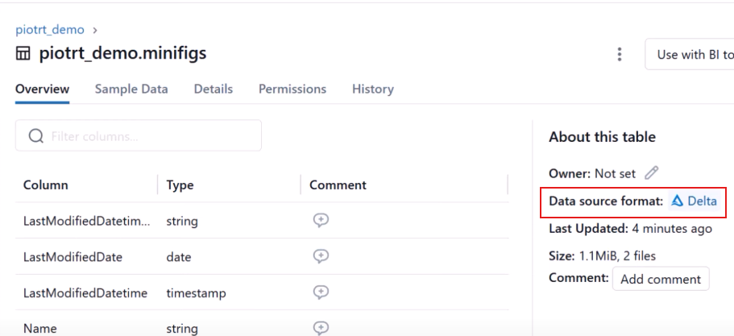

The data is using delta format

Where is the data getting stored? It uses delta format, and delta is a file format so file has to be stored somewhere

Now if you go to Details you will see:

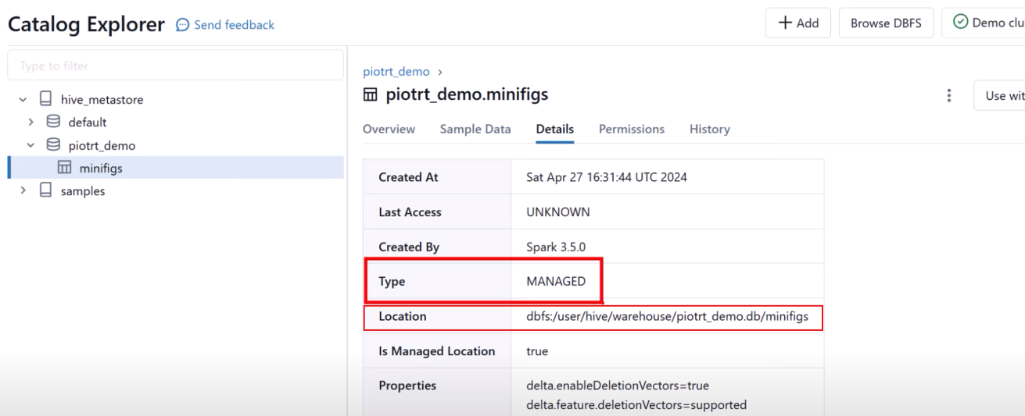

Type = Managed (by Databricks)

Location = dbfs(Databricks File System)

Even though you are the admin of the whole Azure, but you won’t have permission to see data stored in the DataLake managed by Databricks

Only way to have access to that data is to use Databricks. What if some other services like ADF that would like to connect to that data? This will not be possible without going through Databricks. And coz you have no control over that DataLake you have no control to set permission using RBAC or ACL.

We created a Database and inside that we created a table(e.g. Minifigs). The data is not stored somewhere in the Databricks but inside the storage layer. Because you did not provide the path therefore databricks stored it inside its managed RG. The flow is shown below.

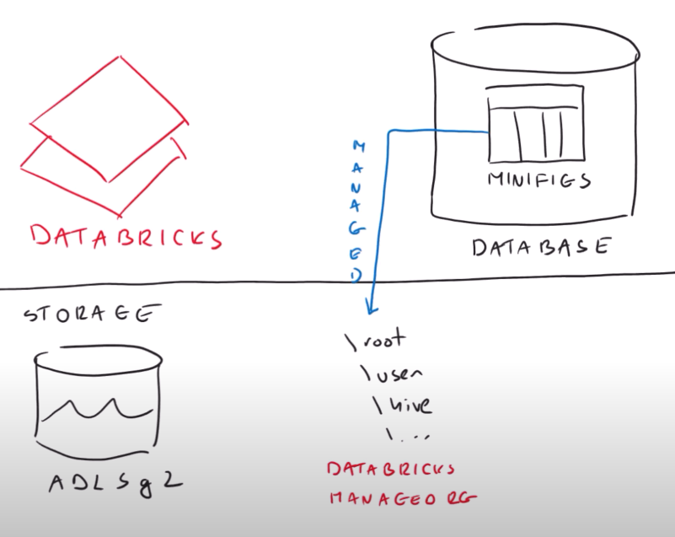

To be specific the definition of database and table is stored inside Hive Metastore(contains metadata of our data)

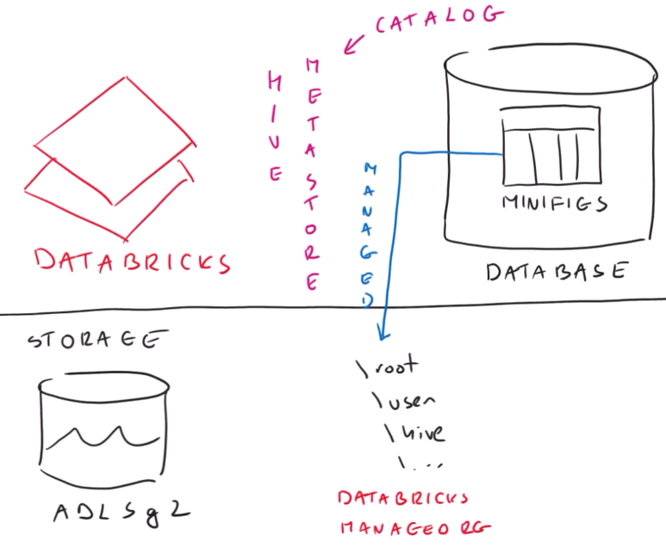

When you tell Databricks to please you can register our table in theDL

Go to your notebook

Create a table

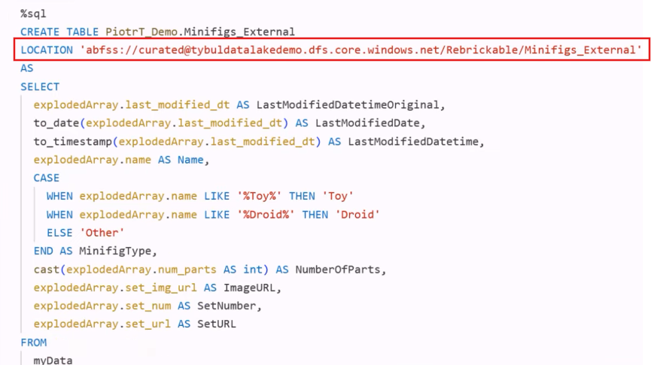

Just a little update, just provide Location to your datalake. Except this everything in code is similar.

Now to verify, if you go to Catalog you should see your external table

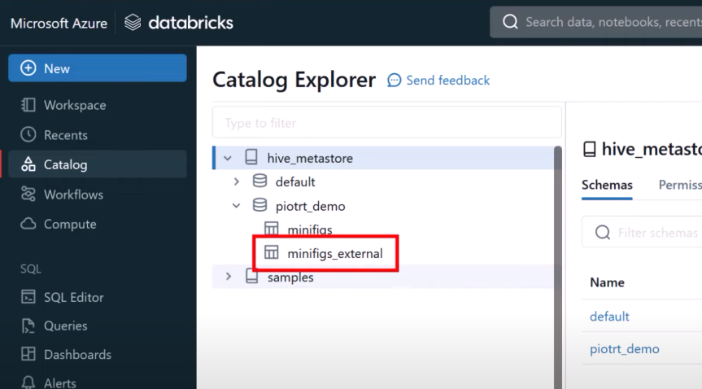

This would mean it is registered at the Catalog

And now if you go to Details

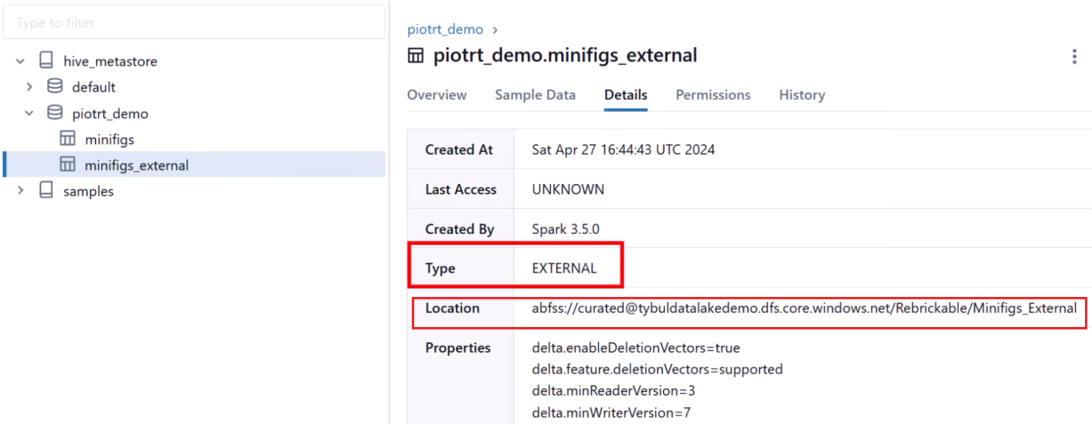

Type = External

Loaction = conatainer inside your datalake

You can even see the sample data

But how come can you see sample data when you are browsing your Catalaog and from there you can go to Datalake and query the data

Ans: we did configuration to connect to data at cluster level

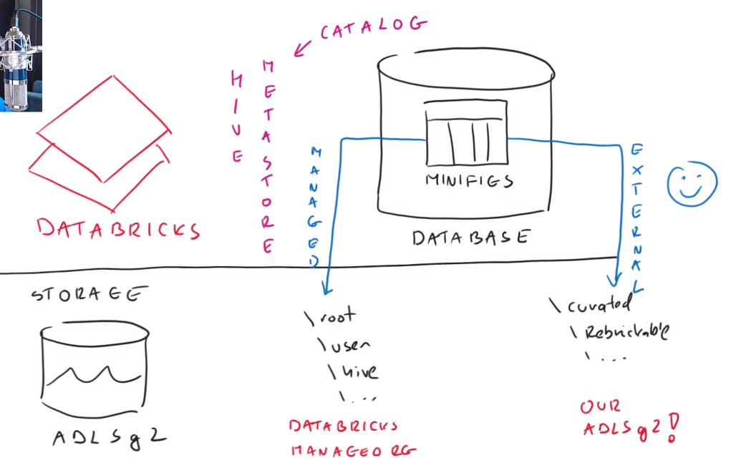

**Uploading data quickly:**

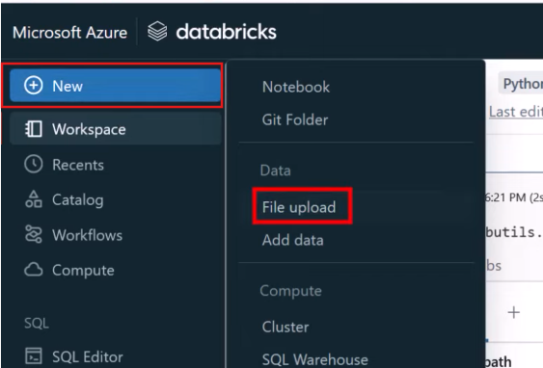

**Drag and drop file in the canvas**

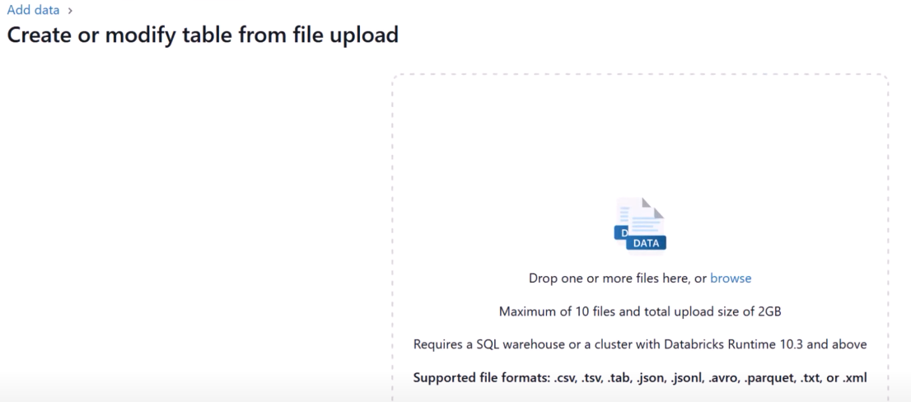

**After uploading the file you specify where to save the data**

* At which catalog
* At which schema
* At which table name

**They used schema analogous to database**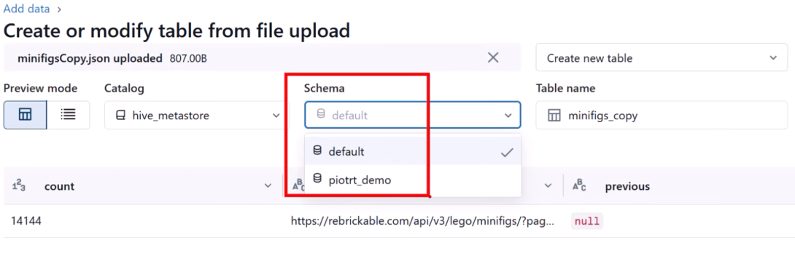

**Create the table**

After that you must see new table

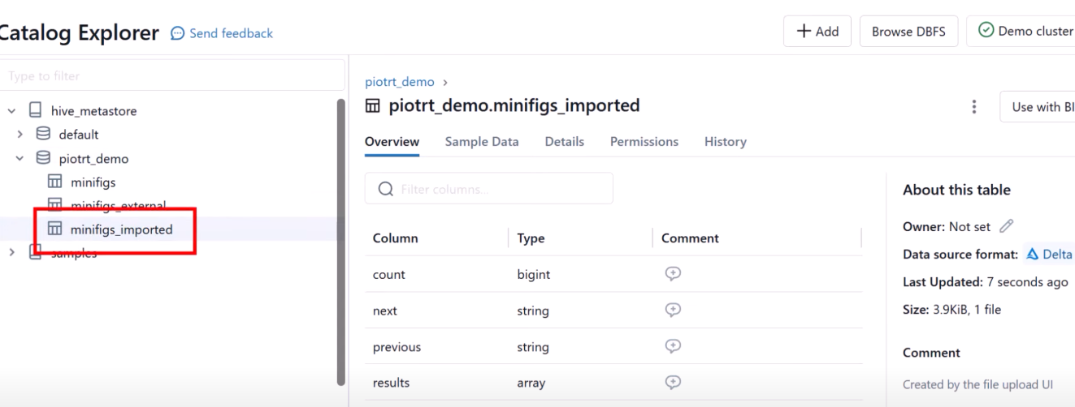

But you will find that it will be saved as managed tables(by Databricks)

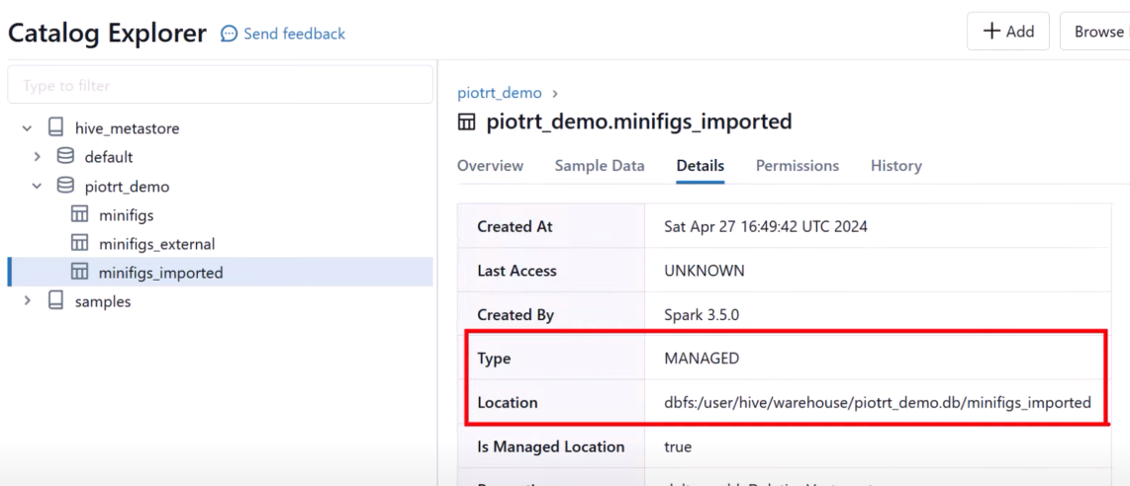

**Database vs Schema**

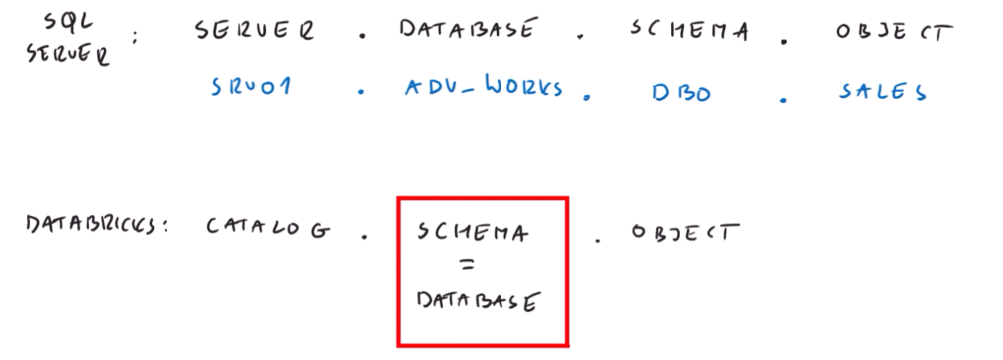

Go back to you notebook and utilize one of the tables that is present in Hive Metastore. But the table should be external

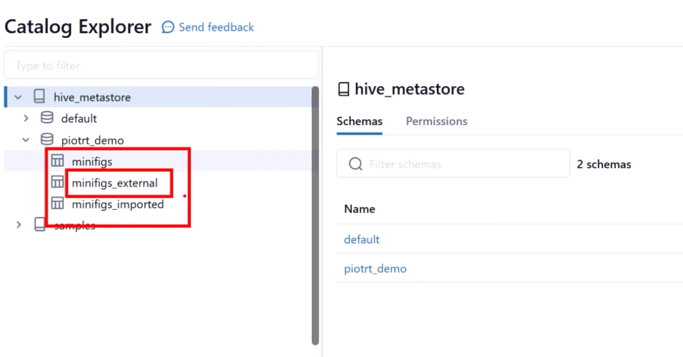

Add a row in your external table

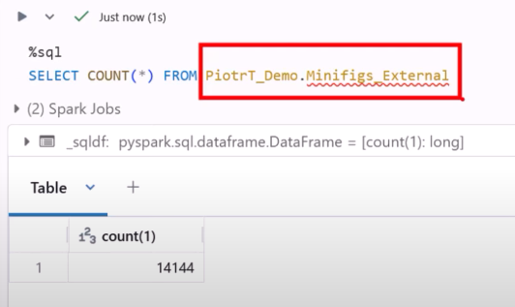

INSERT:

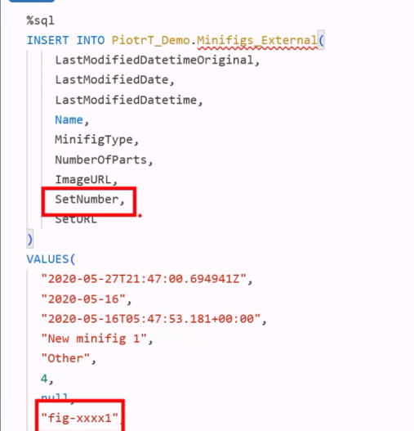

If you rerun the count statement you should see one more row added to the external table

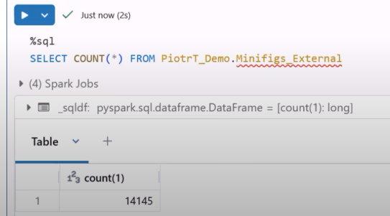

To check if the row really added, verify that at scope of Storage Account

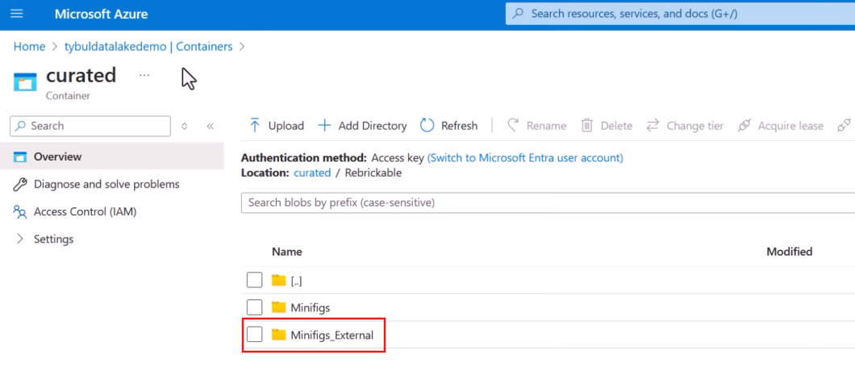

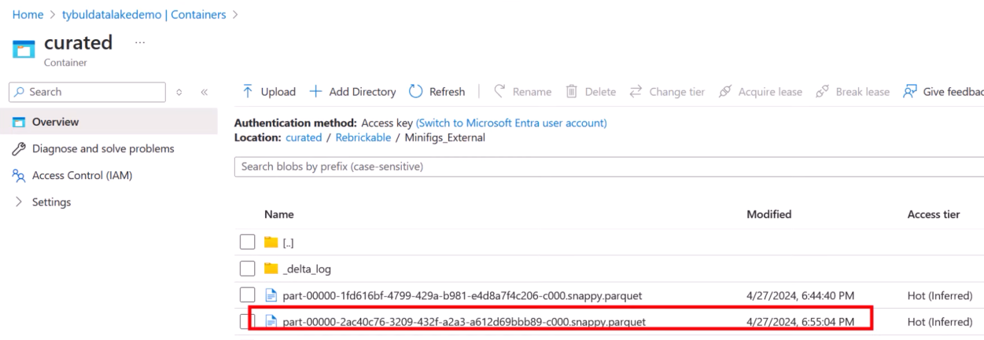

You can see a new file was created

You can also use SELECT statement to verfy

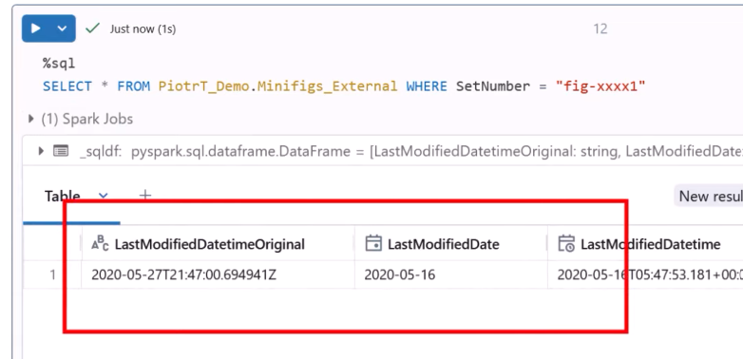

Likewise you can update and delete data

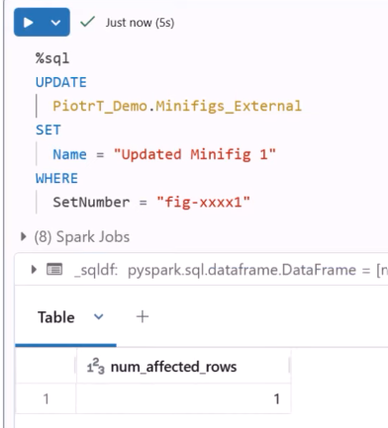

You can see the updated name

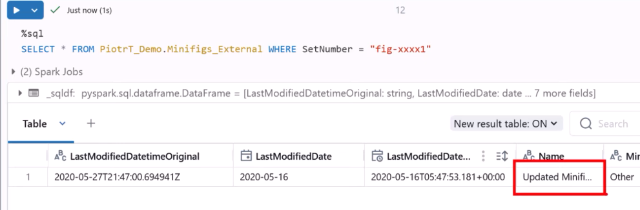

Delete the row:

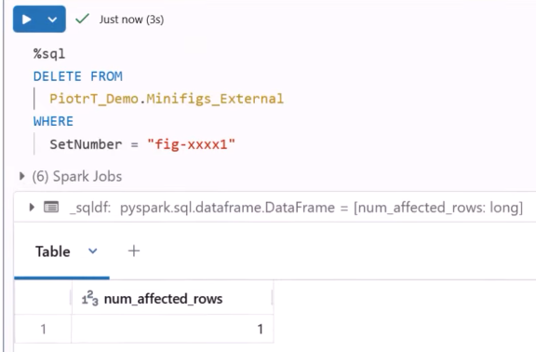

As the row no longer is present you will see result like this:

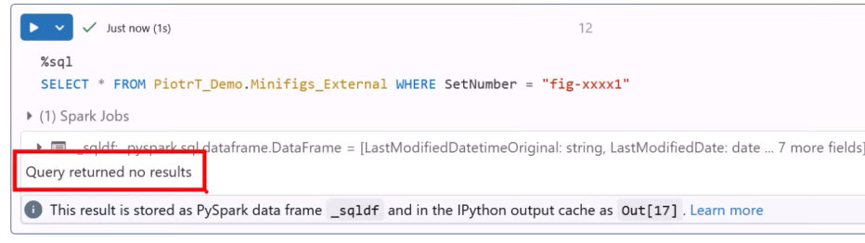

**Identity Column**

In many cases SCD we would like to have some kind of artificial ID column that we could use to uniquely identify a row. It is impornat in case of SCD type 2, where we maty have many versions of same row with same business, which means we cannot use that buss id to identify the row.

In Databricks we can do that with Identity property

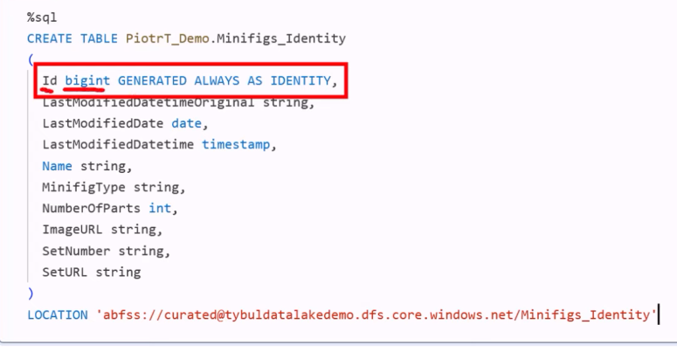

After running this command your table will get registered in the Catalog

It would be empty. Now insert data to the above table

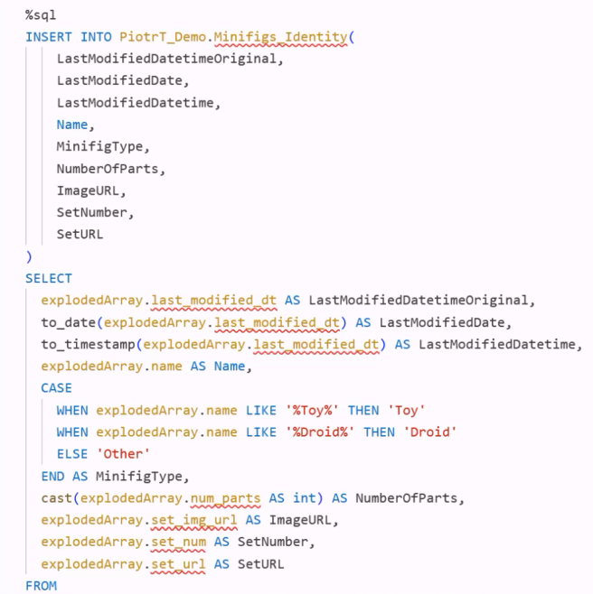

Now query the table. You should see the ID column whose values would be automatically provided by Databricks

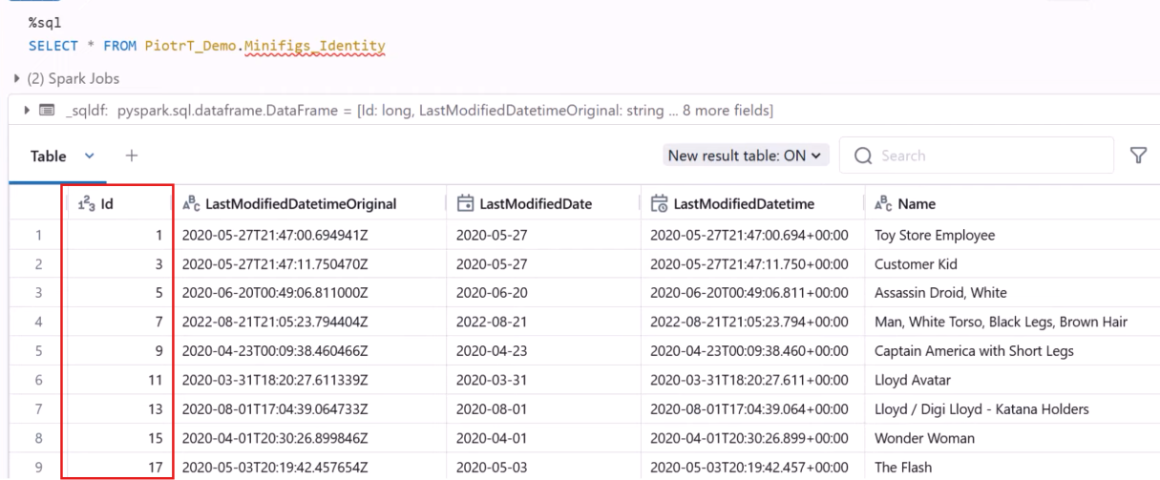

**Lecture 35**

**Automating the process with Azure Databricks Autoloader**

We know that we have multiple data sources like csv, json, xml, databases, APIs etc.

And we don not want to develop any reporting solution directly from the source data. Therefore, we ingest the data in our Datalake, transform the data and then build reporting solutions.

For ingestion we used ADF.

While ingestion data we try to avoid Data Swamp. So, we make different layers within our Datalake.

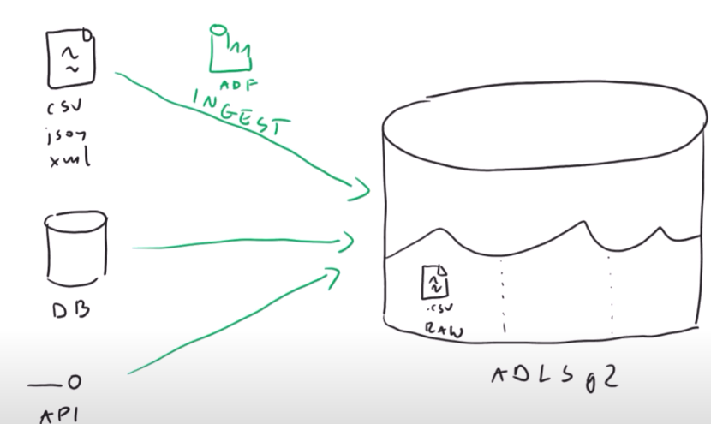

Inside the RAW layer we keep the data in its native state, meaning as it is.

But we know that there is another file format that is better and optimal for data analytics.

Therefore the next that we would do is to convert the data into delta format

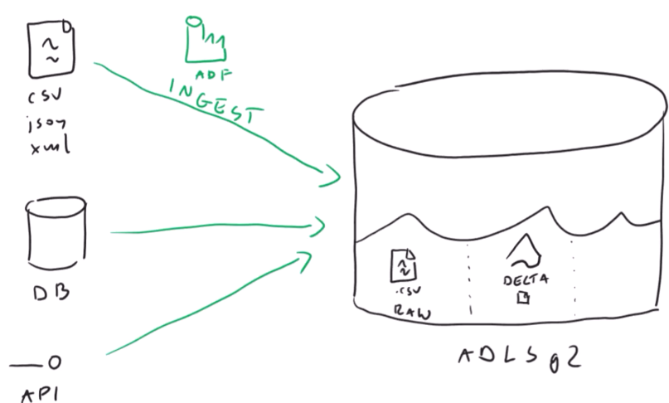

And usually the place where we save the delta files, according to Microsoft Documentation, is Conformed container. You can also name this container as Silver its totally up to the business requirement

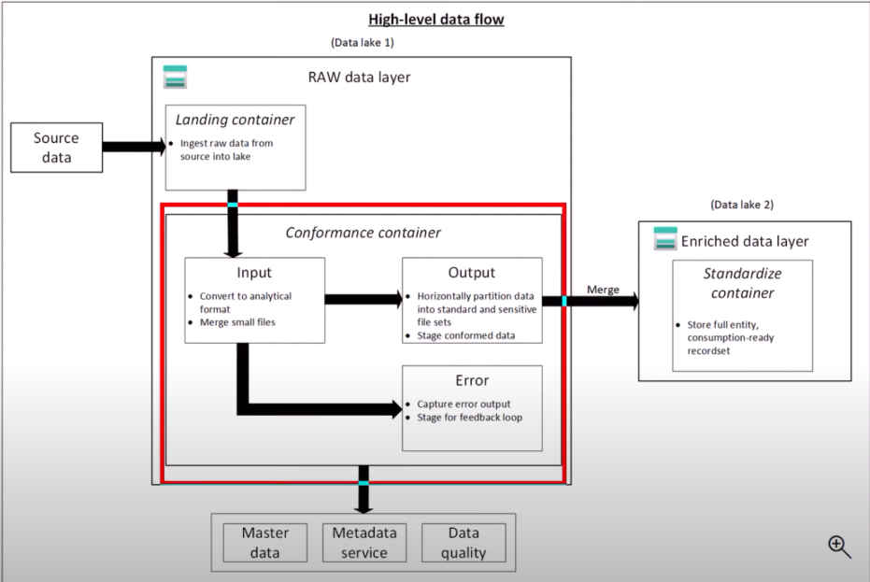

It is totally up to you if you are only converting the data type or doing some other transformation as well.

Agenda: Grab the data from RAW layer, convert the data types, file format to delta or maybe some other steps and save it to another layer. This process could be achieved by Autoloader

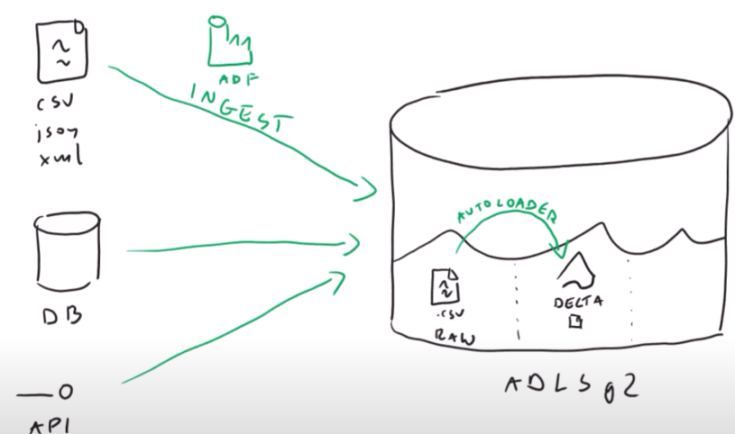

Autoloader: a feature provided by Databricks

**Environment Setup**

Inside the RAW container create *AutoLoaderInput* directory. Suppose we have daily processing

In which ADF connects to data sources, grabs the data and saves it AutoLoaderInput directory as csv format (in our demo). Now, we want Autoloader to detect those files, pick them up, process and save them as delta in different location, i.e, in Conformed container create a separate directory. Additionally, we want to register our newly created data inside Databricks Catalog so that you can easily use data in your queries.

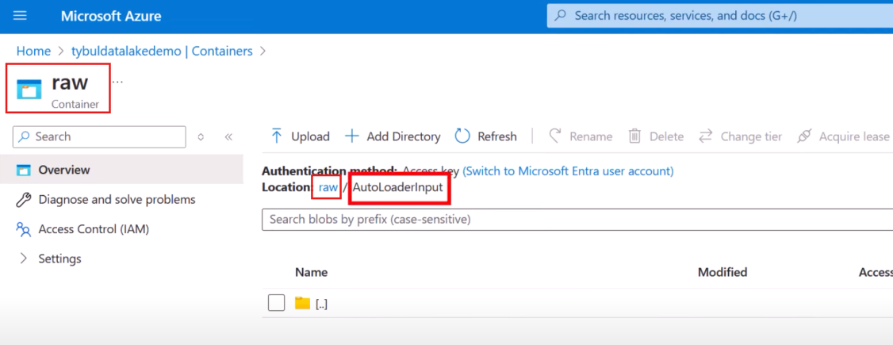

For the demo we manually uploaded a CSV file inside RAW -> AutoLoaderInput

But in real scenarios thi s task would be done by ADF

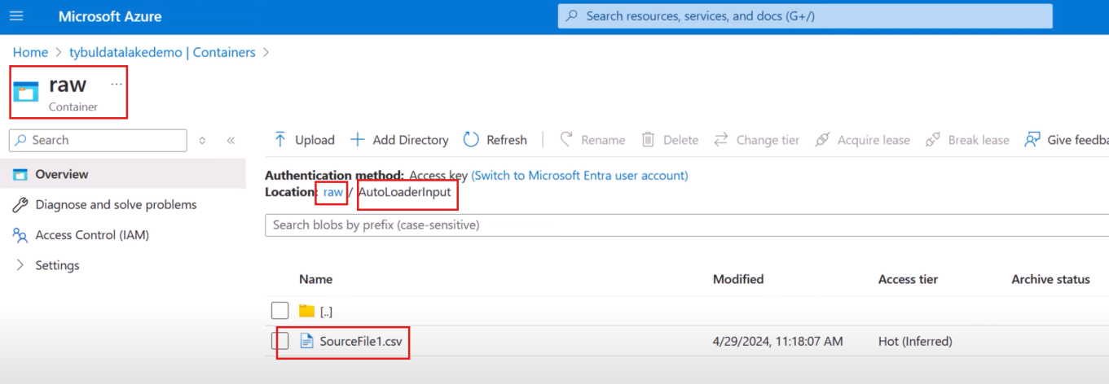

**Code for Autoloader**

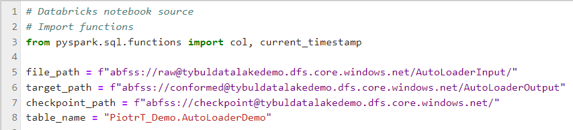

* **File_path** = location from where the AutoLoader should read/detect files(input for Autoloader)
* **Target_path** = location where output should be saved as Delta format (conformed container)
* **Checkpoint_path** = needed by Autoloader to tracks its progress by referring to this container
* **Table_name** = name of database and table to be used in Hive Metastore Catalog.

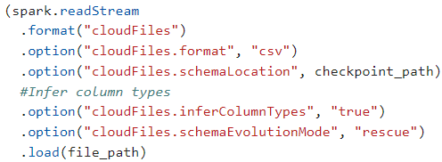

**spark.readStreaim** = hit that Autoloader is using Streaming under the hood

**.format**(“*cloudFiles*”) = Telling Databrick that we want to use Autoloader

**.option**(“*cloudFiles.format*”, “*csv*”) = format of the files input for Autoloader

**.option**(“*cloudFiles.schemaLocation*”, *checkpoint_path*) = location where schema of the input data processed by Autoloader to be saved

**.load**(*file_path*) = load output to the given location

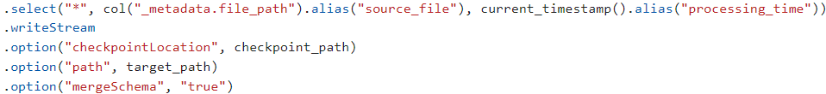

We are adding 2 coulmns : source_file and processing time

.writeStream = once we have the data this phrase will write the data somewhere and that somewhere is defined using the phrase .option(“path”, target_path). And while doing that record your progress to .option(“checkpointLocation”, checkpoint_path).

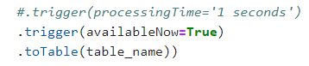

You are asking in code to run the process every 1 sec

Also you are asking to store the data inside Hive Metastore table using .toTable(table_name)

Now to verify if your file inside the AutoloaderInput directory was read, and then put at the conformed container, simply gram the database and table used earlier:

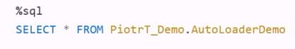

Since you already registered the data in Hive Metastore when you wrote a script for Autoloader

It should be available

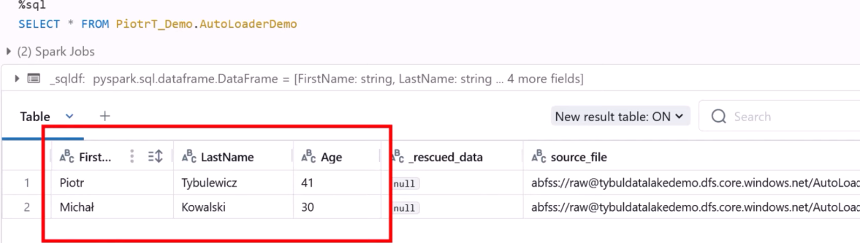

Now to check how our table looks like in the Catalog

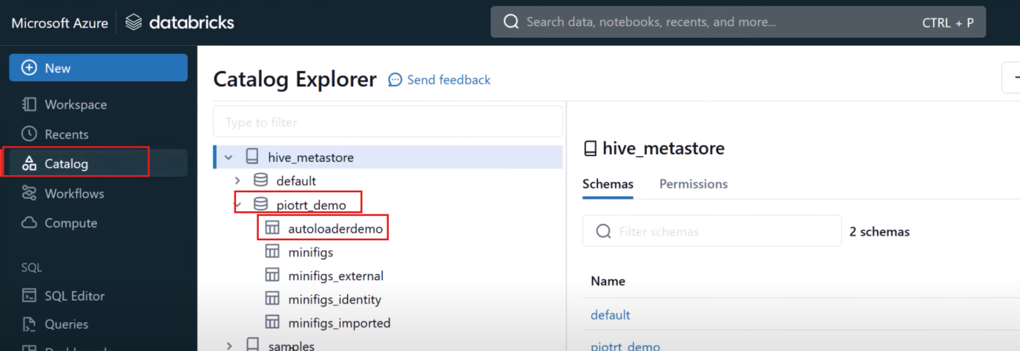

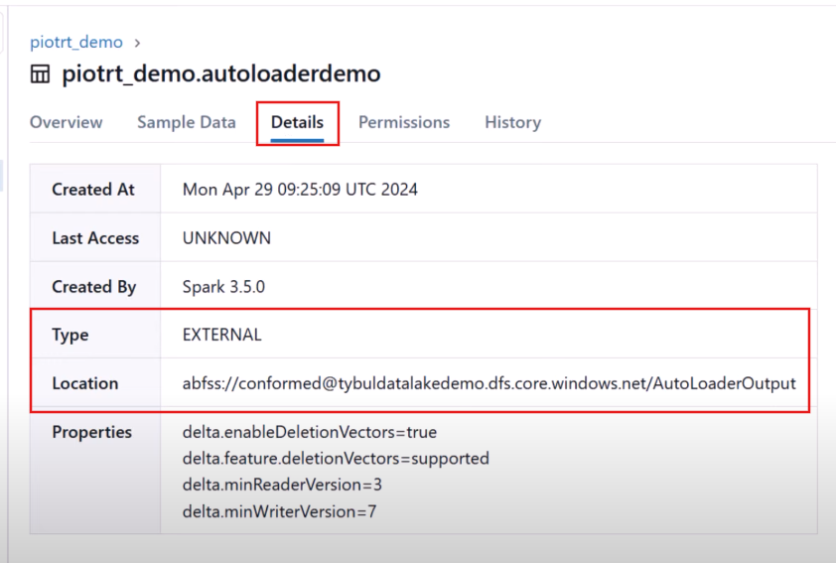

Indeed it is External table and is present in our Datalake

**Schema Inference**

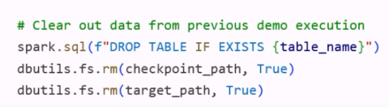

First command will drop you table and last 2 commands will remove data from Datalake.

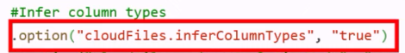

We will ask the Autoloader to infer the schema(data type) of the columns while loading the files

**Schema Evolution**

Suppose source is producing some new columns. And on other hand, the Autoloader has been saving the schema of previously read files inside the “checkpoint_path”

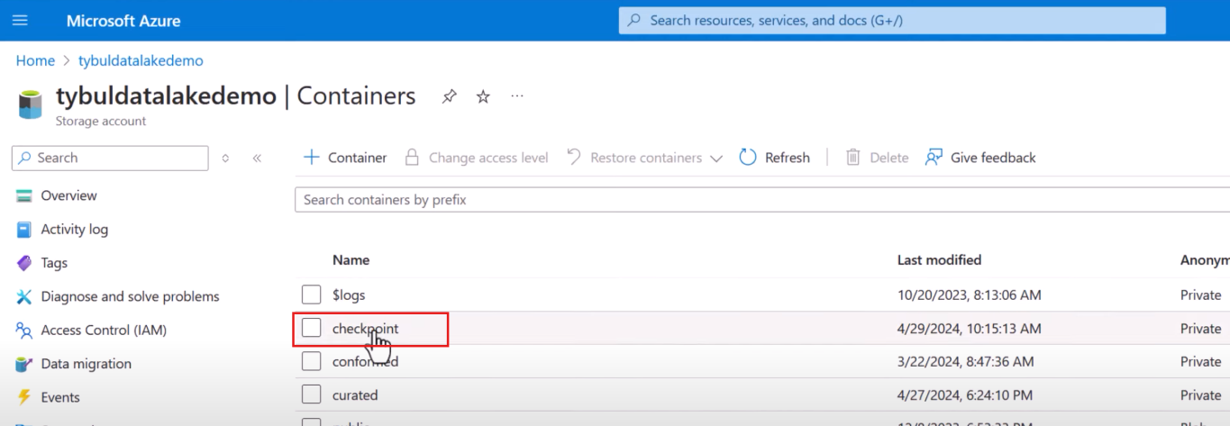

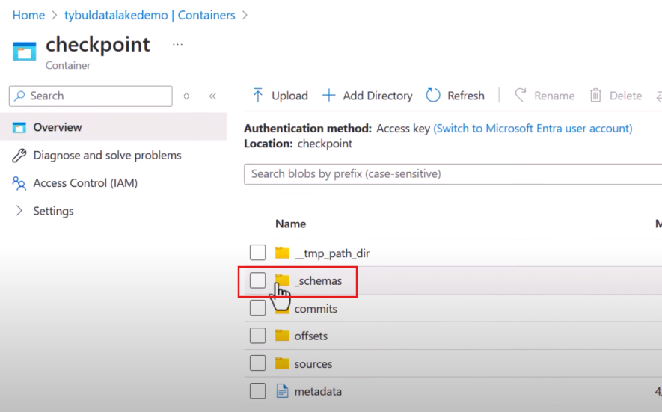

And inside the _schemas container you will have different versions

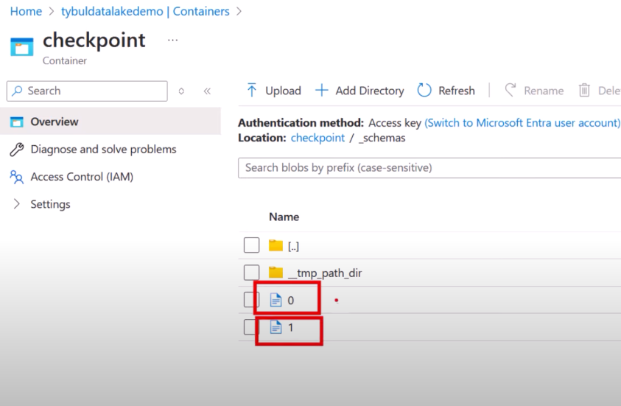

Those versions basically are files that consists of schema generated by Databricks upon reading 2 different files. Meaning if you read n files, the total number of files that would be created inside this _schemas directory will be n.

If you open those files, you can see the columns

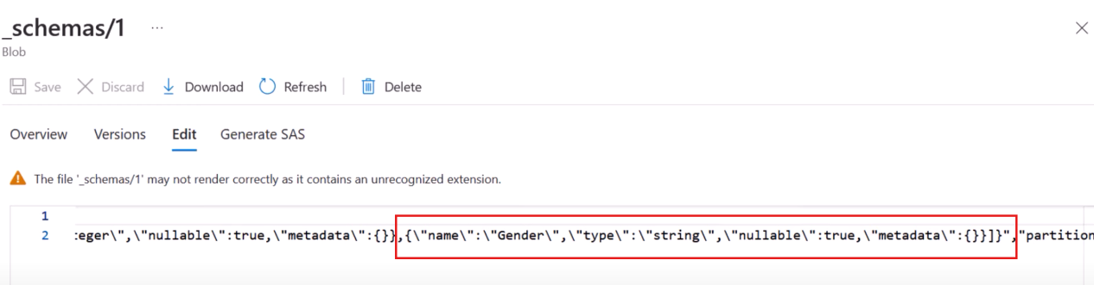

If you want Autoloader to handle schema mismatch issue you use following command



After rerunning the program again you will see new column has been added

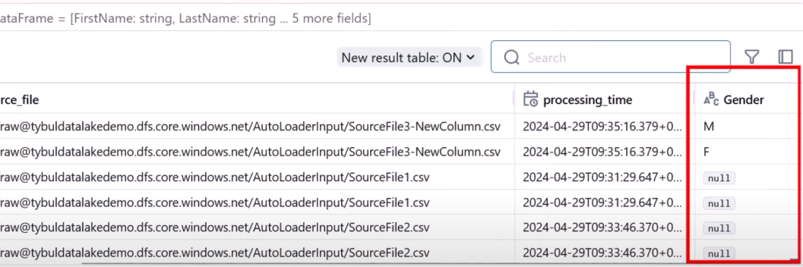

And for rest of the rows the value will be labelled as “null”

There are different modes for Autoloader to address Schema Evolution

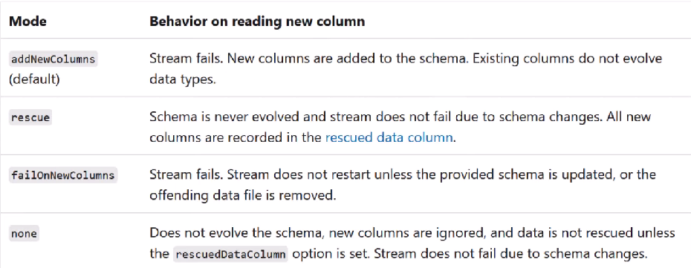

Mode 1 = if there is schema mismatch Autoloader will fail but new columns will be added to the schema and then retry the process.

Mode 2 = The schema will not evolve automatically, and the Autoloader will not fail if there is schema mismatch. Those new columns will be saved in a new column called “rescued data column”

Mode 3 = process will just simply fail if there is schema mismatch. New columns will not be stored anywhere. You must manually update the schema or just delete the file that is creating the error(a strict mode)

Mode 4 = if anything happens, the new columns will be ignored.

Demo (Rescue Mode)

Change the Schema mode



Strat the stream

Now if you rerun your SELECT statement

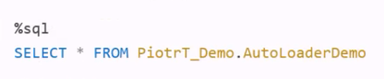

You will see something like

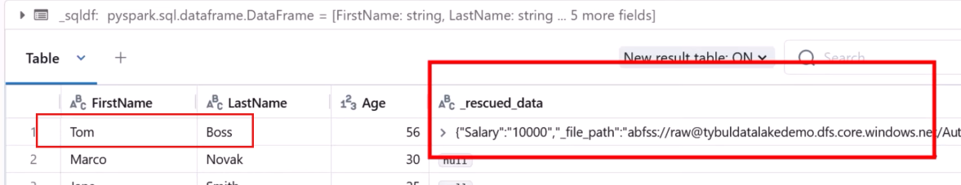

If later if the business wants to incorporate the “Salary” column you can simply parse the rescued data column and reterive the value and put it inside the new column.

**Error Handling**

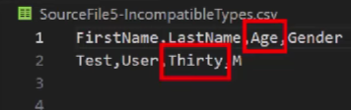

Suppose you can uploading some file and in that file there is “Age” column that accepts integer values. But there is a row that has entry as a string in “Age column”.

And then if you are using rescue mode you would see an entry something like as shown below

You would release the source data is rubbish, and you clean it by updating the value in Age column and change its data type.

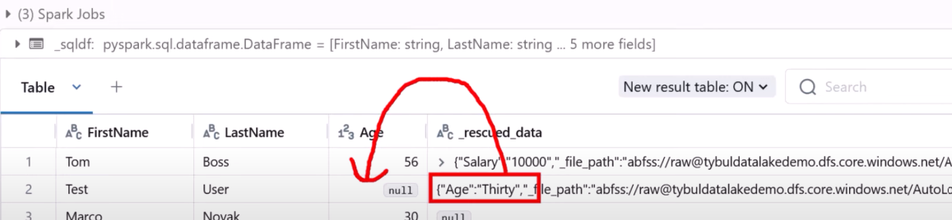

**Batch Processing**

Now there might arise situations when ADF is dumping data in the container that is monitored by the Autoloader. And suppose we configured our pipeline to run during mid-night that would mean our Autoloader would sit ideal for most of the time and under the hood Autoloader is using the Databricks cluster as compute layer that would mean you would have to pay even when nothing is being done.

Change the trigger mode

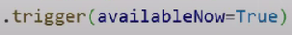

**File Detection Mode**

But the thing is how Autoloader would know which file to process and which files it already processed

The Autoloader saves its progress inside checkpoint location. In this way it knows what things it already has done.



Another thing is we configure input location for Autoloader so that it can detect is something new has been uploaded to that input location. For this Autoloader uses 2 modes:  
a) **Directory listing mode**

evert time Autoloader starts it go to the input location and list everything that is stored in the directory. If there is lots of files, then listing process might take some time and might cost some money.

**b) Notification Mode**

Some process is uploading file to data lake. In Azure there are many events that get created for example when some file is uploaded to a datalake a new event called Evaluation blob created is fired and there are multiple services that could react to the event.

Under the hood it is using Event Grid that is used to manage those events to subscribe to them if something happens.

Autoloader is subscribing to the file created events to the particular location in the Datalake. In the end whenever it's happened autoloader will create a Queue that is part of Storage Account and all of those events will be saves under particular queue as messages. And message will contain information regarding what file was created, where it is stored

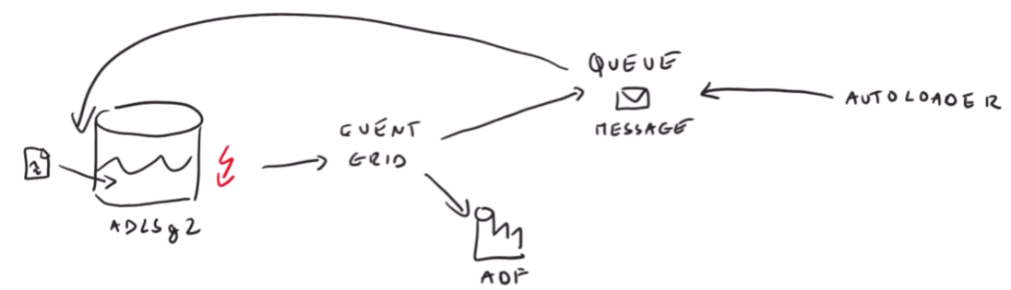

**Lecture 39**

**Azure Synapse Analytics**

Apache Spark is good in processing huge amount of data. And the tool which we were using so far that uses Spark under the hood was Databricks. Databricks is not a product developed by Microsoft. Maybe in company you have some rule not to use 3rd party solution like Databricks. Microsoft gives an option to use Spark Pools in Synapse.

In realty is difficult to work with Spark because it involves configuring various nodes. So, we were using Databricks that made us easier to deploy clusters without caring about the infrastructure.

But if we don’t want to leave Azure Environment, we can do same thing as we have been doing inside Databricks to deploy cluster by utilizing Spark Pools. Therefore, Spark Pools can also be used for data transformation

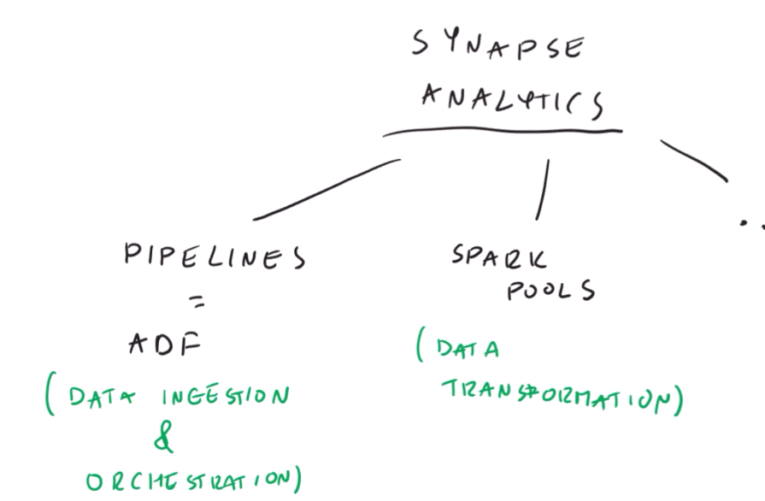

One advantage of using Spark Pools is that it integrates with other Azure services well.

**Setting up Synapse Workspace**

Search “Synapse Analytics”

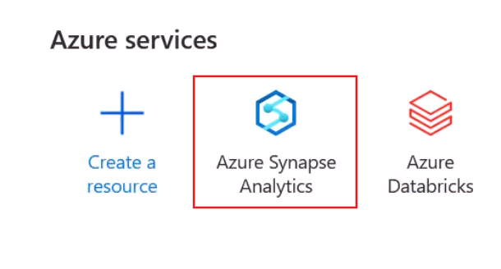

Click on “Create”

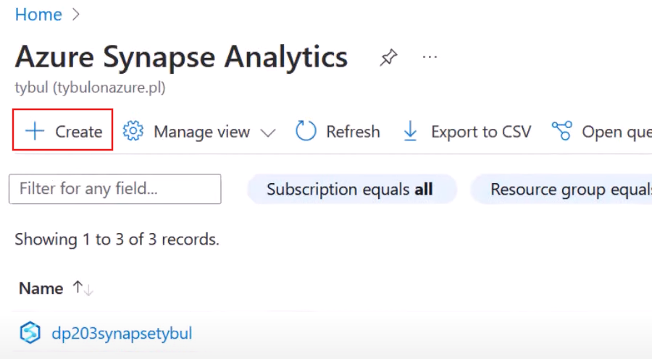

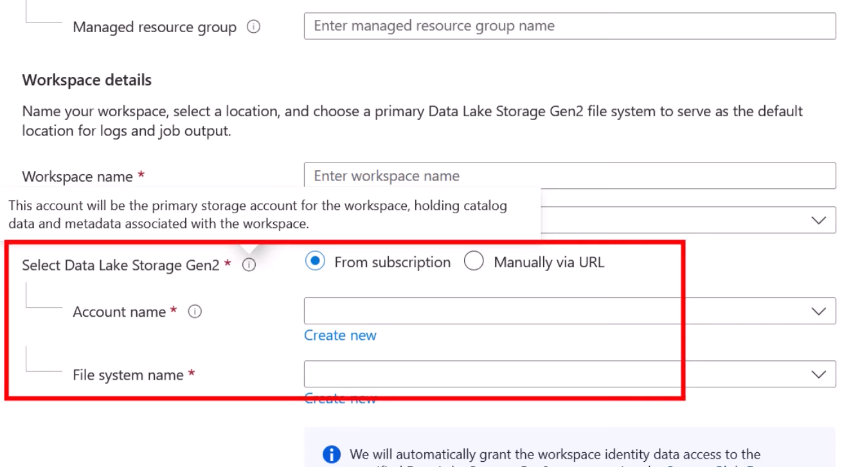

You will have to provide a separate Data Lake for Synapse where it will hold catalog data and metadata associated with the workspace.

Suppose we created the following Storage Account for Synapse. Next step is to create a linked service pointing to the Data Lake dedicated for Synapse Workspace

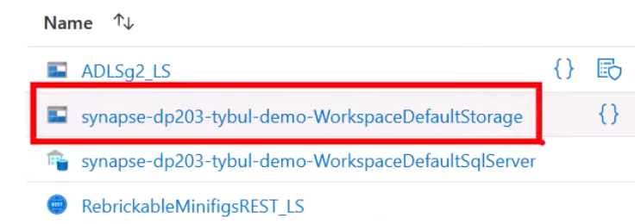

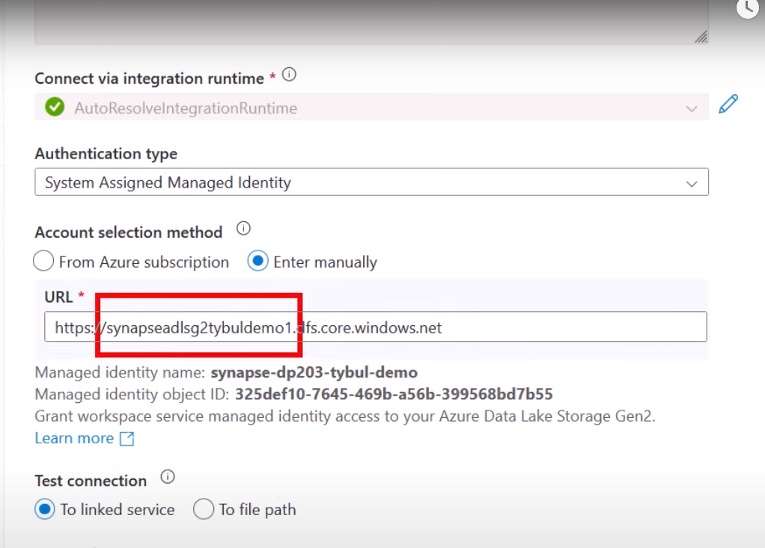

Go to your Synapse Workspace

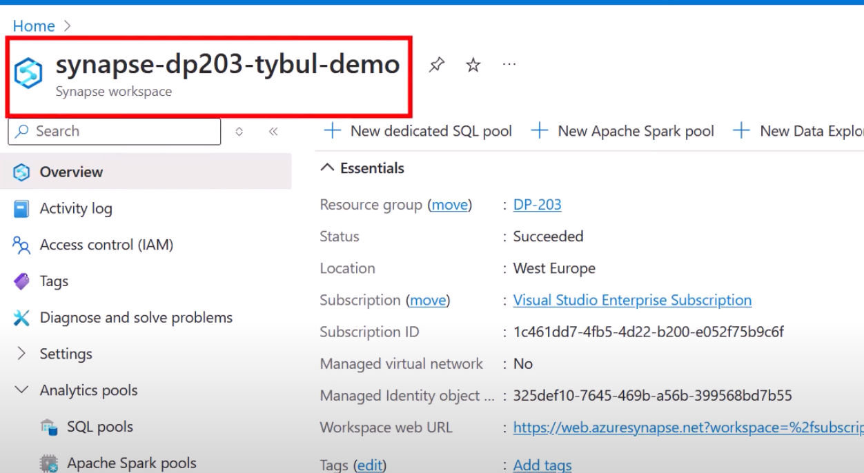

To open UI

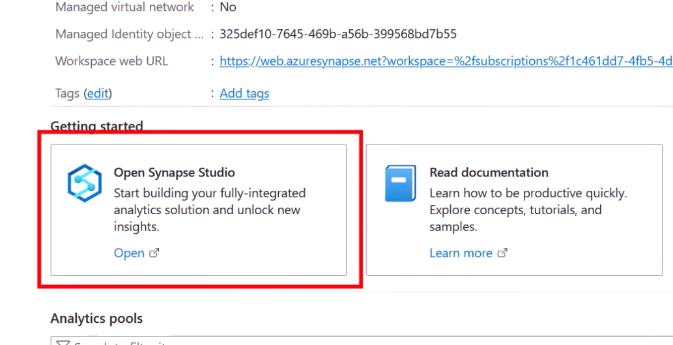

How to make Spark Pool : It is something like cluster from Databricks. Simply a compute power that we will use to run query on our notebooks.

Synapse -> Manage

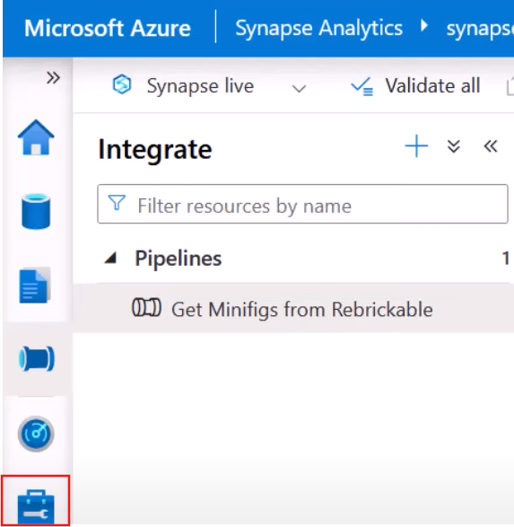

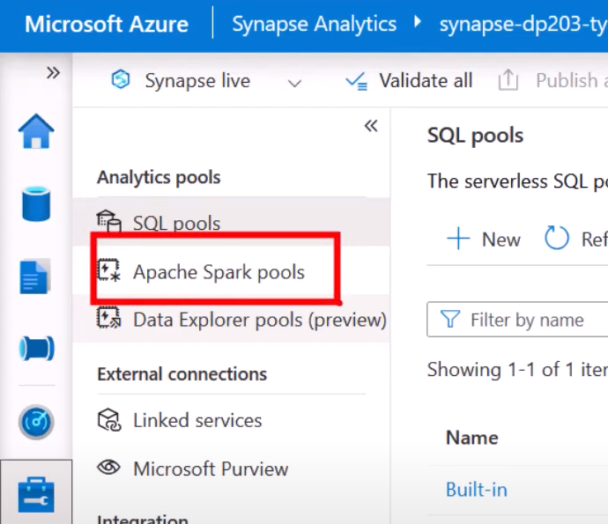

Create a New Spark Pool

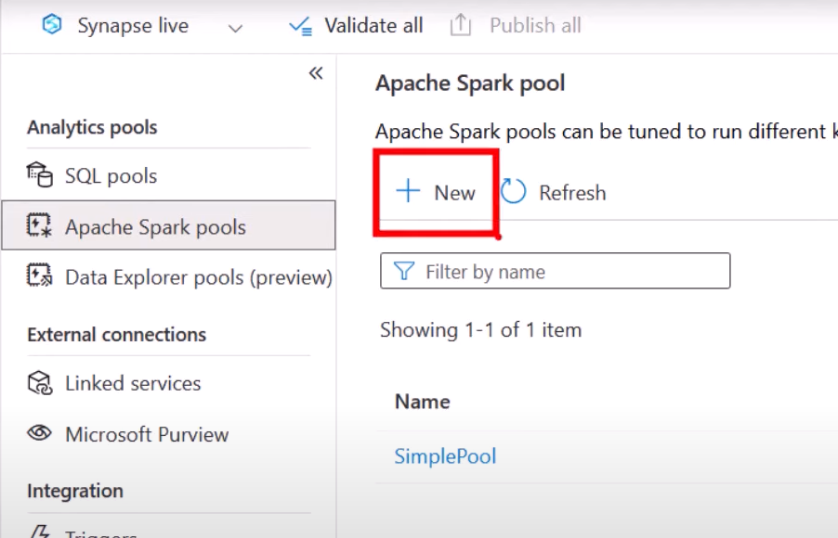

Configure it properly

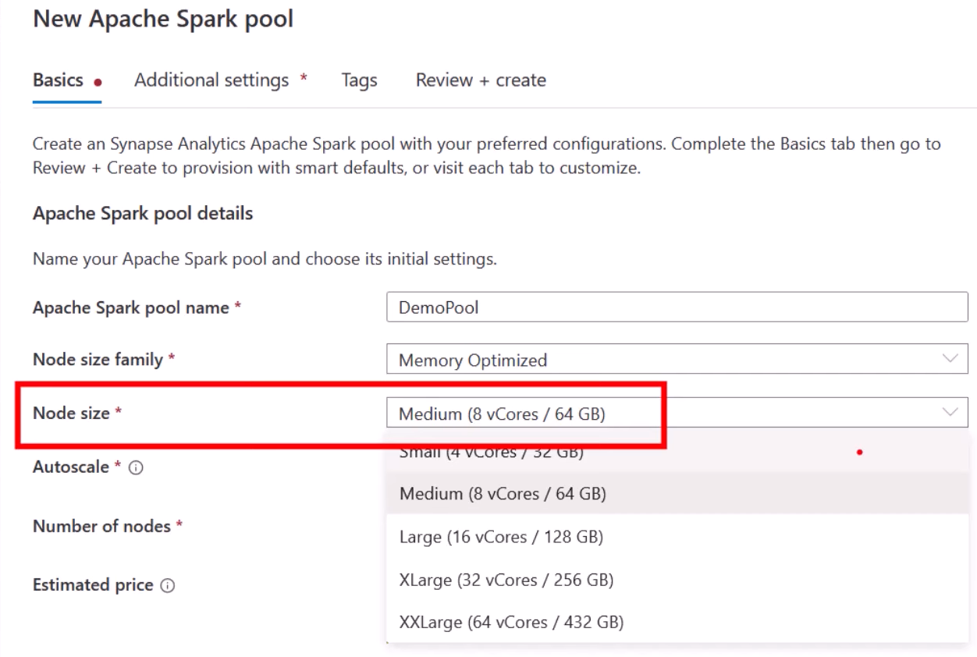

Min Number of nodes always 3

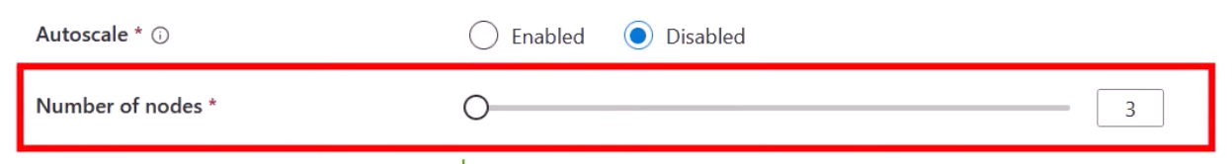

Smallest Pool that you can create consists of 3 nodes. But in Databricks we could create 1 single node

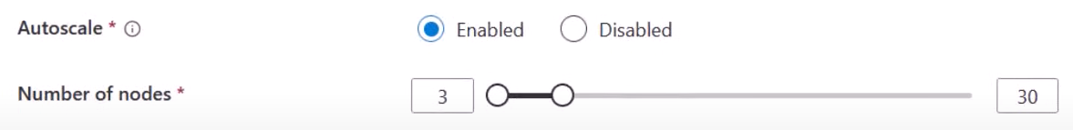

Means as per the demand the number of nodes can be increased but not more than 30

Also, like what we had in Databricks we can turn off the pool when there is no activity

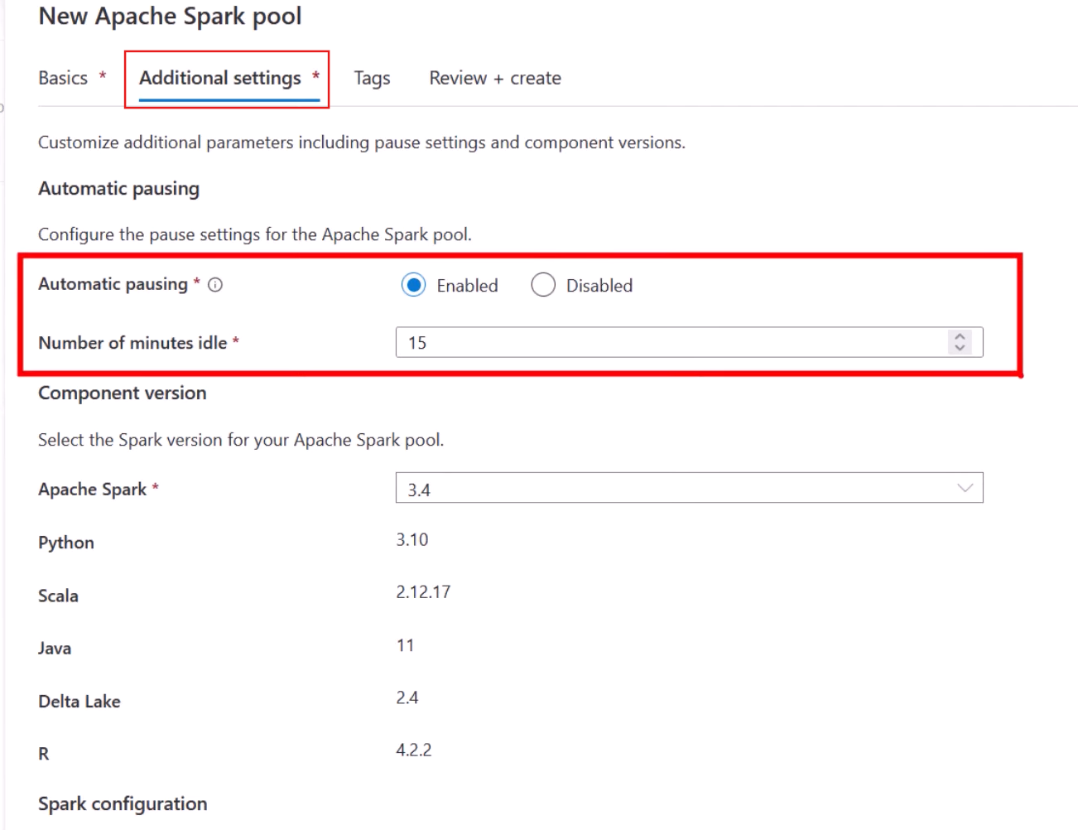

Apache Spark version: they are always behind Databricks in releasing new versions of Spark

Data Tab

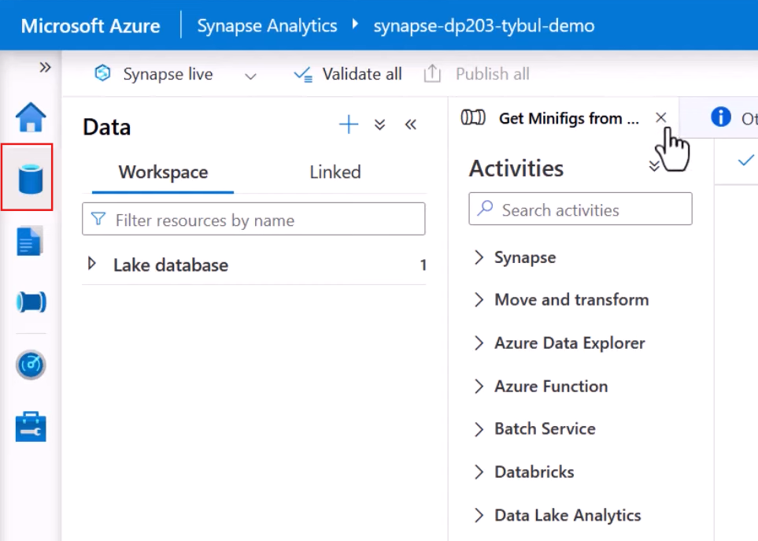

Data tab as 2 inner tabs

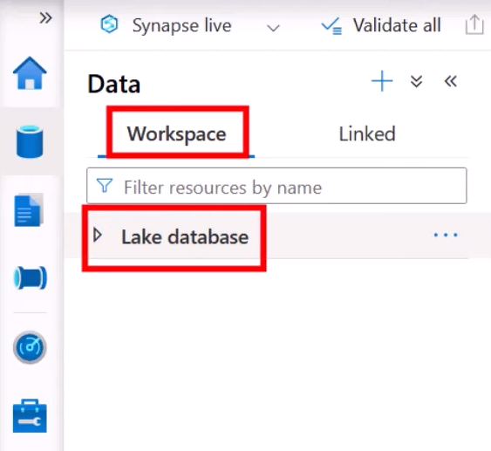

And inside the Linked tab you will see all the linked services related to data that is defined in the workspace

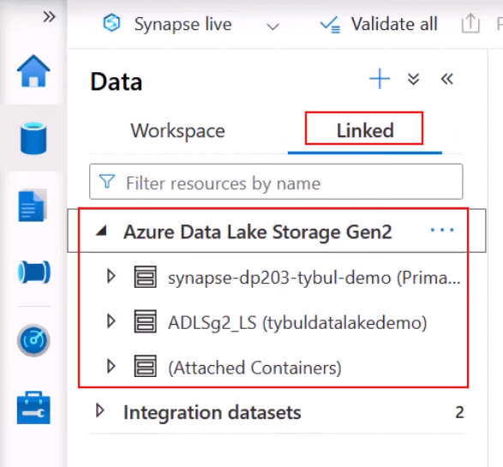

It also allows you to browse the content of the Data Lake without leaving the UI

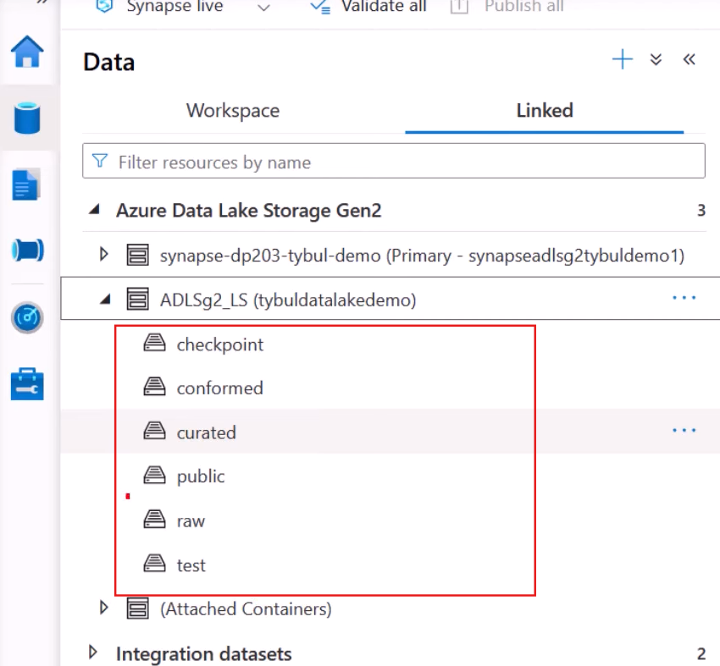

If you open RAW container to which you were ingesting data

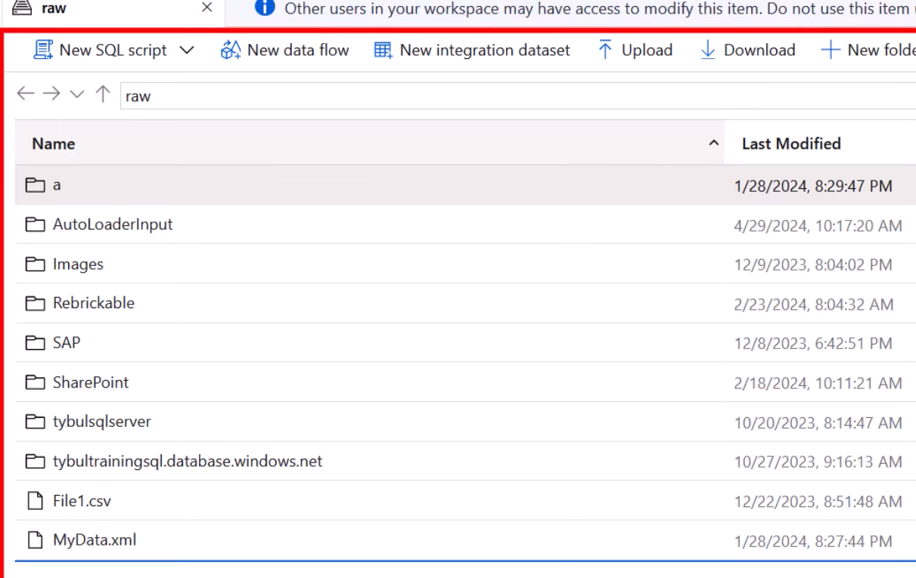

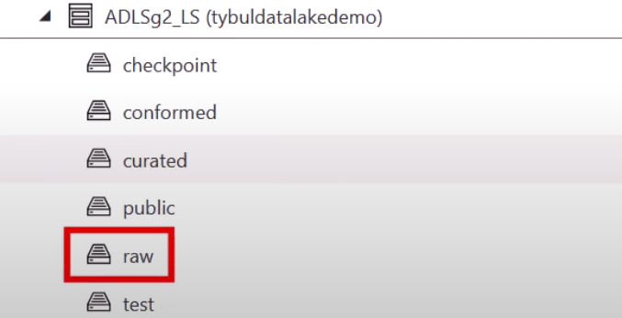

Here you did not configure the security part

One more cool thong is you right click on a file, import it on the Notebook, a code will automatically be generated and then you can run it

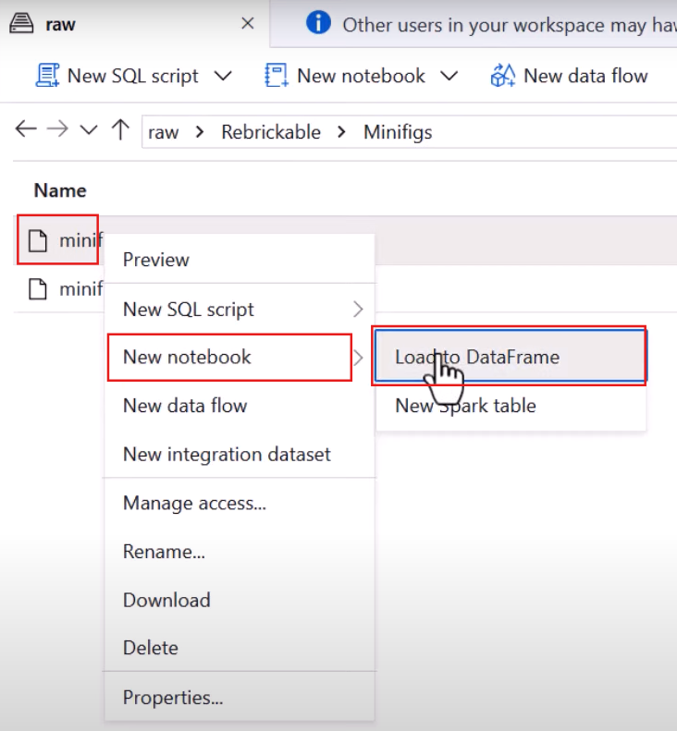

Suppose you are creating a Notebook on Spark Pool. You specify to which pools this notebook should be attached

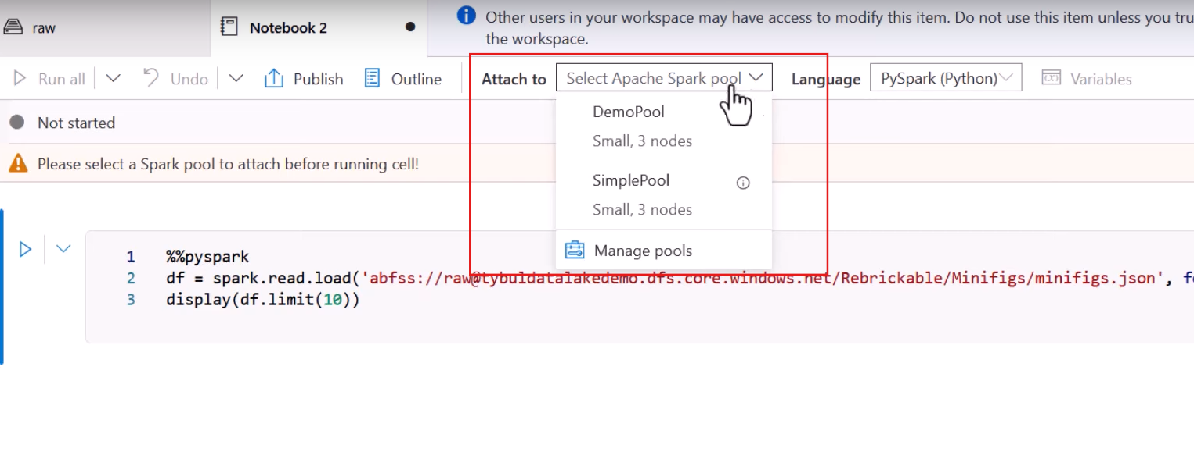

Displaying Data

mssparkutils

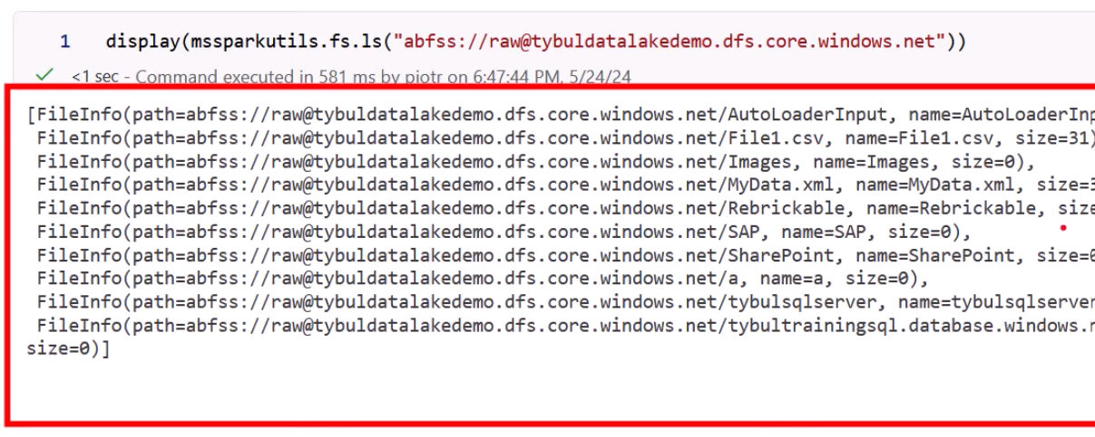

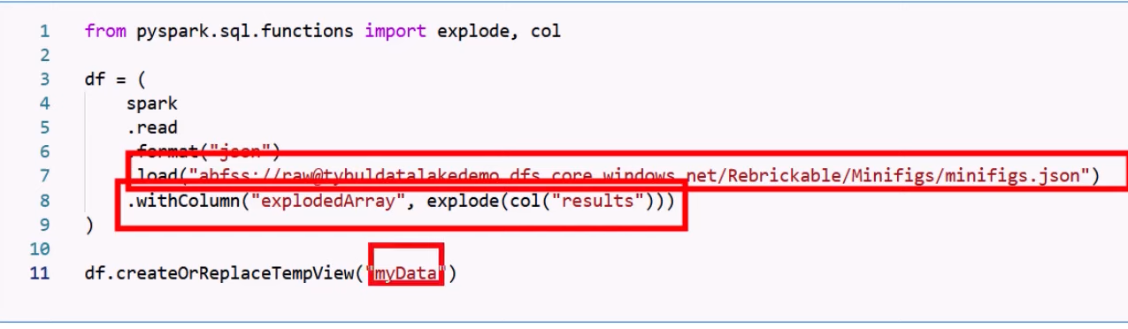

%% , not %

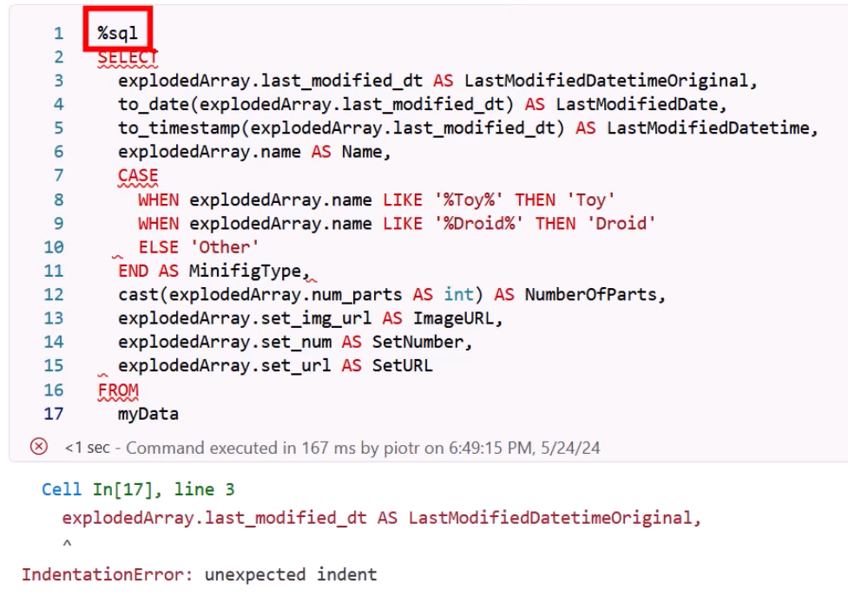

Saving data as delta

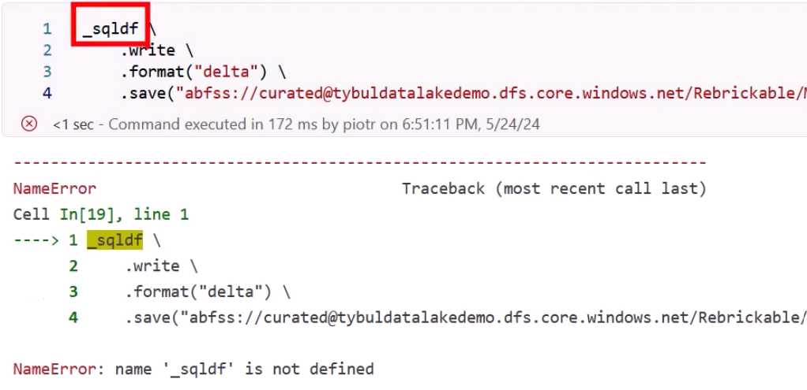

Spark doesn’t know what _sqldf is

Assign explicitly your transformed results to a dataframe

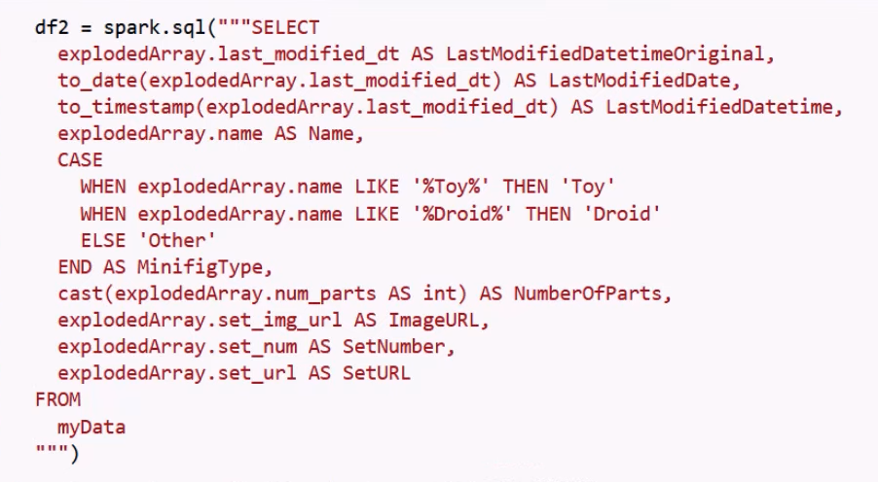

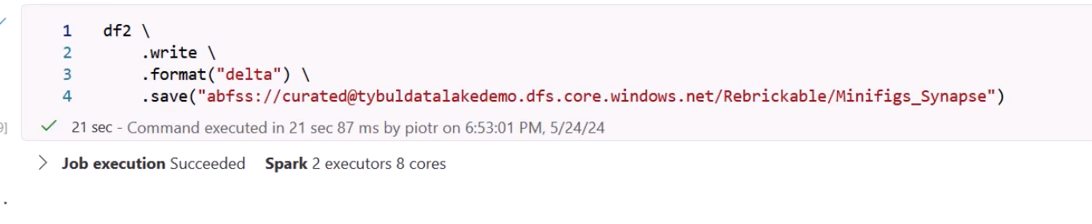

Again, read the delta file

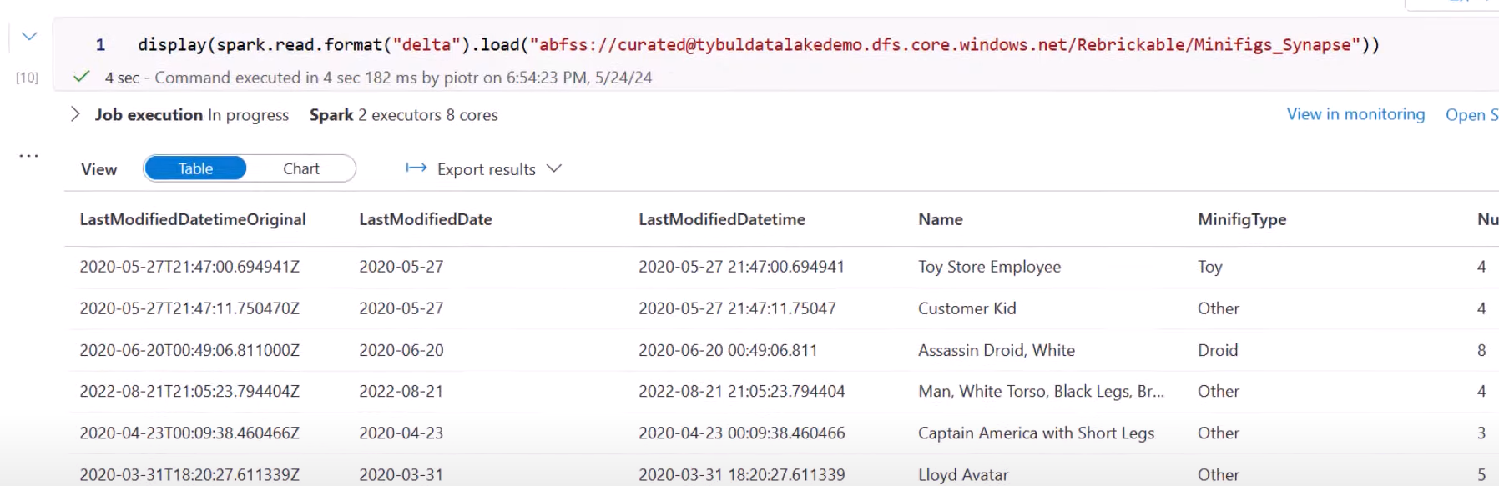

Creating Database

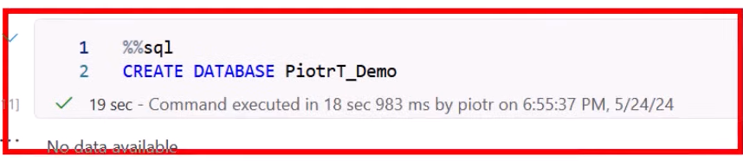

Populate the table

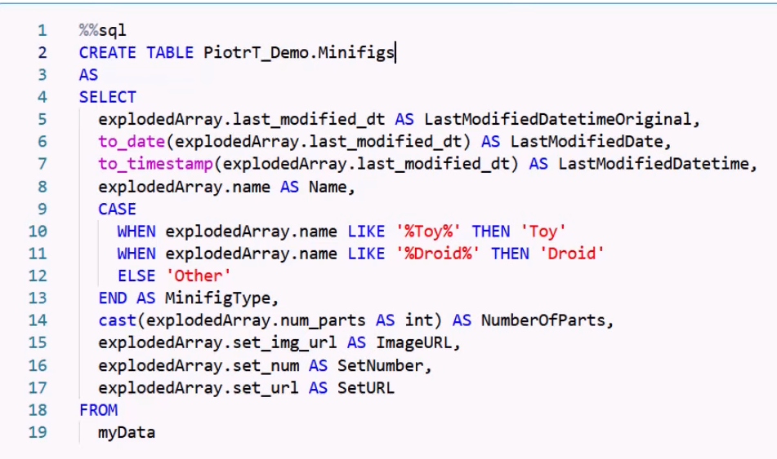

Now read data from this table

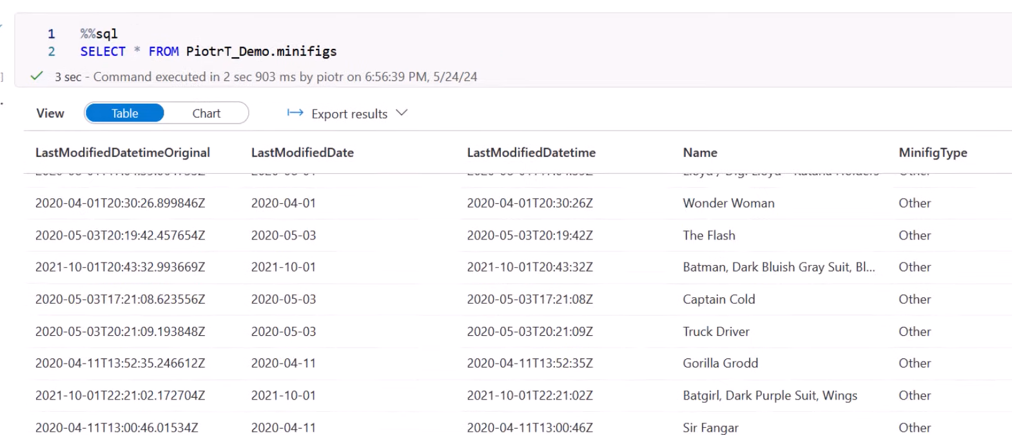

It means that data was saved somewhere and minifig table was registered somewhere. But where>

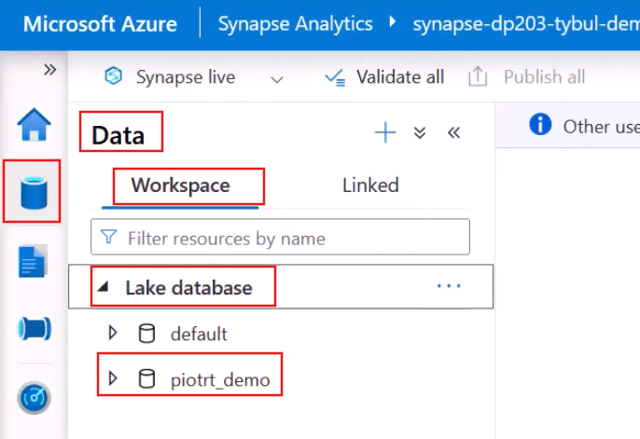

And if you open it

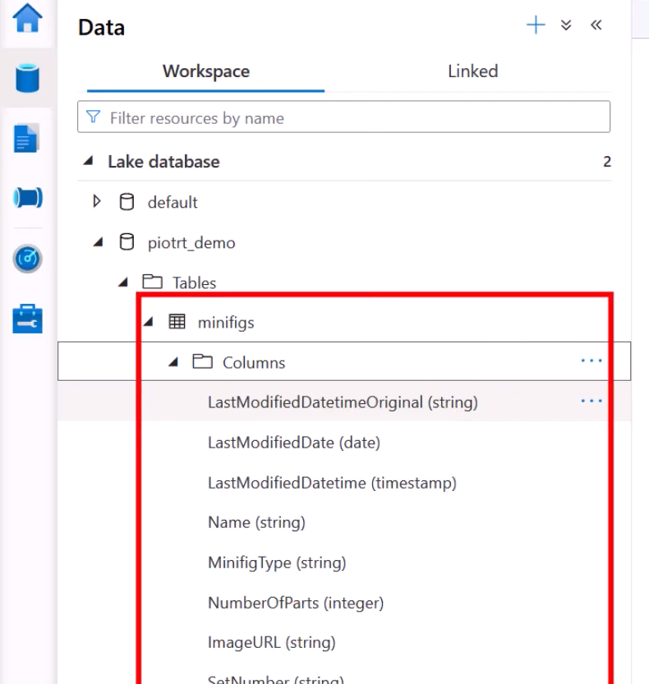

You can see the minifig table with metadata

Remember, in Databricks Hive Metastore we were able to see properties of tables. But in case of Synapse, you have to write a script

Now you are interested in where is minifig getting stored

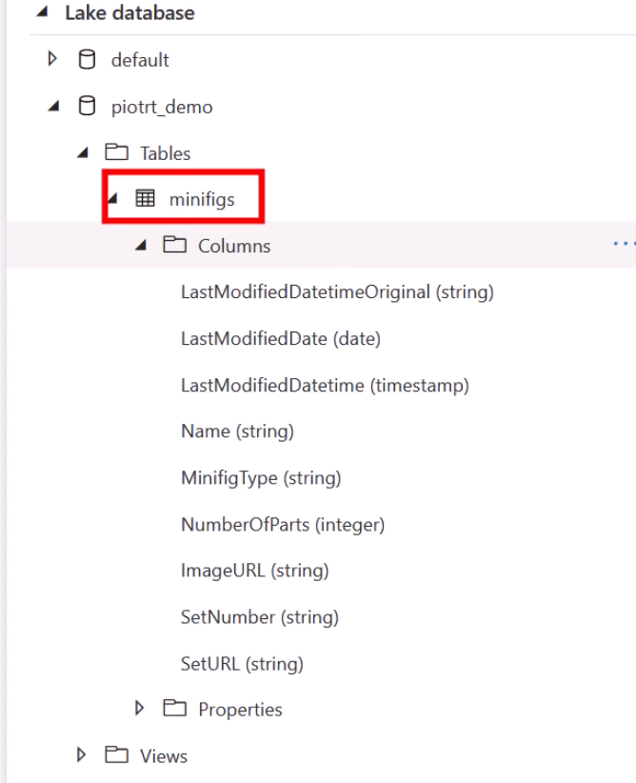

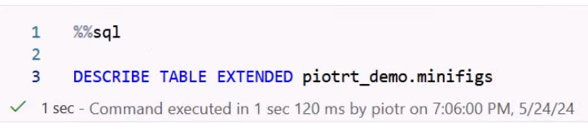

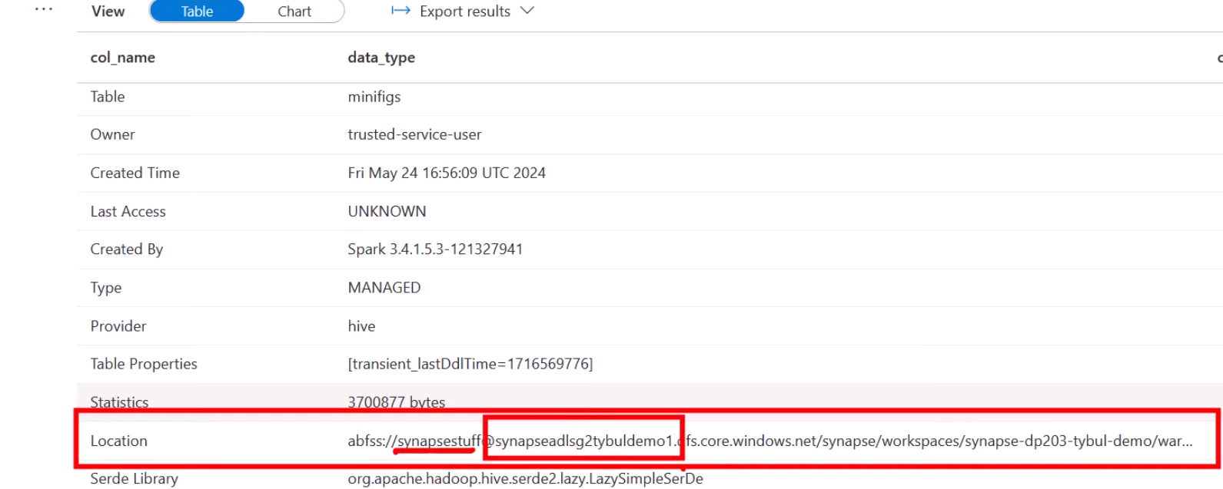

That’s the primary storage of Synapse Workspace

One more thing is Databricks save file as delta by default whereas Synapse doesn’t

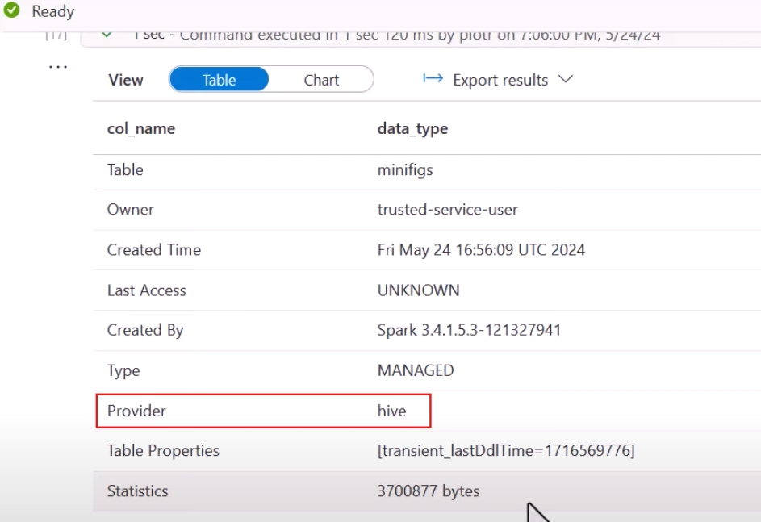

Now if you have to save file as delta you have to tell Synapse explicitly

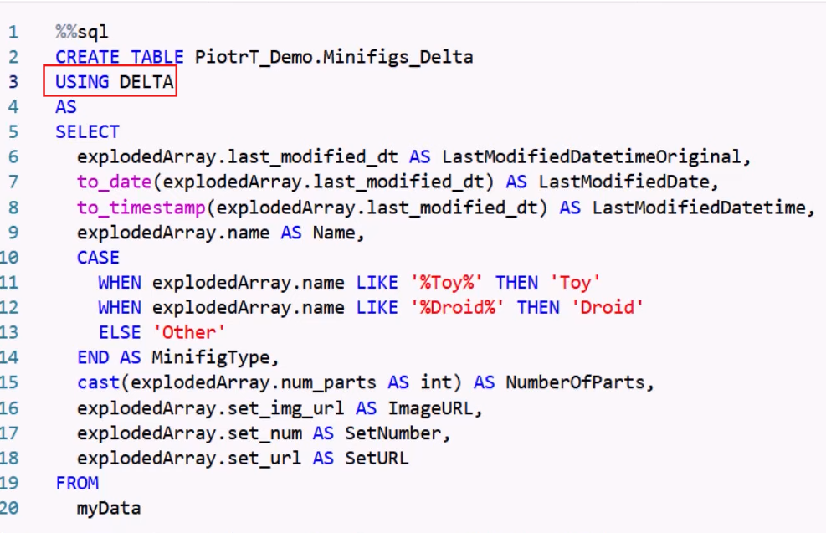

Saving Data to our Data lake

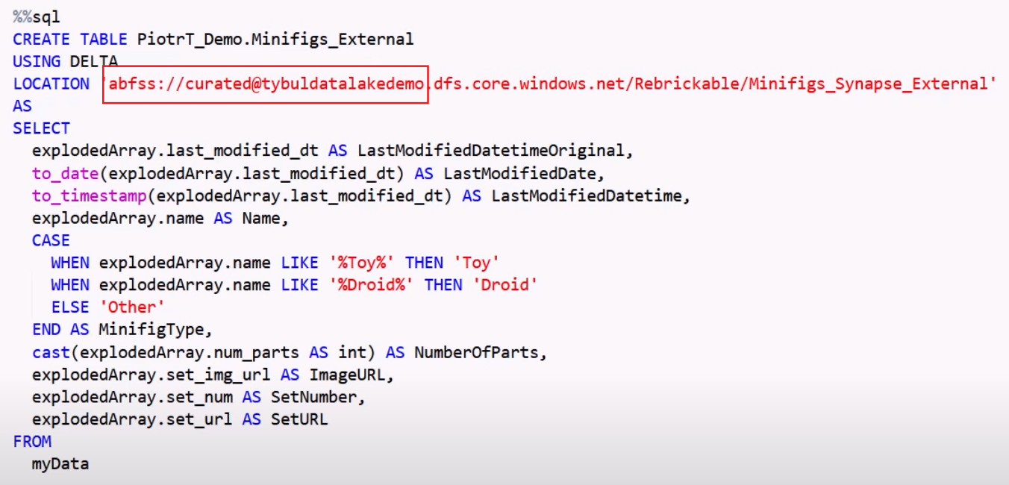

**Lecture 41**

**Transforming data with Data Flows**

## What are data flows?

Data flows are visually designed data transformations in Azure Synapse Analytics. Data flows allow data engineers to develop data transformation logic without writing code. The resulting data flows are executed as activities within Azure Synapse Analytics pipelines that use scaled-out Apache Spark clusters. Data flow activities can be operationalized using existing Azure Synapse Analytics scheduling, control, flow, and monitoring capabilities.

Data flows provide an entirely visual experience with no coding required. Your data flows run on Synapse-managed execution clusters for scaled-out data processing. Azure Synapse Analytics handles all the code translation, path optimization, and execution of your data flow jobs.

## Authoring data flows

Data flow has a unique authoring canvas designed to make building transformation logic easy. The data flow canvas is separated into three parts: the top bar, the graph, and the configuration panel.

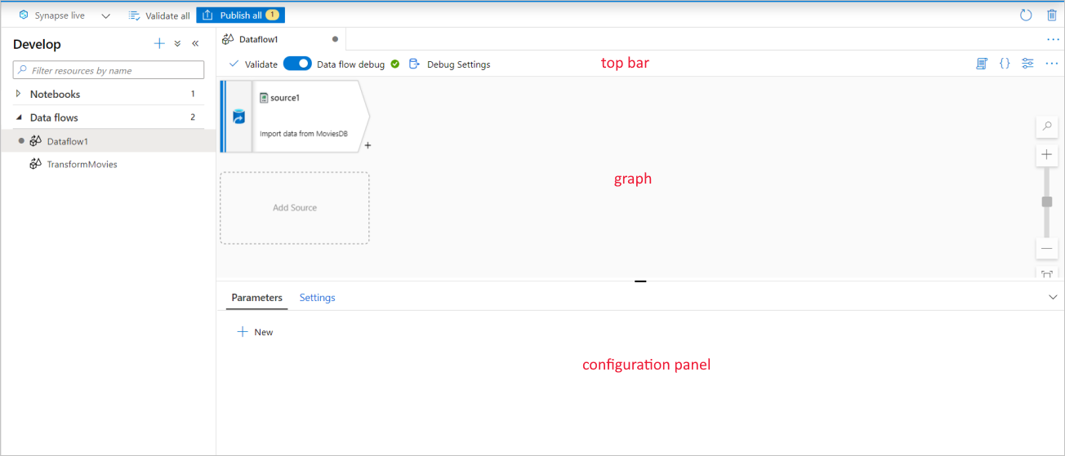

### Graph

The graph displays the transformation stream. It shows the lineage of source data as it flows into one or more sinks. To add a new source, select **Add source**. To add a new transformation, select the plus sign on the lower right of an existing transformation. Learn more on how to [manage the data flow graph](https://learn.microsoft.com/en-us/azure/data-factory/concepts-data-flow-manage-graph?context=/azure/synapse-analytics/context/context).

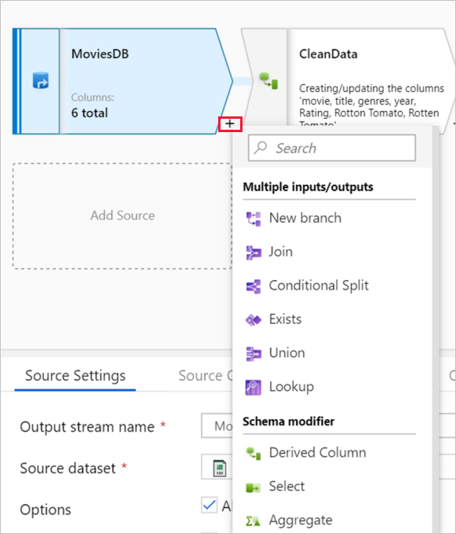

### Configuration panel

The configuration panel shows the settings specific to the currently selected transformation. If no transformation is selected, it shows the data flow. In the overall data flow configuration, you can add parameters via the **Parameters** tab.

Each transformation contains at least four configuration tabs.

#### Transformation settings

The first tab in each transformation's configuration pane contains the settings specific to that transformation.

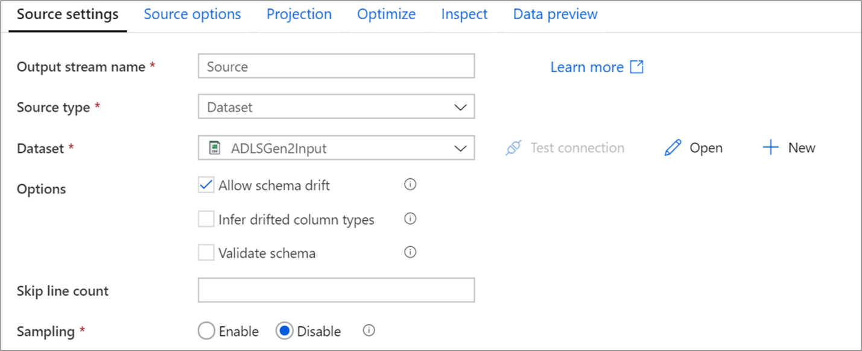

#### Optimize

The **Optimize** tab contains settings to configure partitioning schemes.

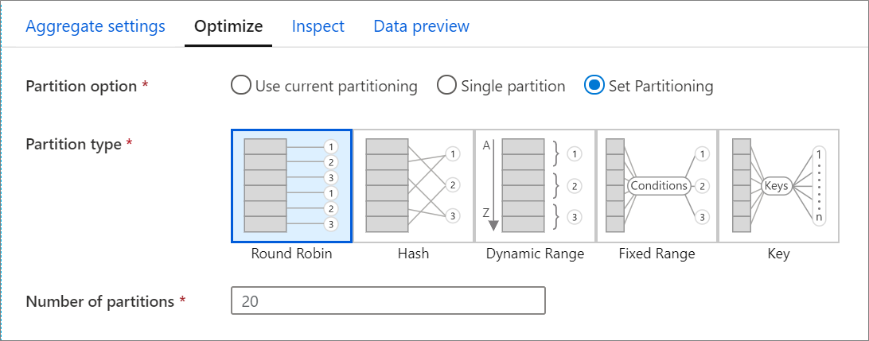

#### Inspect

The **Inspect** tab provides a view into the metadata of the data stream that you're transforming. You can see column counts, the columns changed, the columns added, data types, the column order, and column references. **Inspect** is a read-only view of your metadata. You don't need to have debug mode enabled to see metadata in the **Inspect** pane.

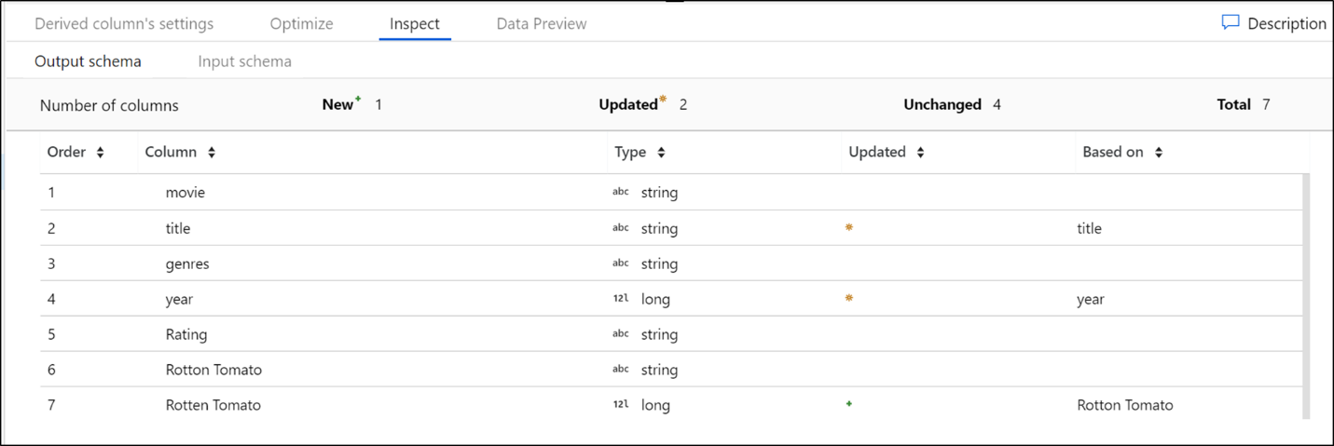

As you change the shape of your data through transformations, you'll see the metadata changes flow in the **Inspect** pane. If there isn't a defined schema in your source transformation, then metadata won't be visible in the **Inspect** pane. Lack of metadata is common in schema drift scenarios.

### Top bar

The top bar contains actions that affect the whole data flow, like validation and debug settings. You can view the underlying JSON code and data flow script of your transformation logic as well.

## Getting started

Data flows are created from the Develop pane in Synapse studio. To create a data flow, select the plus sign next to **Develop**, and then select **Data Flow**.

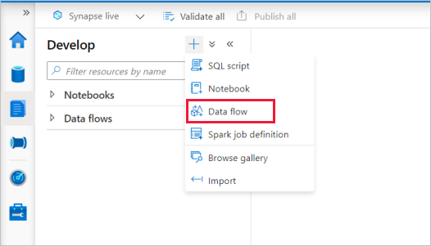

This action takes you to the data flow canvas, where you can create your transformation logic. Select **Add source** to start configuring your source transformation.

# Source transformation in mapping data flows

Data flows are available both in Azure Data Factory and Azure Synapse Pipelines.

A source transformation configures your data source for the data flow. When you design data flows, your first step is always configuring a source transformation. To add a source, select the **Add Source** box in the data flow canvas.

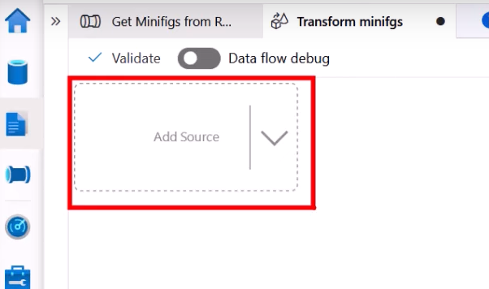

Every data flow requires at least one source transformation, but you can add as many sources as necessary to complete your data transformations. You can join those sources together with a join, lookup, or a union transformation.

Each source transformation is associated with exactly one dataset or linked service. The dataset defines the shape and location of the data you want to write to or read from. If you use a file-based dataset, you can use wildcards and file lists in your source to work with more than one file at a time.

## Integration datasets

It means that reuse one of the datasets that we created previously. This option helps us to choose a dataset that is available and visible in the scope of our whole Synapse Workspace

## Inline datasets

Persists only to the scope of a particular dataflow. They will not be available to be used outside.

Inline datasets are recommended when you use flexible schemas, one-off source instances, or parameterized sources. If your source is heavily parameterized, inline datasets allow you to not create a "dummy" object. Inline datasets are based in Spark, and their properties are native to data flow.

### Schema options

Because an inline dataset is defined inside the data flow, there isn't a defined schema associated with the inline dataset. On the Projection tab, you can import the source data schema and store that schema as your source projection. On this tab, you find a "Schema options" button that allows you to define the behavior of ADF's schema discovery service.

* Use projected schema: This option is useful when you have a large number of source files that ADF scans as your source. ADF's default behavior is to discover the schema of every source file. But if you have a pre-defined projection already stored in your source transformation, you can set this to true and ADF skips auto-discovery of every schema. With this option turned on, the source transformation can read all files in a much faster manner, applying the pre-defined schema to every file.
* Allow schema drift: Turn on schema drift so that your data flow allows new columns that aren't already defined in the source schema.
* Validate schema: Setting this option causes the data flow to fail if any column and type defined in the projection doesn't match the discovered schema of the source data.
* Infer drifted column types: When new drifted columns are identified by ADF, those new columns are cast to the appropriate data type using ADF's automatic type inference.

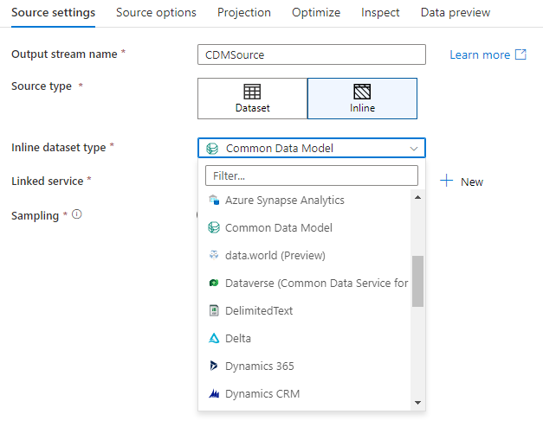

## Workspace DB (Synapse workspaces only)

In Azure Synapse workspaces, an additional option is present in data flow source transformations called Workspace DB. This allows you to directly pick a workspace database of any available type as your source data without requiring additional linked services or datasets. The databases created through the [Azure Synapse database templates](https://learn.microsoft.com/en-us/azure/synapse-analytics/database-designer/overview-database-templates) are also accessible when you select Workspace DB.

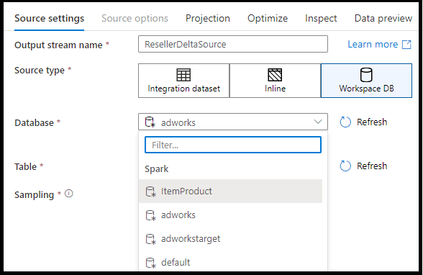

## Source settings

After you've added a source, configure via the **Source settings** tab. Here you can pick or create the dataset your source points at. You can also select schema and sampling options for your data.

Development values for dataset parameters can be configured in [debug settings](https://learn.microsoft.com/en-us/azure/data-factory/concepts-data-flow-debug-mode). (Debug mode must be turned on.)

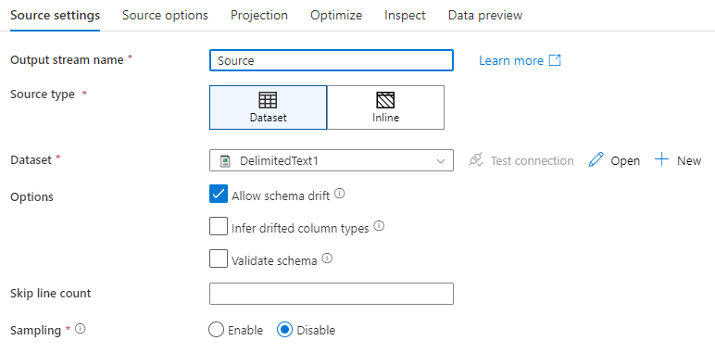

**Output stream name**: The name of the source transformation.

**Source type**: Choose whether you want to use an inline dataset or an existing dataset object.

**Test connection**: Test whether or not the data flow's Spark service can successfully connect to the linked service used in your source dataset. Debug mode must be on for this feature to be enabled.

**Schema drift**: [Schema drift](https://learn.microsoft.com/en-us/azure/data-factory/concepts-data-flow-schema-drift) is the ability of the service to natively handle flexible schemas in your data flows without needing to explicitly define column changes.

* Select the **Allow schema drift** check box if the source columns change often. This setting allows all incoming source fields to flow through the transformations to the sink.
* Selecting **Infer drifted column types** instructs the service to detect and define data types for each new column discovered. With this feature turned off, all drifted columns are of type string.

**Validate schema:** If **Validate schema** is selected, the data flow fails to run if the incoming source data doesn't match the defined schema of the dataset.

**Skip line count**: The **Skip line count** field specifies how many lines to ignore at the beginning of the dataset.

**Sampling**: Enable **Sampling** to limit the number of rows from your source. Use this setting when you test or sample data from your source for debugging purposes. This is very useful when executing data flows in debug mode from a pipeline.

To validate your source is configured correctly, turn on debug mode and fetch a data preview. For more information, see [Debug mode](https://learn.microsoft.com/en-us/azure/data-factory/concepts-data-flow-debug-mode).

.

## Source options

The **Source options** tab contains settings specific to the connector and format chosen. This includes details like isolation level for those data sources that support it (like on-premises SQL Servers, Azure SQL Databases, and Azure SQL Managed instances), and other data source specific settings as well.

## Projection

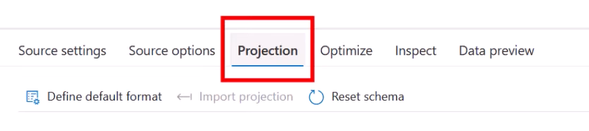

Used to show schema of input and output data. Meaning it will give some idea how our data looks like when it enters the transformation and how the data will look when it leaves our transformation.

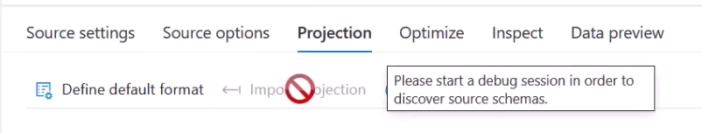

However, the dataflows are visual tool it needs some compute power to execute our steps. In case of pipelines Integration Runtimes were our compute infrastructure.

Debug Mode is telling Azure to prepare Integration Runtime that would execute various steps in our dataflow

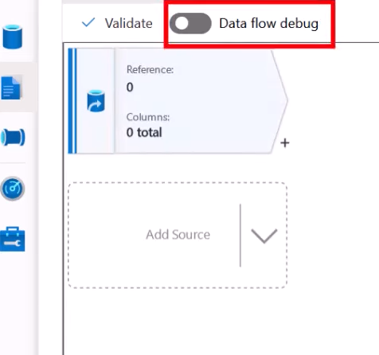 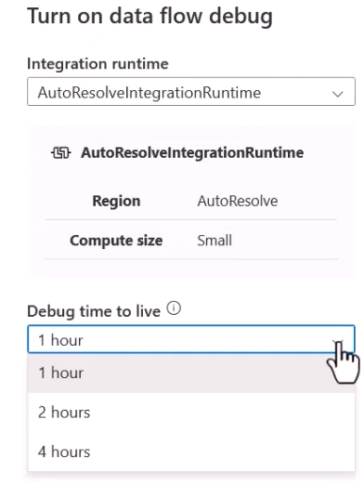

Debug time to live is for shutting down the Spark Cluster when in no use.

Integration Runtime choice: Self-hosted runtimes are not supported. Azure integration runtimes and Azure integration runtime with managed virtual network are supported

Like schemas in datasets, the projection in a source defines the data columns, types, and formats from the source data. For most dataset types, such as SQL and Parquet, the projection in a source is fixed to reflect the schema defined in a dataset. When your source files aren't strongly typed (for example, flat .csv files rather than Parquet files), you can define the data types for each field in the source transformation.

### Import schema

Select the **Import schema** button on the **Projection** tab to use an active debug cluster to create a schema projection. It's available in every source type. Importing the schema here overrides the projection defined in the dataset. The dataset object won't be changed.

Importing schema is useful in datasets like Avro and Azure Cosmos DB that support complex data structures that don't require schema definitions to exist in the dataset. For inline datasets, importing schema is the only way to reference column metadata without schema drift.

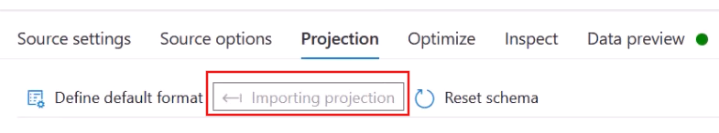

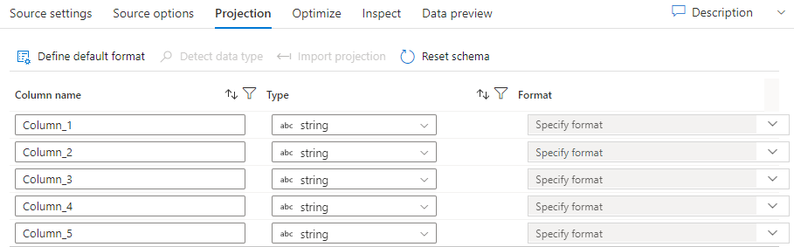

If your text file has no defined schema, select **Detect data type** so that the service samples and infers the data types. Select **Define default format** to autodetect the default data formats.

**Reset schema** resets the projection to what is defined in the referenced dataset.

**Overwrite schema** allows you to modify the projected data types here the source, overwriting the schema-defined data types. You can alternatively modify the column data types in a downstream derived-column transformation. Use a select transformation to modify the column names.

#### Data preview

If debug mode is on, the **Data Preview** tab gives you an interactive snapshot of the data at each transform.

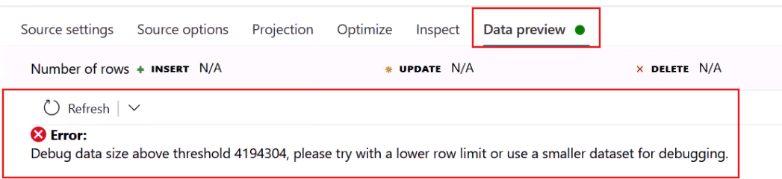

To fix the above error:

Debug Settings 🡺 Row limit

Lower the number of rows to be read

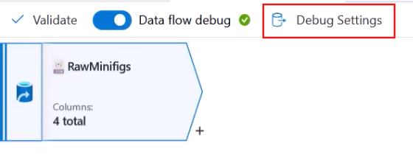

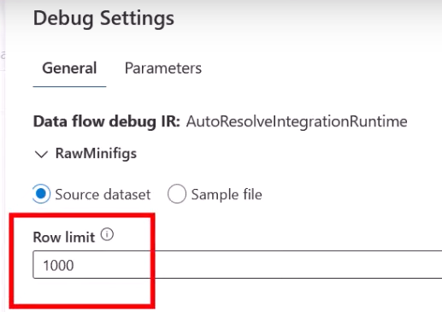

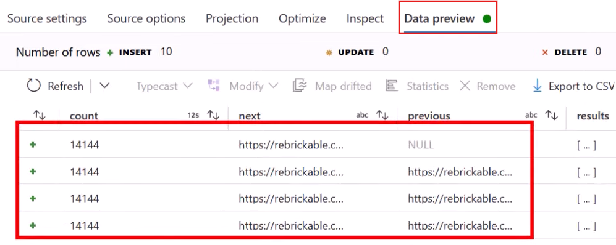

## Optimize the source transformation

The **Optimize** tab allows for editing of partition information at each transformation step. In most cases, **Use current partitioning** optimizes for the ideal partitioning structure for a source.

If you're reading from an Azure SQL Database source, custom **Source** partitioning likely reads data the fastest. The service reads large queries by making connections to your database in parallel. This source partitioning can be done on a column or by using a query.

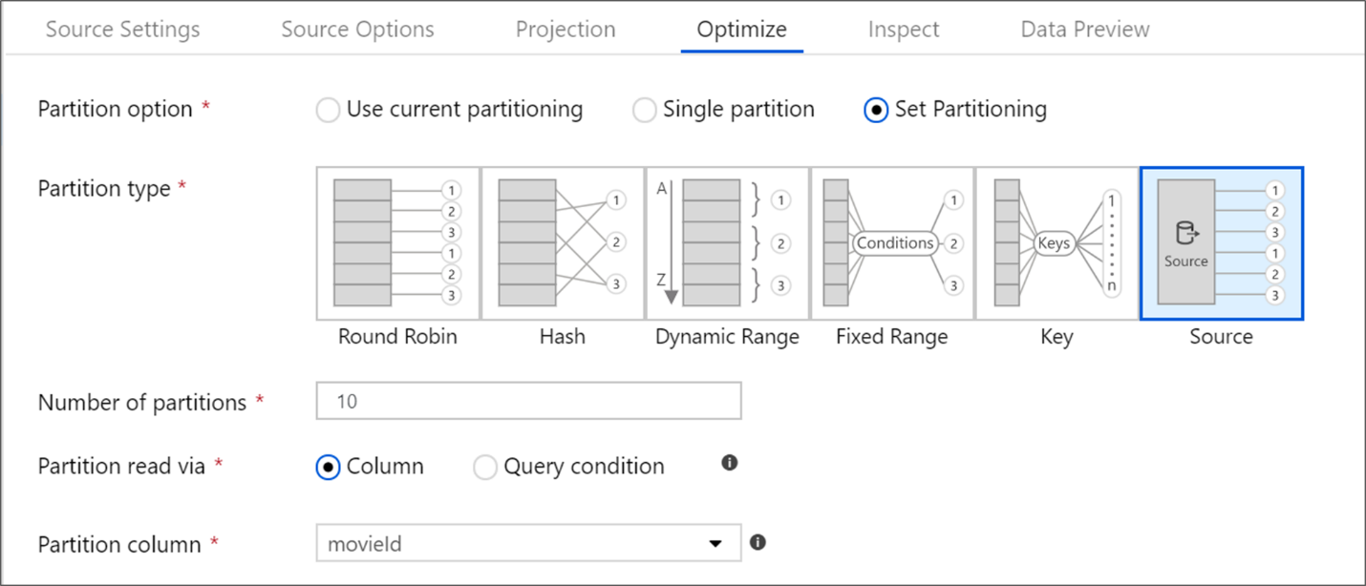

## Flattening the Array

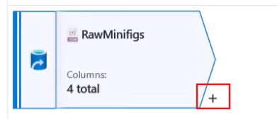

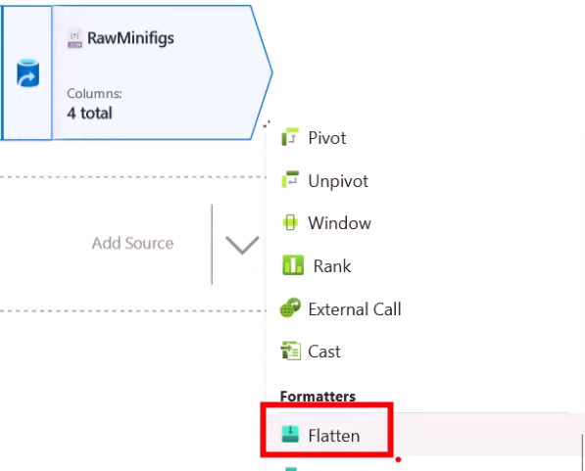

Configure your Flatten activity

Incoming stream : input the Flatten activity

Unroll by the column you want to explode

Input columns: how our data should look like

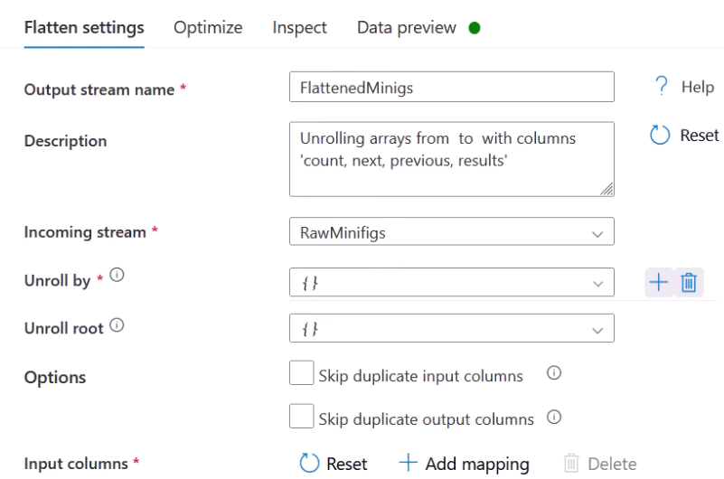

If you preview your data, you will see after selection results in Unroll by our result colum got exploded.

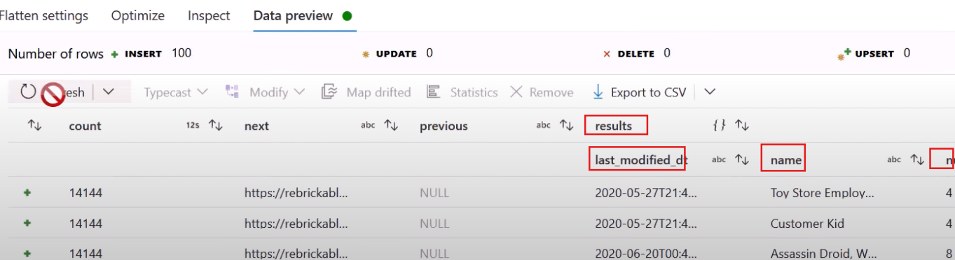

Then in Input columns add the columns explicitly

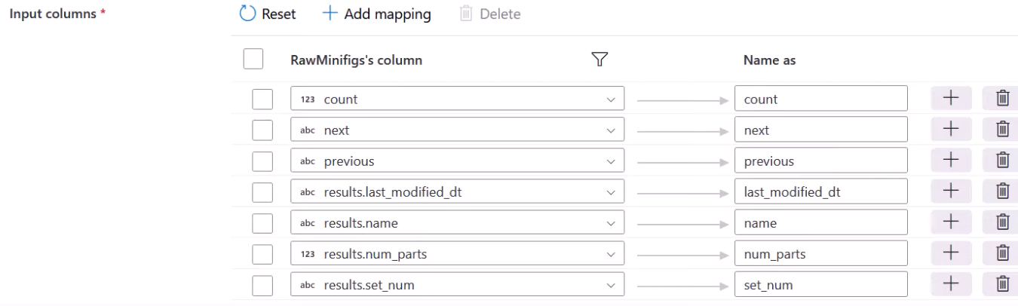

Handling Null

In case when you ingest data from an API, its previous page value was set to NULL for first page. Now maybe we have some business rule that says that replace the “NULL”

To “Not Available ”

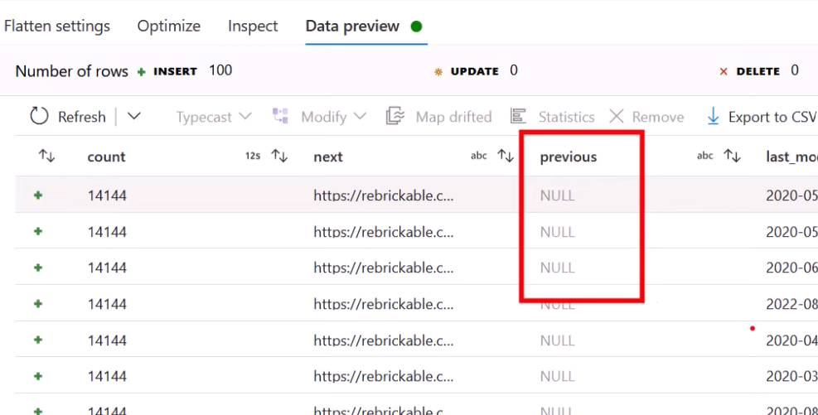

Derived Column (Schema modifier)

It allows us to add a new column or alter an existing column.

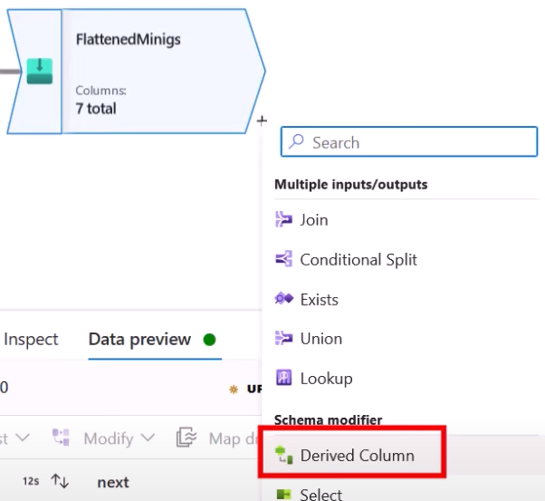

Name your transformation and under Columns choose the column you want to play with

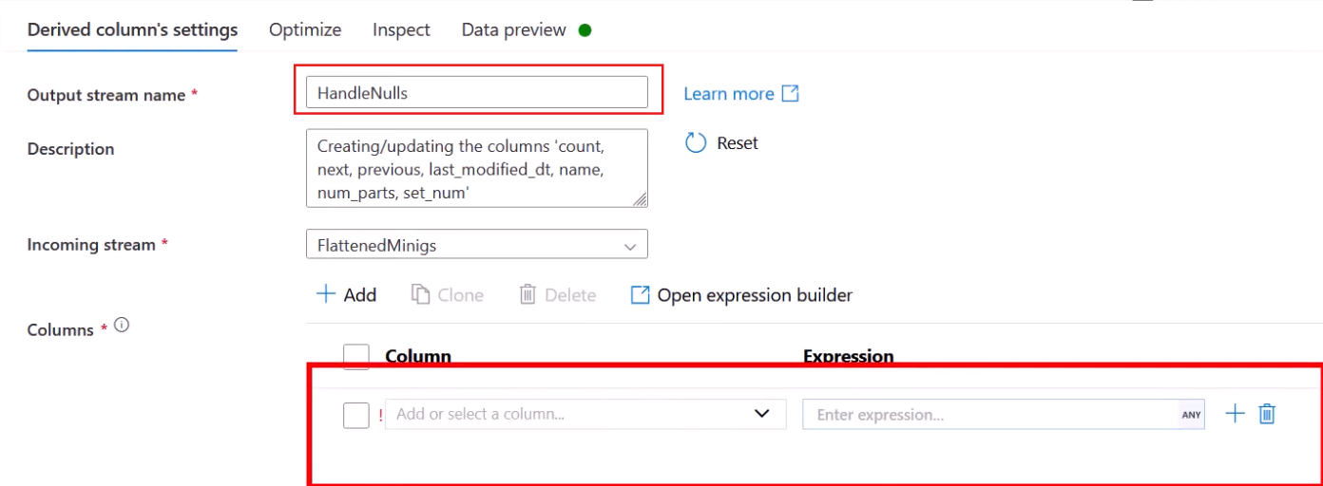

Inside the Expression write your logic

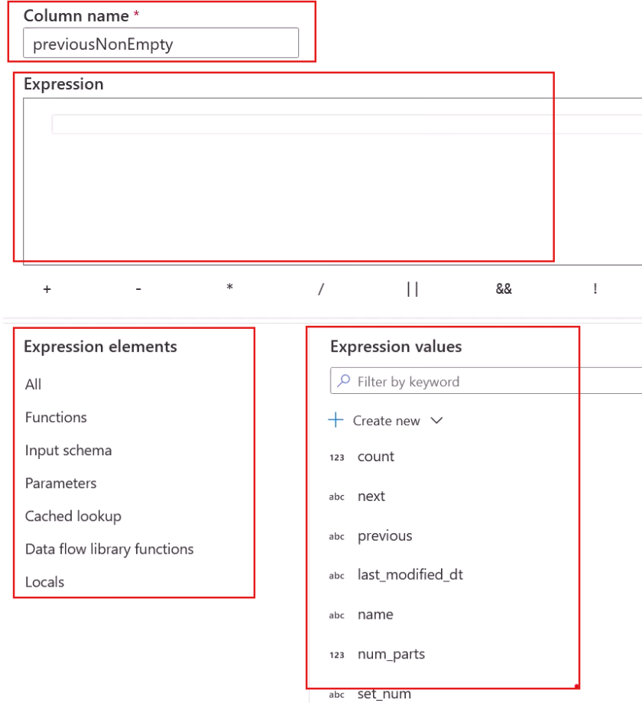

Removing NULL values this time

Filter = where conditions in SELECT statements

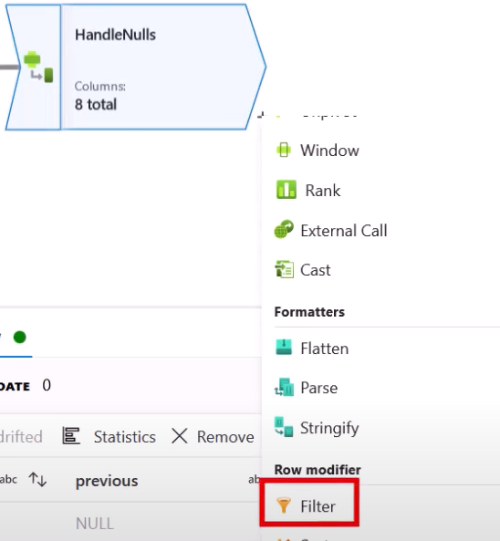

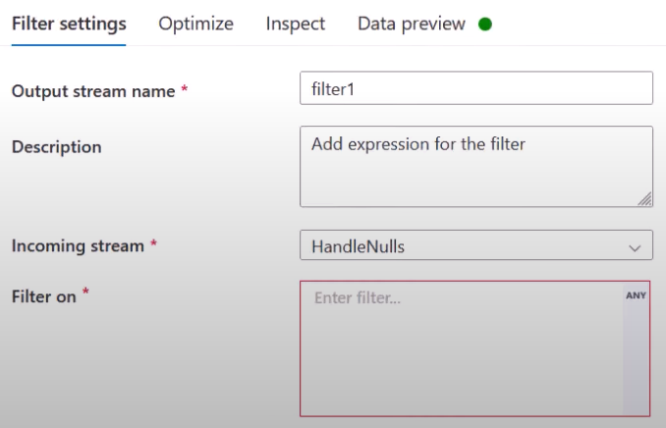

Removing and renaming columns

SELECT transformation

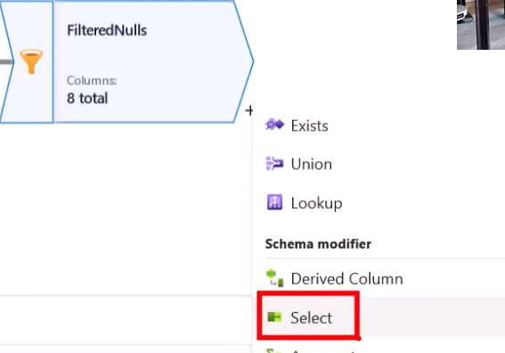

Simply hit on bin icon to remove the column

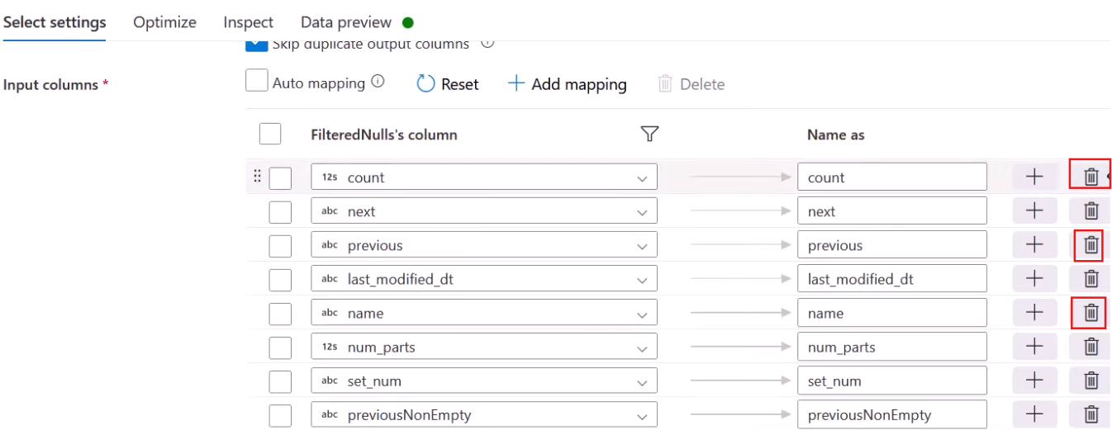

Converting Data types

String to Datetime

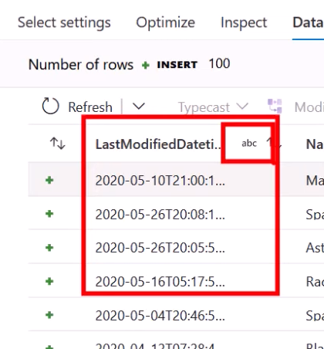

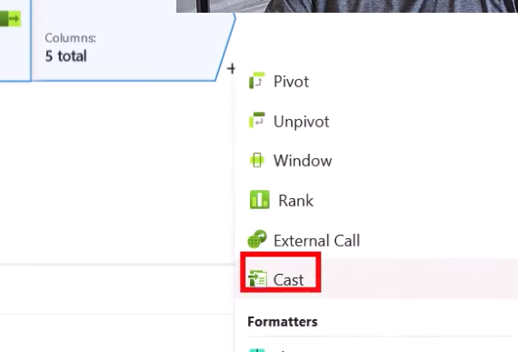

Choose the column

Specify type (timestamp)

Specify format

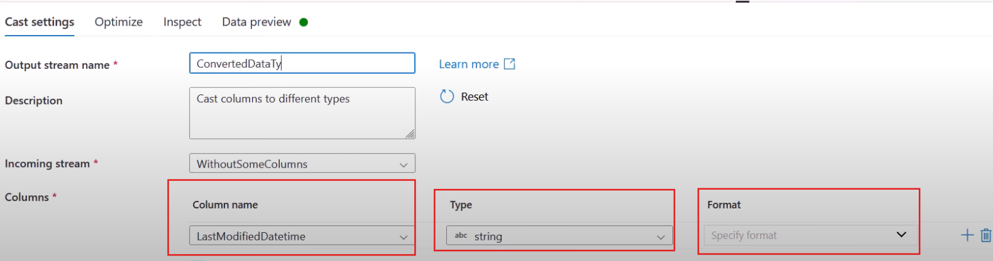

Conditional Logic

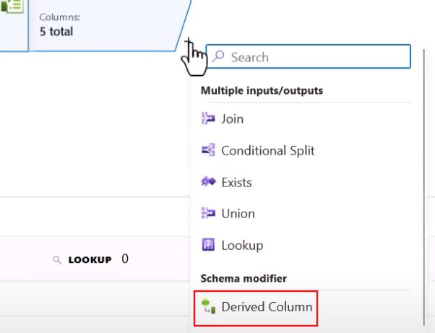

Add a new column and build an expression of it

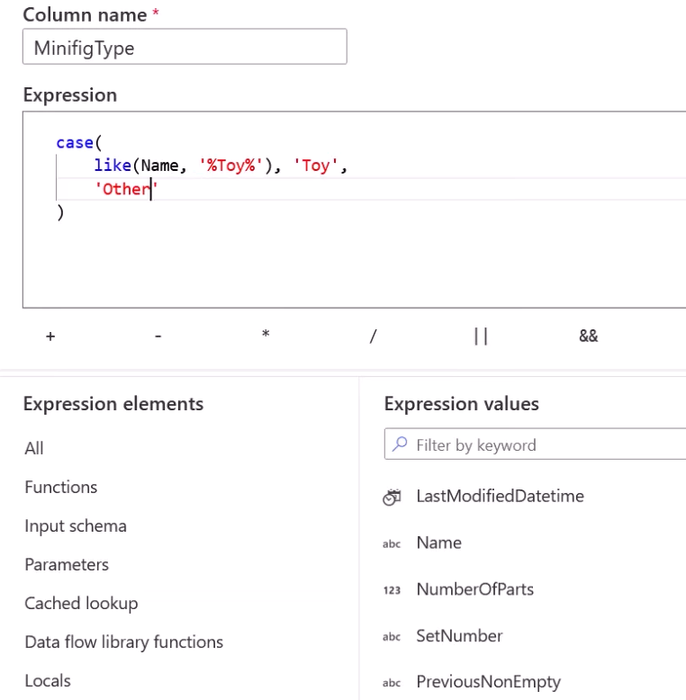

Saving transformed data to a data lake

Choose Sink transformation

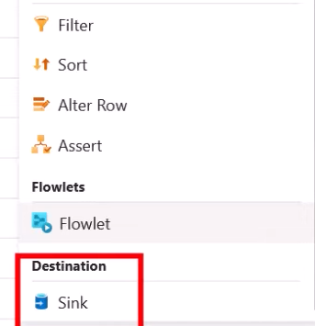



Specify Sink type



Add a new dataset that will store your results as delta format

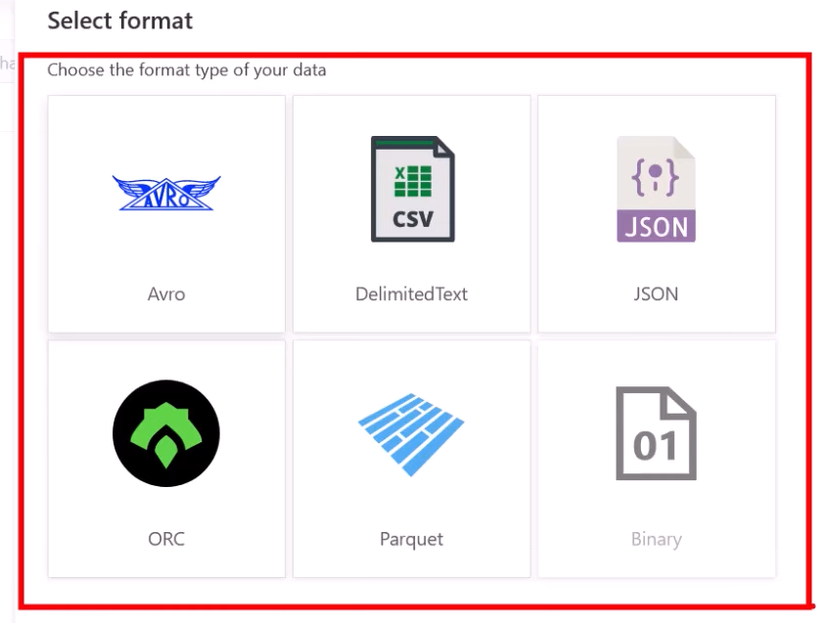

But you will see that there is no option to create a dataset to save our results as delta in case we choose Integration dataset as Sink type.

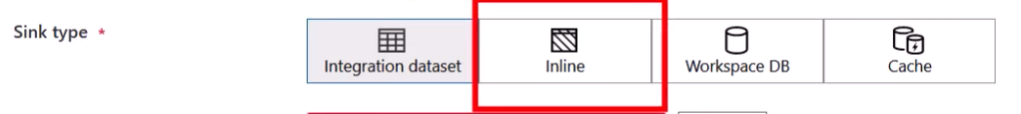

Lets proceed with Inline dataset. And while choosing the Inline dataset you will see from the option that it supports delta format



Indicate the linked service



If you want your result to be stored in a separate container you will have to configure your Sink transformation a bit

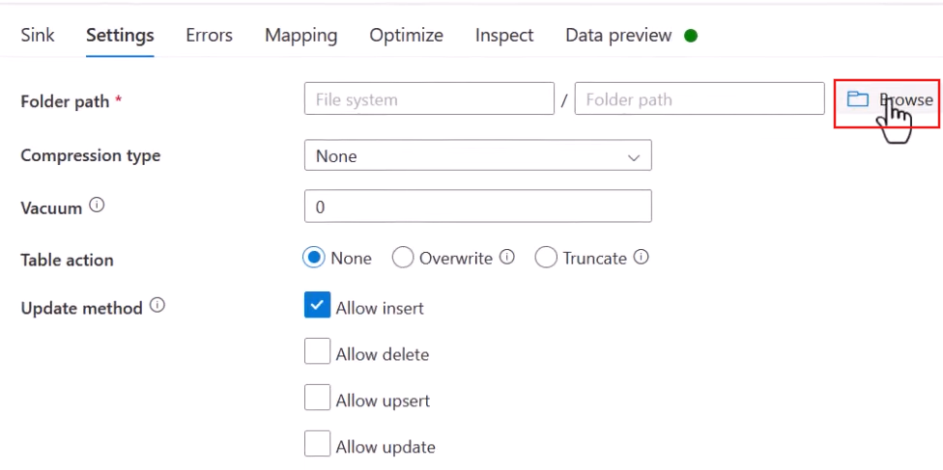

Explicitly add a directory

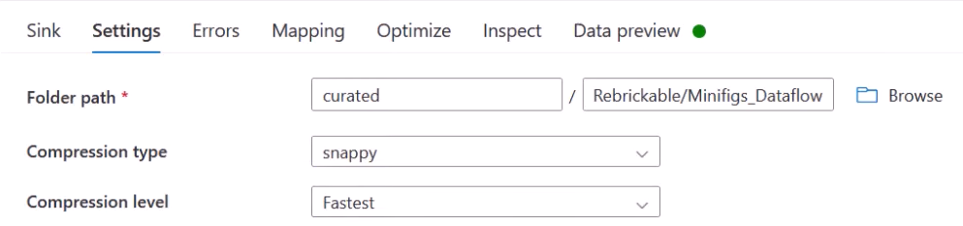

Executing Dataflows

Inside your pipeline simply add Dataflow as an activity. This is the only way to run your flow

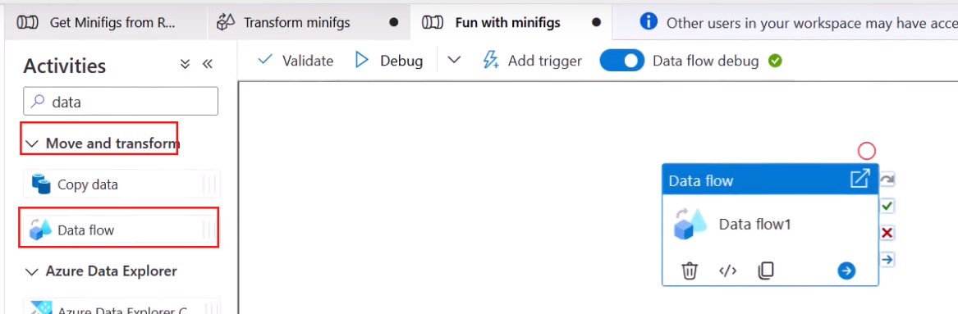

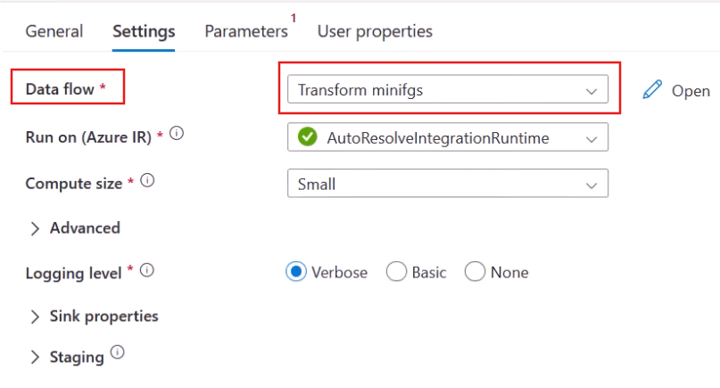

There you will provide the name of your recently created Data flow.

Then you will Debug the pipeline

**LECTURE 44**

**Loading data to Dedicated SQL Pool**

How to load data to dedicated SQL Pool

How to connect to that dedicated SQL Pool

In this demo we already have the transformed data in the Data Lake inside curated layer and at the target side we will delete all the records and grab everything from curated layer and load it to dedicated SQL Pool

**Polybase**

We are considering pull approach here, where SQL Pool is pulling the data from external source(Data Lake in this case). This approach can be used when you have some on-premises Data Warehouse and data is already transformed there implemented as some stored-procedures. Therefore, this is just lift and shift case. There is no involvement of Databricks, ADF or Synapse.

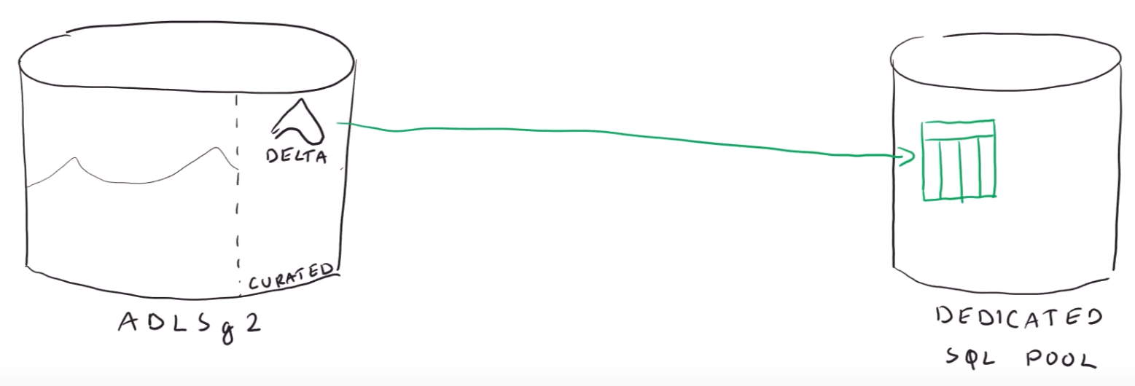

Polybase approach is simply a possibility to query data that is outside our database using T-SQL queries.

You have to create some objects to implement this approach

Go to Synapse Workspace 🡺 Develop tab 🡺 SQL Script

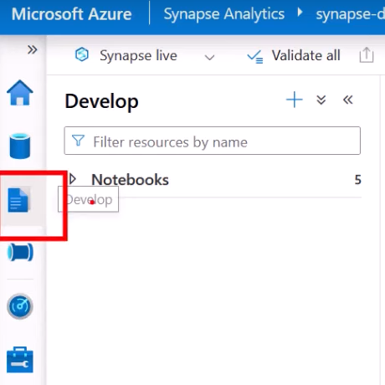 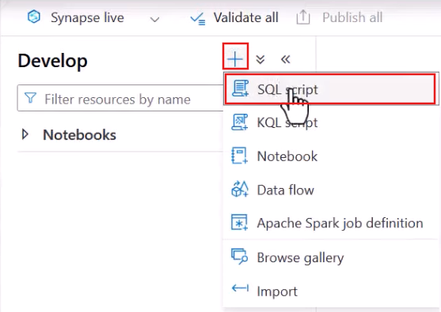

Switch the connection to your dedicated SQL Pool

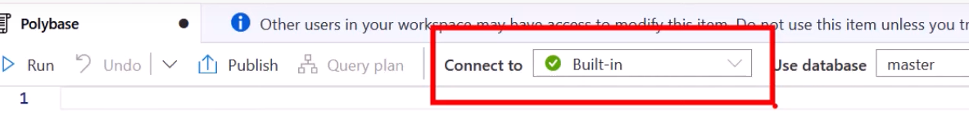

To read the data externally you would require to connect to the source(datalake in our case). For this you create an object called ***Database Scoped Credential*** and configured it using Synapse’s Managed Identity.

This means that the SQL Pool will use Managed Identity of the Synapse Analytics Workspace to connect to the DataLake.

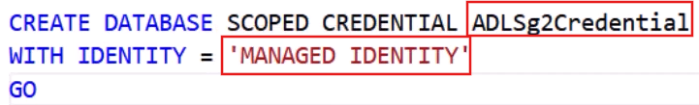

So far you haven’t used it yet.

Next step is created an object for ***External Data source***. It is simply a pointer to the source. While defining external data source you are specify the location of source container/directory on your Data Lake along with authentication method to connect to it.

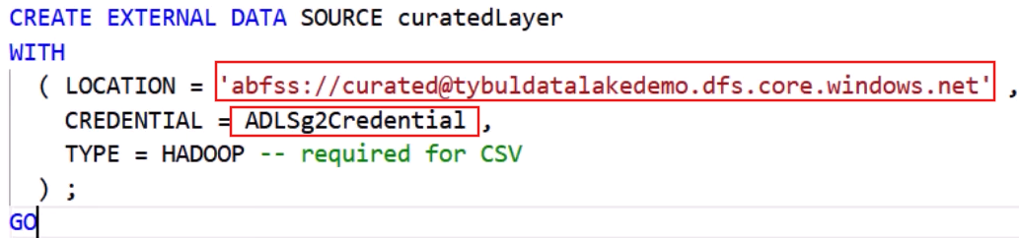

Next step is to define the external file format meaning the format of file to be read by the Synapse from this curated container. But unfortunately, Polybase does not read delta file format. It can either read CSV or parquet file format.

CSV file format

Defining CSV file format

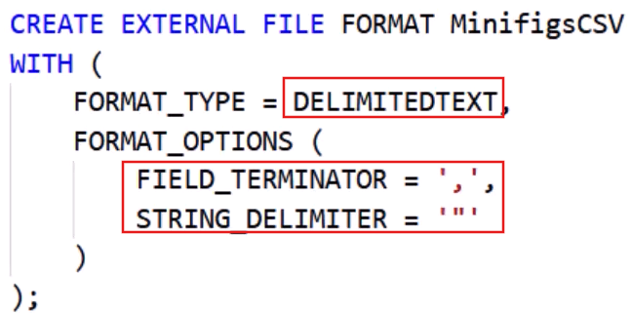

*FORMAT_TYPE* = you are specifying that file is csv

*FILED_TERMINATOR* = columns are separated using “,” character

*STRING_DELIMITER* = strings are delimited by ‘ “ ’ character

The options available are limited while defining CSV format. In case if there is some special characters you wont be able to read the data. There is no option to specify escape characters

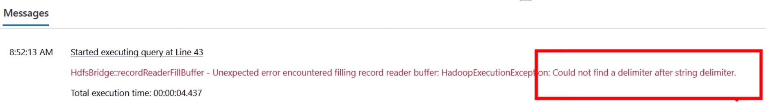

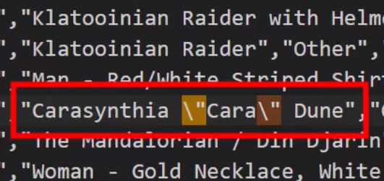

This record has embedded double quotes

Then you create an External Table referencing the External Data source.

EXTERNAL TABLE = meaning the data is not stored inside Synapse, it lies somewhere else. We know that in case of CSVs all columns are string so to avoid the datatype mismatch thing we are defining all the columns to have string type. Also, we are defining the container inside DATA_SOURCE and where exactly under LOCATION and for file format we are providing the file format defined earlier as MinifigsCSV

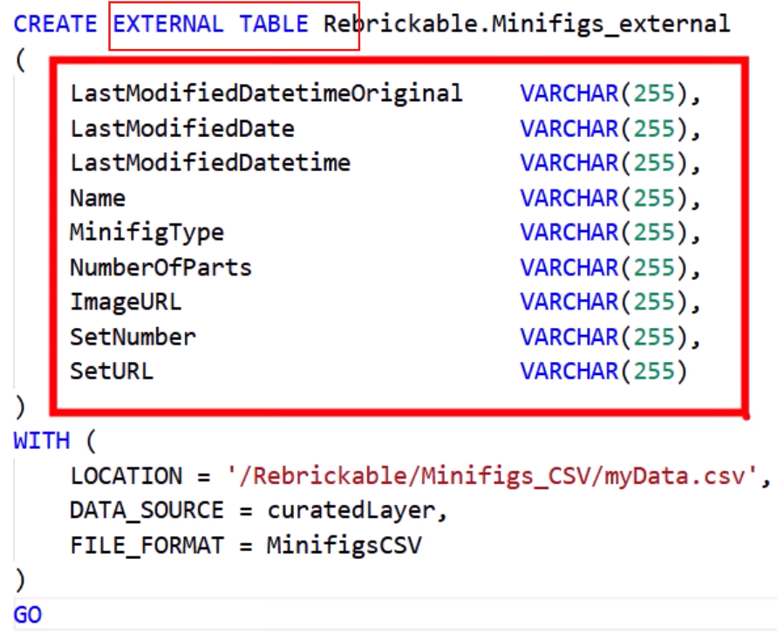

**Note: Make sure to provide Storage Blob Data Contributor role to managed identity of Synapse Workspace on the Data Lake**

**The table definition will appear under SQL Database. The data is not in the Synapse jurisdiction but lies on the DataLake.**

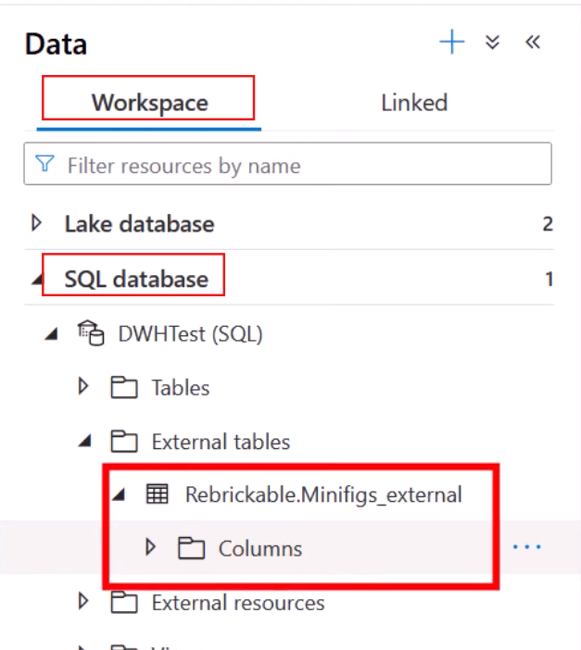

Querying the data

Parquet file format

Create a new file format named as MinifigsParquet

FORMAT_TYPE = PARQUET

DATA_COMPRESSION = snappy

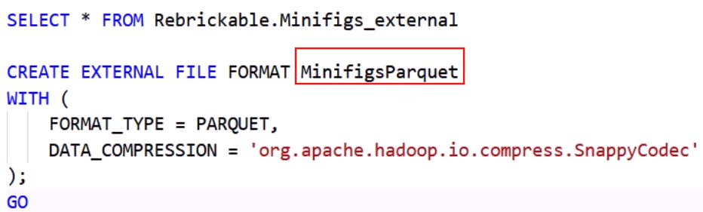

Then recreate another External Table to use the above file format

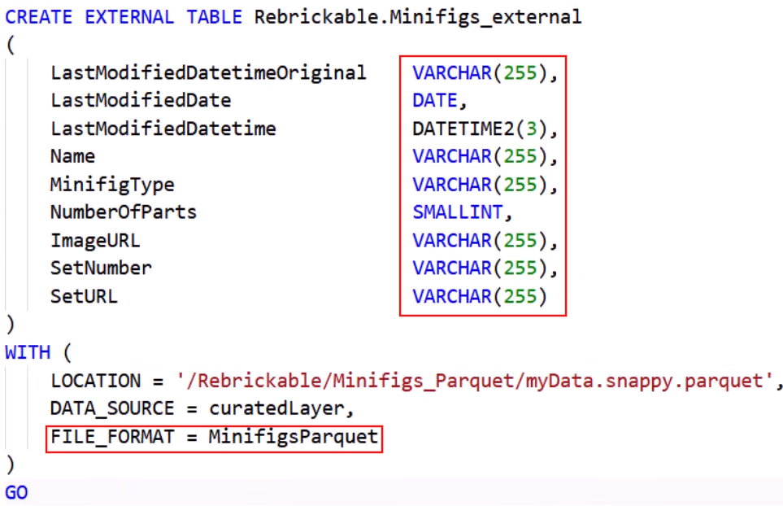

This time you did not provide kept column datatype as string instead you explicitly gave appropriate datatype to columns and there would be no data mismatch upon loading the data because in Parquet schema comes with the file. Also, you specify the FILE_FORMAT that you already created. You also changed the LOCATION

At this point DML operation will not be supported. Meaning you will only be eligible to read the data. Update, Delete records will not be supported because the data still lives on the Data Lake. To have the data make available inside the dedicated SQL Pool. For this you will have to create another separate table and then load the data from External Table to that table using the phrase

**CTAS = Create Table As SELECT**

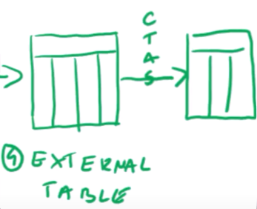

You give name to your table and provide distribution

Populate the new table with rows that are already stored in external table

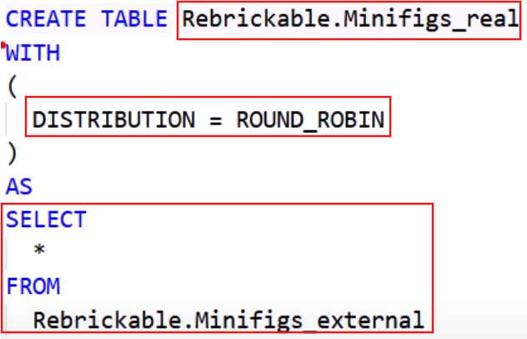

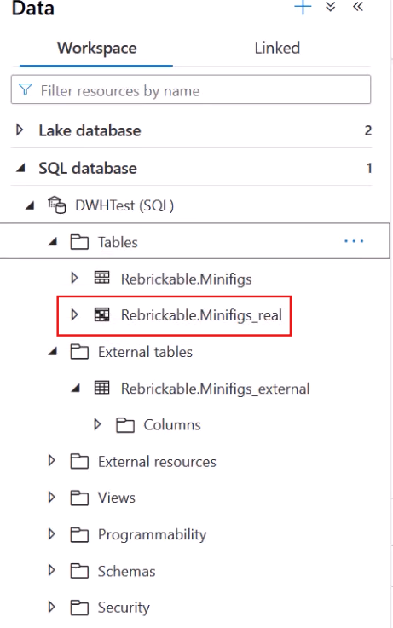

Now you can read, update and delete the data from this table as shown below

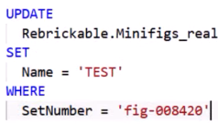

Now, the next challenge is if the data changes in the source it would get reflect inside external table but not inside in the staging table on which you fire DML queries.

**Another Method**

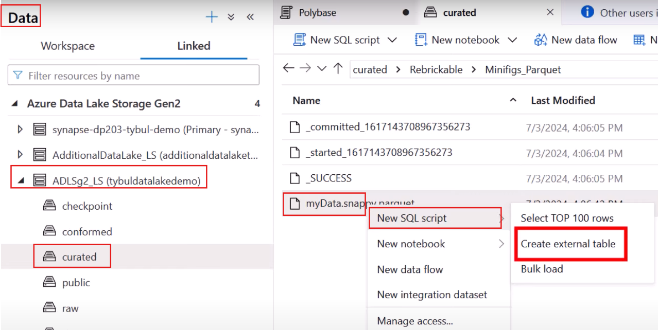

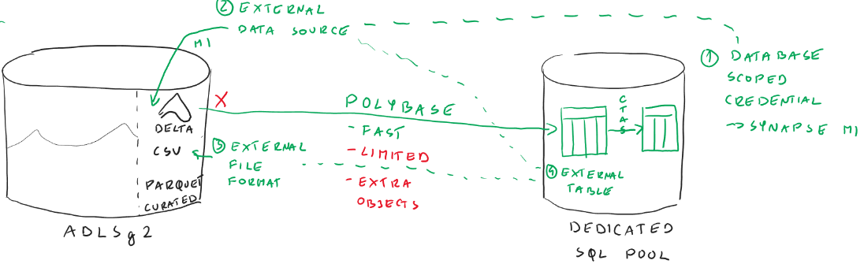

**Copy**

Delta is not supported.

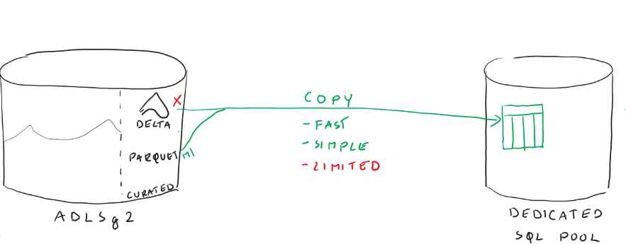

You simply provide target database name and table name(**COPY INTO**), location of data that lives on external source(**FROM**), authentication method(**CREDENTIAL**) and file type(**FILE_TYPE**)

First drop data from the Staging Table that was there from the Polybase Pull exercise by using **TRUNCATE TABLE**

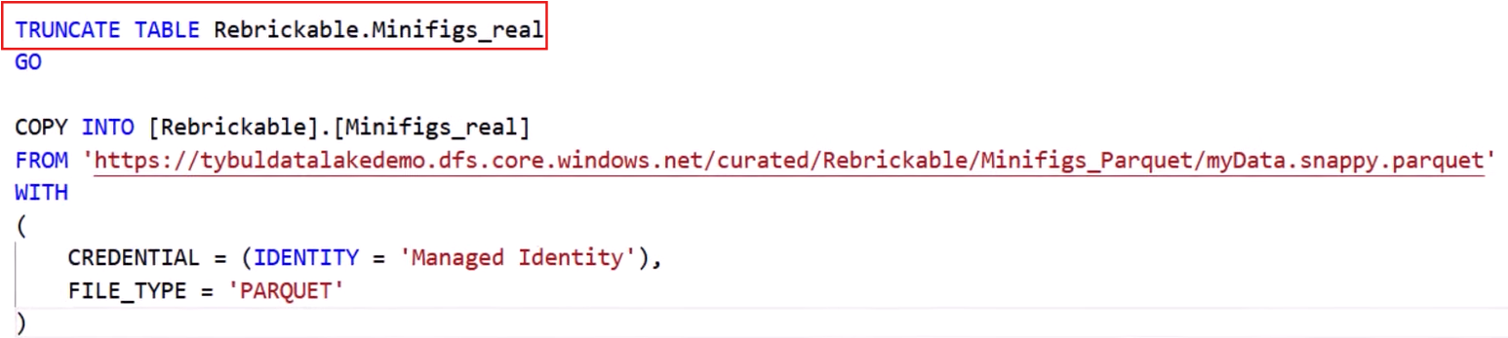

**PUSH**

Go to ADF and use copy activity. We already know that copy activity exists both in ADF and Synapse if we want to move data from one place to another.

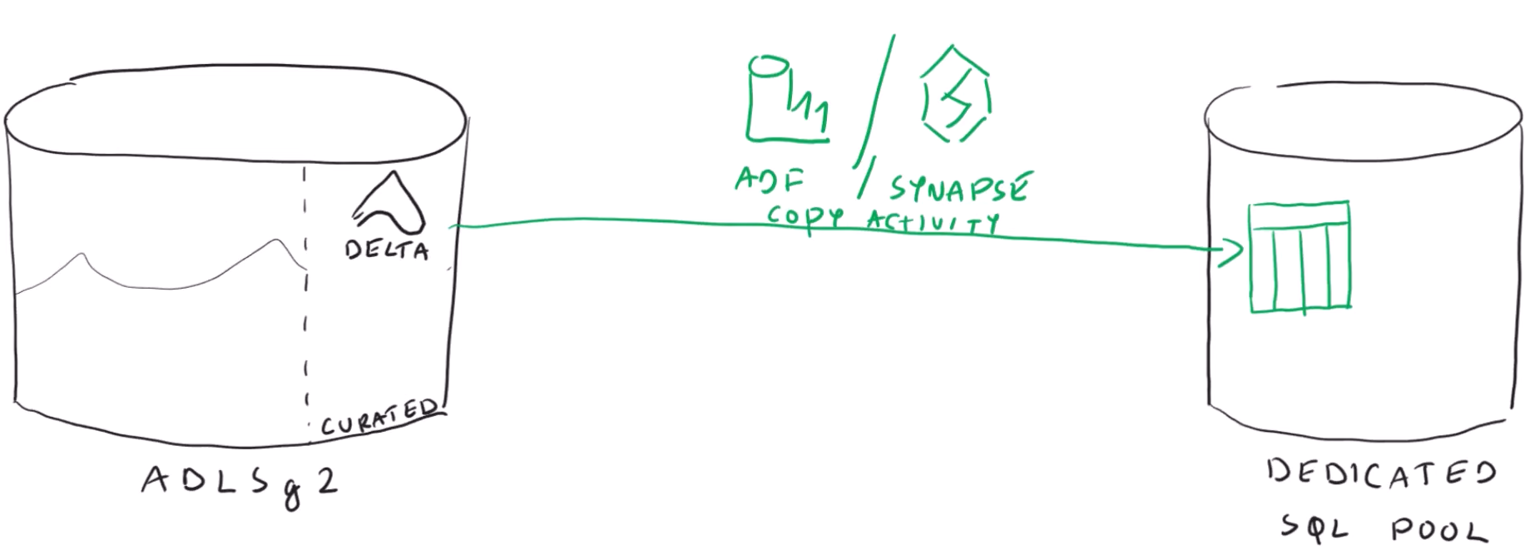

Create a new pipeline 🡺Grab a Copy data activity 🡺 Define Source and Sink

You will find that there is no option to choose delta file format while creating a Dataset

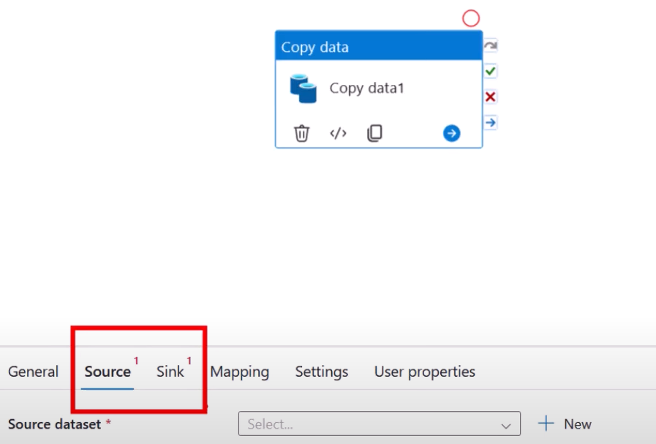 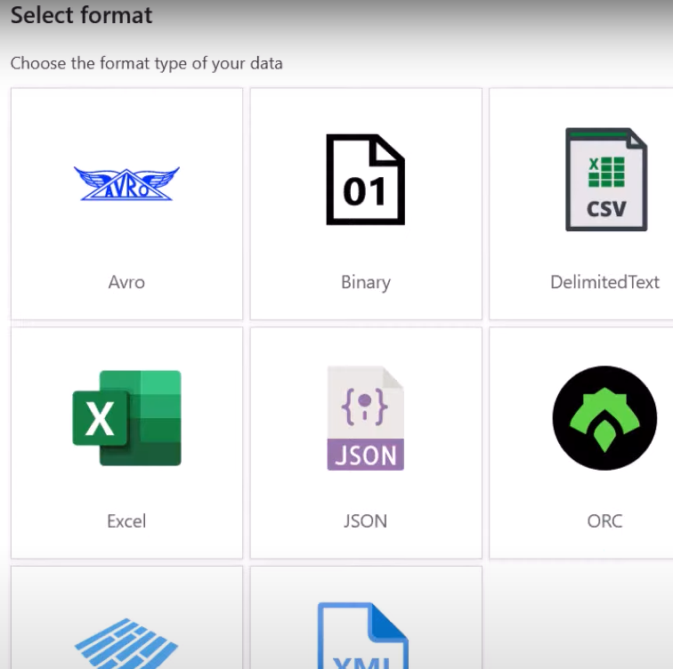

**Note: Delta file format is not supported in Pipelines**

**Creating a Data Flow**

We know we used Data Flows to save files as delta format.

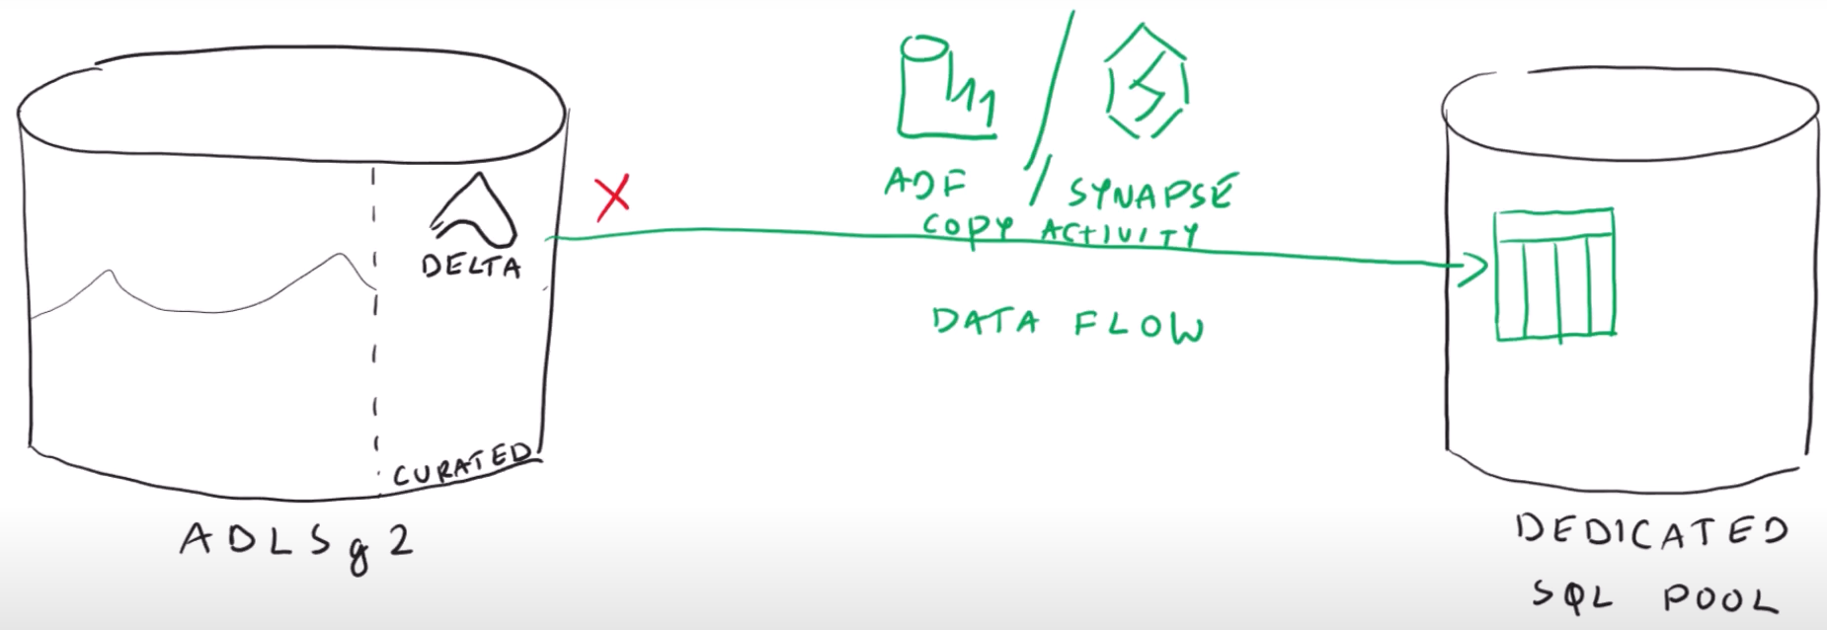

We are using Source Type as **Inline** because **Dataset** at pipeline level does not support delta format

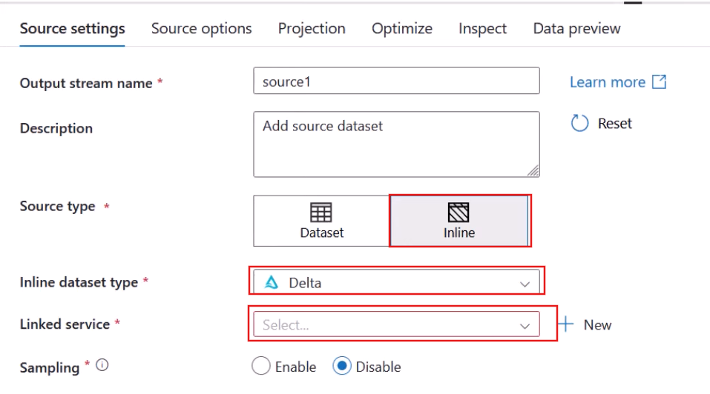

Choose a Liked service pointing Data Lake under **Linked service** option.

Under **Source options** specify where in your Data Lake your data is present.

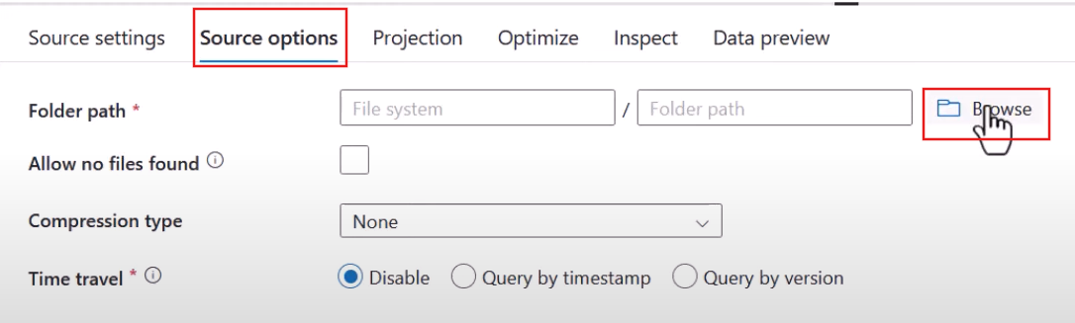

To peek inside the data, enable Data flow debug mode

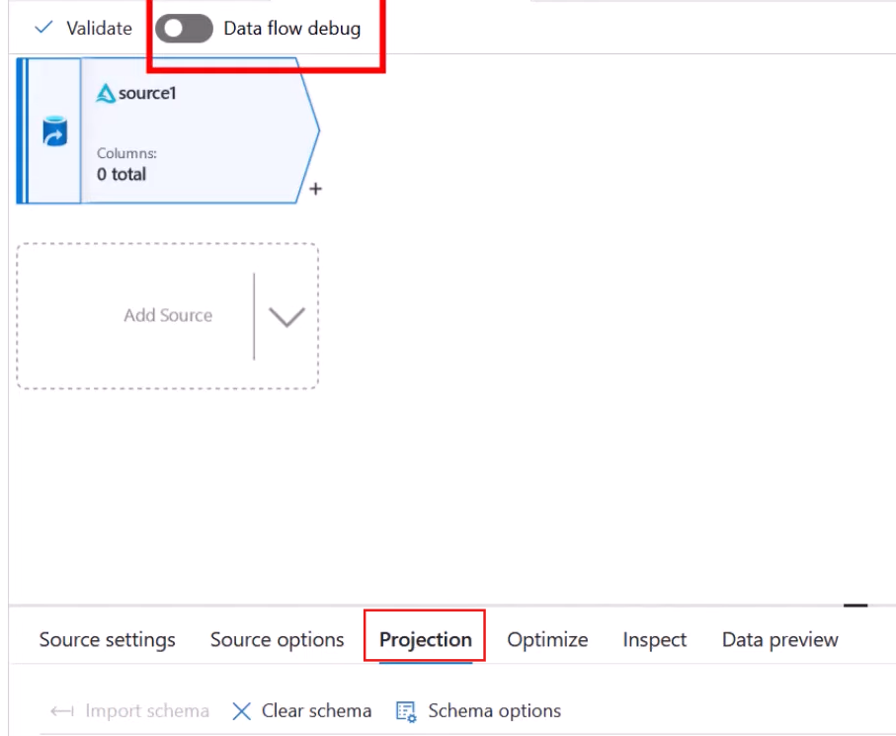

In the **Projection** option click **Import schema**

You can also see your data by clicking on **Data preview**

Next thing is how to connect to Synapse dedicated SQL Pool

Grant **db owner** role to managed identity of ADF on SQL Pool.

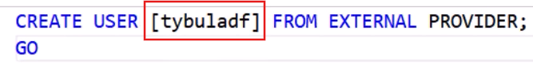

*[tybuladf]* = name of Managed identity

*FROM EXTERNAL PROVIDER* = Entra

Granting managed identity db_owner permission



Also grant DATABASE BULK OPERATIONS permission



Therefore, ADF can connect to dedicated SQL Pool

**Then add Sink activity**

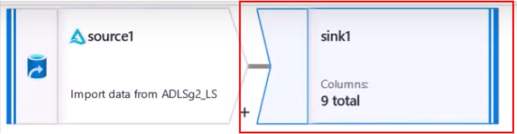

As you know your sink location is dedicated SQL Pool so create a new dataset

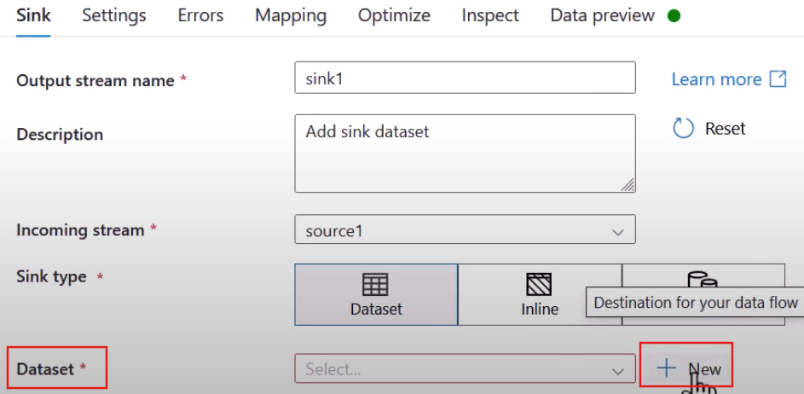

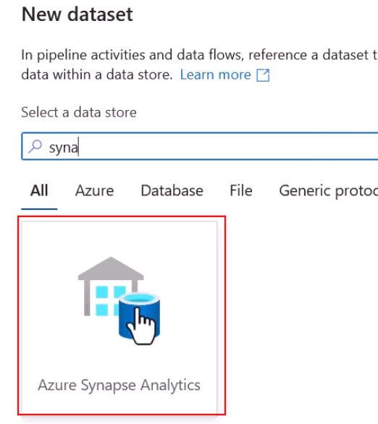

Create a new linked service to Synapse

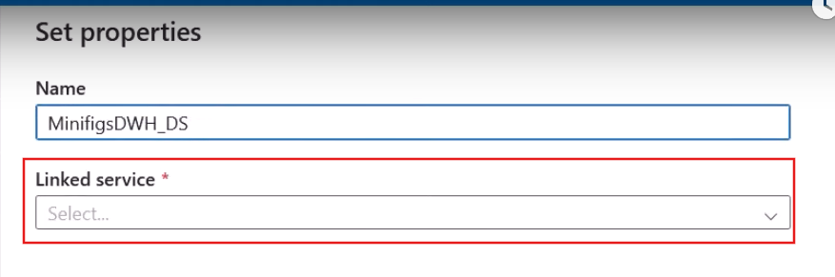

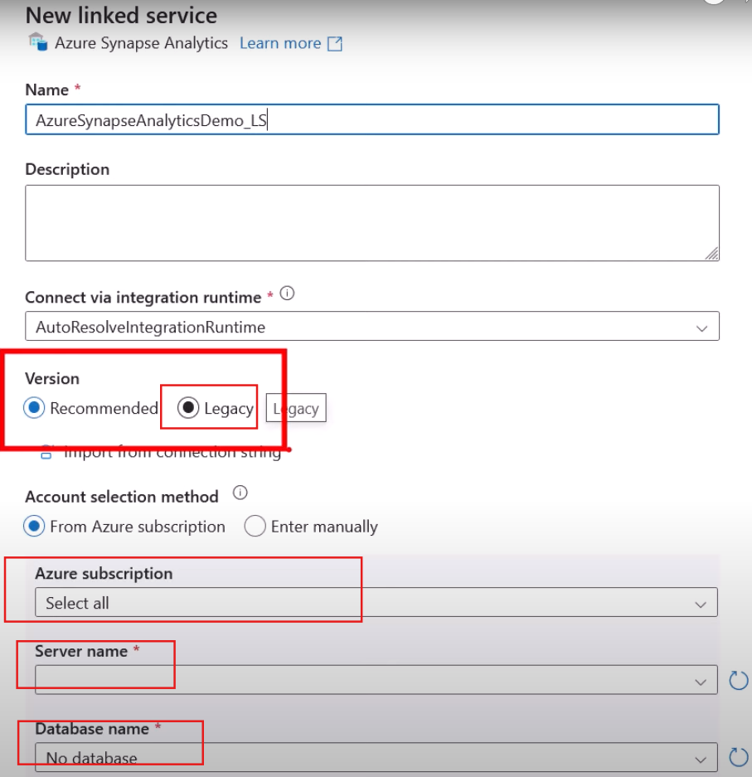

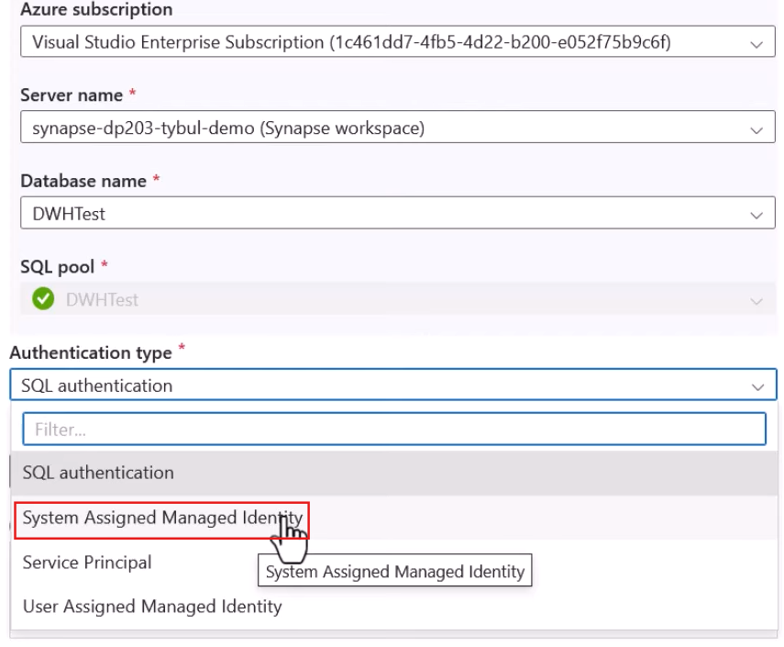

Indicate to which table you want to store the data

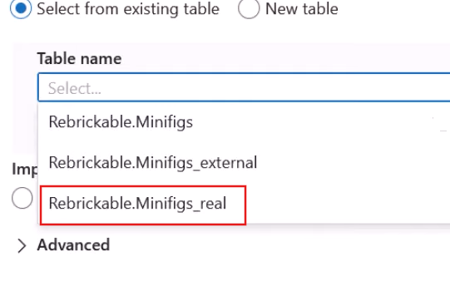

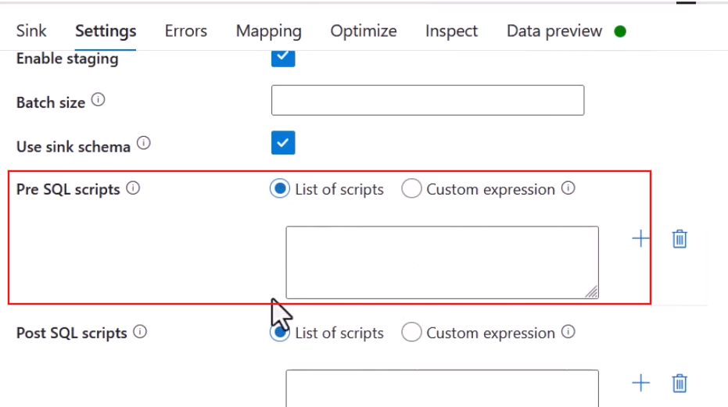

Write a SQL query in **Pre SQL scripts**

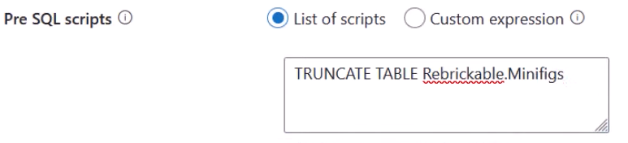

Enable staging option

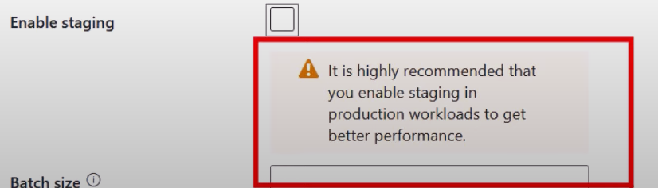

Define a staging location where data will be first dump to a datalake and then from there it will be loaded to dedicated SQL Pool. Dataflow is converting the data in way that is supported by Polybase

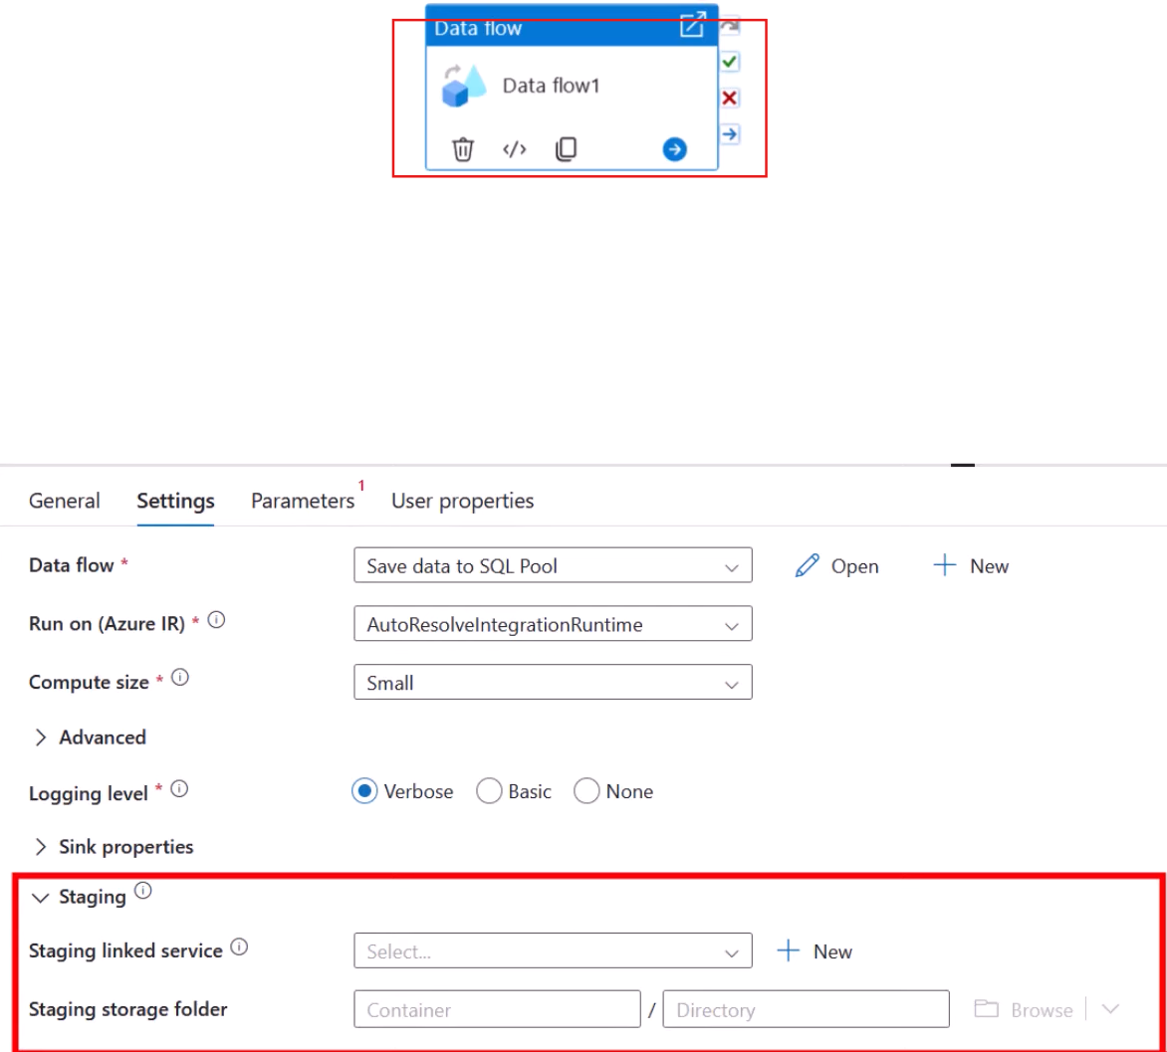

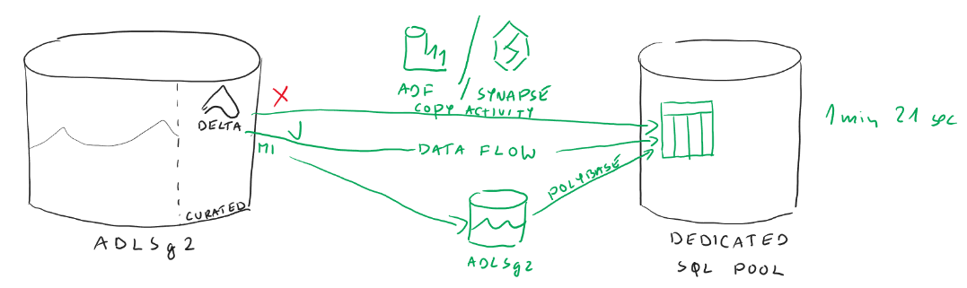

**Copy Activity in ADF**

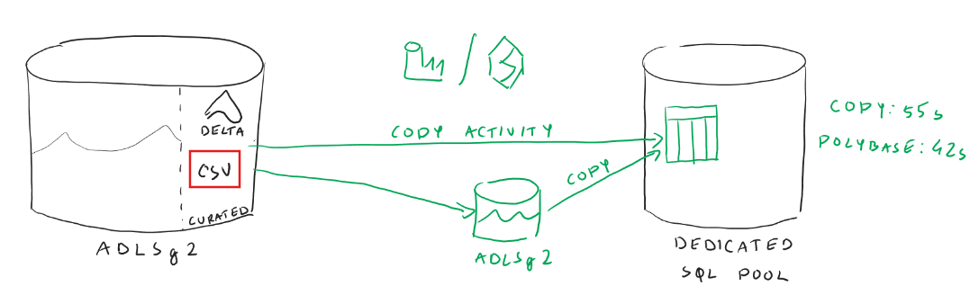

Create a new pipeline 🡺 Use copy activity

**Source side configuration**

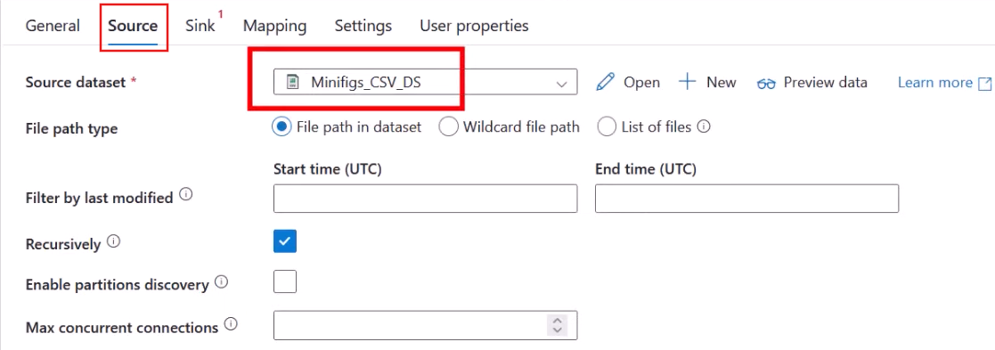

Choose the Dataset that is already configured to read a csv from a DataLake. Just update the path to the data that you would like to be read

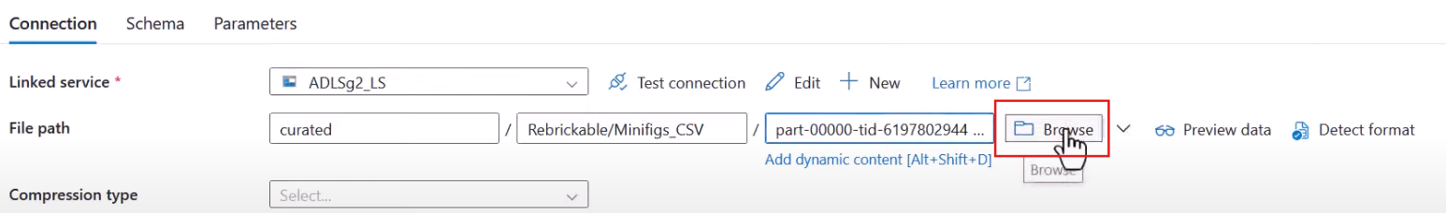

You can also notice that this copy activity has an additional functionality that was not present earlier

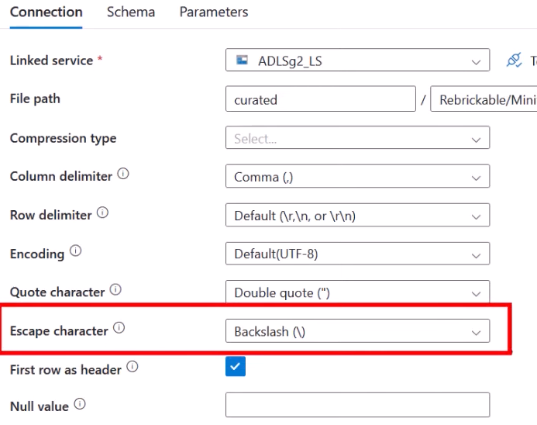

**Sink side configuration**

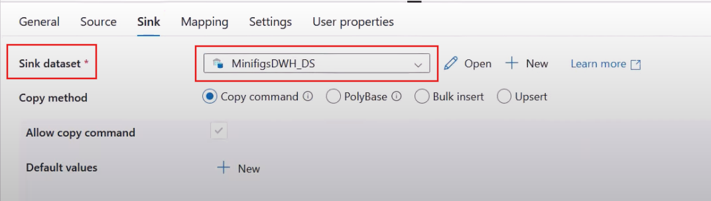

Configure it accordingly

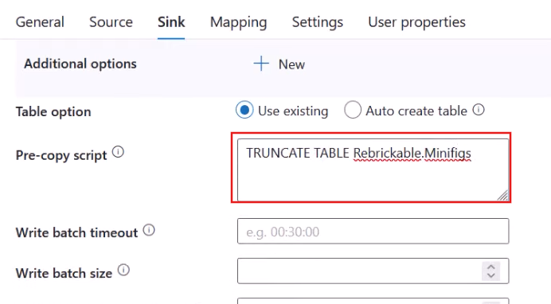

Because you are reading a csv file you can make some changes under Mapping tab

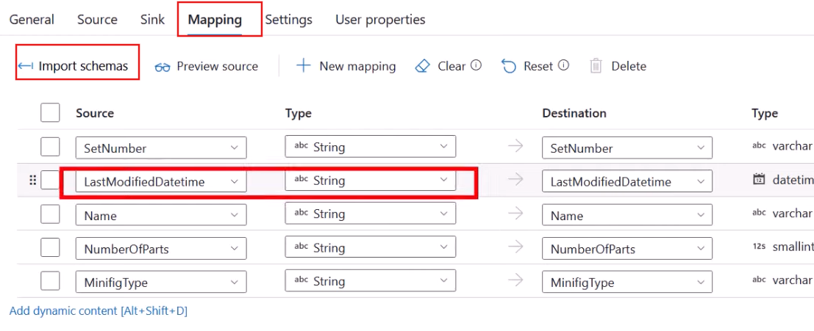

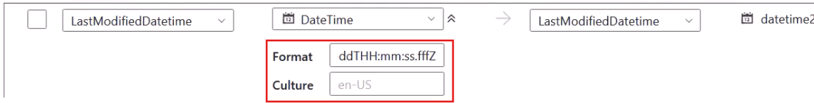

Under Settings tab you can enable staging option

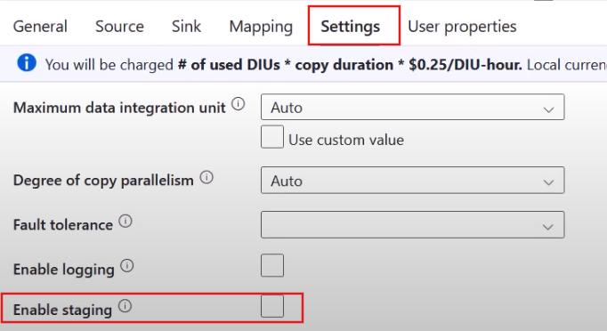

if you do not enable it and click on “debug” you will see a prompt as shown below

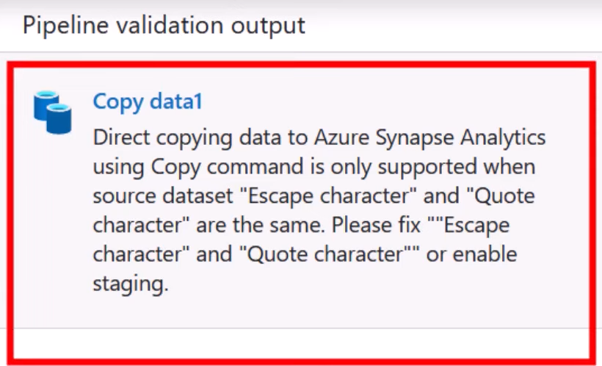

Where to provide information regarding Staging Area

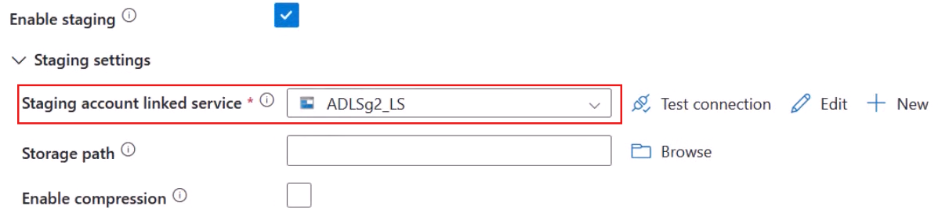

Use the same linked service that points to the Data Lake. Browse and choose Stage container

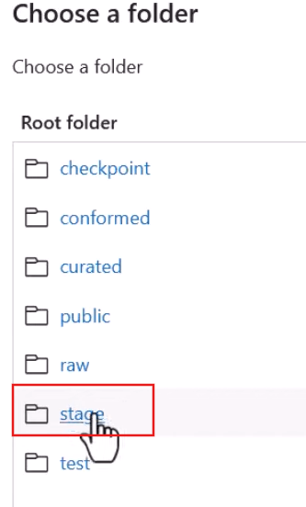

**Using Spark Pools**

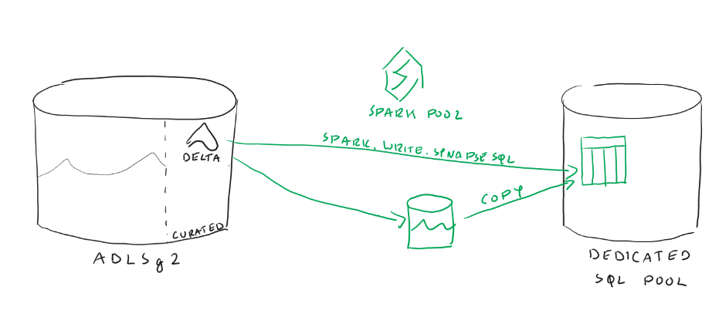

We saw that when we did transformations using Spark Pools, we already had our data available in delta format. Also, Spark can read delta file format. Now the question is can Spark Pool connect to SQL Pool

Create a New Notebook in Synapse Workspace

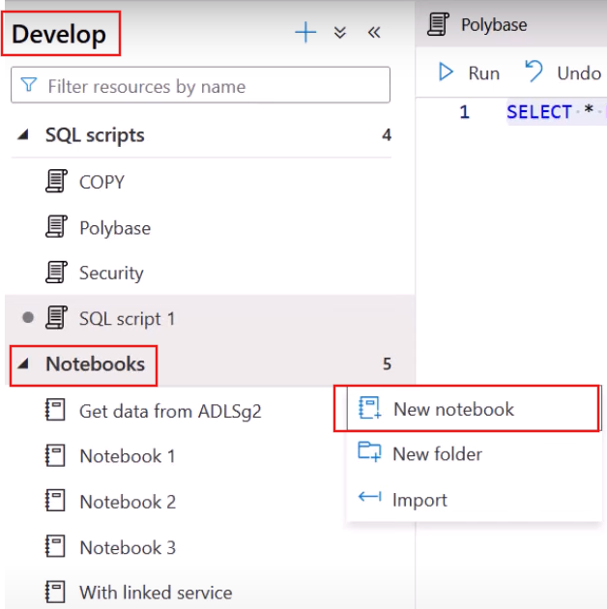

Attach it to the Spark Pool

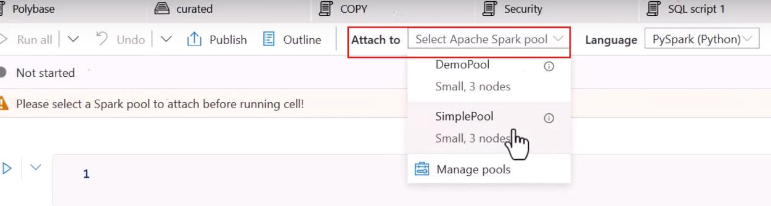

Try to connect to dedicated SQL Pool

Data Tab 🡺 Workspace 🡺 SQL database 🡺 desired table that you wanna load (right click) 🡺 New Notebook 🡺 Load to DataFrame

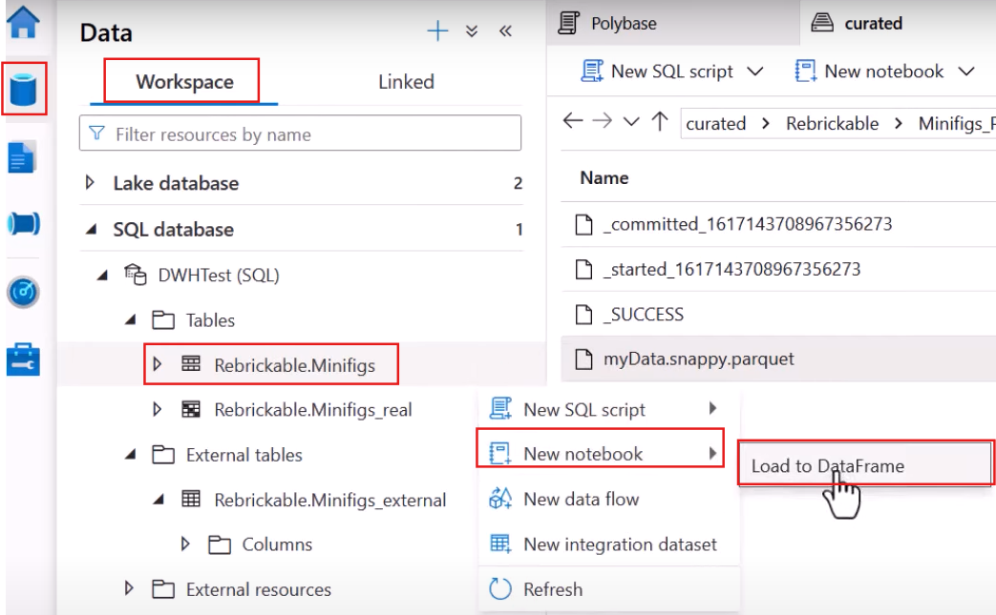

This will result in Scala code to connect to the table to read its content

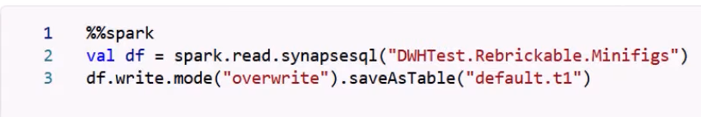

Or else you can use the Python code

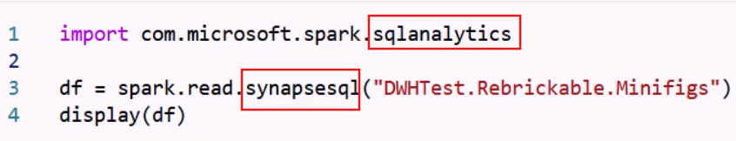

**synapsesql***(“<dedicated-sql-pool.<schema>.<table>”)*

This way you can read data from a table saved on our SQL Pool to a dataframe in Spark Pool

**Saving data to SQL Pool**

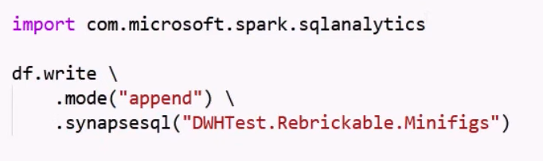

This time we were able to read data from delta format and we used Spark Pools and to make it work we utilized **SPARK.WRITE.SYNAPSESQL** but under the hood it used copy operation.

To check the staging area used by Spark Pool

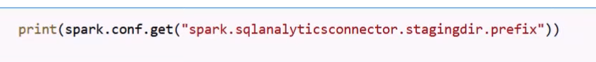



**Using Databricks**

We have got our Databricks workspace that saved the data to our Data Lake as delta format. We will utilize the same workspace.

You have set some initial configurations defining how to connect to data lake and to Synapse. We will use a dedicated Service Principal and store its secret in a key vault

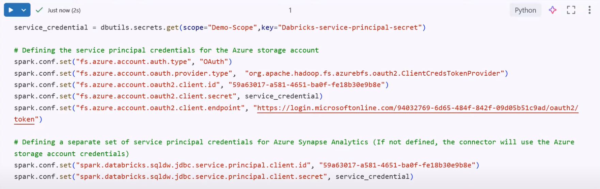

But also, you need to grant permissions to the service principal inside SQL Pool

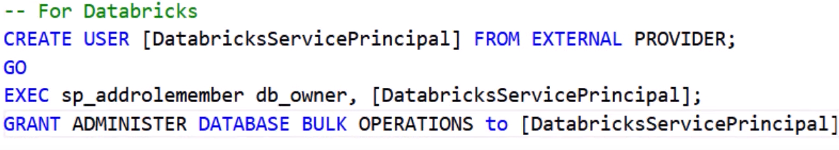

Verify if you can retrieve the data from Data Lake

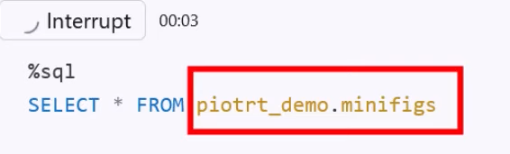

Now write the data to dedicated SQL Pool

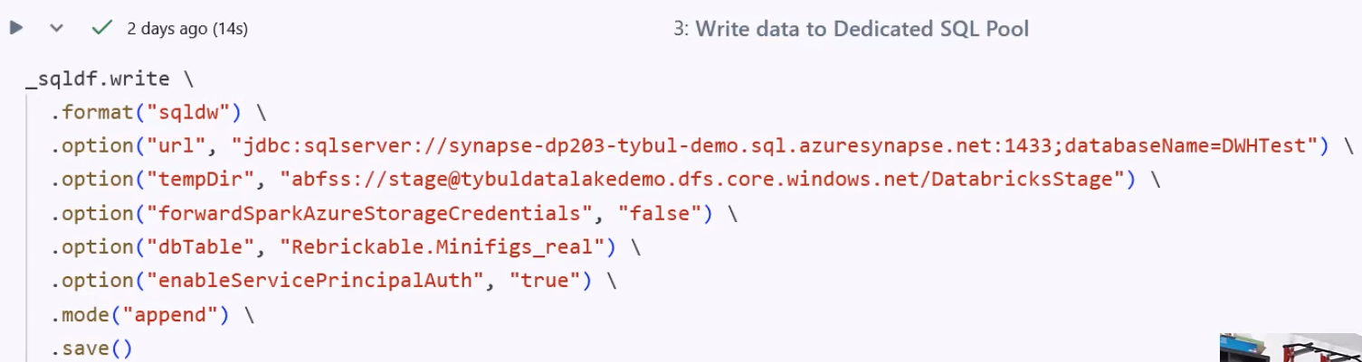

**sqldw** = connector available for Databricks to connect to a SQL Pool

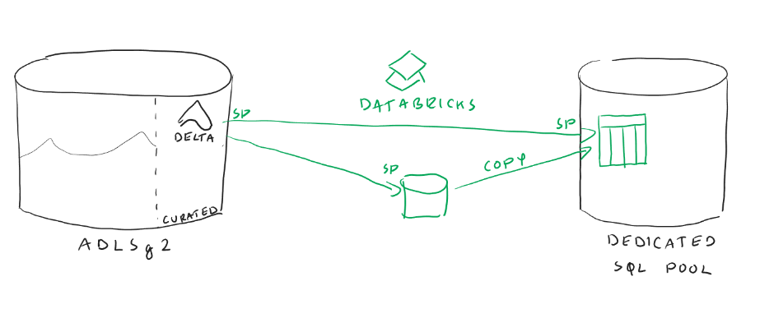

Also, you can read the data from SQL Pools to Databricks

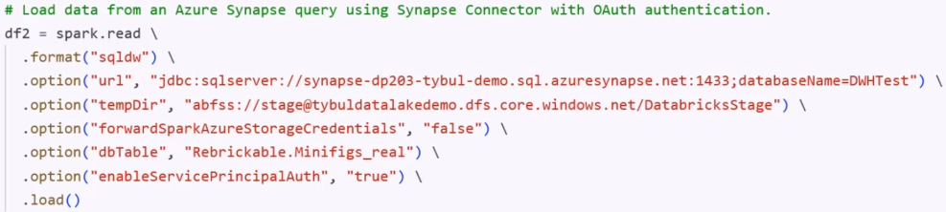

**Lecture 45**

**Result Set Caching**

Go to Synapse Workspace 🡺 Create a Notebook

Suppose this is your query

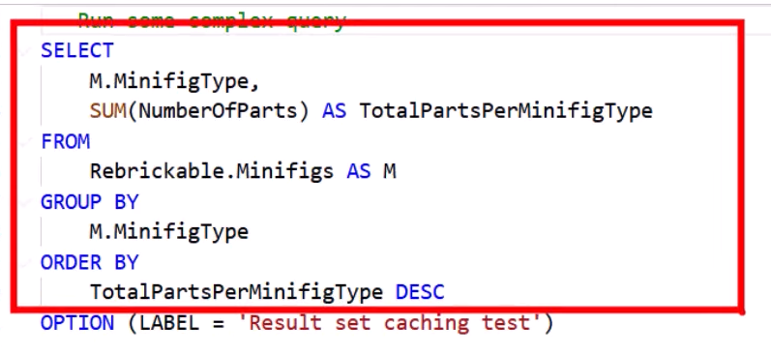

And this is the output

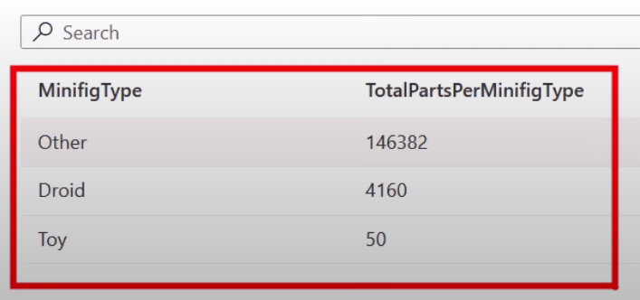

Upon re-running the query again. You will notice that this time query will take more time to be executed

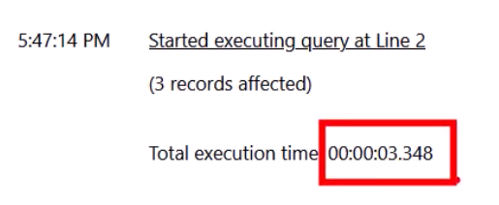

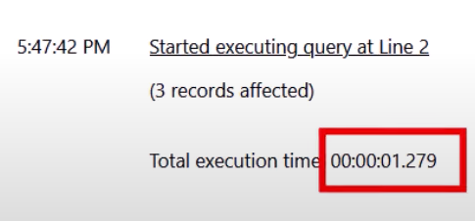

The solution is to cache the data

The following highlighted line just provides label to the query so that you can refer to the same query again and again by this label

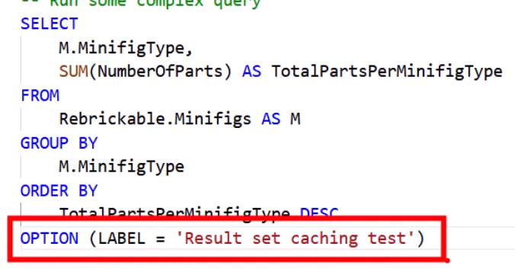

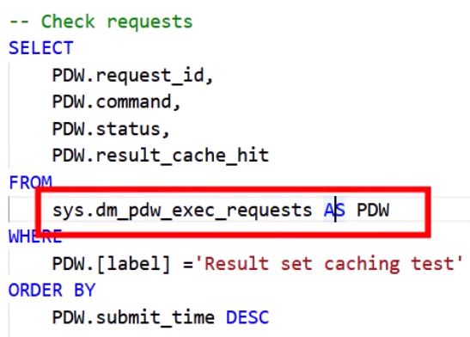

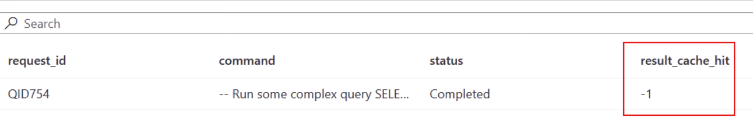

Enabling result cache hit

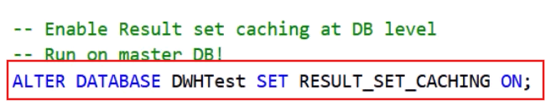

It has to executed on the master database

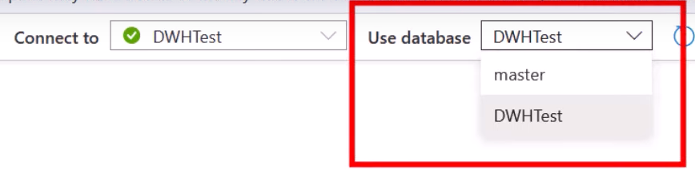

After setting this up if you again rerun your query, the result will be cache

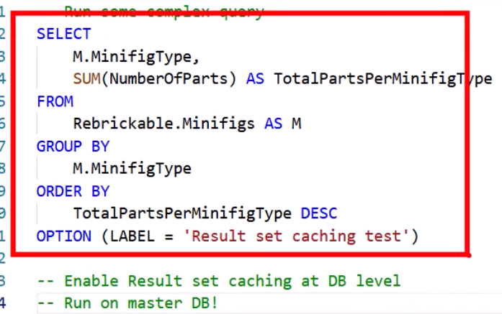

And if you again rerun the query then it will take data from the cached memory

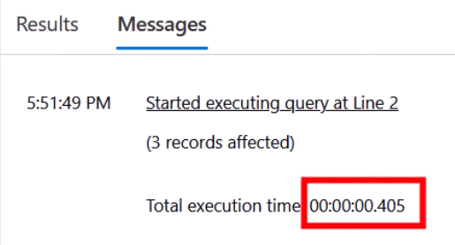

The cached is evicted: every 2-day, if data has changed, if size reaches its limit, if query is non deterministic